**Gathering Pertinent Information**

* **MUSICAL BOT**

* Need statement:

A school in hubali wishes to set up a musical instruments room. To build craze among little kids, the school is looking for some robots that can play musical instruments and entertain the kids.

**Musical instrument: Guitar**

**INTRODUCTION:**

**\***A robot is a machine that executes are commands to complete are tasks in the given time. There are many different types of robots to perform different tasks.

*The bot of ours used to play the guitar for entertaining.



**GUITAR PLAYING BOT**

The guitar is played by the bot to play the music for entertaining kids. By holding the pics of guitar by the pneumatic gripper or servo gripper the bot can plays the music.

DIFFERENT TYPES OF GUITARS

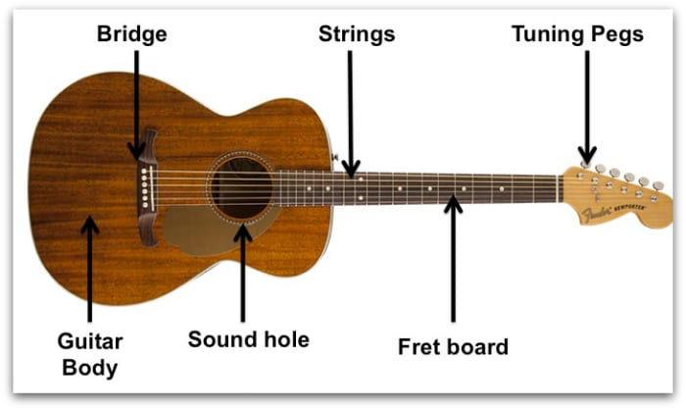

Reference: <https://www.google.com/url?sa=i&url=https%3A%2F%2Fnationalguitaracademy.com%2Ftypes-of-guitar%2F&psig=AOvVaw2hNj82nVzBN_4iPB_Chdku&ust=1623081647081000&source=images&cd=vfe&ved=0CAMQjB1qFwoTCPDD39Kwg_ECFQAAAAAdAAAAABAD>

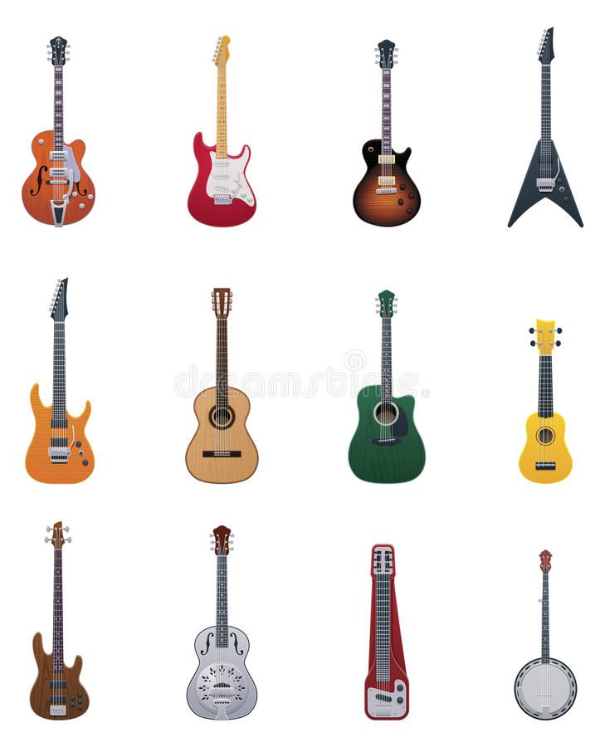

Reference: <https://www.google.com/url?sa=i&url=https%3A%2F%2Fwww.pinterest.com%2Fpin%2F788974428454507798%2F&psig=AOvVaw2hNj82nVzBN_4iPB_Chdku&ust=1623081647081000&source=images&cd=vfe&ved=0CAMQjB1qFwoTCPDD39Kwg_ECFQAAAAAdAAAAABAP>

**COMPONENTS AND SUBCOMPONENTS**

|  |  |  |  |
| --- | --- | --- | --- |
| **S.NO** | **COMPONENT** | **IMAGES** | **REFERENCE** |
| **1** | Dc motor | Brushless DC Motors (BLDC) | ISL Products International Ltd. | **https://www.google.com/url?sa=i&url=https%3A%2F%2Fislproducts.com%2Fcomponent%2Fbrushless-dc-motors%2F&psig=AOvVaw1X2d-bWpqJ-Inq0dGB5rY0&ust=1623083235854000&source=images&cd=vfe&ved=0CAMQjB1qFwoTCNCbhrW2g_ECFQAAAAAdAAAAABAD** |
| **2** | **Servo**  **motor** | Buy Tower Pro SG90 Servo Motor Online – QuartzComponents | **https://www.google.com/url?sa=i&url=https%3A%2F%2Fquartzcomponents.com%2Fproducts%2Ftower-pro-sg90-servo-9-gms-mini-micro-servo-motor&psig=AOvVaw06oauS4YFrI__itaEGWXpe&ust=1623083460882000&source=images&cd=vfe&ved=0CAMQjB1qFwoTCLjSr623g_ECFQAAAAAdAAAAABAD** |
| **3** | **Stepper**  **motor** | Nema 17 Stepper motor, 2.8V 1.33A, 1.8 degree, 2 phase 4 wires | ATO.com | **https://www.google.com/url?sa=i&url=https%3A%2F%2Fwww.ato.com%2Fnema-17-stepper-motor-2-8v-1-33a-1-8-degree-2-phase-4-wires&psig=AOvVaw0MXk4OmZMqPLFugkL_phSZ&ust=1623083686567000&source=images&cd=vfe&ved=0CAIQjRxqFwoTCPCX4Ie4g_ECFQAAAAAdAAAAABAN** |
| **4** | **Pneumatic gripper** | Design Guidelines for Pneumatic Gripper | **https://www.google.com/url?sa=i&url=http%3A%2F%2Fwww.agi-automation.com%2F2015%2F03%2Fdesign-guidelines-for-pneumatic-gripper%2F&psig=AOvVaw1PGIrPH61gt7S18Cc89X2V&ust=1623084736339000&source=images&cd=vfe&ved=0CAMQjB1qFwoTCJD78Py7g_ECFQAAAAAdAAAAABAD** |
| **5** | **Servo**  **gripper** | Servo Gripper Mini Motor, AC Servo Motors, सर्वो मोटर्स, सर्वो मोटर in  Girgaon, Mumbai , Micron | ID: 20928574830 | **https://www.google.com/url?sa=i&url=https%3A%2F%2Fwww.indiamart.com%2Fproddetail%2Fservo-gripper-mini-motor-20928574830.html&psig=AOvVaw1uoXIyUVb-4MLtvoIlKhB8&ust=1623084978121000&source=images&cd=vfe&ved=0CAMQjB1qFwoTCOjn9_G8g_ECFQAAAAAdAAAAABAP** |
| **6** | **Buzzer** | Big Buzzer with Small Enclosed Piezo Electronic Buzzer Alarm 95DB with  Wires PACK OF 5: Amazon.in: Industrial &amp; Scientific | **https://www.google.com/url?sa=i&url=https%3A%2F%2Fwww.amazon.in%2FBuzzer-Small-Enclosed-Piezo-Electronic%2Fdp%2FB07P87BWVY&psig=AOvVaw0LpyramccAm_luaWZg5VUB&ust=1623085153910000&source=images&cd=vfe&ved=0CAMQjB1qFwoTCIjQhNW9g_ECFQAAAAAdAAAAABAD** |
| **7** | **Touch sensor** | ePro Labs TTP223 Ttp223 Based Capacitive Touch Sensor Module for Arduino:  Amazon.in: Industrial &amp; Scientific | **https://www.google.com/url?sa=i&url=https%3A%2F%2Fwww.amazon.in%2FePro-Labs-TTP223-Capacitive-Arduino%2Fdp%2FB01F5BOL12&psig=AOvVaw0voGPSJyee4U7S6KqxLIQ_&ust=1623085360107000&source=images&cd=vfe&ved=0CAMQjB1qFwoTCIiHzaa-g_ECFQAAAAAdAAAAABAD** |
| **8** | **Led indictor** | 8mm 12V LED Indicator Light Pilot Directional Dashboard Lamp Car Truck  Boat: Buy 8mm 12V LED Indicator Light Pilot Directional Dashboard Lamp Car  Truck Boat Online at Low Price in India on | **https://www.google.com/url?sa=i&url=https%3A%2F%2Fwww.snapdeal.com%2Fproduct%2F8mm-12v-led-indicator-light%2F659754863285&psig=AOvVaw2gfoG394730q8FjOkje_sx&ust=1623085491006000&source=images&cd=vfe&ved=0CAMQjB1qFwoTCPiY8OO-g_ECFQAAAAAdAAAAABAD** |

**Musical bot reference:**

**https://youtu.be/cXgB3lIvPHI**