Les Misérables

Auteur : Victor Hugo
Rapport rédigé par : LAWSON-LARTEGO Nadou Emmanuella

Analyse du premier chapitre
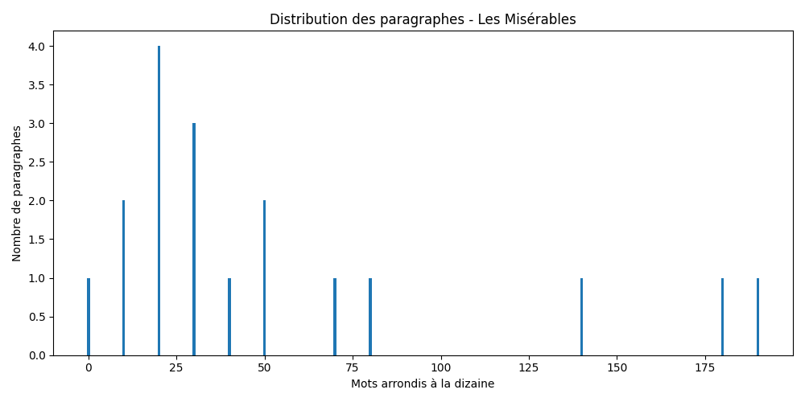

Description et statistiques
Ce rapport analyse le premier chapitre de "Les Misérables", œuvre de Victor Hugo.
Le premier chapitre contient 18 paragraphes pour un total de 1051 mots. La longueur moyenne est de 58.4 mots par paragraphe. Le paragraphe le plus court contient 3 mots et le plus long 197 mots.
Indicateur | Valeur
Nombre de paragraphes | 18
Nombre total de mots | 1051
Moyenne | 58.4
Minimum | 3
Maximum | 197

Extrait
CHAPTER I—M. MYRIEL
In 1815, M. Charles-François-Bienvenu Myriel was Bishop of D—— He was
an old man of about seventy-five years of age; he had occupied the see
of D—— since 1806.
Although this detail has no connection whatever with the real substance
of what we are about to relate, it will not be superfluous, if merely
for the sake of exactness in all points, to mention here the various
rumors and remarks which had been in circulation about him from the
very moment when he arrived in the diocese. True or false, that which
is said of men often occupies as important a place in their lives, and
above all in their destinies, as that which they do. M. Myriel was the
son of a councillor of the Parliament of Aix; hence he belonged to the
nobility of the bar. It was said that hi

