Implementing Toggle Logic w/ Allen-Bradley Micro820 2080-LC50-20QBB

Table of Contents
ToggleProg 3
Local Variables 3
Counter/Modulus 3-4
OSR w/ TFlipFlop 4
XIC w/ TFlipFlop 5
OSR w/ Latch 5

ToggleProg
Local Variables
Name | Alias | Data Type | Dimension | Initial Value | Project Value | Comment | Direction | Retained | String Size
CTU_1 |  | CTU |  | ... | ... |  | Var | True
two |  | DINT |  |  | 2 |  | Var | False
modu |  | DINT |  |  |  |  | Var | False
zero |  | DINT |  |  | 0 |  | Var | False
ToggleState |  | BOOL |  | FALSE |  |  | Var | False
CounterLock |  | BOOL |  | FALSE |  |  | Var | False
ff1 |  | BOOL |  |  |  |  | Var | False
ff2 |  | BOOL |  |  |  |  | Var | False
ff3 |  | BOOL |  |  |  |  | Var | False
ff4 |  | BOOL |  |  |  |  | Var | False
ff5 |  | BOOL |  |  |  |  | Var | False
ff6 |  | BOOL |  |  |  |  | Var | False

Counter/Modulus
Rung1 Diagram
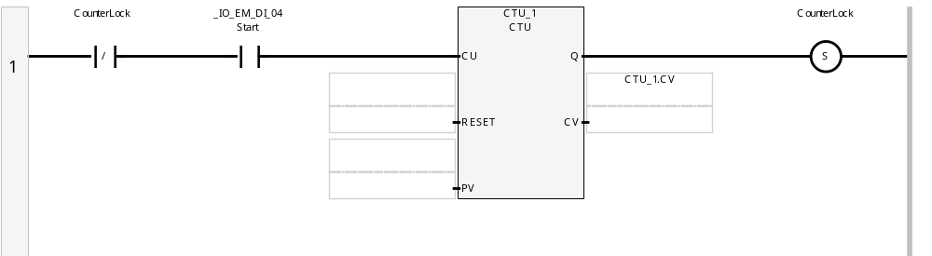
Rung2 Diagram
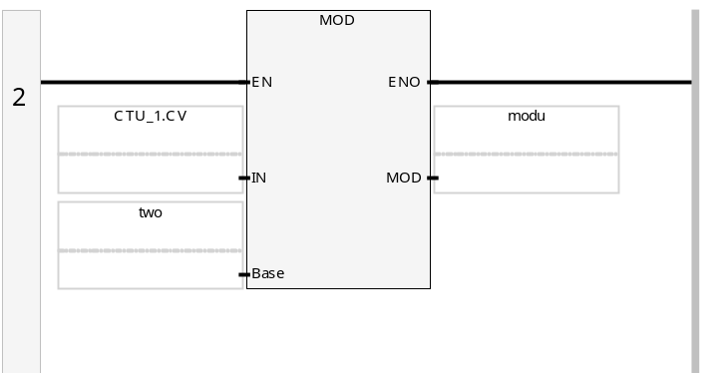

Counter/Modulus
Rung3 Diagram
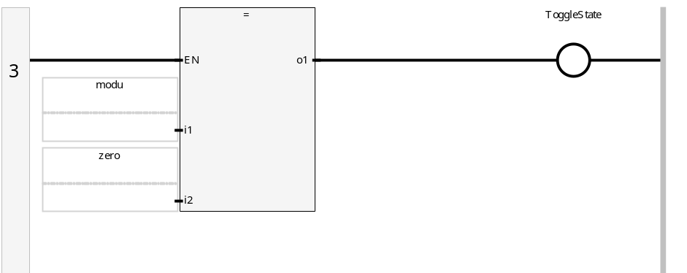
Rung4 Diagram
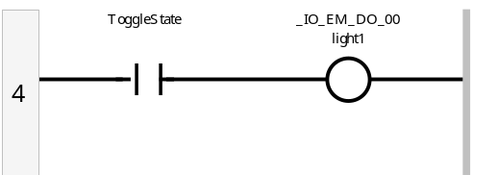
Rung5 Diagram
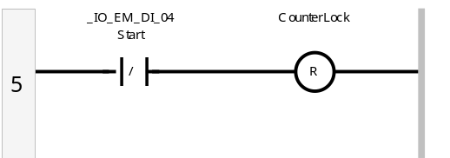

OSR w/ TFLIPFLOP
Rung6 Diagram
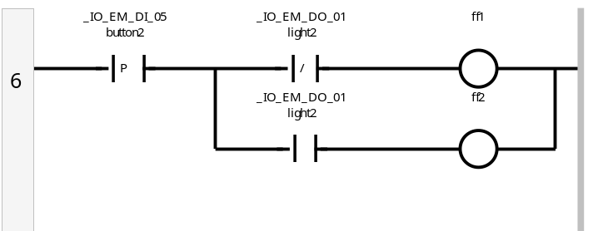
Rung7 Diagram
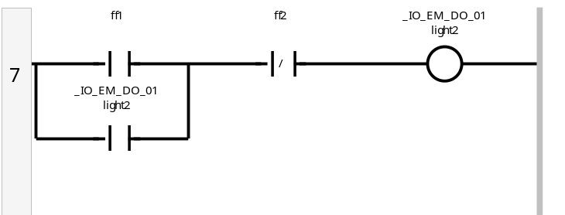

XIC w/ TFLIPFLOP
Rung8 Diagram
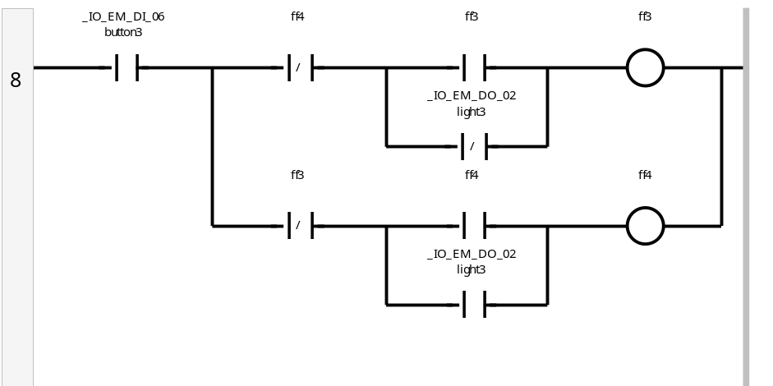
Rung9 Diagram
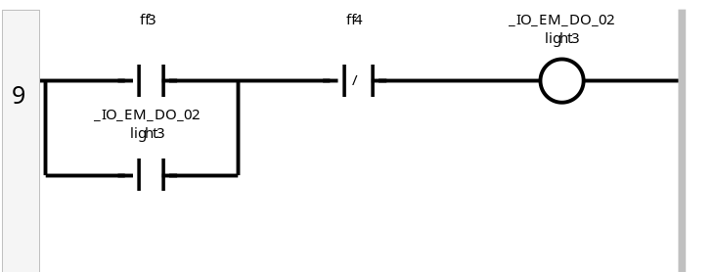

OSR w/ Latch
Rung10 Diagram
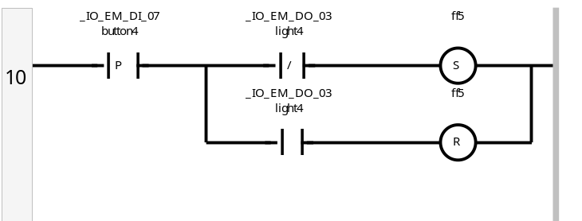
Rung11 Diagram
