

MiniAT 0x01 Architectural Notes
Table of Contents
Instruction Set Architecture 2
Registers 2
Instruction Encodings 3
Instruction Pipeline 4
Microcontroller Architecture 6
Memory Map 6
System Register 8
Watchdog timer 9
Watchdog Control 1 9
Watchdog Control 2 9
4 general purpose timers, Timer 0—Timer 3 9
Timer Control 10
Timer X Compare 11
Timer X Count 11
Port X Directions 11

Instruction Set Architecture
The MiniAT 0x1 embedded microcontroller is a 32 bit architecture. Memory is word addressable with 32 bit address and data buses. A hybridized modified Harvard and Von Neumann architecture is used where separate data and instruction buses connect the CPU to independent caches, but data and instruction caches communicate with all memory mapped resources through a single bus. However, the instruction cache can only address RAM and Flash; otherwise, an illegal address interrupt is scheduled during the fetch stage of the pipeline. The architecture uses little endian byte organization.

Registers
Although all 256 registers are general purpose, one is read only, two have fixed purposes, and two others have suggested uses.
General purpose registers (r0—r255) | fixed/suggested use
r0 | Zero register always contains a 32 bit zero value. This register is read-only, but it may be used as the destination register for any instruction. The zero register is not directly subject to data hazards, nor can it create them. i.e., the instruction  ADD r0, r2, r0, 3 ;r0 = r2 + 3  will not stall any future instruction that uses r0 as an input, nor will it be stalled by a previous instruction writing to r0. However, this instruction may be stalled by previous instructions writing to r2.
r1 | The predicate register is used by a predicating instruction  (instructions with the P bit of the encoding set) to determine whether it should execute or be treated as a NOP. If r1 contains a non-zero value, the instruction is treated as a NOP.
r253 (or RSP) | The Register Stack Pointer (RSP) is suggested for use when synthesizing a stack within the register file using the RLOAD and RSTORE instructions. These two instructions work identically to LOAD and STORE except the displaced register calculation provides the index into the register file, whether source or destination, rather than an address in memory. It's purpose is not to be confused with the register stack frame pointers or register frame pointers of other architectures (e.g., Itanium) where register stacking is specifically for parameter passing, calls, and returns. MiniAT 0x1 register stacks are not nearly so limited.
r254 (or SP) | The Stack Pointer (SP) register is suggested for use when synthesizing a stack in memory using the LOAD and STORE instructions.
r255 (or PC) | The Program Counter (PC) register contains the address of the next instruction and is the primary latch into the fetch stage of the pipeline. It is not in the register file, although it is indexed as such. The PC is not read-only but is otherwise similar to r0; it may be used as the destination register for any instruction, and it is not directly subject to data hazards, nor can it create them. This allows branches with flexible-length delay slots to be achieved using any ALU instruction, LOAD, and RLOAD because the PC is not affected until the Write Back stage of the pipeline. On the other hand, conditional branch instructions employ a branch predictor that modifies the PC, should the prediction indicate a taken branch, by the end of the decode stage of the pipeline.

Instruction Encodings
All instructions in the MiniAT 0x1 architecture follow the same double-word encoding format; although, not all instructions take advantage of all encoding fields. Further, each field is nearly always used identically across all instructions that use the field. This provides extreme orthogonality, ensuring not only that instructions are easy to memorize, but that a student could produce a hand encoded binary using only a small opcode table. As the instruction set evolved toward its final state, all instructions that did not precisely follow the style of other instructions were scrutinized to determine whether they could be synthesized with a sequence of more similar instructions or, better yet, wholly replaced by a single instruction. Because the function of each instruction and instruction field are so consistent, we say the MiniAT 0x1 introduces the Very Similar Instruction Word (VSIW) approach to ISA design :-)
First Instruction word*
31 |  | 29 |  |  |  | 25 | 24 | 23 |  |  |  |  |  |  | 16 | 15 |  |  |  |  |  |  | 8 | 7 |  |  |  |  |  |  | 0
P | H | Opcode |  |  |  |  |  | Register A (rA) |  |  |  |  |  |  |  | Register B (rB) |  |  |  |  |  |  |  | Register C (rC)
H: Branch prediction hint P: Predicate bit
Second Instruction Word**
31 |  |  |  |  |  |  |  |  |  |  |  |  |  |  |  |  |  |  |  |  |  |  |  |  |  |  |  |  |  |  | 0
32 bit Immediate (imm32)
* This 4 bytes occurs at the lower address then the second instruction word.
** This 4 bytes occurs at the higher address then the first instruction word.

Instruction Pipeline
The MiniAT 0x1 employs a four stage pipeline designed for in-order issue and retirement.
- Fetch loads the instruction referenced by the PC, which is at the head of the PC queue, and removes that entry from the queue. The PC is incremented by 2 and enters the PC queue, effectively replacing the PC, only if the PC queue is empty once the head was removed and no other stage is adding to the queue this cycle.
- Decode fetches register operands and calculates the immediate displacement of rC which is used by every instruction except IRET. For conditional branches, the displaced rC is speculatively added to the PC queue if the Hint bit is set. If the Write Back stage is also adding to the queue, the displaced rC is added afterward.
- Execute/Memory uses the ALU for calculations, begins memory transfers on LOADs (and stalls until they are complete), and indirectly indexes the register file in the case of RLOAD and RSTORE.
- Write Back (WB) stores the result of the instruction. No instruction writes more than a single value. At this stage, conditional branches may flush the pipeline and replace the PC queue if the logical result of the comparison is different than the Hint. If the PC is the WB target, the WB data is added to the PC queue.
Following are four high level diagrams of the pipeline with respect to the major instruction types. For simplicity, most control, the PC queue, and flushing units are not shown. The INT and IRET instructions are not represented by any of the diagrams because of their unique nature.

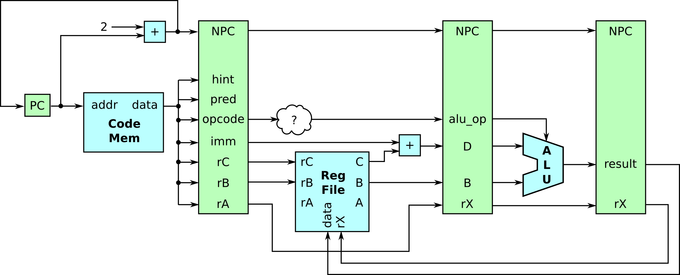
Arithmetic and logic instruction pipeline

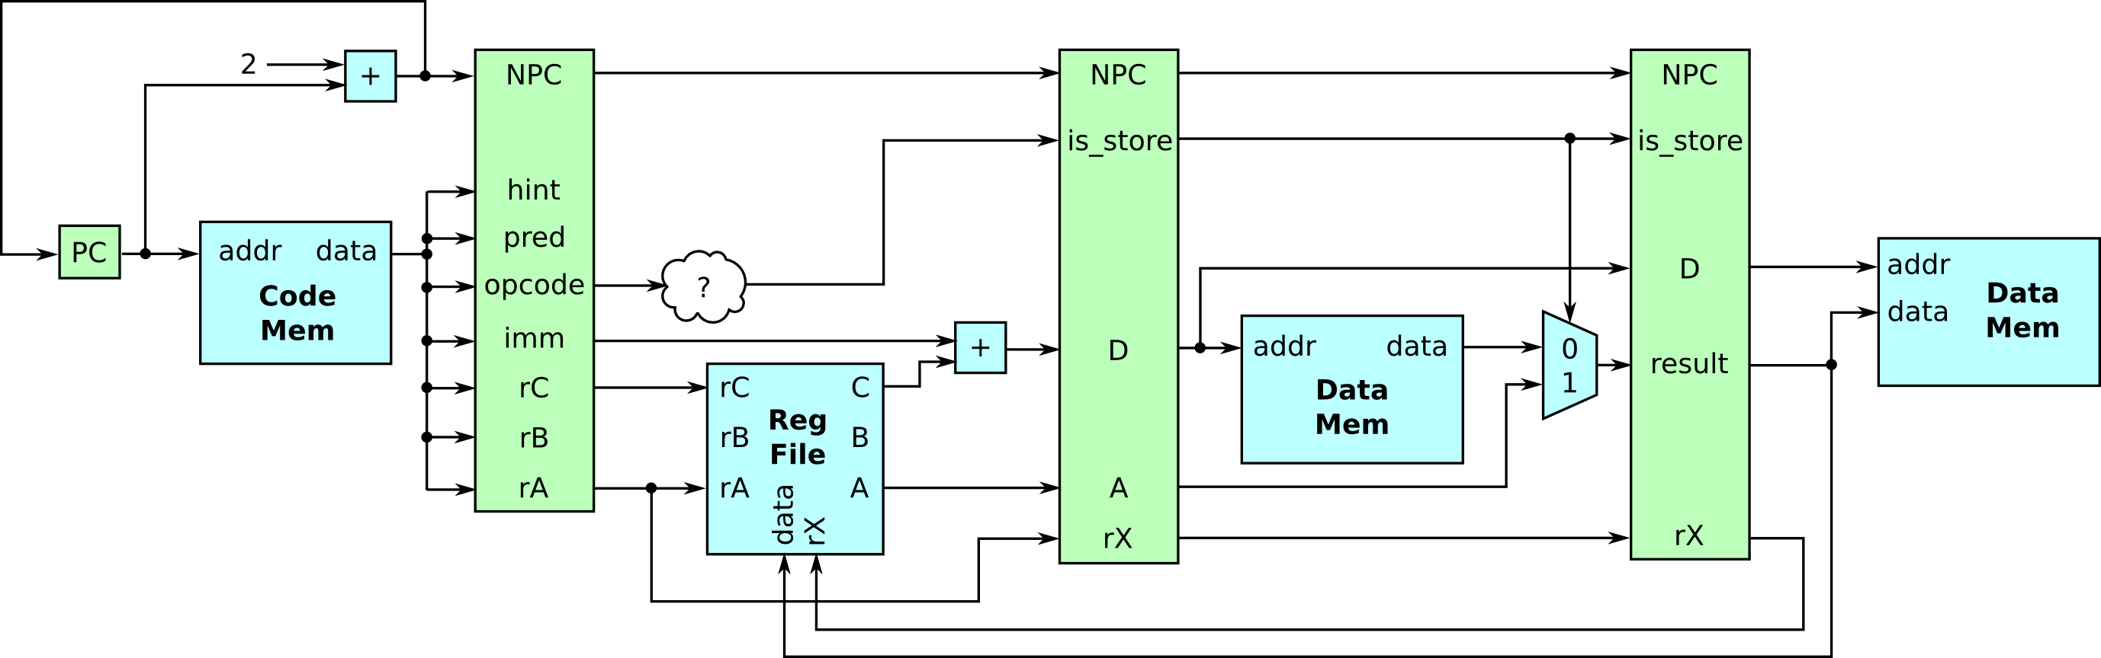
Data (using memory) instruction pipeline

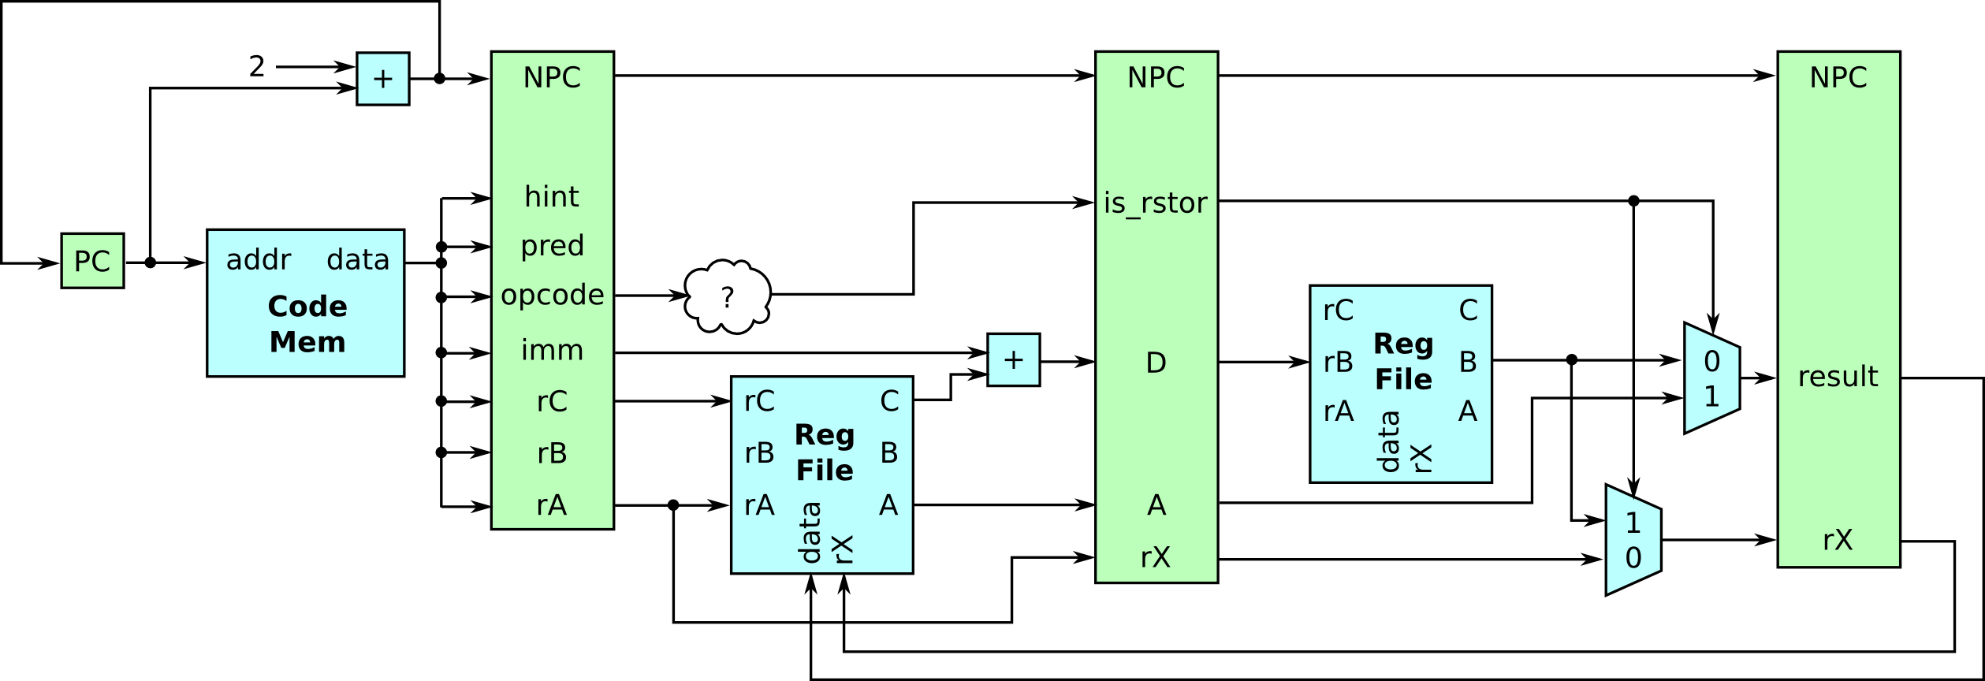
Data (using the register file) instruction pipeline

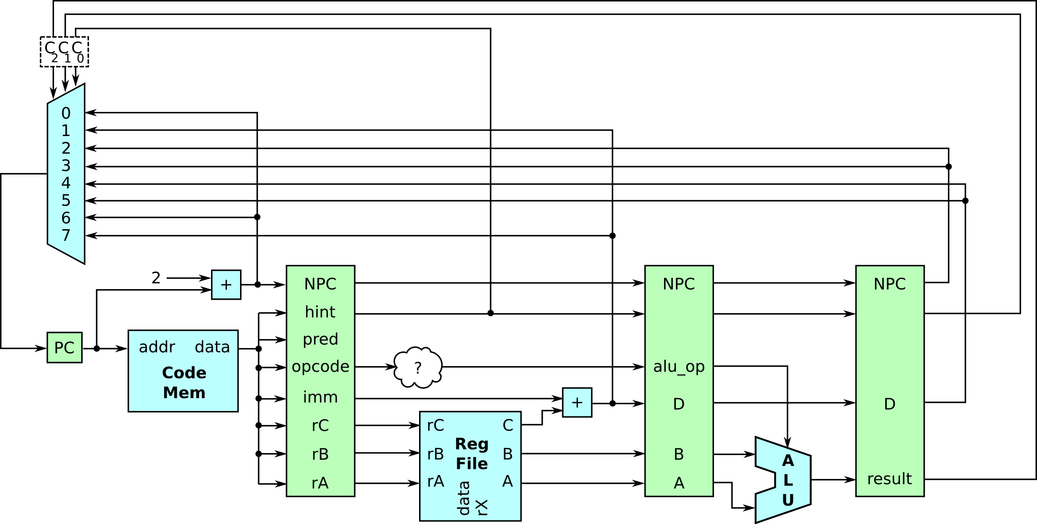
Control (conditional branches) instruction pipeline
Rules on stalling and bubbles
When a arbitrary stage is stopped from moving forward it still continues writing to the latches. All stages look to the previous pipeline stage to see if it is actively stalling. If it is it produces a bubble. If a stage is passively stalling because it can't move forward because it is not giving clock cycles.
In the event of a cache misses in both the data and instruction cache, the request to memory is completed for the data cache first.

Microcontroller Architecture

Memory Map
64K words (32 bit words) total address space with little endian byte ordering
8Kw | 0x0000  ...  0x01FF | Reserved
8Kw | 0x0200  ...  0x19FF | RAM (6Kw)
8Kw | 0x1A00  ...  0x1AD9 | Reserved
8Kw | 0x1ADA  ...  0x1B19 | 64 interrupt vectors (priorities 0:high through 63:low)  0x1ADA–INT0: Reset, pin RES – read only value of 0x2000  0x1ADB–INT1: Illegal Address  0x1ADC–INT2: Illegal Instruction  0x1ADD–INT3: Bus Error  0x1ADE–INT4: Divide by Zero  0x1ADF–INT5: Watchdog  0x1AE0–INT6: Timer 0  0x1AE1–INT7: Timer 1  0x1AE2–INT8: Timer 2  0x1AE3–INT9: Timer 3  0x1AE4–INT10: Overflow  0x1AE5–0x1AF9: reserved  0x1AFA–INT32: External Interrupt, pin XINT0  0x1AFB–INT33: External Interrupt, pin XINT1  0x1AFC–INT34: External Interrupt, pin XINT2  0x1AFD–INT35: External Interrupt, pin XINT3  0x1AFE–INT36: External Interrupt, pin XINT4  0x1AFF–INT37: External Interrupt, pin XINT5  0x1B00–INT38: External Interrupt, pin XINT6  0x1B01–INT39: External Interrupt, pin XINT7  0x1B02–INT40: External Interrupt, pin XINT8  0x1B03–INT41: External Interrupt, pin XINT9  0x1B04–INT42: External Interrupt, pin XINT10  0x1B05–INT43: External Interrupt, pin XINT11  0x1B06–INT44: External Interrupt, pin XINT12  0x1B07–INT45: External Interrupt, pin XINT13  0x1B08–INT46: External Interrupt, pin XINT14  0x1B09–INT47: External Interrupt, pin XINT15  0x1B0A–0x1B19: reserved
8Kw | 0x1B1A  ...  0x1B1D | General Purpose I/O pins  0x1B1A–Port A: pins PA0..PA15  0x1B1B–Port B: pins PB0..PB15  0x1B1C–Port C: pins PC0..PC15  0x1B1D–Port D: pins PD0..PD15
8Kw | 0x1B1E  ...  0x1F1D | Control/Status Registers  0x1B1E-System Register  0x1B1F–Watchdog Compare  0x1B20–Watchdog Control  0x1B21–Timer Control  0x1B22–Timer 0 Compare  0x1B23–Timer 1 Compare  0x1B24–Timer 2 Compare  0x1B25–Timer 3 Compare  0x1B26–Timer 0 Count  0x1B27–Timer 1 Count  0x1B28–Timer 2 Count  0x1B29–Timer 3 Count  0x1B2A-Timer I/O pins T0_Out, T0_In, T1_Out, T1_In, T2_Out, T2_In, T3_Out, and T3_In  0x1B2B..0x1F15-reserved  0x1F16-Port A Directions  0x1F17-Port B Directions  0x1F18-Port C Directions  0x1F19-Port D Directions  0x1F1A-IERA: Interrupt Enable Register A, INT0..INT31  0x1F1B-IERB: Interrupt Enable Register B, INT32..INT63  0x1F1C-IFFA: Interrupt Flag Register A, INT0..INT31  0x1F1D-IFRB: Interrupt Flag Register B, INT32..INT63
8Kw | 0x1F1E  ...  0x1FFF | Virtual Machine Identification (ROM)
8Kw | 0x2000  ...  0x3FFF | Flash
48Kw | 0x4000  ...  0xFFFF | Peripheral Memory Space

System Register
The System Register (SR 0x1B1E) contains several CPU level control bits:
- Interrupt Enable (IE) globally enables or disables interrupts (except Reset) without regard or change to any Interrupt Enable Register.
- Saturation Enable (SE) prevents overflow. When set, signed and unsigned results are clipped to 0x8000 and 0x0000 respectively and saturated at 0x7FFF and 0xFFFF respectively.
- Unsigned (U) forces the ALU and the register displacement adder in the decode stage of the pipeline to calculate results based on unsigned operands/operations and affects saturation if SE is set.
- When set, “Flush on IER write” (FI) forces a pipeline flush whenever the Write Back stage of the pipeline manipulates either the IERA or IERB registers.
- When set, “Flush on System register write” (FS) forces a pipeline flush whenever the Write Back stage of the pipeline manipulates the SR register.

31 |  |  |  |  |  |  |  |  |  |  |  |  |  |  |  |  |  |  |  |  |  |  |  |  |  | 5 | 4 | 3 | 2 | 1 | 0
 |  |  |  |  |  |  |  |  |  |  |  |  |  |  |  |  |  |  |  |  |  |  |  |  |  |  | FS | FI | U | SE | IE

Manipulations of the System Register immediately alter the functionality of various stages in the pipeline and might therefore inappropriately affect instructions already fetched. To avoid these problems, one should take care where in the instruction stream the System Register is modified or flush the pipeline and PC queue immediately following such modifications...
BRAE {false} r0, r0, PC, 0
This instruction purposefully mispredicts branching to the next instruction. Thus, when it reaches the Write Back stage of the pipeline it flushes all previously fetched instructions/data and replaces the PC queue with the original next line of code. This effectively delays the runnable fetch of the instruction following the mispredicted branch by four cycles.

Watchdog timer
- Watchdog timer will set IFRA→INT6 to 1 (or cause Reset INT0 if the watchdog vector is NULL) when enabled (Watchdog Control→Enable is set to 1) and Watchdog Control→Count >= Watchdog Compare→Compare. In this event the hardware will also do the equivalent of setting reset to 0. Software must keep Watchdog Control→Count low to prevent the interrupt from firing.
- Watchdog Control→Count is incremented once everyclock ticks where CPS (Clock Pre-Scale) is the 5 bit Watchdog Compare→CPS, managed by a private modulus counter. This provides watchdog periods up to 2.8*10¹⁷ clock ticks... approximately 91 years for a 100MHz clock rate.
- Watchdog Control→Enable (dis)allows clock ticks to affect the modulus counter, but will not reset this counter when reset to 0
- Watchdog Control→Reset will disable the watchdog timer (Watchdog Control→Enable reset to 0), reset the modulus counter to 0, and clear (reset to 0) Watchdog Control→Count

Watchdog Compare
31 | 30 | 29 | 28 | 27 | 26 |  | 0
CPS |  |  |  |  | Compare

Watchdog Control
31 | 30 | 29 | 28 |  | 0
Enable | Reset |  | Count

4 general purpose timers, Timer 0—Timer 3
- Each behaves in one of four modes: time, count, toggle, or pwm
- Each mode (except count) uses a prescaled clock to signal each operation
  - prescaled clock rate =where CPS (Clock Pre-Scale) is a 4 bit value defined separately for each timer as Timer Control→CPS X. This prescaled rate is achieved by modulus counting of clock ticks via private registers, one for each timer. When the register is cleared (reset to 0) by the modulus counter, a prescaled clock tick occurs.
- Timer operations are “pausable”. Disabling a timer only prevents clock ticks from affecting the modulus counter so that operation might be enabled (“resumed”) from the original disabled state. Only a timer reset operation (Timer Control→Reset X = 1) will guarantee the modulus counter is initialized to 0.
- Timers are preloadable regardless of mode by writing to Timer X Count.
- Timer modes:
  - timer (mode 0) – increments Timer X Count. When Timer X Count >= Timer X Compare, IFRA→Timer X and Timer I/O→TX_O are set to 1, the timer is disabled (Timer Control→Enable is reset to 0), the prescalar modulus is reset, and Timer X Count is reset to 0.
  - count (mode 1) – same as timer mode except Timer X Count increments when Timer I/O→TX_I transitions from 0 to 1.
  - toggle (mode 2) – same as timer mode except Timer I/O→TX_O is toggled when Timer X Count >= Timer X Compare, and the timer is not disabled (concurrently providing a continuous timing mechanism).
  - pwm (mode 3) – pulse modulates a waveform on Timer I/O→TX_O based on a 16 bit frequency (Timer X Compare→31:16) and 16 bit duty (Timer X Compare→15:0).

Timer Control
High wyde, high byte = Timer 3

31 | 30 |  | 29 | 28 | 27 |  | 24
Reset | Mode |  |  | Enable | CPS
High wyde, low byte = Timer 2

23 | 22 |  | 21 | 20 | 19 |  | 16
Reset | Mode |  |  | Enable | CPS

Low wyde, high byte = Timer 1

15 | 14 |  | 13 | 12 | 11 |  | 8
Reset | Mode |  |  | Enable | CPS

Low wyde, low byte = Timer 0
7 | 6 |  | 5 | 4 | 3 |  | 0
Reset | Mode |  |  | Enable | CPS

Timer X Compare
In modes 0..2, this is a 32 bit unsigned number. In mode 3 (pwm):
31 |  | 16 | 15 |  | 0
Frequency |  |  | Duty

Timer X Count
In all modes this is an unsigned 32 bit number.

Port X Directions
Port A Directions, Port B Directions, Port C Directions, and Port D Directions work identically with bit Y indicating the signal direction of the Yth pin of the port... 1 = input and 0 = output. This assignment of 1/0 to input/output respectively is counter to many designs. In this case, it was chosen strictly for the aesthetic fact that 1 looks like I, and 0 looks like O... 1/0 → I/O. The upper half word of each of these is unused; reads return 0, writes do nothing.

NOTES:

Data Cache
set associative
# of sets
blocks per set
words per block
random or least recently used replacement

Instruction Cache
Default perfect
first place of lua script

Definition of Clock Cycle, Bill is doing this 01-26-2010

Instruction set would be a nice addition.
Assembly language (pseudo) instructions.

How interrupts are handled in the pipeline, the IFR gets updated at WB and before pipeline runs it is scheduled into the PC and flushes the PC queue.
Better description of flushing the pipeline means, as data hazard queues are flushed and the PC is flushed and updated with the WB PC.

Data hazard queue has a max length of 3. This was determined by a pipeline with no data dependencies (densest pipeline, aka no bubbles). This would be 2 3 element arrays. One for registers one for mem addresses. It would store the write register. Instructions in the Decode stage would place the register/mem address to write in this queue and would clear its entry in the WB stage. This would be the first thing done in the Decode or last thing in WB stage. The decode stage checks this queue on all instructions and if a read register is marked for a write, the decode stage stalls and spits out NOPS as the forward stages progress.

Handshake protocol
address
data
req
ack
rW

Decisions:
1 cycle RAW... writeback happens at the start of the cycle reads happen in the second half of the cycle.

