**Select Employee**

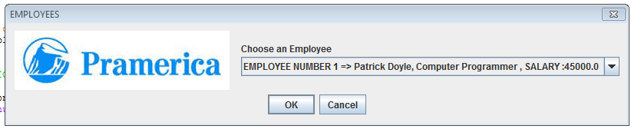

**Main GUI**

