Plagiarism Is:
The act of presenting as your own, the words or ideas of someone else, whether publisher or not, without proper acknowledgement, within one’s own work is called plagiarism. There are three main types of plagiarism, which could occur within all modes of assessment (including examination):
- Direct copying of text from a book, article, fellow student’s essay, handout, web page or other source without proper acknowledgement
- Claiming individual ideas derived from a book, article etc. as one’s own and incorporating them into one’s work without acknowledging the source of these ideas
- Overly depending on the work of one or more other sources without proper acknowledgement of the source, by constructing an essay, project etc. extracting large sections of text from another source and merely linking these together with a few of one’s own sentences.

Declaration:
I confirm that the work in the attached document and any related artefacts such as software are, unless clearly stated otherwise, my own work. I understand the definition of plagiarism as described above and I confirm that this work has not been plagiarised.
Name (In block capitals): _________________________

Signature: _________________________

Class: _________________________

Date: _________________________

B.Sc. Applied Computing,
B.Sc. Computing with Games Development,
Final Year Project
Amend breath-first Algorithm, Dijkstra's Algorithm, A Algorithm for shortest time and real path length.

Student Name: Dietmar Steiner
Student ID: L00131070
Student E-Mail: L00131070@student.lyit.ie

Table of Contents
Abstract 4
1. Aims & Objectives 5
1.1. Aims 5
1.2. Objectives 5
2. Project Plan & Scope 6
2.1. Scope 6
2.2. Project Plan 6
3. Literature Survey 7
3.1. Algorithms 7
3.1.1. Breath First 7
3.1.2. Dijkstra Algorithm 7
3.1.3. Algorithm A 7
3.2. Heuristics 7
3.3. Data Structures and Search Graphs 7
1.1.1. Heading Three 7
2. Software Requirements Specification 8
2.1. Heading Two 8
2.2. Heading Two 8
2.2.1. Heading Three 8
2.2.2. Heading Three 8
3. Design 9
3.1. Heading Two 9
3.2. Heading Two 9
3.2.1. Heading Three 9
3.2.2. Heading Three 9
4. Implementation 10
4.1. Heading Two 10
4.2. Heading Two 10
4.2.1. Heading Three 10
4.2.2. Heading Three 10
5. Conclusions 11
5.1. Heading Two 11
5.2. Heading Two 11
5.2.1. Heading Three 11
5.2.2. Heading Three 11
6. References 12
7. Bibliography 13
8. Appendix One 14

Table of Figures

- Abstract

Body ext text text text text text text text text text text text text text text text text text text text text text text text text text text text text text text text text text text text text text text text text.
- Aims & Objectives
  - Aims

To learn more about algorithms.

To learn more about search graphs.

  - Objectives

To gain a thorough understanding of breath-first Algorithm, Dijkstra's Algorithm and A Algorithm.

To identify weaknesses in the application of the algorithms for movement-modes and time based searches.

To design A* heuristic functions for time paths and movement modes.

To design a capable search graph model and associated data structures for variable path costs.

To develop a simulator for the original and amended algorithms.

To present the results of the algorithm simulations for path length and path time for different movement modes.

- Project Plan & Scope
  - Scope
Pathfinding Algorithms use a very simplified model to find the lowest cost path based on path length. In general the movement in the algorithms can be described as:
- move to centre of grid
- turn/straight
- move to next grid
This is a very limited model of movement.
In this project a three step approach is used to develop a more accurate model of movement based on a mobile robot traversing a grid maze from start to goal. The three steps are as following:
- Adding real path-length for turning in an arc movement.
- Adding time as the major path cost (including stop to turn penalty).
- Adding acceleration in straights and deceleration for turns as cost reduction or gain respectively.
The algorithms under investigation are breadth-first Algorithm(Nilsson 1982, Cormen 2009), Dijkstra's Algorithm (Cormen 2009) and A Algorithm(Nilsson 1982). Heuristics have to be developed for A* in respect to time based path search and modes of movement.
Search graph models and associated data structures have to be designed to describe the movement modes and time properties, because the entry direction, movement in the grid cell and entry speed determine the cost attached to moving within the grid cell.
Three modes of movement the robot will use for this project:
- constant speed - with stop and turn in the middle of the grid cell for turns.
- constant speed - with arch-cornering
- acceleration on straight paths through multiple cells and deceleration for turns.
Maze maps from the IEEE Micromouse competition (University of California 2015) are used with a grid size of 16x16.
To document the outcome of the tests with different algorithms on different movement modes a simulator is developed. This simulator is developed in JAVA.
A presentation and discussion of the outcomes will conclude the project.

  - Project Plan

Fig 2.1

- Literature Survey
  - Algorithms
    - Breath First Search
Breadth first search(Cormen 2009) searches the search graph by expanding from 1 level to the next from the start. Breath first search finds all shortest paths, if the cost of traversing from one node to another is of constant value (Figure 1). Breadth first search stops when no more unexplored nodes exist, which is called exhaustive search.

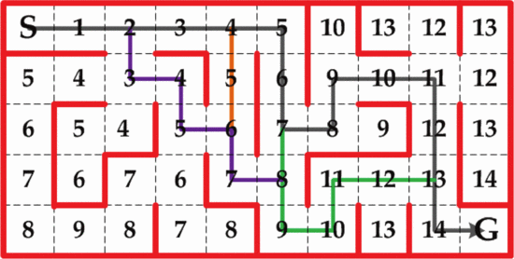
Figure 1 all shortest paths with constant cost (Juing-Huei et al. 2014)

If the cost of traversing from one node to another is variable, nodes might need to be put back in the discovered state, if the cost of reaching this node has been lowered.
Breath first uses a FIFO to hold discovered but unexplored nodes.
Breath first search runs in linear time only dependent on the number of nodes in the graph.(Cormen 2009) for constant cost.
The exhaustive search makes breath first search difficult for larger search graphs, as it might not reach a conclusion in the given time, also the memory requirement rises with every level, dependent on the branching factor.
No literature could be found for breath first with variable traversal cost.
As one of the goals of this project is to compare the different algorithms, this possibly needs an extension to the basic breath first search for variable costs.

    - Dijkstra Algorithm
Dijkstra's algorithm(Cormen 2009) is a focused breath first algorithm for positive traversal costs. It always selects the next node with the shortest distance from the start of the search and will find the shortest path to the goal. It uses a greedy strategy(Cormen 2009).
It uses a minimum priority queue to hold discovered but unexplored nodes.
It only works for graphs with positive and variable costs, because if the cost is constant it is a breath first search with the additional cost of a minimum queue. As it prunes off nodes initially it has less nodes to process, which might result in less time and memory.
Dijkstra will only find the one minimum path.

    - Algorithm A
The Algorithm A(Luger 2002) best first search algorithm with an added heuristic function. Through the addition of a heuristic function the algorithm becomes informed(Luger 2002).
Algorithm A becomes algorithm A* when the heuristic function h(n) < h*(n) and by that f(n) is admissible(Luger 2002) and therefore the optimal path will be found by the algorithm A*.
Algorithm A uses a priority queue based on the result of f(n) to hold discovered but unexplored nodes.
The danger is if the calculation time of the heuristic function uses more time than the gain is from exploring less nodes(Luger 2002).

  - Heuristics
Heuristics functions are used to reduce the number of nodes explored during a path search. The heuristic function returns the sum of the cost for the path from the start and an estimated cost to the goal.
The general form of f_{n} is: F(n) = G(n) + h(n), where G(n) is the accumulated cost until node N and h(n) is the estimated cost by the heuristic function from node n to the goal. A special form of this equation is f*(n) = g*(n) + h*(n), where g*(n) is the minimal cost to node n and h*(n) is the minimal cost to the goal(Luger 2002).
The heuristic function designed in this project must be admissible.

    - Admissible

An admissible function f_{n,} is: f(n) <= f*(n).
Admissibility is important as it guaranties the optimal path will be found.

    - Monotone
    - Informedness
Informedness(Luger 2002) compares two heuristic function f₁(n) and f₂(n). f₂(n) is more informed than f₁(n), if f₁(n) <= f₂(n) for all n in the search space with still being admissible.
The design of the heuristic function in this project should be highly informed.

  - Search Graph

The particular problem in this project is to find the optimal path through a maze based on movement-modes and fastest time. An interesting approach to the problem has been made here (Gene Eu et al. 2009). It proposes to split the centre of a node maze into 4 nodes on the edge of the node which are shared with their respective neighbour nodes (Figure 2). This is done to cater for the different costs of moving through the node. The disadvantage of this approach is that for this stricter the node count and therefore the complecity of the search is higher by a factor of 2.
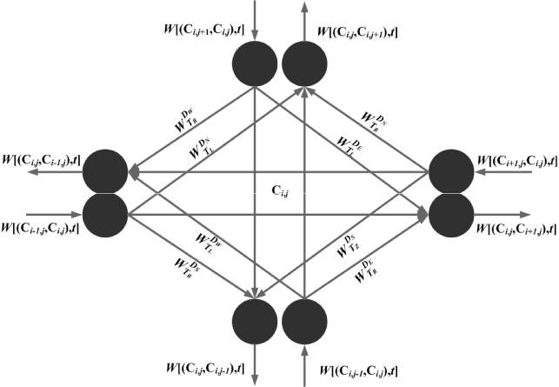
Figure 2 Node Graph (Gene Eu et al. 2009)
This model can be directly transformed into the search graph model for this project.
A similar approach to splitting the

Fig 3.1
- Software Requirements Specification
  - Heading Two
Body ext text text text text text text text text text text text text text text text text text text text text text text text text text text text text text text text text text text text text text text text text.

  - Heading Two
Body ext text text text text text text text text text text text text text text text text text text text text text text text text text text text text text text text text text text text text text text text text.

    - Heading Three
Body ext text text text text text text text text text text text text text text text text text text text text text text text text text text text text text text text text text text text text text text text text.

    - Heading Three
Body ext text text text text text text text text text text text text text text text text text text text text text text text text text text text text text text text text text text text text text text text text.

Fig 4.1
R001
R001.1

- Design
  - Heading Two
Body ext text text text text text text text text text text text text text text text text text text text text text text text text text text text text text text text text text text text text text text text text.

  - Heading Two
Body ext text text text text text text text text text text text text text text text text text text text text text text text text text text text text text text text text text text text text text text text text.

    - Heading Three
Body ext text text text text text text text text text text text text text text text text text text text text text text text text text text text text text text text text text text text text text text text text.

    - Heading Three
Body ext text text text text text text text text text text text text text text text text text text text text text text text text text text text text text text text text text text text text text text text text.

Fig 5.1
- Implementation
  - Heading Two
Body ext text text text text text text text text text text text text text text text text text text text text text text text text text text text text text text text text text text text text text text text text.

  - Heading Two
Body ext text text text text text text text text text text text text text text text text text text text text text text text text text text text text text text text text text text text text text text text text.

    - Heading Three
Body ext text text text text text text text text text text text text text text text text text text text text text text text text text text text text text text text text text text text text text text text text.

    - Heading Three
Body ext text text text text text text text text text text text text text text text text text text text text text text text text text text text text text text text text text text text text text text text text.

Fig 6.1
- Conclusions
  - Heading Two
Body ext text text text text text text text text text text text text text text text text text text text text text text text text text text text text text text text text text text text text text text text text.

  - Heading Two
Body ext text text text text text text text text text text text text text text text text text text text text text text text text text text text text text text text text text text text text text text text text.

    - Heading Three
Body ext text text text text text text text text text text text text text text text text text text text text text text text text text text text text text text text text text text text text text text text text.

    - Heading Three
Body ext text text text text text text text text text text text text text text text text text text text text text text text text text text text text text text text text text text text text text text text text.

Fig 7.1
- References

- Bibliography
There are no sources in the current document.
- Appendix One

