Terraform apply

Instance on the AWS

Terraform destroy

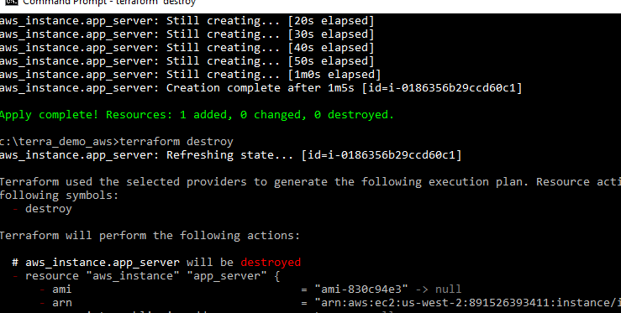

Aws instance destroyed

