L00163278_Q3_File_2: Screenshots.

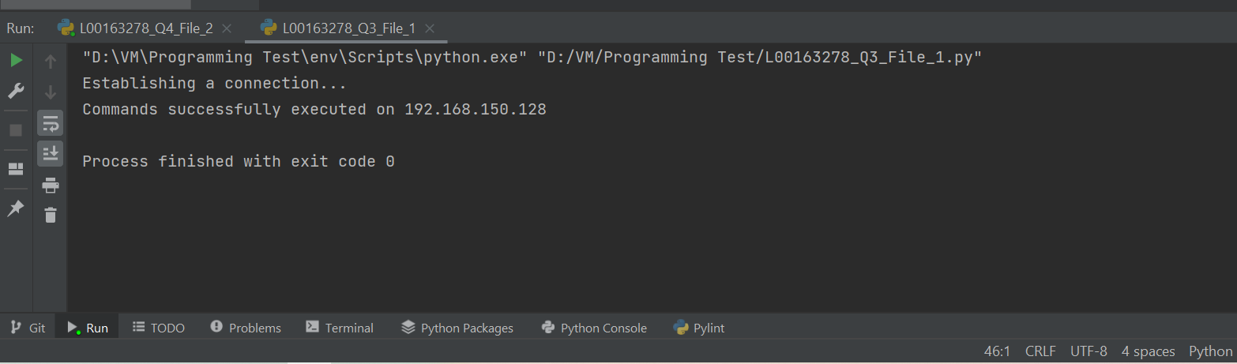

Figure : Connection Successful

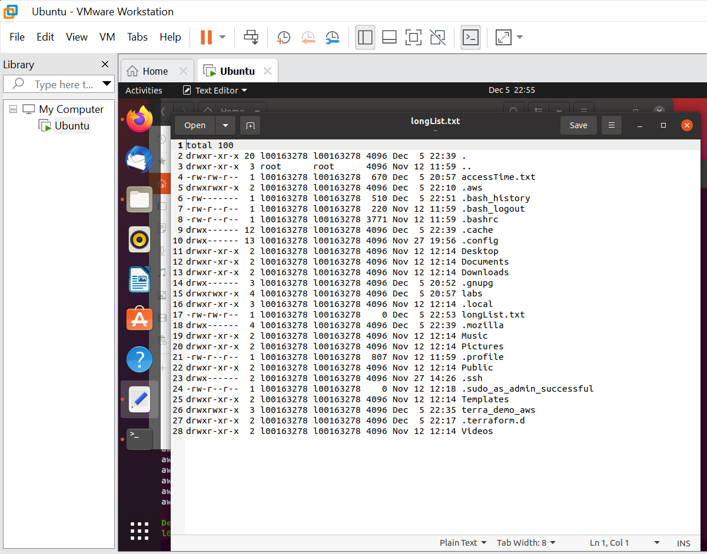

Figure : Long List File