L00163278_Q4_File_1: Screenshots:

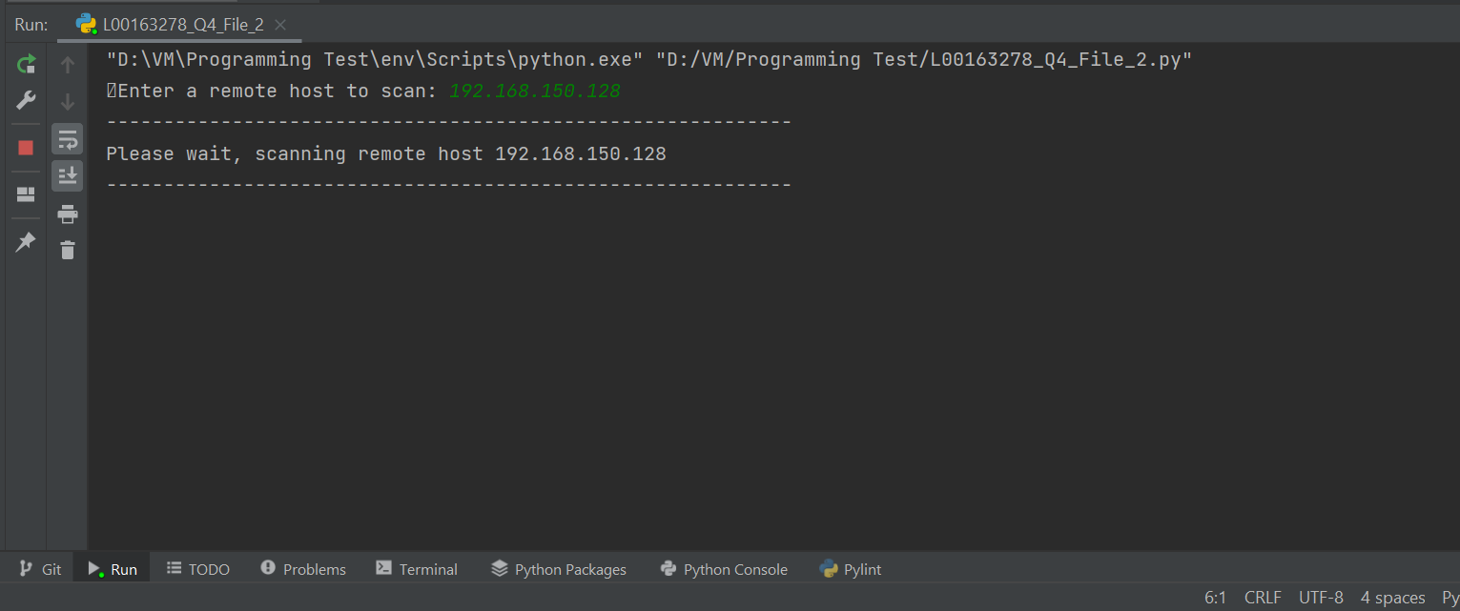

Figure : Establishing connection to the server

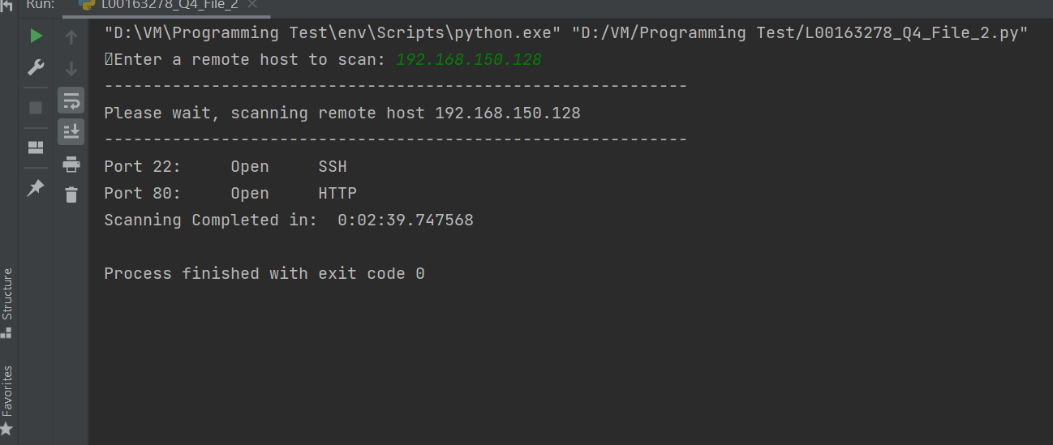

Figure : Showing open ports with name and number