L00163278_Q5_File_1

As per question number 5, installation of curl was done in ubuntu machine, using python script. Directories were created as directed in the question, as Lab1 and Lab2. And lastly access time was checked while logging into the ubuntu VM.

All the necessary screenshots are herewith attached as per the sequence:

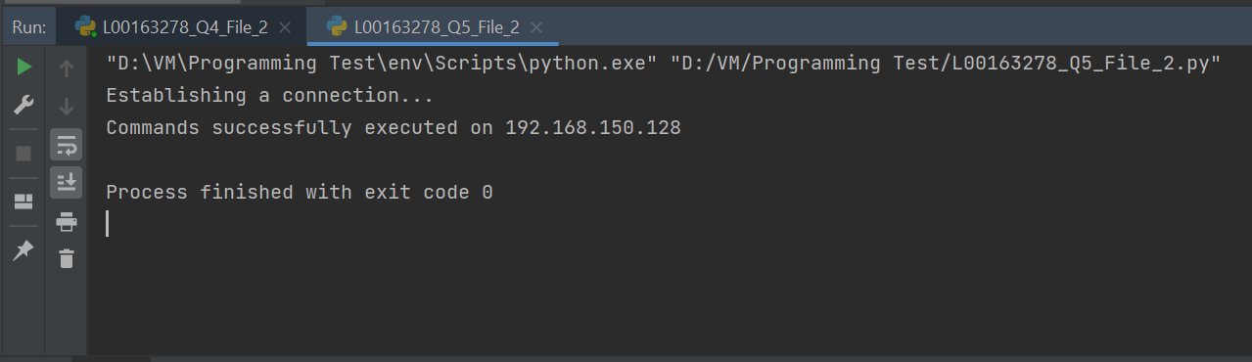

Figure : Connection Successful

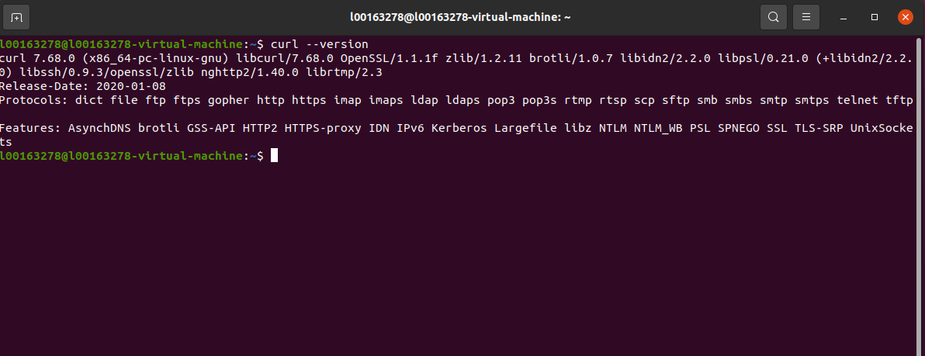

Figure : Installation of Curl, successful.

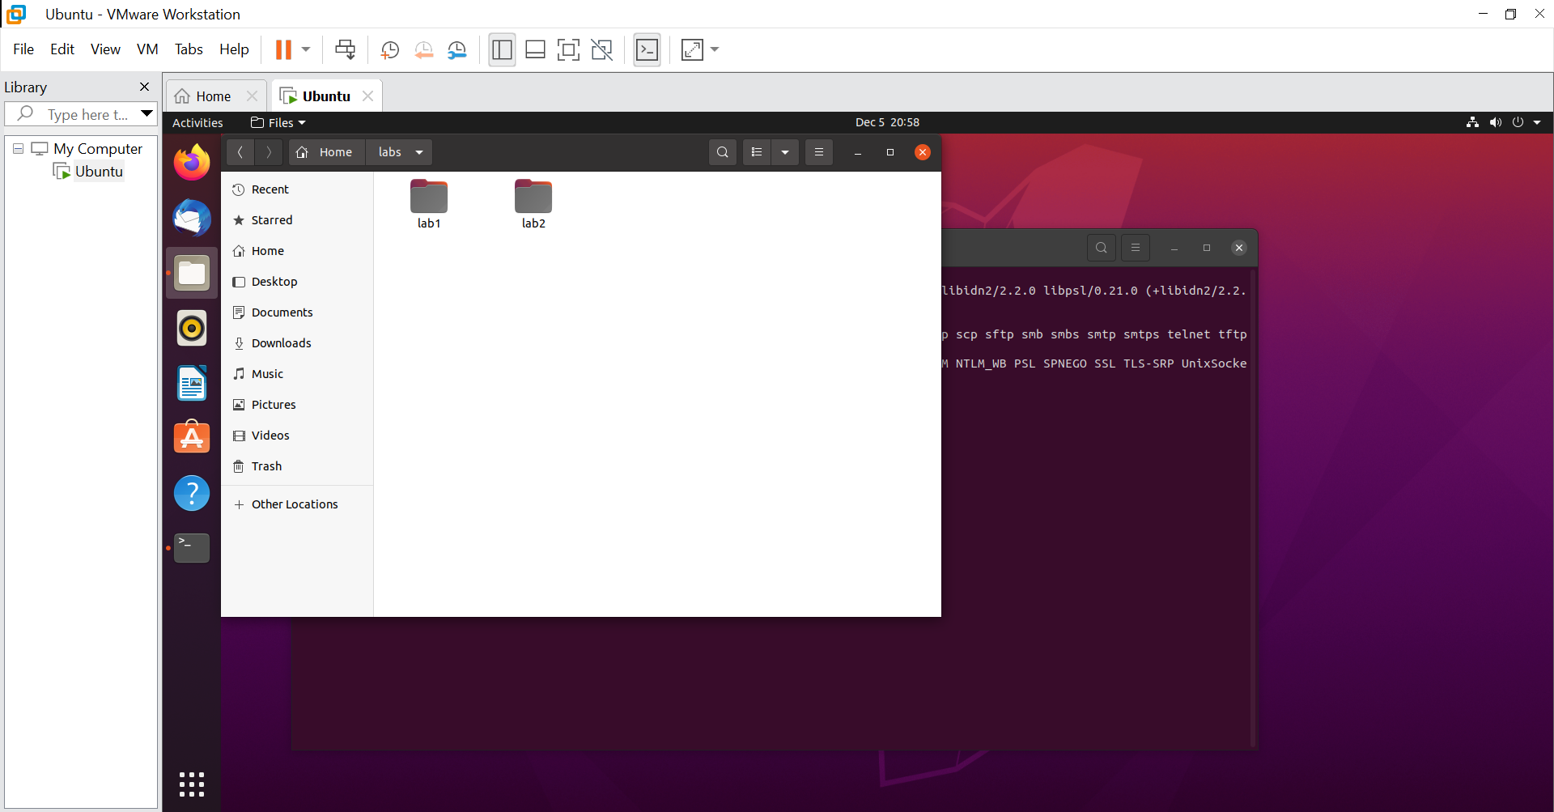

Figure : Directory Creation.

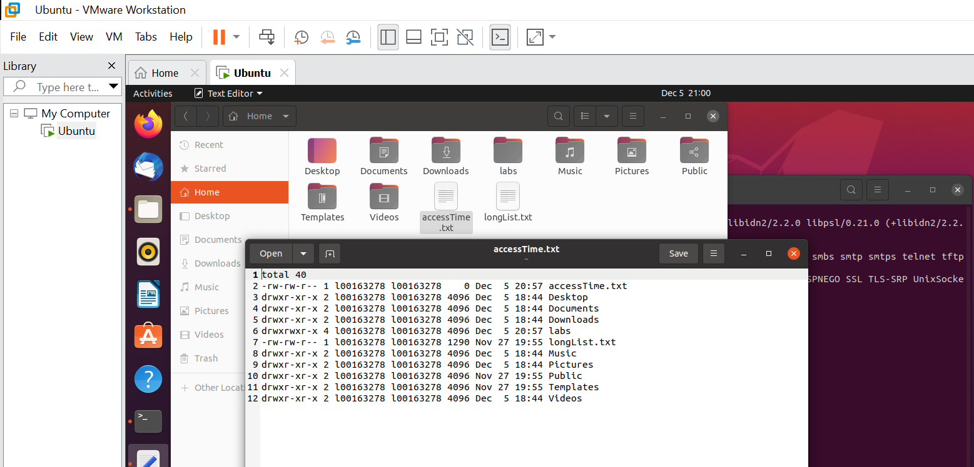

Figure : Last Access Time.