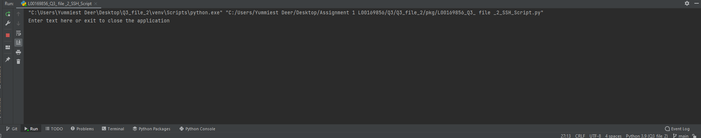

The first prompt the user sees

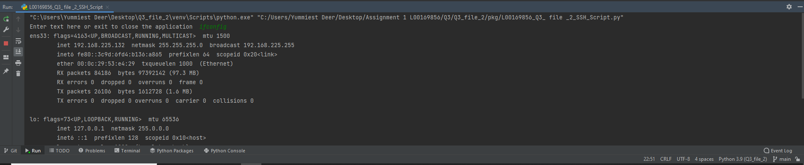

Ifconfig working through an SSH connection to the VM

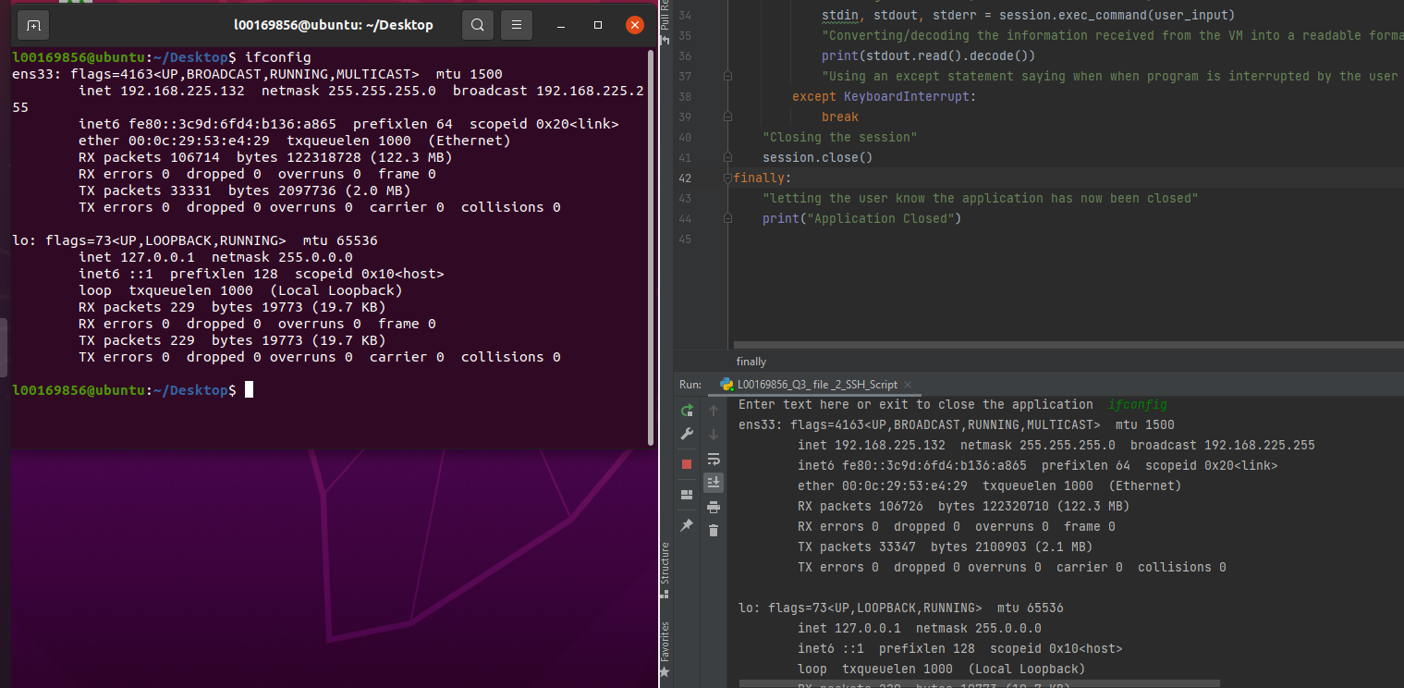

Both the output in the VM and script matching showing the SSH hasn’t made any mistakes

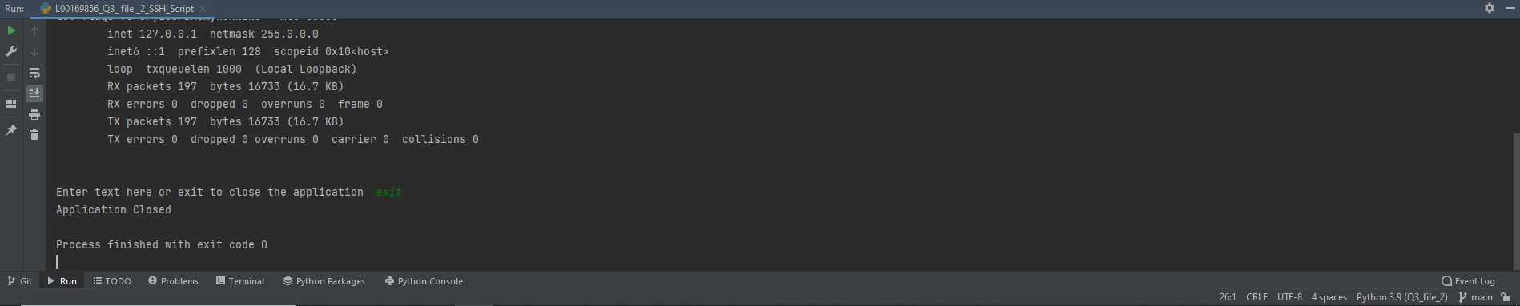

When the user enters “Exit” the script exits