1. SSH installation in VM

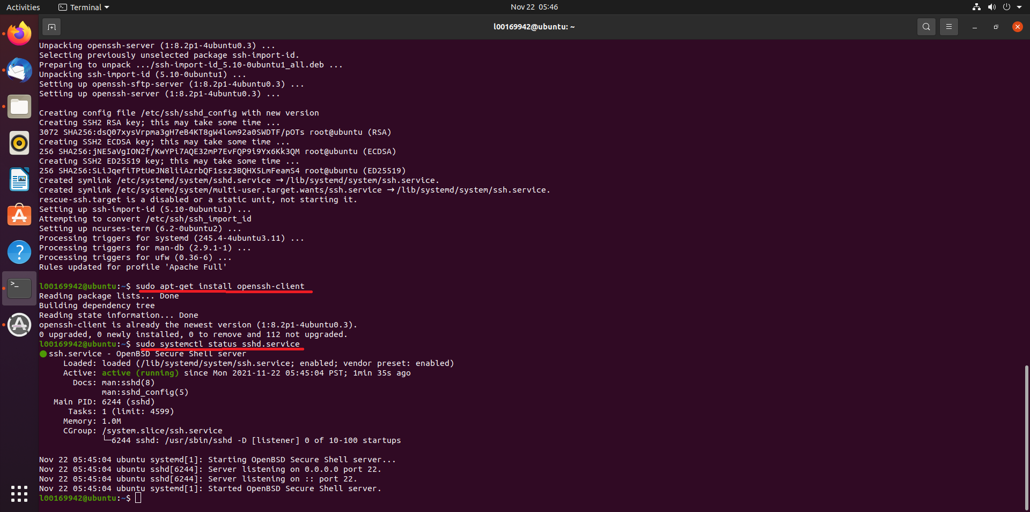

1. Connection established

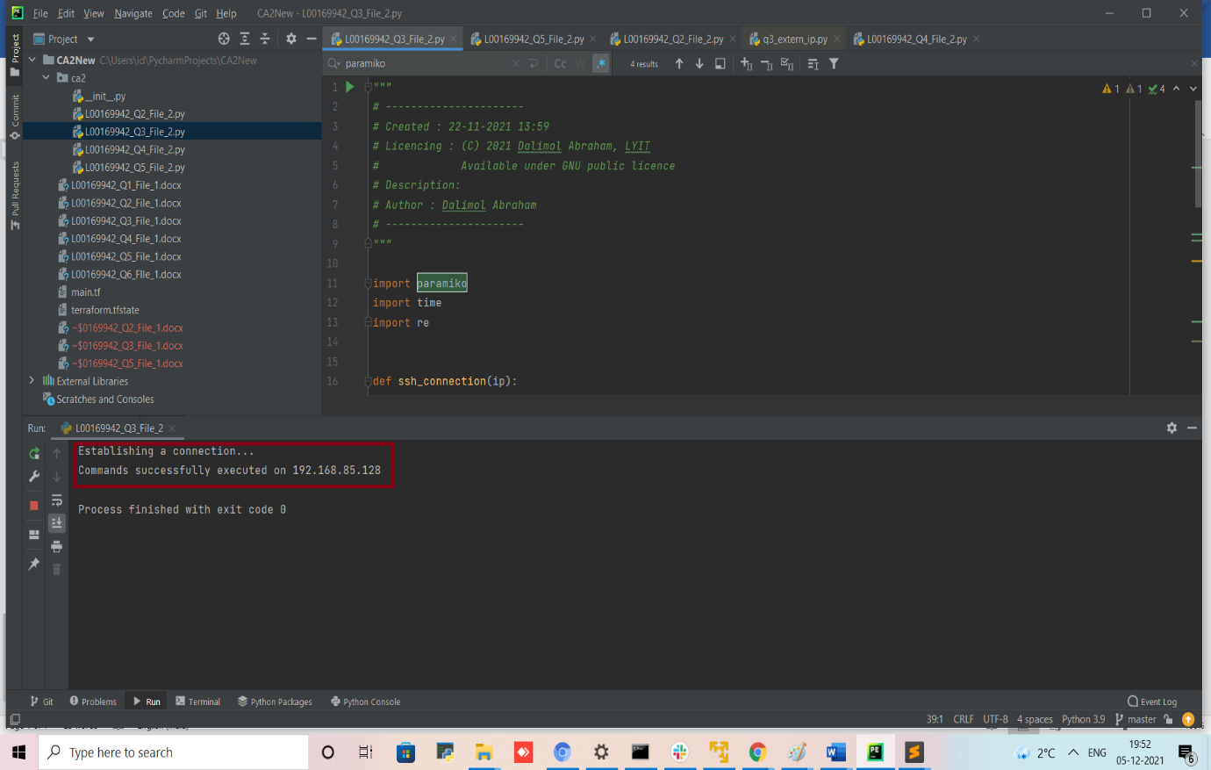

3. Successfully connection opened in VM and the file ‘dir_context.txt’ has created which contains the root folders list.

