1. Connection established in remote server.

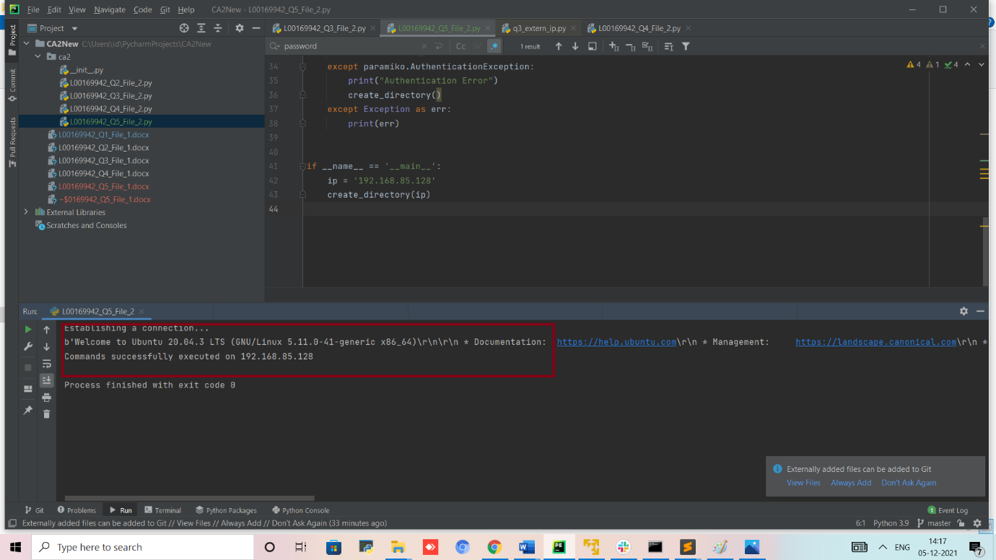

1. Folder structure created in VM

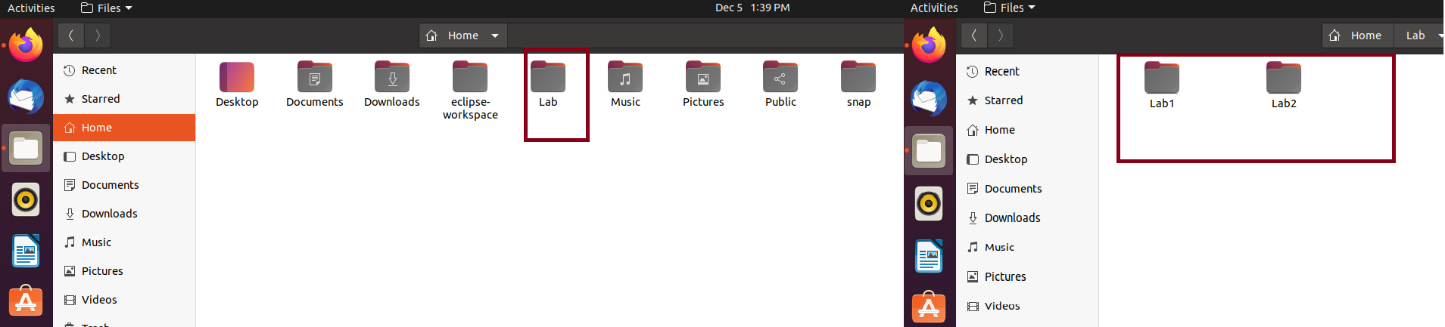

1. Files accessed time from home directory

