LETTERKENNY INSTITUTE OF TECHNOLOGY

ASSIGNMENT COVER SHEET

Lecturer’s Name: Ruth Lennon
Assessment Title: OOPR For Server Admin
Work to be submitted to: Ruth Lennon
Date for submission of work: 30/11/2021
Place and time for submitting work: Blackboard as per submission link

To be completed by the Student
Student’s Name: Luis Gonzalez
Class: OOPR For Server Admin
Subject/Module: OOPR For Server Admin
Word Count (where applicable): N/A
I confirm that the work submitted has been produced solely through my own efforts.
Student’s signature: Luis Gonzalez Date: 05/12/2021

Notes
Penalties: The total marks available for an assessment is reduced by 15% for work submitted up to one week late. The total marks available are reduced by 30% for work up to two weeks late. Assessment work received more than two weeks late will receive a mark of zero. [Incidents of alleged plagiarism and cheating are dealt with in accordance with the Institute’s Assessment Regulations.]
Plagiarism: Presenting the ideas etc. of someone else without proper acknowledgement (see section L1 paragraph 8).
Cheating: The use of unauthorised material in a test, exam etc., unauthorised access to test matter, unauthorised collusion, dishonest behaviour in respect of assessments, and deliberate plagiarism (see section L1 paragraph 8).
Continuous Assessment: For students repeating an examination, marks awarded for continuous assessment, shall normally be carried forward from the original examination to the repeat examination.

Aims/Description
As per Assignment Question:

Write a Python script to determine which ports are open and display the
information in a tidy format. Where port 22 is shown as open display the word
“SSH” where port 80 is shown as open display the word “HTTP”. Take screenshots
of the code running on your system. Save them to a file named
L0012345_Q4_File_1 where L0012345 is replace by your own L number. Save the
script as L0012345_Q4_File_2

Results

- Python project to scan ports and show result with ports and names successfully created
- Current file, script and PyCharm project were uploaded to Student’s GitHub Repository into OOPRAssignment_Q4
https://github.com/L00170299/OOPRForServerAdmin

Conclusions

Some more reading was required to finally achieve this. Some ports appear in the list as open even though ports are not allowed in firewall (ufw). Looks like its able to tell which ports are listening, which is curious.
This project could be applied to some kind of maintenance or security scanning. Its an interesting one to apply to any stage/pipeline of DevOps.

For Student this project was much faster as previous examples helped a lot.

Appendix

PyCharm with Output

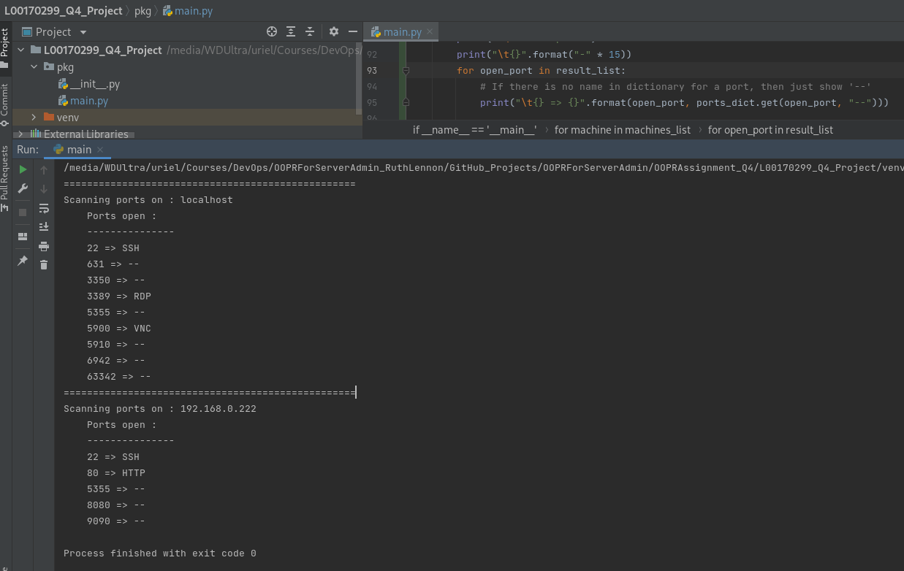

localhost with ports listening (open):
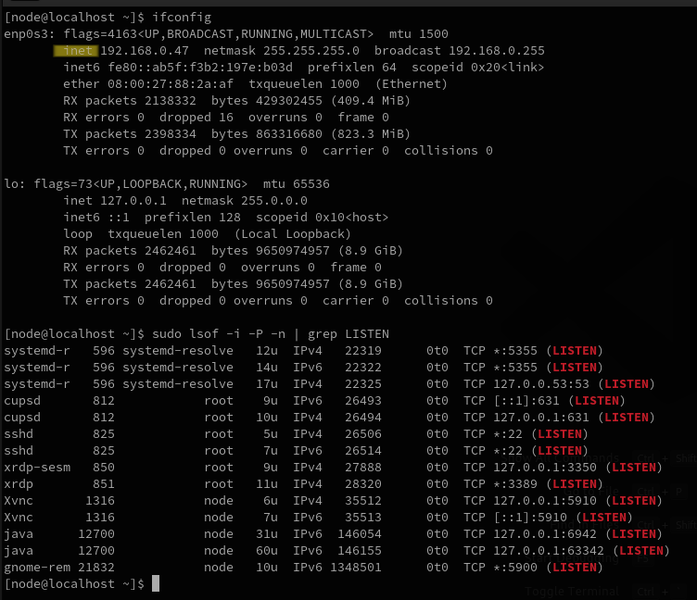

vserver (192.168.0.222) with ports listening (open):

