LETTERKENNY INSTITUTE OF TECHNOLOGY

ASSIGNMENT COVER SHEET

Lecturer’s Name: Ruth Lennon
Assessment Title: OOPR For Server Admin
Work to be submitted to: Ruth Lennon
Date for submission of work: 29/11/2021
Place and time for submitting work: Blackboard as per submission link

To be completed by the Student
Student’s Name: Luis Gonzalez
Class: OOPR For Server Admin
Subject/Module: OOPR For Server Admin
Word Count (where applicable): N/A
I confirm that the work submitted has been produced solely through my own efforts.
Student’s signature: Luis Gonzalez Date: 29/11/2021

Notes
Penalties: The total marks available for an assessment is reduced by 15% for work submitted up to one week late. The total marks available are reduced by 30% for work up to two weeks late. Assessment work received more than two weeks late will receive a mark of zero. [Incidents of alleged plagiarism and cheating are dealt with in accordance with the Institute’s Assessment Regulations.]
Plagiarism: Presenting the ideas etc. of someone else without proper acknowledgement (see section L1 paragraph 8).
Cheating: The use of unauthorised material in a test, exam etc., unauthorised access to test matter, unauthorised collusion, dishonest behaviour in respect of assessments, and deliberate plagiarism (see section L1 paragraph 8).
Continuous Assessment: For students repeating an examination, marks awarded for continuous assessment, shall normally be carried forward from the original examination to the repeat examination.

Aims/Description
As per Assignment Question:

(Preparation: Not code) Install apache2 on the vm.

The first command installs the web server. The second allows the server through
the firewall – if this was a production machine I would not do it this way! The next
command reboots the vm to allow the changes to take effect. Next, start the server
and then test that it is running.
sudo apt-get install apache2
sudo ufw allow 'Apache Full'
sudo init 6
sudo systemctl start apache2
sudo systemctl status apache2
Open a browser on your own host machine (not the vm) and point it to the ip
address of the vm. It should show a default web page. Use screenshots to
demonstrate that this worked. Save them to a file named L0012345_Q1_File_1
where L0012345 is replace by your own L number.

Results

- Virtual Server was installed (Fedora Server 35) successfully
- httpd (apache) service was installed
- Firewall (ufw) ports were open to allow connection to server
- Successfully able to connect to port 80 (apache) & port 22 (ssh)
- Current file was uploaded to Student’s GitHub Repository into OOPRAssignment_Q1
https://github.com/L00170299/OOPRForServerAdmin

Conclusions

Student have always loved/used Linux at home. Creating a new virtual server and installing services is something Student is used to.
Although Ubuntu has been used in the past by Student. It was decided to use Fedora as the distribution to work with as its the main/favourite to use at home.
This particular question was easy to have it done.

Appendix

VirtualBox running Fedora Server 35
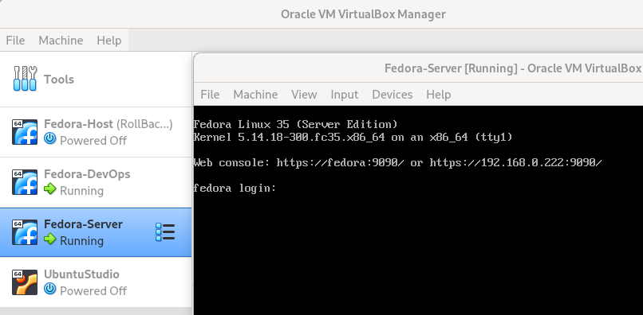
Installing httpd service (apache)

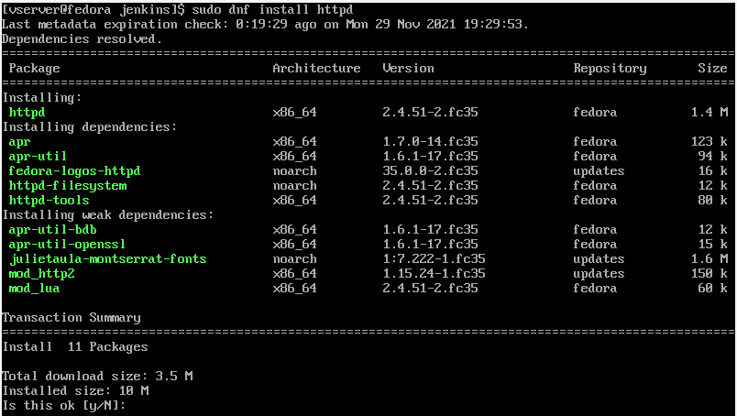

Check status, enable & start httpd service

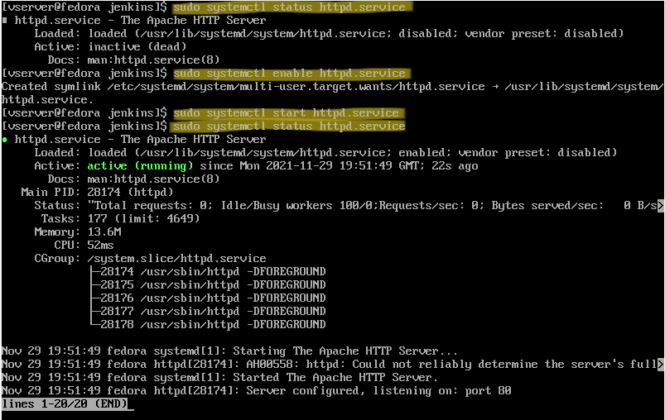

Check status , enable, allow port 80 (apache) and reload of rules of firewall (ufw). SSH its allowed by default

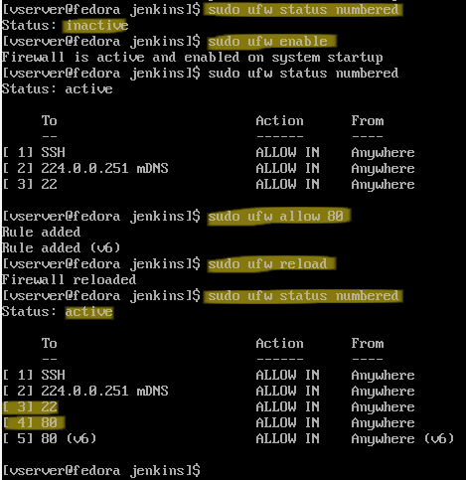

Accessing Fedora Server from another Terminal (ssh)
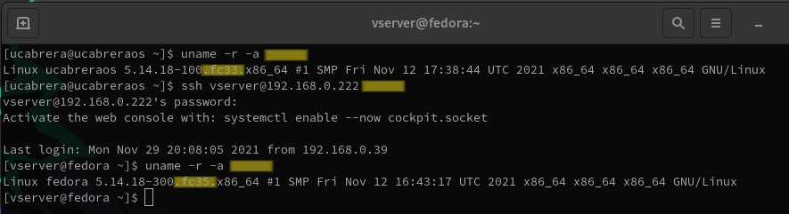
Browsing httpd website (default apache)
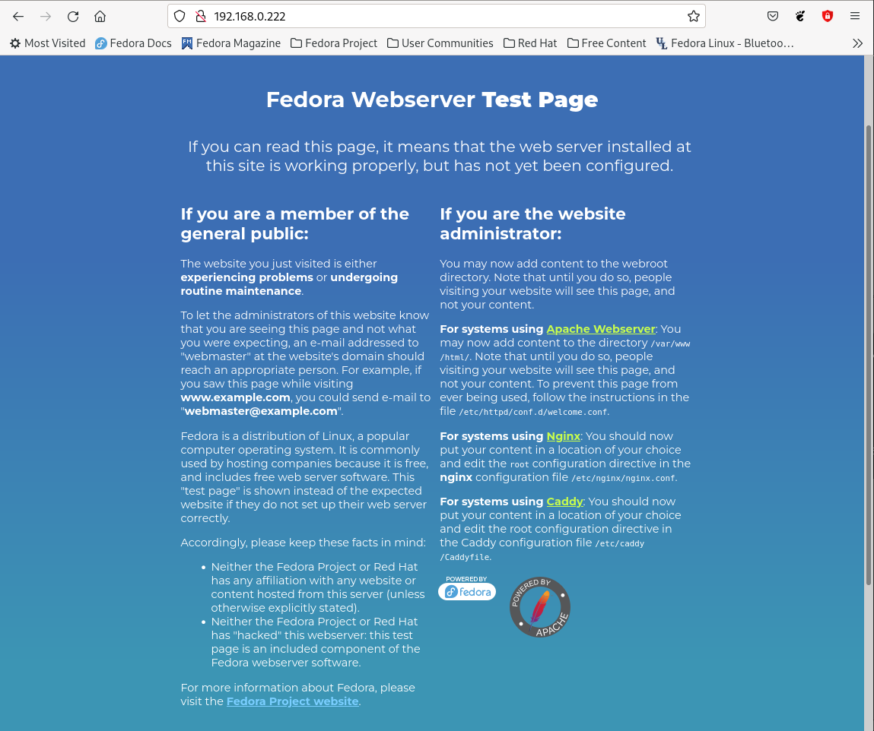

Other web tools installed and ports open:
9090: Web Admin console from RedHat
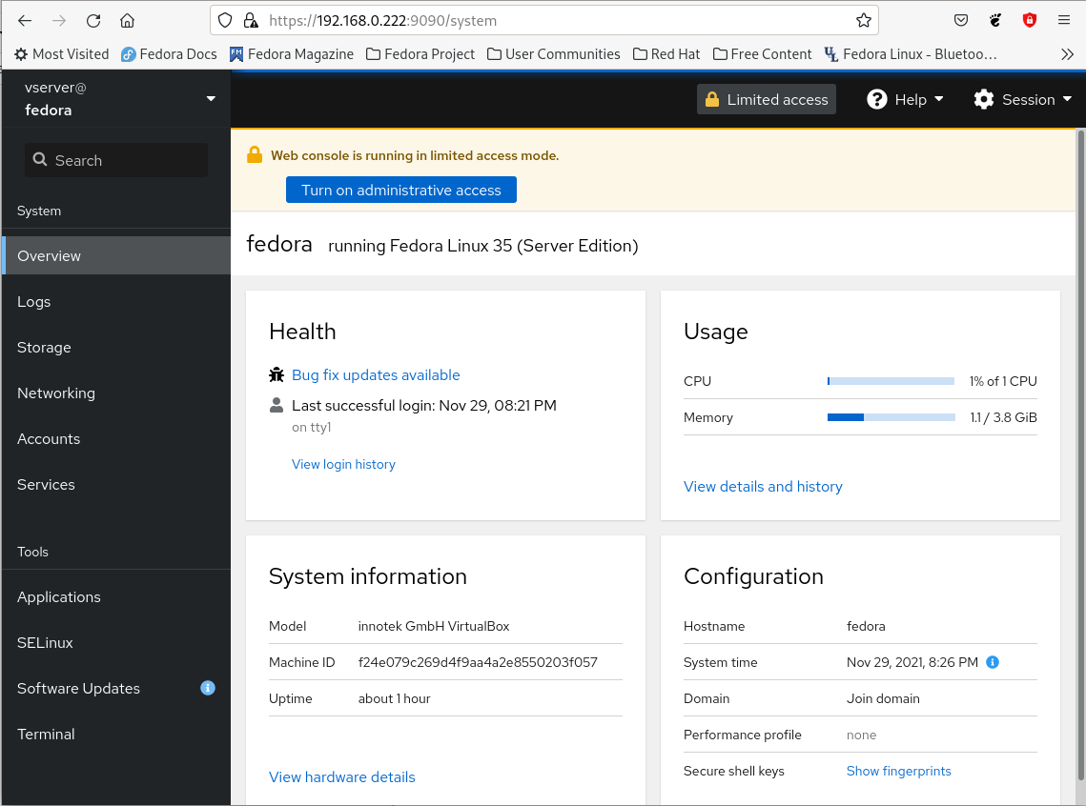

8080: Jenkins
