LETTERKENNY INSTITUTE OF TECHNOLOGY

ASSIGNMENT COVER SHEET

Lecturer’s Name: Ruth Lennon
Assessment Title: OOPR For Server Admin
Work to be submitted to: Ruth Lennon
Date for submission of work: 30/11/2021
Place and time for submitting work: Blackboard as per submission link

To be completed by the Student
Student’s Name: Luis Gonzalez
Class: OOPR For Server Admin
Subject/Module: OOPR For Server Admin
Word Count (where applicable): N/A
I confirm that the work submitted has been produced solely through my own efforts.
Student’s signature: Luis Gonzalez Date: 04/12/2021

Notes
Penalties: The total marks available for an assessment is reduced by 15% for work submitted up to one week late. The total marks available are reduced by 30% for work up to two weeks late. Assessment work received more than two weeks late will receive a mark of zero. [Incidents of alleged plagiarism and cheating are dealt with in accordance with the Institute’s Assessment Regulations.]
Plagiarism: Presenting the ideas etc. of someone else without proper acknowledgement (see section L1 paragraph 8).
Cheating: The use of unauthorised material in a test, exam etc., unauthorised access to test matter, unauthorised collusion, dishonest behaviour in respect of assessments, and deliberate plagiarism (see section L1 paragraph 8).
Continuous Assessment: For students repeating an examination, marks awarded for continuous assessment, shall normally be carried forward from the original examination to the repeat examination.

Aims/Description
As per Assignment Question:

Connect to the virtual machine using a python script using the ssh port via
modifying a previous script from the ‘Networking Labs’. Establish that the
connection was successful. Use screenshots to demonstrate that this worked. Save
them to a file named L0012345_Q3_File_1 where L0012345 is replaced by your own
L number.

Results

- Library Paramiko installed successfully
- Python Project using Paramiko, sys and time was created
- Project to connect to a remote machine through ssh and run basic commands tested successfully.
- Current file, script and PyCharm project were uploaded to Student’s GitHub Repository into OOPRAssignment_Q3
https://github.com/L00170299/OOPRForServerAdmin

Conclusions

Student found this project very interesting and useful. This could be used for personal task/projects at home.
It required a lot of reading and understanding of new syntax and modules but after a bit of research and once things started to make sense then it was just matter of put it together.
There many things that could have being different like maybe make it a class, create a config file to avoid hardcoding connection details, make functions generic so it would run commands for any Linux distribution or even Windows with openSSH.
Student really loved this project!!

Appendix

Installing paramiko: Fedora pkgs
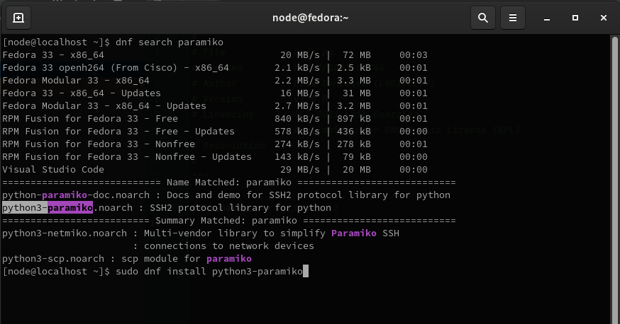
Installing paramiko: PyCharm environment
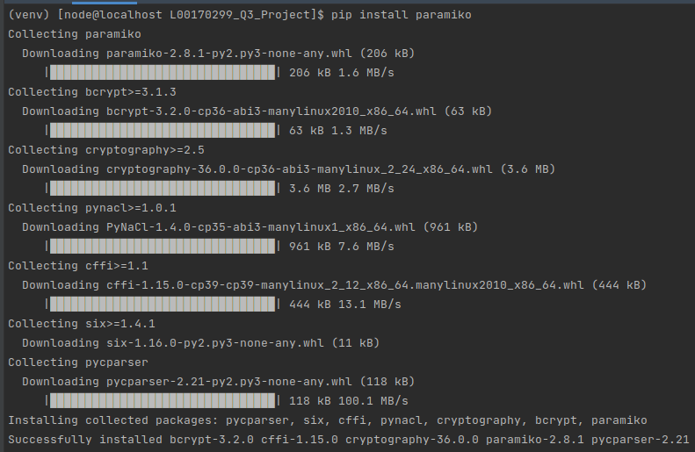

Project output:

