LETTERKENNY INSTITUTE OF TECHNOLOGY

ASSIGNMENT COVER SHEET

Lecturer’s Name: Ruth Lennon
Assessment Title: OOPR For Server Admin
Work to be submitted to: Ruth Lennon
Date for submission of work: 30/11/2021
Place and time for submitting work: Blackboard as per submission link

To be completed by the Student
Student’s Name: Luis Gonzalez
Class: OOPR For Server Admin
Subject/Module: OOPR For Server Admin
Word Count (where applicable): N/A
I confirm that the work submitted has been produced solely through my own efforts.
Student’s signature: Luis Gonzalez Date: 30/11/2021

Notes
Penalties: The total marks available for an assessment is reduced by 15% for work submitted up to one week late. The total marks available are reduced by 30% for work up to two weeks late. Assessment work received more than two weeks late will receive a mark of zero. [Incidents of alleged plagiarism and cheating are dealt with in accordance with the Institute’s Assessment Regulations.]
Plagiarism: Presenting the ideas etc. of someone else without proper acknowledgement (see section L1 paragraph 8).
Cheating: The use of unauthorised material in a test, exam etc., unauthorised access to test matter, unauthorised collusion, dishonest behaviour in respect of assessments, and deliberate plagiarism (see section L1 paragraph 8).
Continuous Assessment: For students repeating an examination, marks awarded for continuous assessment, shall normally be carried forward from the original examination to the repeat examination.

Aims/Description
As per Assignment Question:

Code: Using Python on your host (windows) pc scrape the Apache 2 page you just
created (or LYIT web page) and parse it minimally for later processing. For example:
a. What are the headings?
b. How many times does the word Apache2 appear ?
Think of searching for an event id or user id that is in your system.
c. Any other item

Use BeautifulSoup or any other parser that you have never used before for this task.
https://pypi.org/project/beautifulsoup4/
The purpose of this task is both to install
software and to use an api you have not seen before to carry out a minimal task.
If apache is properly installed it should be visible from the host by typing in the ip
address in your browser. See below.
ip addr show
Use screenshots to demonstrate that this worked. Save them to a file named
L0012345_Q2_File_1 where L0012345 is replace by your own L number. Save the
script as L0012345_Q2_File_2

Results

- Library BeautifulSoup4 installed successfully
- Python Project using BeautifulSoup4 & requests was created
- Project to scrape websites was tested successfully
- Current file, script and PyCharm project were uploaded to Student’s GitHub Repository into OOPRAssignment_Q2
https://github.com/L00170299/OOPRForServerAdmin

Conclusions

Student found some difficulties importing the new module within PyCharm. Fedora system was reporting that module was installed but project was failing to import it.
Student found that system had installed module installed just for one of python versions. Which was updated after project got created.

Student found interesting the use of python to scrape websites, specially because in the past Student needed something similar for a personal project.

Appendix

Checking if beautifulsoup4 is installed and quick test:
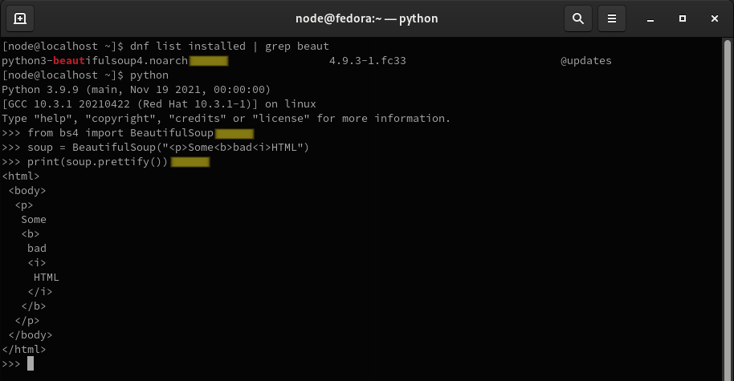
PyCharm wasn’t able to load module. So installed within its environment:
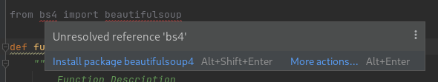

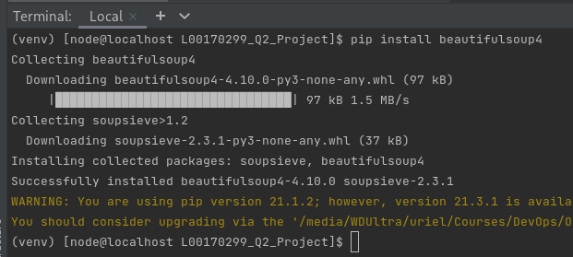

PyCharm with Project & Code

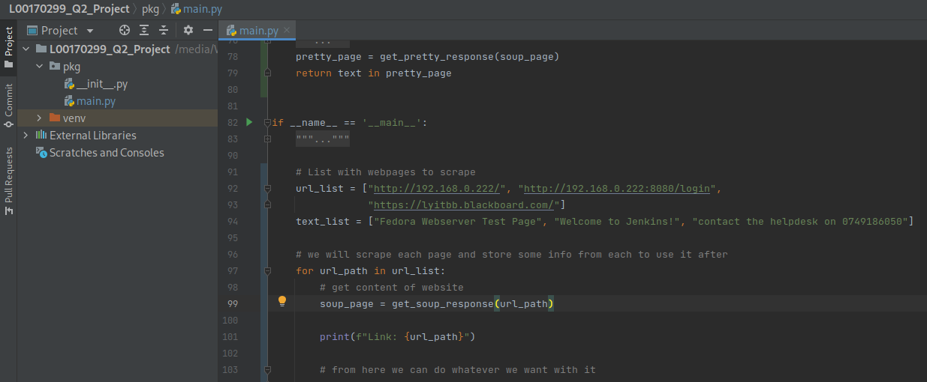
Output of code:

