LETTERKENNY INSTITUTE OF TECHNOLOGY

ASSIGNMENT COVER SHEET

Lecturer’s Name: Ruth Lennon
Assessment Title: Scripting The Deploy Pipeline
Work to be submitted to: Ruth Lennon
Date for submission of work: 20/03/2022
Place and time for submitting work: Blackboard as per submission link

To be completed by the Student
Student’s Name: Luis Gonzalez
Class: Scripting The Deploy Pipeline
Subject/Module: Scripting The Deploy Pipeline
Word Count (where applicable): N/A
I confirm that the work submitted has been produced solely through my own efforts.
Student’s signature: Luis Gonzalez Date: 20/03/2022

Notes
Penalties: The total marks available for an assessment is reduced by 15% for work submitted up to one week late. The total marks available are reduced by 30% for work up to two weeks late. Assessment work received more than two weeks late will receive a mark of zero. [Incidents of alleged plagiarism and cheating are dealt with in accordance with the Institute’s Assessment Regulations.]
Plagiarism: Presenting the ideas etc. of someone else without proper acknowledgement (see section L1 paragraph 8).
Cheating: The use of unauthorised material in a test, exam etc., unauthorised access to test matter, unauthorised collusion, dishonest behaviour in respect of assessments, and deliberate plagiarism (see section L1 paragraph 8).
Continuous Assessment: For students repeating an examination, marks awarded for continuous assessment, shall normally be carried forward from the original examination to the repeat examination.

Aims/Description
As per Assignment Question:

Create a Cloud Formation Stack using the designer.
The purpose is to replicate the mini network created previously.

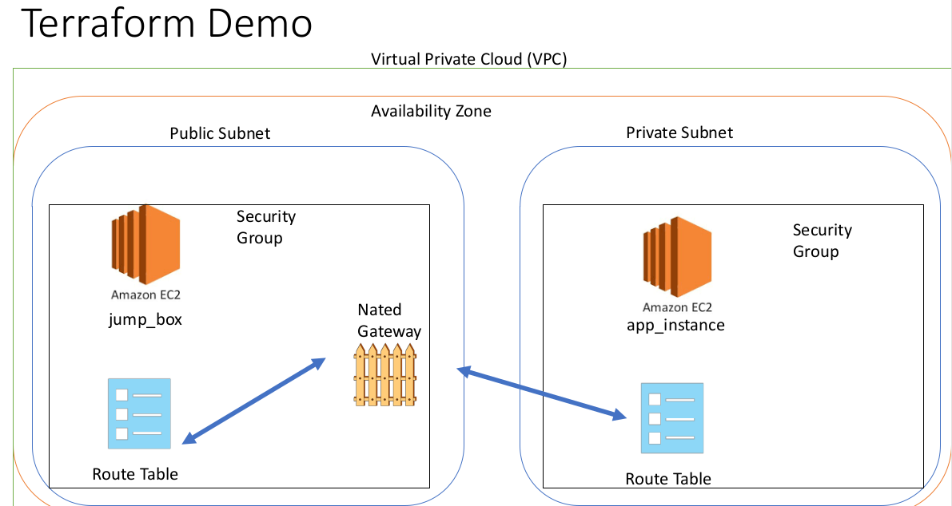

Results

- AWS CloudFormation template was created in Designer
- Virtual Private Cloud was configured and template was validated
- Stack was created and instances ran successfully.
- User was able to remote to public instance by ssh and using key.
- Within Public Subnet user was able to access Private Subnet.
- Current file was uploaded to Student’s GitHub Repository into CloudFormation
https://github.com/L00170299/ScriptingTheDeployPipeline

Conclusions

Student was able to learn and understand basics of CloudFormation in AWS. Template wasn’t working at first and there were multiples attempts and failures but each time something new was discovered or understood. Finally pieces started to make sense and with some extra research about how to do small mapping between elements the VPC started to work.

Student tried to follow best practices like add descriptions, tags, avoid security within code, etc.
The idea of implementing a VPC is to protect our infrastructure from possibles attacks by hiding it and allow just one instance to be accessed from internet and therefore harden the security in that single instance point.
In this example student used KeyPair file as security measure to access that instance exposed to internet and allow just an specific range of public IP’s to get access. KeyPairName must be a key previously generated in AWS and just Name needs to me referenced when running Stack

Appendix

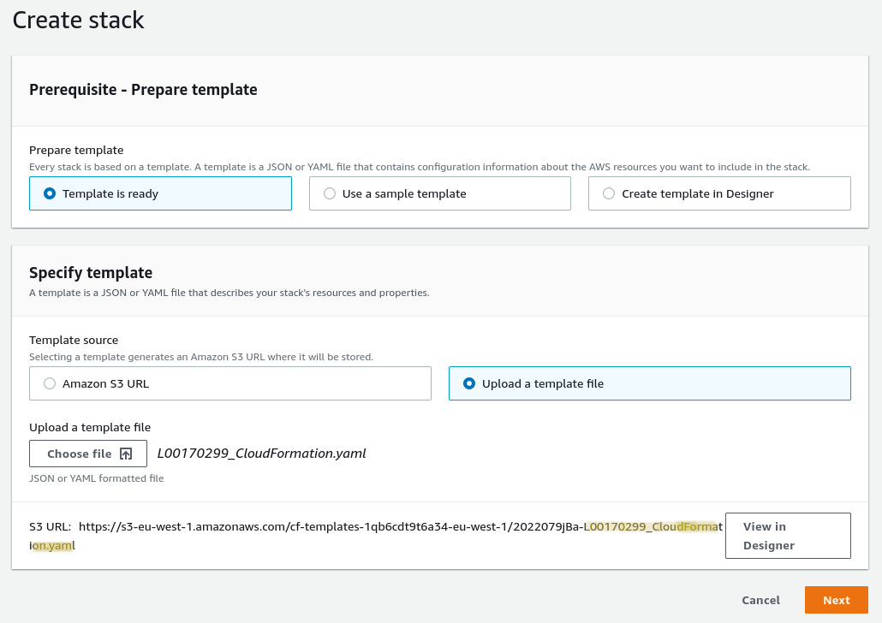
Loading template

VPC diagram from template showing both Subnets
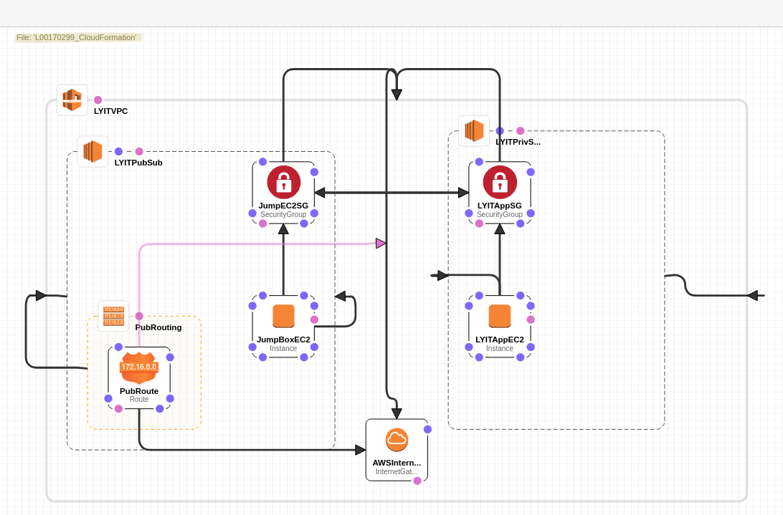
Filling in details before running Stack
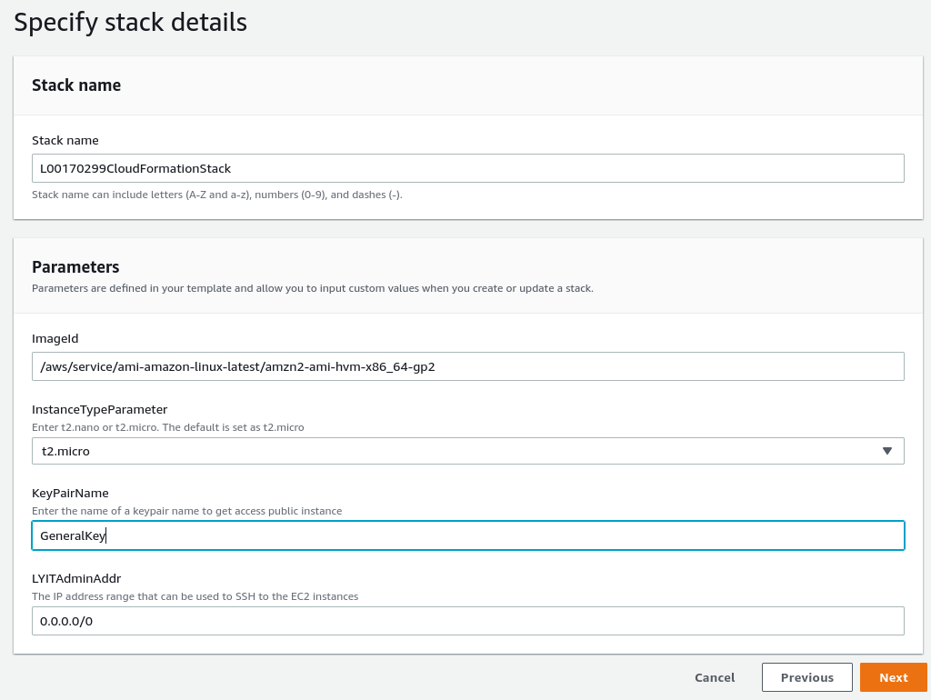

Stack finished creating VPC and showing both instances

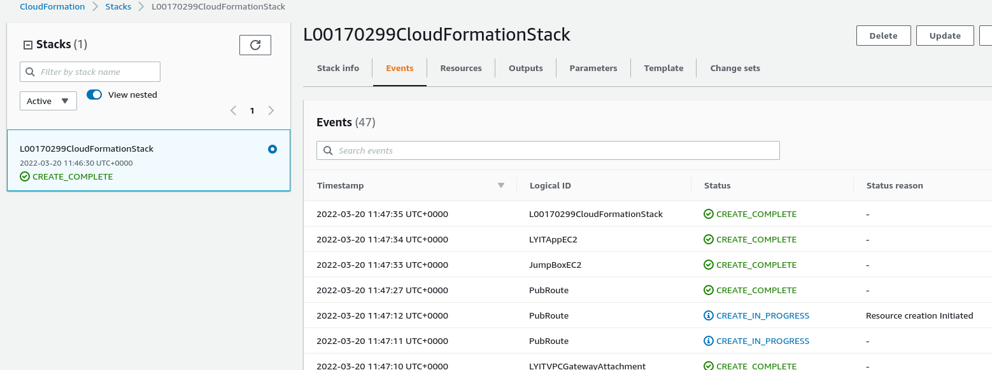
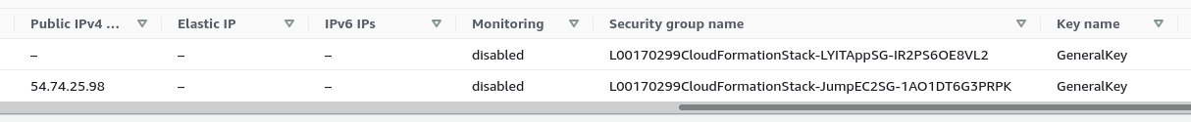
Connecting to public IP using KeyFile specified (subnet IP: 192.168.1.80)
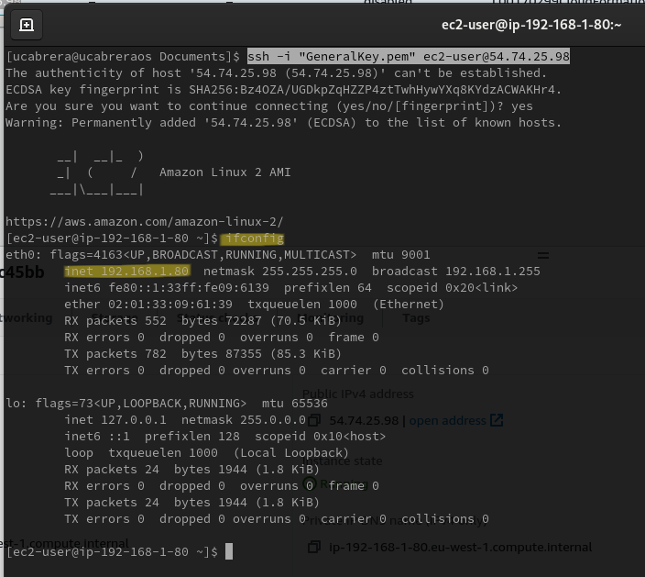

Accessing private Instance from public instance using same KeyFile (subnet IP: 192.168.0.187)
**Key needed to be copied first to public one.
