LETTERKENNY INSTITUTE OF TECHNOLOGY

ASSIGNMENT COVER SHEET

Lecturer’s Name: Ruth Lennon
Assessment Title: Scripting The Deploy Pipeline
Work to be submitted to: Ruth Lennon
Date for submission of work: 21/03/2022
Place and time for submitting work: Blackboard as per submission link

To be completed by the Student
Student’s Name: Luis Gonzalez
Class: Scripting The Deploy Pipeline
Subject/Module: Scripting The Deploy Pipeline
Word Count (where applicable): N/A
I confirm that the work submitted has been produced solely through my own efforts.
Student’s signature: Luis Gonzalez Date: 21/03/2022

Notes
Penalties: The total marks available for an assessment is reduced by 15% for work submitted up to one week late. The total marks available are reduced by 30% for work up to two weeks late. Assessment work received more than two weeks late will receive a mark of zero. [Incidents of alleged plagiarism and cheating are dealt with in accordance with the Institute’s Assessment Regulations.]
Plagiarism: Presenting the ideas etc. of someone else without proper acknowledgement (see section L1 paragraph 8).
Cheating: The use of unauthorised material in a test, exam etc., unauthorised access to test matter, unauthorised collusion, dishonest behaviour in respect of assessments, and deliberate plagiarism (see section L1 paragraph 8).
Continuous Assessment: For students repeating an examination, marks awarded for continuous assessment, shall normally be carried forward from the original examination to the repeat examination.

Aims/Description
As per Assignment Question:

- Create a web page with your Lnumber, name, date and time. Upload to a github repo. Set up a playbook to configure a WebServer
- Set up a playbook to configure a Secure Database Server of your choice.
- Only use the Ansible guidebook to help you. Copy a file from s3 to your database using
Ansible.
- Compare Ansible with other solutions you have used (Python, Terraform, CloudFormation) for the purposes of server configuration. Do not exceed 2 pages.
a. Draw on your personal experience with each technology.
b. Back up your opinion with referenced work.
c. Images and references are not included in the page limit.

Results

- VM’s with Fedora server created for ansible lab successfully.
- User configured ssh access with rsa_key and nopassword(sudoers).
- Ansible and required tools installed in Ansible Control PC successfully.
- Playbook created and tested to configure web server with packages, services and deploy website from github that communicates to database.
- Playbook to download source file from AWS S3 and import to database created and tested successfully.
- After running playbooks user was able to remote to target pc with ssh.
- After running playbooks user was able to connect to database through db gui.
- After running playbooks user was able to access website showing records in database.
- Current file was uploaded to Student’s GitHub Repository into Ansible
https://github.com/L00170299/ScriptingTheDeployPipeline

Conclusions

Ansible is very easy to understand tool to configure and administrate resources (orchestration)
Student found it super interesting and extremely easy to get started with. There is a huge list of modules than can be installed depending the tasks that are needed which makes it very dynamic and growing constantly.

Is very useful to automate repetitive tasks either in a single device or multiple devices that required the same set of tasks. Task like update operative system, creating files, download, upload, connect, etc. are the kind of task that can be done manually in a console or maybe can be automated using python or even using Cloud Formation. But each of these tools were created for different purposes.

Automate task is possible in so many ways and with a long list of tools. But each of those were created with a set of capabilities thought for a type of task in particular. Just because a tool is able to execute particular tasks doesn't mean is the correct tool or way of doing it.
For example, with python user could create functions to connect, download and install packages which is a completely valid use of it but if there is a tool that does the same with much less effort then we can save time and could guarantee that implementation and use of it is less painful if we considered that there is a long list of people/companies testing it.

The same way if I’m trying to create a infrastructure probably I would use cloud formation or vagrant which are tools created for that purpose event though python or Ansible would be able to automate some scripts here and there to achieve the same results. But again we would be “using/forcing” a tool to something that it wasn’t designed for.

As part of course student has learned about new tools and has better idea of the best uses for tools. If student had to create new servers, configure, install pkgs, schedule repetitive tasks, create and deploy in house software this is how it probably would look like:

Cloud Formation/Terraform/Vagrant => create servers, networks, open ports.
Ansible => to install, update OS, run specific commands, maintenance, etc.
create tools (scripts, website, etc) => Python, PowerShell, C#, bash, etc.

The previous is just an attempt to exemplify which tool use for which task but there is tons of information to consider.

In an article by (Brikman, 2016) the author explains what are the factors they have considered to take a decisions between tools. I think those can be apply to different set of tools like if its open source, how easy is to implement, security, maintenance, the community, mature vs cutting edge, etc.

References & Bibliography
Brikman, Yevgeniy. (2016) "Why we use Terraform and not Chef, Puppet, Ansible, SaltStack, or CloudFormation".
Available at: https://blog.gruntwork.io/why-we-use-terraform-and-not-chef-puppet-ansible-saltstack-or-cloudformation-7989dad2865c (Accessed: 21 March 2022).

Terra, John. (2022) "Ansible vs Chef: What’s the Difference?".
Available at: https://www.simplilearn.com/ansible-vs-chef-differences-article (Accessed: 21 March 2022).

Appendix

Clean VM’s with Fedora Server.
Devices:
acontrolpc
atargetpc

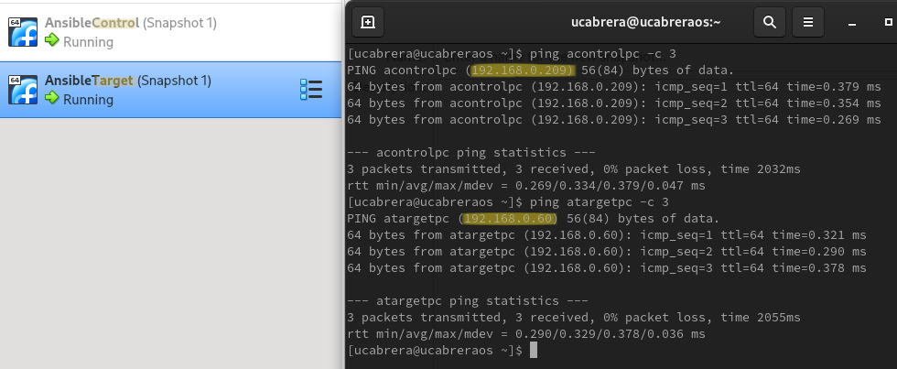
Target PC without webservice and not mysql

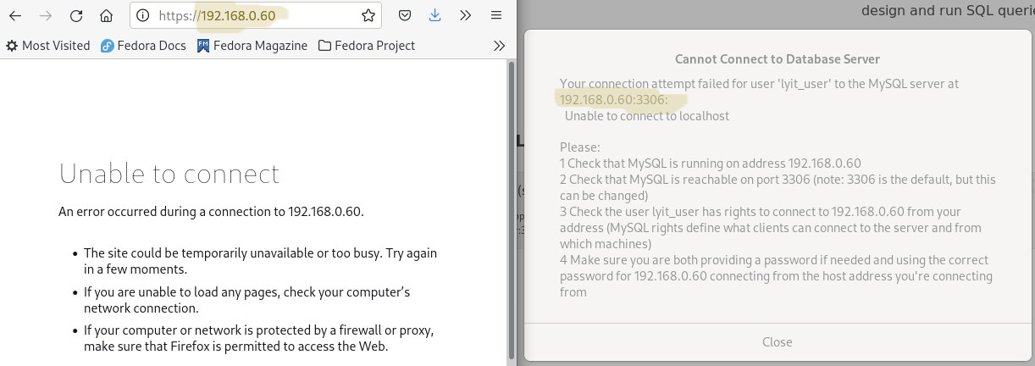
Control PC with 2 playbooks and a vault file to keep secrets.

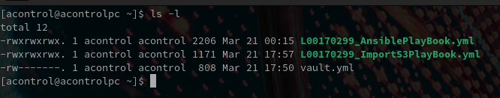
Output from first playbook to configure webserver and sqlserver.
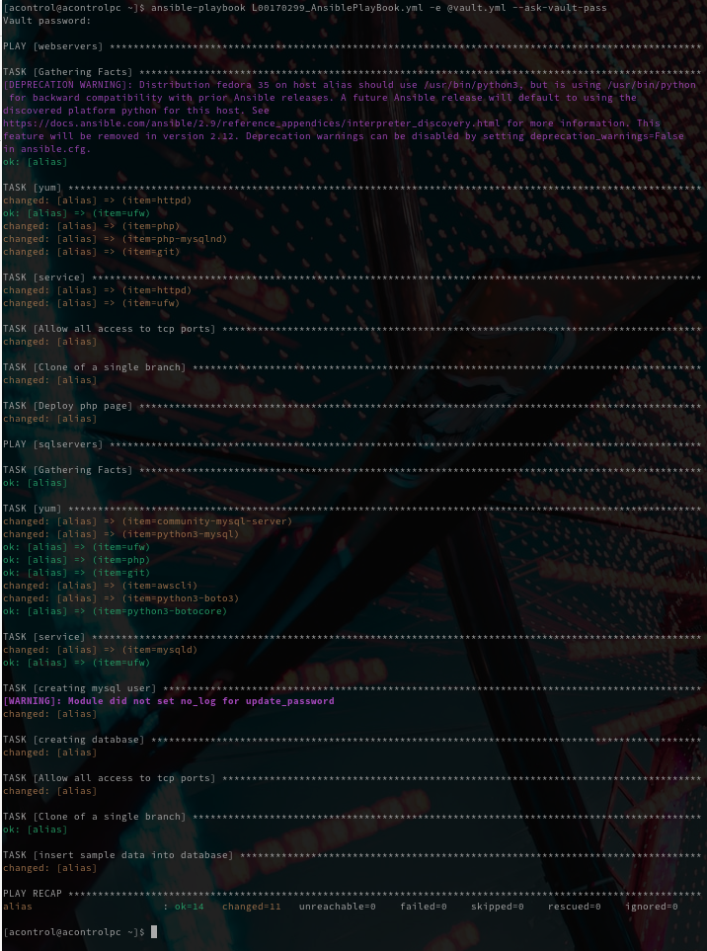

Result after running first playbook to configure with website and database.
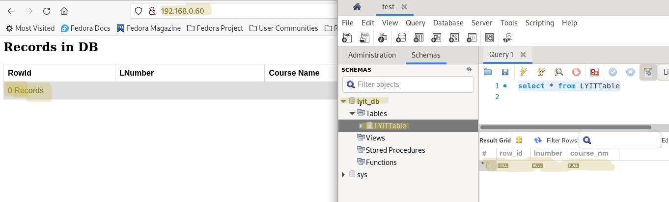
Source file and content of it in AWS S3 before running Importing playbook

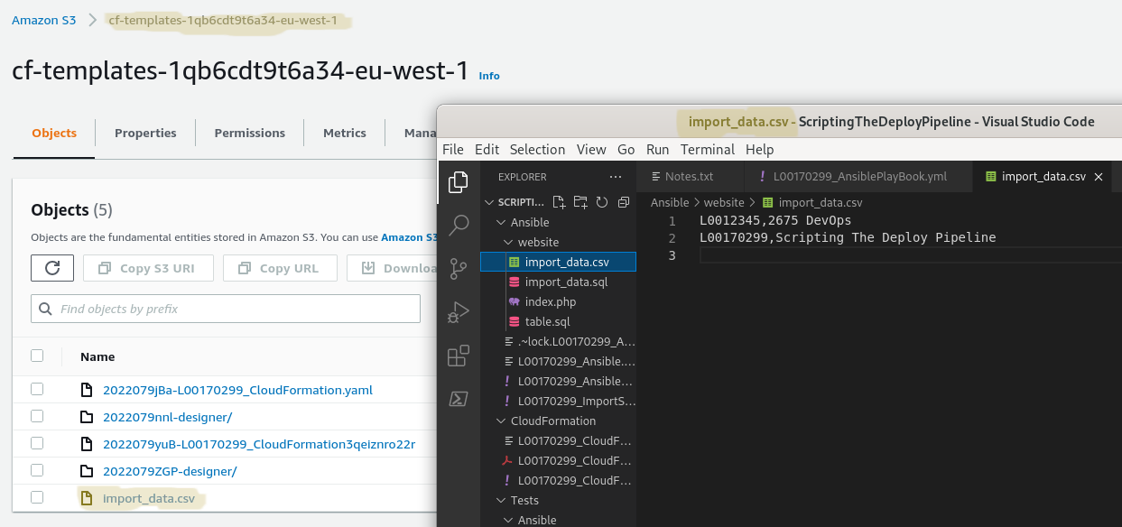

Output from second playbook to download and import file from AWS S3

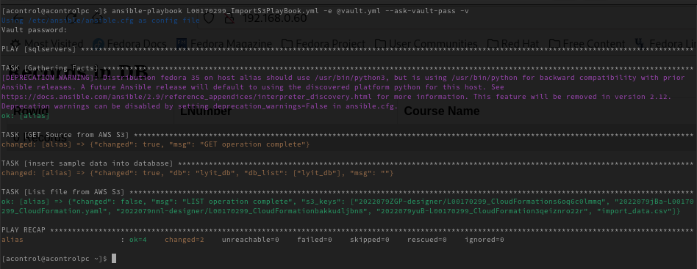
Result after running importing playbook with records in database and showing in website

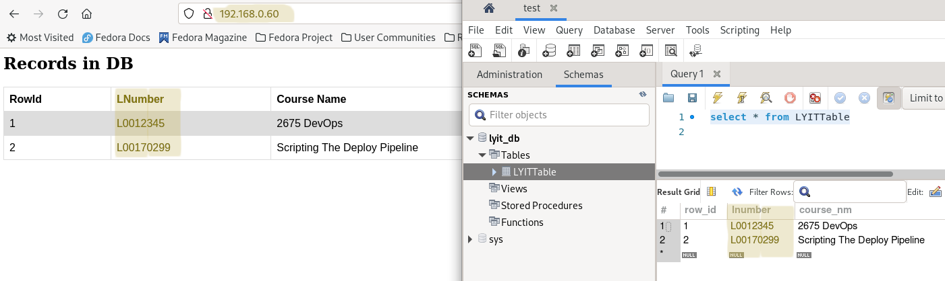
Ansible Inventory with groups

