Student: Anne O’Brien

Student ID: L00170336

Course: BSc Data Centre Management

Module: OOP

1. I started by installing beautifulsoup4

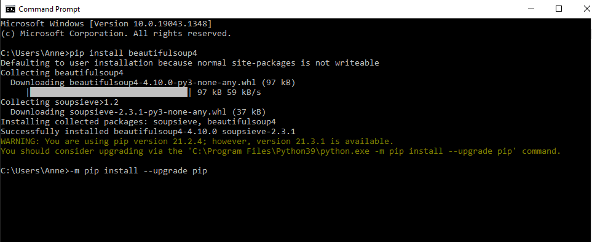

1. I got the message above saying that I needed to upgraded pip. I ran the pip upgrade command but it told me that pip was already up to date! So, I continued on
2. I then ran the command to install lxml. Again I got the message to say that pip was out of date but I ignored it this time.

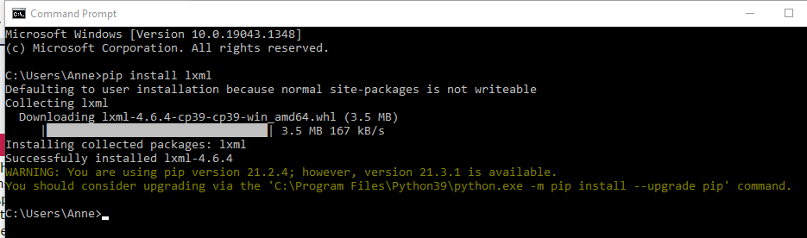

1. So then, referencing demo notes from my lecturer Ruth Lennon and some internet research, I created a script to parse the headings. I only managed to parse the headings. See below screenshots of the script being run on Pycharm. See also the python file in Pycharm.

