Student: Anne O’Brien

Student ID: L00170336

Course: BSc Data Centre Management

Module: OOP

Question 5.1

Install curl

(Please note that this is a new Ubuntu server that I have created for question 5 because I had previously installed Curl on the other VM but had not taken any screenshots. So the IP address below is different from that in the other questions.)

1. I installed Putty from the link given by my lecturer Ruth Lennon from link: <https://www.chiark.greenend.org.uk/~sgtatham/putty/latest.html>
2. I connected to the VM using Putty:

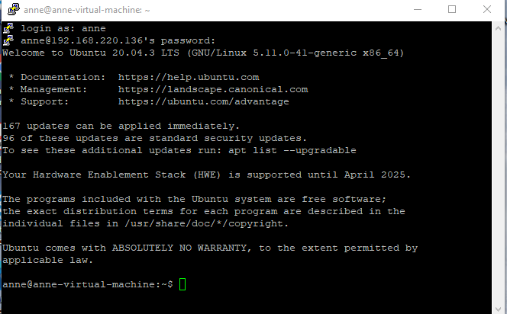

1. I searched for Curl but it’s not installed so I can now install it.

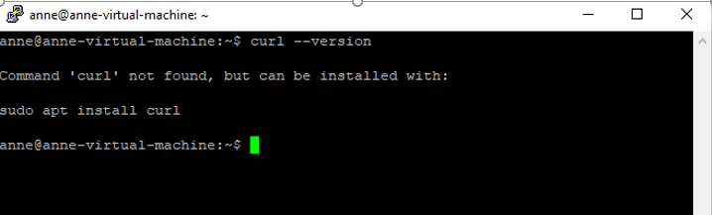

1. I can now install Curl by running the command: sudo apt install curl

