Student: Anne O’Brien

Student ID: L00170336

Course: BSc Data Centre Management

Module: OOP

Question5_File_2

1. Curl already installed via SSH using the putty tool.
2. I created a script is to create a directory structure called labs with subfolders called lab1 and lab2.
3. See next page for the screen shot of the server showing the folders created.

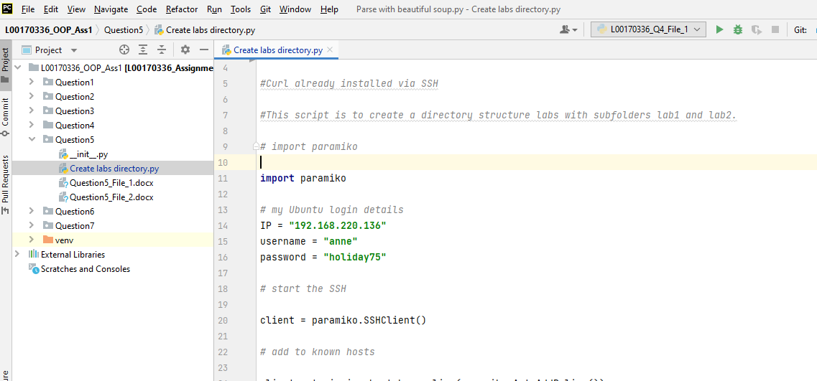

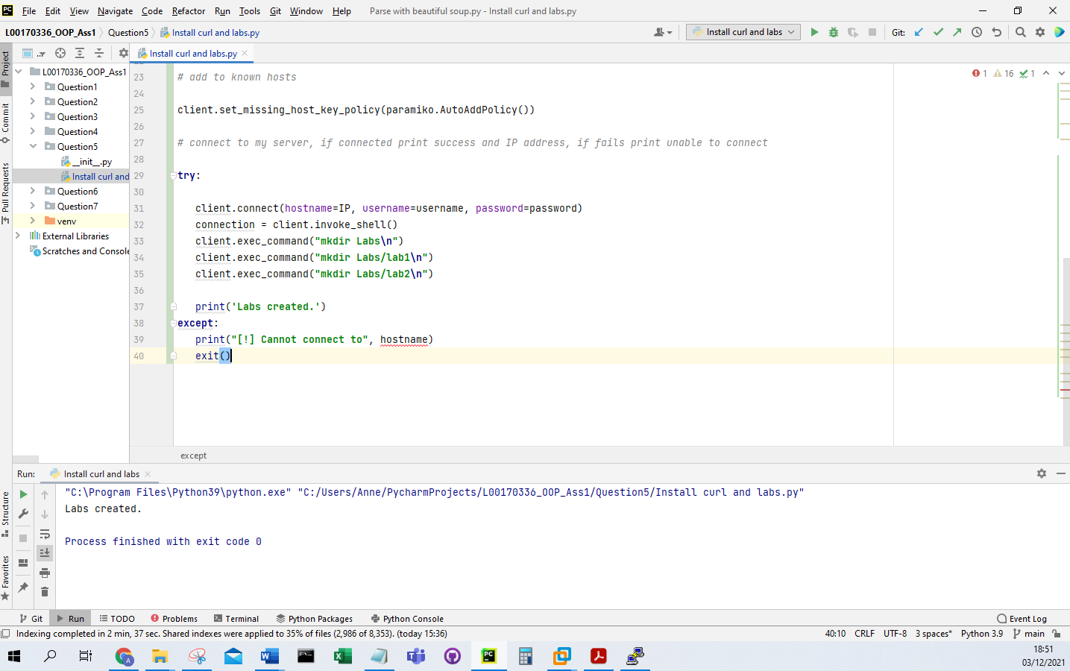

1. This shows my folders created on my server.

