Student: Anne O’Brien

Student ID: L00170336

Course: BSc Data Centre Management

Module: OOP

Question 7 Terraform

1. I created an account on AWS.

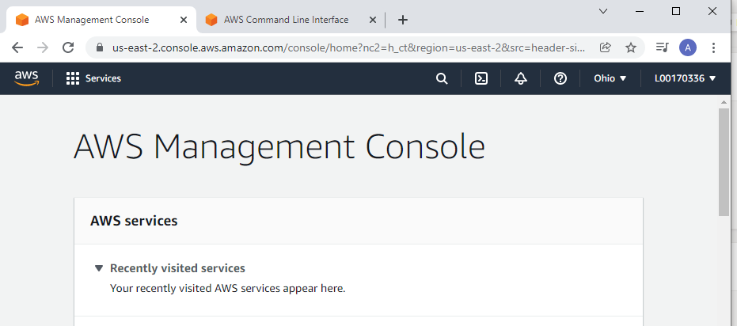

1. I installed Terraform on my Windows PC, ensuring to edit the path variable.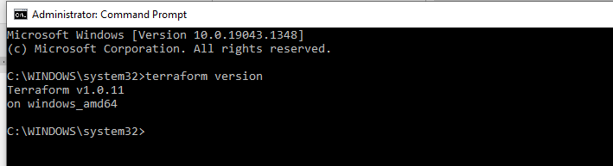
2. I installed AWS CLI

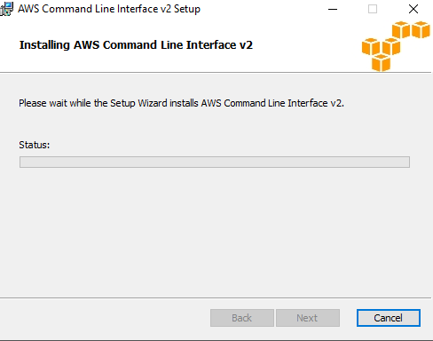

1. I ran a command to check the version, to ensure that AWS CLI had installed correctly.

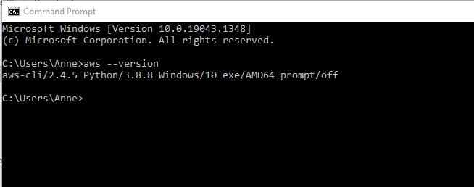

1. I configured my aws account and entered the key

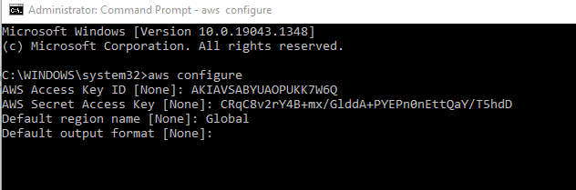

1. I created a new directory and a new file.

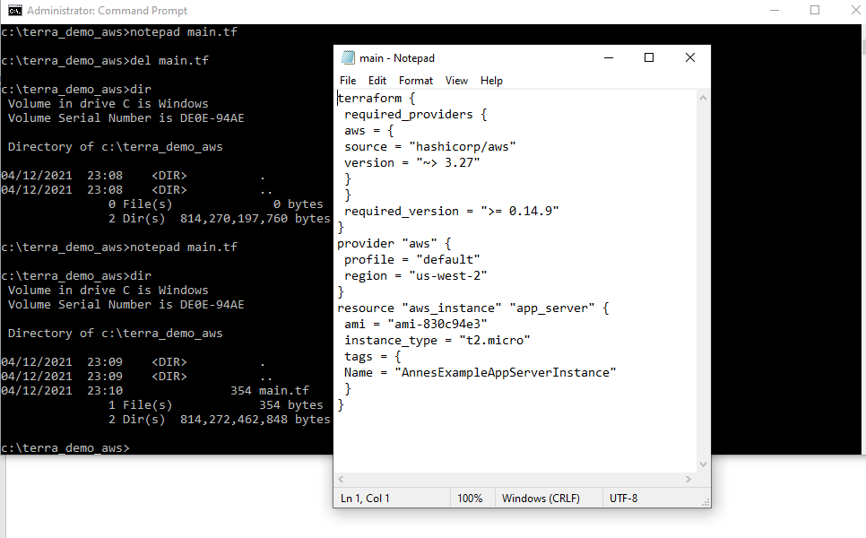

1. I initialised, formatted and validated Terraform:

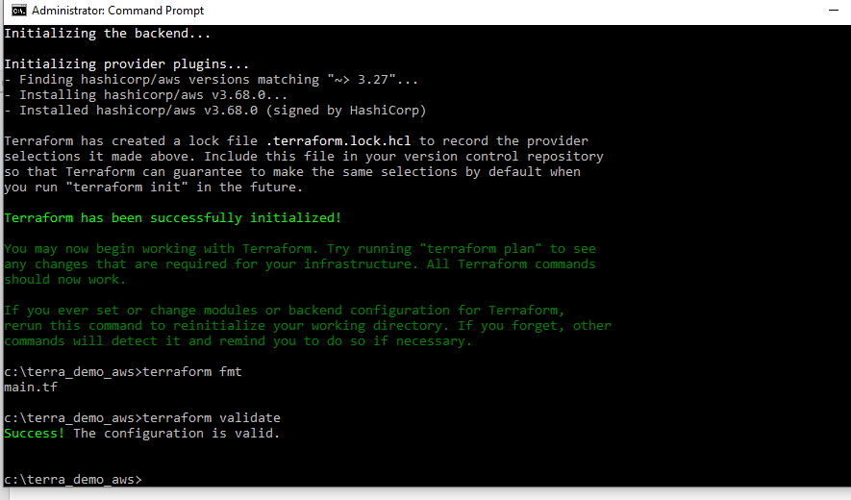

1. I created the new instance:

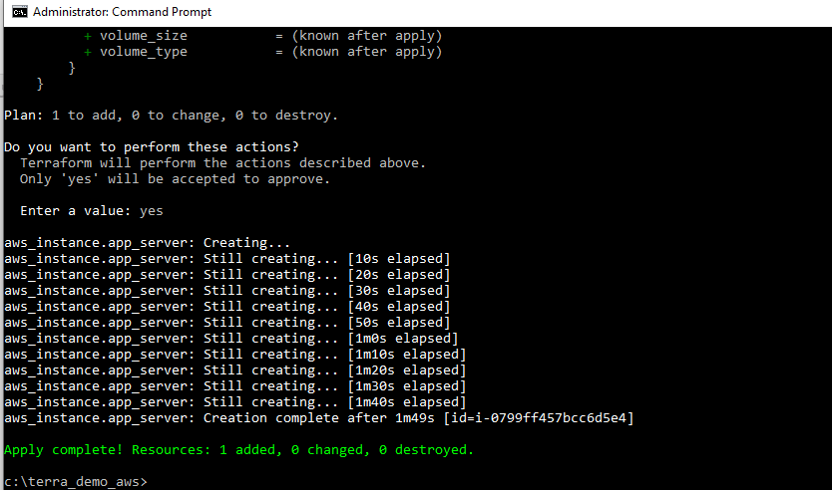

1. My Instance has been created

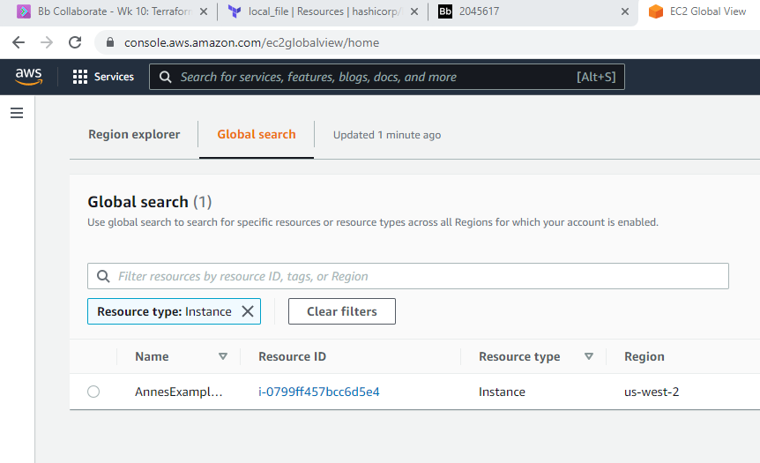

1. I amended the file and ran the command terraform plan

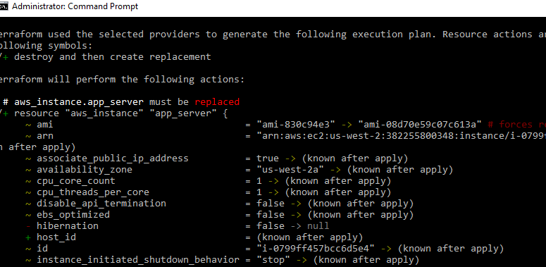

1. I now have 2 instances although I do not have the column to show that one of them is terminated. I later found that area in AWS where I could see the instances were both terminated (next screenshot).

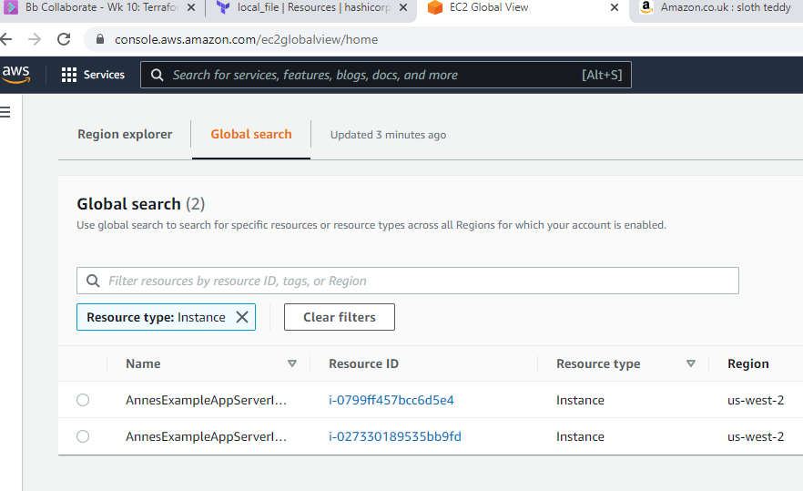

1. I ran the terraform destroy command and terminated both instances.

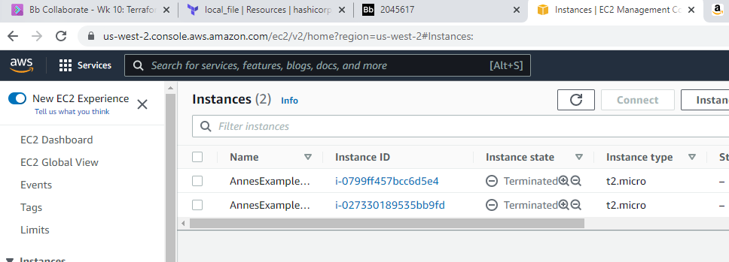

1. I created a new file called outputs.tf

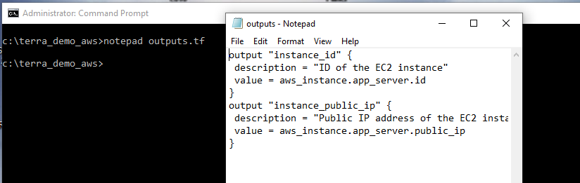

1. I ran terraform validate, plan and apply and the instance was created.

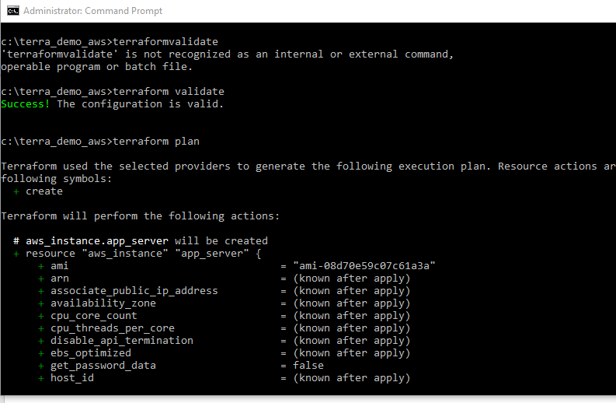

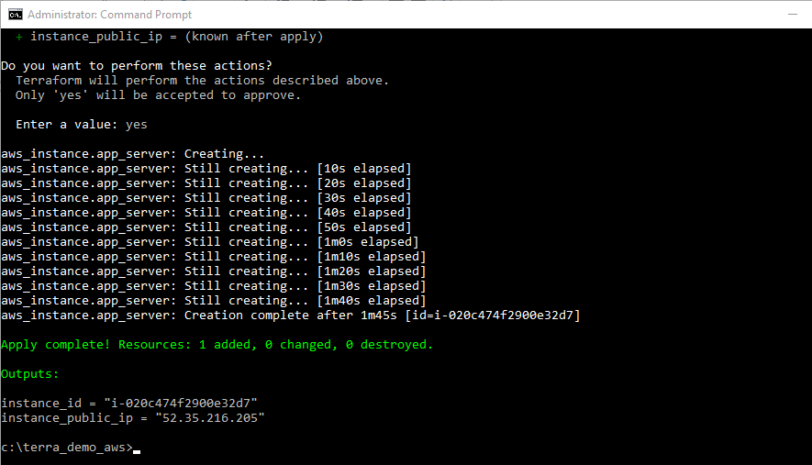

1. My Instances has been created in AWS as per screen shot below. I will terminate it now:

