LETTERKENNY INSTITUTE OF TECHNOLOGY

ASSIGNMENT COVER SHEET

**Lecturer’s Name:** Ruth Lennon

**Assessment Title:** Programming Assessment Q1.

**Work to be submitted to:** Ruth Lennon

**Date for submission of work:** Sunday, 05 December 2021

**Place and time for submitting work:** Blackboard

**Student’s Name:** Wagner Ribeiro

**Class:** SPA DevOps in Software Engineering

**Subject/Module:** OOPR for Server Admin

**Word Count (where applicable):** N/A

**I confirm that the work submitted has been produced solely through my own efforts.**

**Student’s signature:** Wagner Ribeiro **Date:** 04/12/2021

|  |
| --- |
| **Notes**  **Penalties:** The total marks available for an assessment are reduced by 15% for work submitted up to one week late. The total marks available are reduced by 30% for work up to two weeks late. Assessment work received more than two weeks late will receive a mark of zero. [Incidents of alleged plagiarism and cheating are dealt with in accordance with the Institute’s Assessment Regulations.]  **Plagiarism:** Presenting the ideas etc. of someone else without proper acknowledgment (see section L1 paragraph 8).  **Cheating:** The use of unauthorized material in a test, exam, etc., unauthorized access to test matter, unauthorized collusion, dishonest behavior in respect of assessments, and deliberate plagiarism (see section L1 paragraph 8).  **Continuous Assessment:** For students repeating an examination, marks awarded for continuous assessment, shall normally be carried forward from the original examination to the repeat examination. |
|  |

# 

# Q6 - Write a Terraform Script to create a sample infrastructure in the public cloud on AWS.

1. Installed Terraform package, created the file “create_aws_instance.tf” with the aws definitions and deployed the VM on AWS.

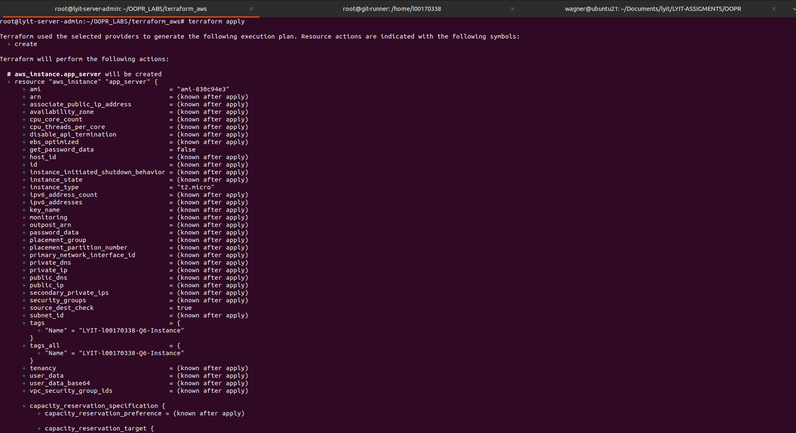  
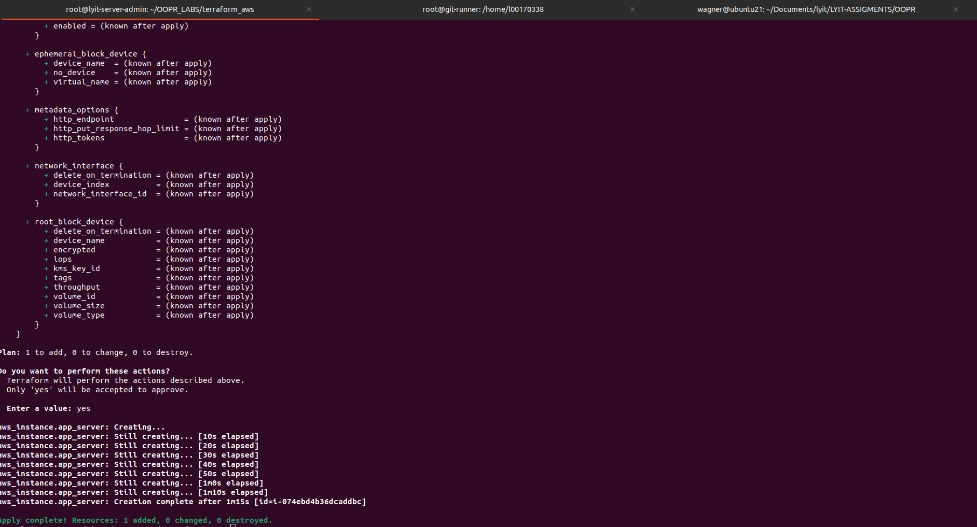

1. AWS instance was deployed correctly through Terraform.

