ATLANTIC TECHNOLOGICAL UNIVERSITY

ASSIGNMENT COVER SHEET

To Be Completed By The Student

Lecturer’s Name: Mrs. Ruth Lennon

Assessment Title: Broken Code Assignment

Submission Date: 25-Nov-2022

Student’s Name: Gourish Biju Id. Number: L00170995____

Course / Stage Master’s in DevOps

Subject/Module: IaC for DevOps Pipelines (2022/23)

Word Limit: Actual Word Count: _________________

I confirm that the work submitted has been produced solely through my own efforts.

Student’s signature: Gourish Biju Date: 25-Nov-2022

|  |
| --- |
| **Note**: **PENALTIES**   * The total marks available for an assessment will be reduced by 15% for work submitted up to one week late. The total marks available are reduced by 30% for work up to two weeks late. * Assessment work received more than two weeks late, without prior approval by the lecturer will receive a mark of zero. * Marks awarded will be reduced by 10 % if submitted work is greater than 10% above or below the assigned word limit. * A further hard or electronic copy of your submitted work may be requested, and therefore you must keep a copy on disc. * Incidents of alleged plagiarism and cheating are dealt with in accordance with the Institute’s Assessment Regulations   **Plagiarism:** Presenting the ideas, words of someone else without proper acknowledgement. Refer to the Institutes’ procedures and guidelines for the assessment of learners. |

DevOps Implementation framework

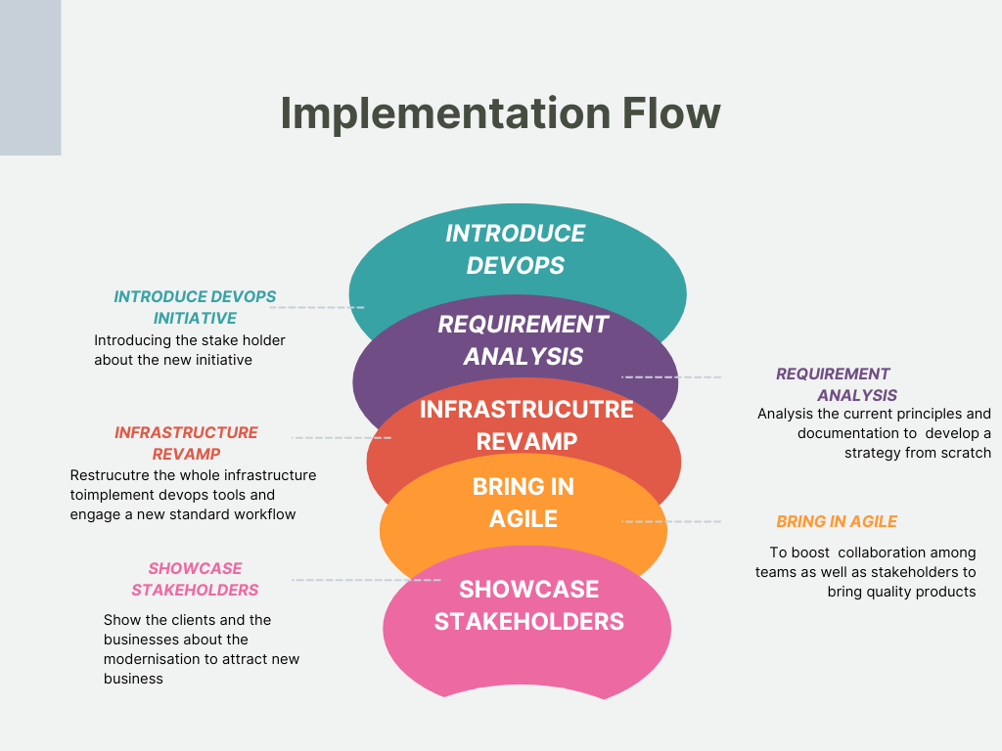

1. **Introducing devops initiatives**

Most of the stakeholders of the company and products we make is mostly known to old technologies. We need to make aware the team of this new initiative and its benefits. We need to understand the stakeholder how we will be benefitted economically and technologically with the implementation of devops . A all-hand meeting can be setup for an interactive Q&A session on this because everybody may not be welcoming the changes in the work. They should know that devops is not about new technology or losing their job rather it’s an adoption of new culture of software development. I can start from my team mate Ren who was working in the old technology for most of his lifetime. If Ren is convinced it can develop a sense of understanding in other stakeholders. This process starts the implememtation of devops in our company.With the meetings and session people can makeup their mind for changes to come and we can start with other processes.

1. **Requirement analysis**

Most of the employee have left because of the economic boom. The product which we produced are outdated. With Ren in the team we can get a clear picture of the existing product and the core principle followed by the company. Ren can give us how the products where developed , which all teams worked for this and the methodology they followed. Even tough the products and older teams doesn’t make any sense, we can use it develop the root of the strategy for modernisation. This could help us implement the new culture slowly which wont cause any chaos inside. Building over the top and refactoring the existing principle wont create a sense of alienation for them .

1. **Infrastructure revamp**

Developing a new infrastructure is an very important factoring in modernising products and services.For Developing a new modern infrastructure we can use IaC concept. We can create a standard infrastructure in AWS or Azure DevOps or many other services available so that it can help with scalability of the company in the future and also its very cost effective method. Over the top we could get security provided by the services itself without incurring extra cost.. With a good infrastructure planning we can implement these resources effectively One of the first things that we would do in a devops infrastructure revamp is to set up a continuous integration and continuous deployment pipeline. This would allow us to automatically push code changes to our servers and keep our infrastructure up-to-date. We would also set up monitoring and logging to help us keep track of our infrastructure and identify any potential issues.A standard workflow will be developed by the time frame so that it can be followed by all employees for all the process. And we would automate as much as possible to make our infrastructure more efficient. Infrastructure will take more time(~3-6 months) as we need to build from the scratch the whole thing. Most of them are new to the structure so training should be given for them to familiarise.

1. **Bring in Agile**

Agile methodology help in smoother and easy implementation of devops. The more beneficial thing about agile in this scenario is that it will help boost the collaboration between team rather developers and testers . Developers and tester should work together devops to function and agile helps in this. Also setting up scrums meeting and sprints allows to keep track of the progress of the projects and helps the stakeholders to be motivated towards the product.Jalen who is exposed to agile methodology while in his studies can conducts scrums and facilitate the transition

Timeframe: Establishing agile to will be a long task. All the employers are following old methods so transition to a new methodology will take time. The complete implementation of will take a lot of time because agile is not just about meetings.

1. **Showcasing the stakeholders**

The purpose a company is built on is business. Only good business will bring in money for the company. With the starting of the modernisation we can showcase ourself to the clients and outside business world that we ae adapting to the new technologies. There may be old trustworthy clients who is still looking to do business with our company but rather backed down because of the older technologies we follow. We can also attract new business for the future. The economic benefits we attain from business helps to develop and invest more into the company. This phase could take a year to be completed because after all the revamps we need to exhibit and prove to the clients we are futureroof.

# Code modernisation and Code review

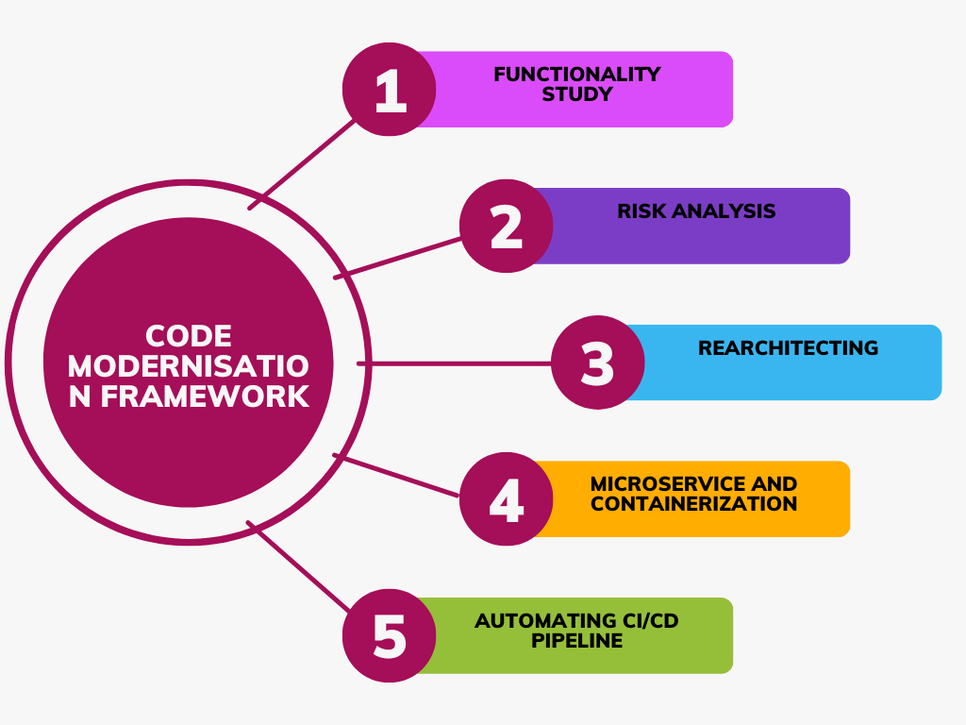

A legacy code is outdated code which still necessary for the company because it contains necessary operation and contains business critical data. On the process of modernising the whole product modernising the legacy code is very important. Legacy code is difficult to maintain which cost money to the company over that its less secure and lack integration with other tools. Security risk is a major factor for considering modernisation. By modernising we are updating its architecture with modern tools and hosting it on a new platform which helps with security , reliability , scalability and ease of improving functionality .First approach towards modernising the legacy code is to analyse the core **functionality of the code**. Ren plays the major role in this because he was there in company for that long .For understanding the code and its function Ren is the guy to approach to. The code here given runs network commands to test if a host is trusted host, then saves it in the array. Next to go with is **Risk analysis** which is very much important on our case because the company was using the code till now. A security analyst help will be needed for this step.We should look out for all the security issues with code.As it is a old code security risks will be high also we need to analyse the after effects when we touch that. Lot of dependencies may be associated with that. After a good report of analysis we can we project the major issues and start with a strategy. Next we need to change the whole **architecture** and build on a new one. PowerShell is OS dependent code will work with only Microsoft’s OS. Modern solutions should be OS independent as users may be using multiple OS.We need to develop a new underlying architecture to enhance the functionalities and capabilities. This will be time consuming process to develop a completely new architecture. Hosting the new code on a modern cloud platform is another step towards modernising. There are many added advantages for using cloud computing such as scalability , agility and major cost cut for the maintenance. Rather than hosting the code in a a server which add cost to the security and maintenance cloud computing help in economic aspects. Modernising the code takes in the future needs and expectation. Technologies are ever evolving so we cant develop anything without addressing future expectation and customer needs. **Microservices** is efficient practise to meet these needs. Microservices basically means splitting up a software into different units with specific functionality. The best method to implement microservice is through containerization. Each service will run in different isolated container thus helping us to work on a single service if needed. Also, since the containers are isolated if offers more security because security vulnerability cannot spread to the whole product. Containers are supported by most of the cloud platforms. Automating the procedure is important part of modernising. Configuring a automated CI/CD pipeline is important. We can track the progress and it will also help with testers and developers with testing of the code and rectify errors on the go. Also automating the tests and build will help save lot of time and can deploy the products with minimal bugs.

# Conclusion

DevOps is a set of principle which facilitates efficient software or application delivery while taking in customer feedback to improve continuously. This whole assignment have concreted the above statement. As many may think DevOps is adapting the most modern technology and automating the process is completely false. DevOps is more of a cultural shift in the process of software development however it needs modern tools and stuff. Customer feedback is the facilitates the delivery of products through DevOps.

While taking the case of Shinty software I could understand how difficult it is to have a cultural shift in software industry. Thinking from point of view of employee who used to work on older technology we could think that it may end of our career because our technology is outdated rather it paves a bridge for collaboration of teams and customer to make the delivery process smooth and efficient. However, implementing devops is a time driven task. All the changes could not be done in a day or two. It may take months to completely restructure everything. Starting small is the key factor here.

I believed that DevOps rely solely on agile methodology. On implementing the devops I could see that devops can be implemented without agile methodology but using agile is more efficient and enhances team collaboration. Agile boosts devops very effectively. Coming to code modernisation we had explore tools and many modern approaches towards automation and infrastructure planning. The task explained the necessity of modernisation and why to be future ready. Technology is ever evolving and the modern technology today maybe outdated next day.Future proofing our products is very much necessary now .We cant predict the tomorrow but we can leave the space and scope for the next thing today. Every approach towards software implememntation should focus on scalabilty and future needs.With devops we can achieve this as devops leverages very much on customer feedback.

# Appendices

Link to github repo: https://github.com/L00170995/DevOps-implementation.git