Implementing Consumer-Driven Contract Testing in a DevOps Pipeline

Priya Joy Kaviyil

M.Sc. in Computing in DevOps 2023



Department of Computing, ATU Donegal, Port Road, Letterkenny, Co. Donegal, Ireland.

Implementing Consumer-Driven Contract Testing in a DevOps Pipeline

Author: Priya Joy Kaviyil

Supervised by: Ruth Lennon

A thesis submitted in partial fulfilment of the requirements for the

Master of Science in Computing in DevOps

Submitted to Atlantic Technological University*Arna chur isteach chuig Ollscoil Teicneolaiochta an Atlantaigh* September 2023

# Declaration

I hereby certify that the material, which l now submit for assessment on the programmes of study leading to the award of Master of Science in Computing in DevOps, is entirely my own work and has not been taken from the work of others except to the extent that such work has been cited and acknowledged within the text of my own work. No portion of the work contained in this thesis has been submitted in support of an application for another degree or qualification to this or any other institution. I understand that it is my responsibility to ensure that I have adhered to ATU’s rules and regulations.

I hereby certify that the material on which I have relied on for the purpose of my assessment is not deemed as personal data under the GDPR Regulations. Personal data is any data from living people that can be identified. Any personal data used for the purpose of my assessment has been pseudonymised and the data set and identifiers are not held by ATU. Alternatively, personal data has been anonymised in line with the Data Protection Commissioners Guidelines on Anonymisation.

I consent that my work will be held for the purposes of education assistance to future students and will be shared on the ATU Donegal (Computing) website (www.lyitcomputing.com) and Research THEA website (https://research.thea.ie/). I understand that documents once uploaded onto the website can be viewed throughout the world and not just in the Ireland. Consent can be withdrawn for the publishing of material online by emailing Thomas Dowling; Head of Department at thomas.dowling@lyit.ie to remove items from the ATU Donegal Computing website and by email emailing Denise McCaul; Systems Librarian at denise.mccaul@lyit.ie to remove items from the Research THEA website. Material will continue to appear in printed formats once published and as websites are public medium, ATU cannot guarantee that the material has not been saved or downloaded.

Signature of Candidate Date

# Acknowledgements

I would like to thank…(write only the week before submission)

# Abstract

Written here is no more than 250 words of summary of the problem, hypothesis and main conclusions. The abstract will entice people to read the rest of the document. Remember that this abstract may also be used as a descriptor for the storage of dissertation as necessary. Write only when all other sections are complete.

(no references in the abstract; strictly 250 words so that it works with the online repository)

# Acronyms

|  |  |  |
| --- | --- | --- |
| Acronym | Definition | Page |
| CDC | Consumer-Driven Contract | 4 |
|  |  |  |
|  |  |  |
|  |  |  |
|  |  |  |

# Table of Contents

1 Declaration iv

2 Acknowledgements v

3 Abstract vi

4 Acronyms vii

5 Table of Contents viii

6 Table of Figures x

7 Table of Tables x

8 Table of Code Listings xi

1. Introduction 1

1.1. Purpose 1

1.2. Background 2

1.3. Problem Statement 3

1.4. Research Question 3

1.5. Scope and Limitations 4

1.6. Report Outline 4

2. Literature Review 5

2.1. DevOps Pipeline 5

2.1.1. Build and Integration Test 6

2.1.2. Continuous Deployment 7

2.2. Microservice 8

2.2.1. Testing Microservices 10

2.2.2. Containerization 10

2.3. Microservice Architecture Enables DevOps 11

2.4. Consumer-Driven Contract Testing 13

2.4.1 Contract Testing in DevOps 16

2.4.2. Testing Frameworks 17

3. Design Introduction 18

3.1. PACT Contract Test Framework 18

3.1.1 PACT Flow 19

3.1.2 Pact Broker and CI/CD integration 20

3.1.3 PACT JVM 20

3.2. Dockerized Pact Broker 21

3.2.1 Docker Compose 22

3.3. Jenkins CI/CDs Pipeline 22

4. Implementation 24

4.1. Some Title with keyword from RQ 25

4.2. Some Title with keyword from RQ 25

4.3. Chapter Conclusions 25

5. Test Strategy, Results and Analysis 26

5.1. Test Strategy 26

5.2. Test Type 1 (Name linked to keyword in RQ/Aims) 27

5.3. Test Type 1 (Name linked to keyword in RQ/Aims) 27

5.4. Chapter Conclusions 27

6. Conclusions 28

6.1. Conclusions on Theoretical Research 28

6.2. Conclusions on Practical Research 28

6.2.1. X Discussion (name linked to keyword 1 in RQ/Aim) 28

6.2.2. X Discussion (name linked to keyword 2 in RQ/Aim) 29

6.2.3. X Discussion (name linked to keyword 3 in RQ/Aim) 29

6.2.4. Some other Technology Example Heading 29

6.3. Limitations 29

6.4. Chapter Conclusions 29

9 References 30

10 Appendices 34

11 Appendix A: Code Listing Location 35

# Table of Figures

Figure 1 Atlantic Technological University Donegal Logo 2

Figure 2 ATU Donegal, Letterkenny 2

# Table of Tables

Table 1. Table Formatting Guidelines 15

Table 2 Second Sample Table 16

# Table of Code Listings

Code Listing 1 MDBean Message Handling 16

# Introduction

Technology is currently witnessing a dual transition, shifting from monolithic architectures to microservice architectures and from traditional software development life cycle (SDLC) practices to DevOps. The two transitions are interconnected as both DevOps and microservice deployment stresses on continuous integration (CI) and continuous deployment (CD). With this industry shift, it is important to ensure the speed of release cycle as well as a reliable deployment for which correct testing is required. The goal of fast and reliable testing pipelines is to be able to release software often and regularly (Nagel n.d.). One testing method that has emerged as a testing method specifically designed for microservices is consumer-driven contract (CDC) testing. Consumer-Driven Contract testing is a methodology that enables the testing of communication between services in an isolated manner (‘Testing Microservices - Contract Tests’ 2023). In this dissertation, we study how integration of contract test framework into the DevOps pipeline by executing them within containers, maximize the effectiveness of continuous testing (CT) in a distributed system. For this we design a DevOps pipeline, that incorporates multiple microservices and leverages containerization technology orchestration and deployment. This design integrates contract testing frameworks, ensuring that the interactions between microservices are thoroughly validated based on defined contracts.

## Purpose

The purpose of this dissertation stems from the growing adoption of microservice architecture and the need to ensure its successful integration within DevOps pipelines. With the increasing complexity of distributed systems, the speed and reliability of software releases have become critical (Nagel n.d.). Consumer-Driven Contract testing offer a promising solution in this regard (‘Testing Microservices - Contract Tests’ 2023). Containers, as lightweight and isolated environments, offer an ideal solution for managing and deploying microservices (‘DevOps for Microservices - Creating Change Together’ 2021). By incorporating consumer-driven contract tests into the DevOps pipeline and executing them within containers, organizations can effectively validate service contracts and identify compatibility issues early on. This approach enables teams to effectively validate service contracts, detect compatibility issues early on, and improve the overall quality and reliability of distributed software systems. This research aims to provide insights and practical guidance on integrating consumer-driven contract tests to DevOps pipeline leveraging containers to enhance integration testing within DevOps practices.

## Background

DevOps represents a transformative shift in how organizations approach software development, deployment, and maintenance, encompassing the entire software development lifecycle (SDLC) as a more collaborative process (Wickramasinghe 2023). A microservice architecture is a software design approach that involves breaking down an application into a distributed collection of loosely coupled services (Dhaduk 2022). Containers provide a standardized and lightweight method for applications to seamlessly transition between environments, containing everything required to run the application within the container object itself. This includes the code, runtime, system tools, libraries, and dependencies (‘Microservices and Containers 101 - Learn all About Microservices’ 2023). Containers offer an efficient approach for deploying microservices, as they provide a consistent and isolated environment for each individual service (‘The Role of Containers in Your Microservice Architecture’ 2021). By combining a microservices framework with containers, organizations can create a highly scalable and distributed system. This combination enables the establishment of continuous integration/continuous delivery (CI/CD) pipelines for applications, facilitating rapid and seamless development, testing, and deployment processes (‘What Are Containerized Microservices? – DreamFactory Software- Blog’ 2023). Meanwhile, when dealing with microservices, the testing process becomes more complex due to the crucial role of communication within a microservice architecture. Fortunately, there is a solution in the form of consumer-driven contract testing, which addresses the challenges specific to microservices testing. Consumer-Driven Contract testing is an approach used to verify integrations between services, where a crucial aspect is the establishment of a contract between the consumer (an application or service) and the provider (another service) when the consumer utilizes the API provided by the provider. (Lehvä 2019). There are two popular frameworks for the contract test — Spring Cloud Contract (SCC) and PACT that provide a way for contract definition and automate the test process (Fong 2022). A blend of these emerging technologies, including DevOps practices, microservices, containerization, and contract testing can have a significant impact on enabling fast and reliable software product releases (‘DevOps for Microservices - Creating Change Together’ 2021). By leveraging these technologies together, organizations can achieve enhanced scalability and maintainability in their software development and deployment processes. This integrated approach facilitates quicker iterations, smoother collaboration between teams, efficient resource utilization, and robust validation of microservice interactions, ultimately leading to accelerated and more dependable software releases.

## Problem Statement

With the rise of microservice architecture and the increasing emphasis on continuous delivery, there is a demand for ensuring the quality and reliability of software systems (‘How Contract Tests Improve the Quality of Your Distributed Systems’ 2023). However, traditional testing approaches often struggle to keep up with the speed and complexity of microservices.

The problem statement is:

Testing microservice components within a DevOps pipeline, validating the interaction between client and server, lacks a comprehensive approach that goes beyond unit testing. By implementing contract testing framework, consumers can define their expectations through contracts, enabling effective integration testing.

The objective of this dissertation is to effectively implement contract testing framework in DevOps pipeline, enabling organizations to validate service contracts, detect compatibility issues early on, and ensure the smooth and reliable deployment of microservices.

## Research Question

The research question considered in this research is:

How does the integration of contract testing frameworks, within a Container-based DevOps pipeline enhance the validation of microservice interactions?

In order to answer this research question three aims were identified. They are:

1. To explore and evaluate the viability with integration of contract testing frameworks within the designed DevOps pipeline.
2. To explore how validation of microservice interactions within containers can be carried out based on defined contracts
3. To assess the effectiveness and benefits of integrating consumer-driven contract testing within containers in terms of enhancing the quality, speed and reliability of microservice-based systems within the DevOps pipeline.

## Scope and Limitations

Outline what is or is not covered and why. This is just a short paragraph.

## Report Outline

The thesis includes a comprehensive literature review in chapter 2, which examines the relevant research on DevOps Pipeline, Microservices and Consumer-Driven Contract (CDC) Testing. Chapters 3 and 4 focus on the design and implementation of a Container-based DevOps pipeline that incorporates contract testing frameworks. These chapters address the research question that was introduced in chapter 1. Finally, in chapter 6, the thesis concludes by discussing the implemented solution's architecture and suggesting future areas of research and development in this domain.

# Literature Review

In this literature review, the initial research lies on the DevOps pipeline and microservices, with a detailed exploration of key aspects such as build and integration testing, deployment, and containerization. Furthermore, the study investigates how the adoption of microservice architecture facilitates the implementation of a DevOps pipeline. Finally, it examines the emergence of Consumer Driven Contract (CDC) testing and its significance within the context of microservices and CI/CD pipeline. The subsequent focus of this dissertation is to assess the effectiveness of integrating the CDC framework into the DevOps pipeline.

## DevOps Pipeline

DevOps encompasses a collection of methodologies designed to minimize the duration between making modifications to a system and deploying those changes to the production environment (Balalaie et al. 2016). DevOps places a significant emphasis on ensuring the quality of software, encompassing both the code itself and the delivery process. Any approach or technique that supports these objectives can be classified as a DevOps practice (Bass et al. 2015; Brunnert et al. 2015). Like agile methodologies, DevOps breaks down software applications into discrete components or modules to enhance processing speed and enhance overall quality (Amrit et al. n.d.). DevOps places emphasis on achieving specific objectives rather than prescribing specific methods. The primary aim of DevOps practices as mentioned before is to minimize the time elapsed between making a change to a system and incorporating that change into the production environment. The longer it takes for a release to reach the market, the fewer benefits can be gained from the new features or quality enhancements introduced in that release. The ideal approach is to have a continuous release cycle enabled by DevOps practices, commonly referred to as continuous delivery or continuous deployment (Bass et al. 2015). However, to ensure the continuous delivery of reliable and high-quality software, software testing is a crucial aspect and its integration into DevOps pipeline is essential. This dissertation specifically concentrates on incorporating microservices and Consumer-Driven Contract (CDC) test frameworks into the pipeline to test the interactions among microservices. By including these testing frameworks, the aim is to enhance the overall testing process and ensure effective validation of the microservices within the DevOps pipeline.

### 2.1.1. Build and Integration Test

The build process involves creating an executable artifact by using input such as source code and configuration to generate a deployable output (Bass *et al.* 2015). Continuous integration (CI) servers are responsible for performing the build and integration tests. After the build is finished, a series of automated tests are conducted to verify if the integration with other parts of the system exposes any errors (Bass *et al.* 2015; Jokinen 2020). This step is known as integration testing, where the constructed executable artifact is thoroughly tested.

Testing plays a crucial role in the success of a DevOps pipeline, as it directly impacts the achievement of desired outcomes. According to Agrawal and Rawat (Agrawal and Rawat 2019) expertise in testing process is the key factor that contribute to the advancement of continuous integration, continuous delivery, and continuous deployment. These testing practices are instrumental in ensuring the smooth and reliable functioning of the DevOps pipeline.

Continuous testing is a valuable practice that helps to identify integration issues at earlier stages in the software development life cycle. Continuous testing involves early and frequent testing at various stages, incorporating it throughout the software development life cycle, and automating the testing process (Agrawal and Rawat 2019). By integrating testing throughout the process, defects and issues can be detected and resolved more efficiently and cost-effectively. This approach also allows testers to allocate their time more effectively, as continuous testing reduces the need for repetitive and time-consuming manual testing (Angara *et al.* 2018).

Continuous testing (CT) faces a significant challenge in dealing with heterogeneous environments that do not completely mirror the production environment and application architecture (Agrawal and Rawat 2019). This discrepancy between the testing environment and the actual production environment can lead to potential issues and limitations in accurately assessing the performance and behaviour of the software. It becomes crucial to address this challenge by striving to create test environments that closely resemble the production environment, incorporating similar infrastructure, configurations, and architectural components. By minimizing the disparities between the testing and production environments, organizations can improve the effectiveness and reliability of continuous testing processes.

As teams release updates at varying speeds, the testing team faces the challenge of planning robust end-to-end testing, especially in case of microservices where services depend on different interconnected services. Moreover, running a complete production-like cluster for testing purposes can be expensive, making it impractical for each team to have its own full-scale cluster solely for testing (Amrit *et al.* n.d.). Therefore, it is necessary to find alternative solutions to simulate the production environment effectively and conduct comprehensive testing while optimizing resource utilization.

In order to address the discrepancy between testing environments and production environments in microservice-based DevOps pipelines, various approaches are being employed. One such approach is the use of Consumer-Driven Contract (CDC) test frameworks which enable the execution of isolated integration tests for microservices (Fischer 2021). These frameworks facilitate testing interactions between microservices in a controlled manner, ensuring that each microservice behaves correctly based on the contracts defined by its consumers. The dissertation will thoroughly analyse and assess the benefits, challenges, and potential impact of adopting CDC test frameworks on the testing practices within the DevOps pipeline.

### 2.1.2. Continuous Deployment

Continuous deployment is a software development strategy that involves the direct deployment of new code or changes to the production environment, following a series of comprehensive automated tests (Oberoi 2023). This approach ensures a rapid and seamless delivery of updates to the production environment. In fact, the primary objective of the DevOps CI/CD pipeline is to accelerate software delivery, enabling more frequent and rapid releases. Continuous Testing is indeed a crucial aspect of implementing Continuous Deployment, as stated by Oberoi (Oberoi 2023). Organizations are adopting continuous delivery and deployment in response to dynamic business requirements and increased market competition (Victor 2023). DevOps revolutionizes the software development and delivery landscape, enabling organizations to keep up with the demands of today's fast-paced market (‘10 Best Deployment Tools for DevOps in 2023’ 2023). Thus, DevOps enables organizations to evolve and produce products at a faster pace while maintaining superior quality compared to traditional infrastructure management processes and traditional software development approaches.

Numerous tools are available for managing deployments in the software development process. The advent of lightweight containers and image management tools has greatly facilitated the deployment process for developers, particularly in creating small-scale production-like environments for testing purposes (Bass *et al.* 2015). These tools provide efficient means to package applications and their dependencies into portable containers or images, enabling easy deployment and reproducibility across different environments.

Containers are a popular approach used in software development, packaging, and deployment (Pahl 2015). Containers encapsulate all the necessary components, including the application code, runtime environment, libraries, and system tools, into a single, portable unit (‘What is a Container Deployment? | VMware Glossary’ 2023). With the use of containers and image management tools, developers can swiftly set up isolated testing environments that closely resemble production, allowing for comprehensive testing and validation of software changes before deploying them to the actual production environment.

## Microservice

The architecture of cloud computing has undergone significant transformation, transitioning from a monolithic structure to a more agile and scalable microservices approach (Saboor *et al.* 2022). Over the past few years, cloud platforms such as Amazon, Microsoft, and IBM have become increasingly popular among companies as the preferred method for delivering and operating modern applications (Cito *et al.* 2015). They have gained mainstream adoption as companies recognize the benefits and advantages these platforms offer (Keni and Kak 2020). The Microservices Architecture (MSA) has gained relevance in recent years as an architectural style that allows organizations to harness the benefits of cloud computing(Mazlami *et al.* 2017). According to the International Data Corporation's forecast, by 2021, the majority of application development on cloud platforms is expected to utilize microservices, accounting for approximately 80 percent of the total (Larrucea *et al.* 2018). Companies such as Netflix, Twitter, eBay, Amazon, Hailo, Groupon, and Zalando have adopted cloud-based microservices architecture within their operations (Saboor *et al.* 2022).

Netflix, being at the forefront, was among the early adopters of Microservices Architecture (MSA) when it transitioned its system from a monolithic architecture. Currently, Netflix's platform has evolved into an extensive system comprising hundreds of microservices (*Microservices at Netflix Scale: Principles, Tradeoffs & Lessons Learned • R. Meshenberg • GOTO 2016* 2016). Uber, renowned for its ride-sharing service, has developed a platform consisting of approximately 2,200 microservices (Gluck 2020). This extensive system of microservices powers the various functionalities and operations of the Uber platform.

In the past, large companies like Amazon and eBay relied on the traditional approach of Monolithic Architecture (MA) for software development, which has since been surpassed by the microservices (De Lauretis 2019). In a Monolithic Architecture (MA), all functions are contained within a single application. While monolithic applications have advantages, such as ease of development, testing, and deployment for simpler applications, they pose challenges when the complexity of the application grows (‘From Monolith to Microservices: A Dataflow-Driven Approach | IEEE Conference Publication | IEEE Xplore’ 2023).

In applications based on Microservices Architecture (MSA), the system is divided into small and independent microservices (Lewis and Fowler 2023). In a microservices architecture, the individual services are designed to be loosely coupled and they communicate with each other through platform-independent interfaces, enabling flexibility and interoperability within the architecture (Zimmermann 2016). As a result, the individual microservices within a microservices architecture can be developed, tested, and deployed independently of each other (Newman 2018; Fischer 2021) which enables faster deployment of new features or bug fixes, as only the relevant microservices need to be deployed or updated. And, for each service most of the testing, packaging, and deployment tasks can be automated(‘The Role of Containers in Your Microservice Architecture’ 2021). Each service has the ability to be deployed independently on different platforms and technology stacks. It runs as a separate process and communicates with other services using lightweight communication mechanisms like RESTful (Representational State Transfer) APIs (Balalaie *et al.* 2016).

### 2.2.1. Testing Microservices

To be integrated into the actual system, individual microservices need to establish interactions with each other using either synchronous or asynchronous messaging protocols. Validating the proper functioning of these interactions is crucial, and integration testing plays a vital role in this process. Integration testing involves testing the collaboration and data exchange between different microservices to ensure they work correctly as a cohesive system (Fischer 2021).

However, integration testing is often highlighted as one of the significant challenges in Microservices Architecture (MSA)-based applications due to its distributed nature and the complexity that arises from coordinating and validating their interactions (Soldani *et al.* 2018; Waseem *et al.* 2020).Also, the need to run tests in isolation without dependent services while accurately validating the interactions with those services is a challenge. To overcome this, various approaches are currently employed to reconcile this discrepancy and enable effective integration testing in Microservices Architecture (MSA)-based applications. To address the challenge, the application of Consumer Driven Contract (CDC) testing practice can help mitigate the issue. CDC testing framework enables a more effective approach to integration testing, alleviating the problem at hand (Fischer 2021).

### 2.2.2. Containerization

Deploying microservices in the development environment can present challenges. Despite having the application code isolated into separate services, developers still need to deploy the dependent services alongside the isolated services to run them on their local machines(Balalaie *et al.* 2016). As companies continue to produce an increasing number of microservices, the deployment environment becomes more complex. Without proper configuration and management, a roadmap of microservices can quickly become unmaintainable (Amrit *et al.* n.d.).

Containerization is a concept that enhances and complements microservices-based models in addressing the challenges of deployment and management (Amrit *et al.* n.d.). Containerization is a virtualization technique that aims to achieve efficient resource isolation by sharing the kernel with the host operating system, allowing for lightweight and efficient encapsulation of applications and their dependencies within containers (Pahl 2015). By encapsulating microservices and their dependencies into containers, containerization provides a standardized and portable environment that simplifies deployment, scalability, and maintenance of microservices-based systems (Singh and Singh 2016; Keni and Kak 2020). Microservices bundled into containers can be deployed on physical hardware, ensuring a consistent software execution environment that remains consistent from the developer's environment to the end consumer's system (Keni and Kak 2020).

The emergence of lightweight containers has facilitated developers in deploying their applications into small-scale production-like environments more effortlessly, primarily for testing purposes. These technologies streamline the process of creating reproducible and isolated testing environments, enabling developers to validate their applications in conditions that closely resemble production settings (Bass *et al.* 2015).

## Microservice Architecture Enables DevOps

DevOps is a cultural approach that integrates updated methodologies, procedures, team dynamics, and tools to optimize an organization's capacity to swiftly deliver applications and services (Mueller, 2018; Sánchez-Gordón and ColomoPalacios, 2018). In fact, DevOps can serve as a process framework that can be utilized for the development, deployment, and management of Microservices Architecture (MSA) (Larrucea *et al.* 2018). The combination of microservices and DevOps facilitates the coexistence of various benefits, including reusability, decentralized data governance, automation, and inherent scalability (Balalaie et al., 2016).

MSA and DevOps share numerous common characteristics, making them highly compatible with each other. Both MSA and DevOps emphasize the concept of breaking down complex problems into smaller components and addressing them through small cross-functional teams (Watts, 2020). DevOps provides continuous integration and deployment, enabling containerized microservices to operate independently and autonomously. While it is not mandatory to adopt Microservices Architecture (MSA) when implementing DevOps, utilizing MSA can effectively address many challenges that arise in the context of DevOps. (Bass et al., 2015). Also, though DevOps can be applied to monolithic software systems as well, but microservices provide an effective environment for implementing DevOps practices by emphasizing the significance of small teams (Balalaie *et al.* 2016).

Indeed, the structure of microservices emerged as a result of the widespread adoption of DevOps principles, which originated from pioneering companies like Amazon, Facebook, Google, Netflix, and SoundCloud (Amrit *et al.* n.d.). By utilizing microservices, DevOps teams gain the ability to develop independent features concurrently. Instead of following a sequential handoff process (e.g., from development to testing to production), cross-functional teams collaboratively build, test, release, monitor, and maintain applications together. This promotes parallel development and efficient collaboration within the DevOps workflow (Amrit *et al.* n.d.). Therefore the popularity of Microservices Architecture (MSA) in the industry has been driven by its numerous advantages, including enhanced availability, flexibility, scalability, loose coupling, and the ability to achieve high velocity in software development and deployment (Hasselbring and Steinacker 2017) .

According to the International Data Corporation (‘IDC: The premier global market intelligence firm.’ 2023), it was projected that by the end of 2021, approximately 80% of cloud-based applications would be developed using Microservices Architecture (MSA) (Larrucea *et al.* 2018). Also, it was predicted that the global DevOps market would reach a value of $5.6 billion in 2021 (Elliot et al., 2018)(‘IDC: The premier global market intelligence firm.’ 2023). According to Google Trends data (Balalaie et al. 2016), both DevOps and microservices have exhibited similar growth rates since 2014, indicating their increasing popularity and adoption within the technology landscape. Another report, authored by (Yousif 2016), highlights that organizations adopt MSA for various reasons, including gaining agility (82%), improving organizational performance (57%), and achieving scalability (78%). The report also indicates that 47% of organizations implemented MSA as a result of their motivation to embrace DevOps (‘Lightstep’ 2018).

For ensuring fast and reliable delivery of microservices through DevOps, the (CI)/(CD) pipeline has to be of high quality and efficiency. In order to fully leverage the advantageous aspect of microservices in DevOps, it is essential to have expedited testing processes. The introduction of microservices in architecture significantly increases the number of accessible interfaces. Since the majority, if not all, of the communication between microservices depends on these interfaces, it presents a new challenge in testing (Nagel n.d.). It is essential to ensure reliable and efficient testing of these interfaces within the DevOps pipeline. Fortunately, there is a pattern available to address this challenge, it is contract testing. In this dissertation, we will examine the effectiveness of integrating contract testing frameworks into the pipeline to enhance efficiency of testing the microservice interfaces.

## Consumer-Driven Contract Testing

Testing plays a crucial role in identifying faults within MSA based systems by uncovering issues that may arise from dependencies between various services. Moreover, these tests need to accurately assess the correctness of interactions with those specific services. An important topic of discussion in microservices architectures (MSAs) revolves around the granularity of services, which often vary in their levels of abstraction (Newman 2019). Different test types in microservices architectures (MSAs) reflect the varying granularity of tests (Vocke 2023). Microservices' individuality, as highlighted by Lewis and Fowler (Lewis and Fowler 2023), necessitates the inclusion of unit tests within the software development lifecycle, as emphasized by Newman (Newman 2019). However, the broader architectural scope of microservices also encompasses other types of tests, such as integration tests, as discussed by Waseem, Liang, and Shahin (Waseem *et al.* 2020). Integration-level, component-level, and system-level testing are essential for validating the interactions of individual microservices and ensuring their seamless integration into the overall system. According to a study (‘Design, monitoring, and testing of microservices systems: The practitioners’ perspective’ 2021), the ability to write effective integration test cases is considered the most crucial skill for adequately testing microservices. End-to-end testing in Microservices-Based Architectures (MSAs) can be challenging due to the decentralized nature of the system and the independent release cycles of different teams. In addition, due to the high cost associated with running a full-scale production cluster, it is often impractical for each team to maintain their own dedicated cluster solely for testing purposes (Amrit *et al.* n.d.).

A recent publication titled "Testing Strategies in a Microservice Architecture" (‘Testing Strategies in a Microservice Architecture’ 2023), states that among various approaches being employed to address this challenge, the use of Consumer-Driven Contract (CDC) testing is considered a potential solution to overcome the challenges associated with integration testing. A substantial number of researches has concluded that CDC testing is the ideal choice for testing microservices (Dai *et al.* 2007; Lehvä *et al.* 2019; Waseem *et al.* 2020; Fischer 2021; Ayas *et al.* 2022; Wu *et al.* 2022; Vocke 2023; Nagel n.d.; Nyman n.d.; Selleby n.d.).

The book DevOps a software architect’s perspective (Bass *et al.* 2015), states that proper implementation of Consumer-Driven Contract (CDC) testing can result in a high level of confidence in the microservice, reducing the need for extensive end-to-end test cases. CDC testing serves as a coordination method and influences the composition and evolution of user stories within a microservice over time. Both consumers and microservice developers collaboratively create and take ownership of the user stories. The definition of CDC becomes a function of how functionality is allocated to the microservice, managed by the service owner as part of the coordination that defines the next iteration. As a result, CDC does not impede the progress of the current iteration.

In a case study conducted by (Lehvä 2019) on an industrial system, the application of Consumer-Driven Contract (CDC) testing revealed several benefits. These advantages encompassed isolated integration testing, enhanced communication between teams, increased flexibility for providers to accommodate consumer needs, and efficient detection of breaking changes in the API. Moreover, the study suggested that CDC tests have the potential to replace traditional integration tests, as they successfully captured all defects arising from the implemented integrations. Based on these findings, it can be concluded that consumer-driven contract testing is a valuable addition to testing strategies, particularly for integration-heavy systems, especially those based on microservices.

In his thesis paper titled "Analysis of Consumer-driven contract tests with asynchronous communication between microservices," Florian Nagel (Nagel n.d.) asserts that Consumer-Driven Contract (CDC) testing provides faster execution and yields reliable results, often detecting errors before the need for extensive end-to-end tests. As a consequence, the reliance on end-to-end tests can be reduced in the testing pipeline, thereby diminishing their intensity and necessity. The implementation of fast and dependable testing pipelines enables frequent and regular software releases, leading to an efficient DevOps pipeline.

Consumer-Driven Contract (CDC) testing is a testing method that verifies the integrations between services and ensures their continued functionality following the introduction of new changes to the system (‘Consumer-Driven Contracts: A Service Evolution Pattern’ 2023). the main concept of Consumer-Driven Contract (CDC) testing is that when an application or service (referred to as the consumer) utilizes an API offered by another service (known as the provider), a contract is established between them (Lehvä *et al.* 2019). The contract encompasses details on how the consumer interacts with the provider, including the specific method of invocation and the data utilized from the responses received. Within the contract, the consumer expresses its expectations to the provider, who subsequently confirms its capability to meet these expectations. Once confirmed, these expectations become binding and form a contractual agreement between the consumer and the provider (Fischer 2021; Ayas *et al.* 2022). Both parties can access the contract which facilitates independent testing.

Through testing against these contracts, the verification process ensures that the consumer and the provider can seamlessly integrate and effectively communicate with each other (‘Testing Microservices - Contract Tests’ 2023). Any changes made to the contract must be effectively communicated between all parties involved (Bass *et al.* 2015; Vocke 2023). CDC tests can extend beyond the scope of individual services as they necessitate communication and collaboration between the teams responsible for the interacting microservices. However, the actual testing itself can be conducted in isolation, focusing on the specific interactions between the consumer and provider without requiring the simultaneous involvement of all microservices(Fischer 2021). When both parties adhere to the contract, they can utilize it as a foundation to verify their respective sides of the integration process. The consumer can employ the contract to create mocks or simulate the behaviour of the provider during their own testing procedures (Lehvä *et al.* 2019). This ensures that the consumer's tests align with the expected behaviour defined by the contract, promoting effective integration verification. On the other hand, the provider can utilize the contract to replay the consumer's requests against its API (Lehvä *et al.* 2019). By doing so, the provider can validate that its API implementation correctly handles the expected requests defined in the contract. This helps ensure that the provider's side of the integration functions as intended and aligns with the agreed-upon contract specifications.

However, it is important to note that CDC tests do not specifically target testing the functionality or business logic of the individual services (Fischer 2021). Instead, their primary focus is on verifying the communication and interaction between the services involved. CDC tests aim to ensure that the consumer and provider can effectively communicate and exchange data according to the contract, rather than validating the internal workings or specific functionalities of each service in isolation.

### 2.4.1 Contract Testing in DevOps

According to a recent study on testing approaches for CI/CD Pipelines (‘Effective Test Automation Approaches for Modern CI/CD Pipelines’ 2023), the increasing popularity of CI/CD has brought about a significant transformation in the field of software testing. Developers now require fast feedback from pipelines to determine the success of their software updates. In order to adapt to this significant change and ensure the delivery of high-quality automated tests, the study proposes several solutions, one of which involves the use of mocks and stubs whenever feasible. To achieve more dependable test results, as well as gain better control over testing efforts and enhance coverage, the recommended approach is to incorporate mocking into the test framework and rely on stubs to intercept complex data patterns instead of relying solely on external functions. This makes CDC testing frameworks a vital suite for modern CI/CD pipelines.

Lastminute.com has recently implemented contract tests to address challenges associated with system-level integration tests, aiming to enhance the feedback cycle and development process. Similarly, eBay is utilizing contract testing to facilitate the safe evolution of their internal APIs and cater to the requirements of client teams. (‘eBay and lastminute.com Adopt Contract Testing to Drive Architecture Evolution’ 2023). Lastminute.com experienced a significant positive impact on their microservice architecture and delivery process by adopting contract tests, resulting in a substantial reduction in test-execution times compared to traditional system-level tests. eBay utilizes contract testing to validate integration points within their platform, facilitating collaborative efforts and ensuring the smooth evolution of internal APIs without compatibility issues.

### 2.4.2. Testing Frameworks

There are two prominent frameworks – PACT and Spring Cloud. ……..

In this literature survey, we have encountered compelling evidence showcasing the effectiveness of CDC as the optimal testing strategy for microservices. The seamless integration of DevOps and microservices has further reinforced the importance of CDC. Additionally, various studies have highlighted the pressing need for efficient testing frameworks in modern CI/CD DevOps pipelines. In this dissertation paper, our aim is to adopt the CDC testing framework within a DevOps pipeline and investigate the deployment of reliable distributed software with enhanced efficiency.

# Design Introduction

The system design adopts a simplified pipeline methodology using Jenkins for CI/CD workflows. The pipeline integrates the Pact contract test framework, Pact Broker for centralized contract management, and Docker Compose for containerized test environments. The main goal of this design is to create the Pact contract test framework, Pact Broker, and Docker Compose and integrate these within the Jenkins CI/CD workflow. The pipeline automates contract tests, generates detailed test reports, and leverages Docker Compose to create isolated and reproducible test environments.

Insert image…**

## 3.1. PACT Contract Test Framework

Pact is a code-first tool designed for testing HTTP and message integrations through contract tests (‘Introduction | Pact Docs’ 2022). These contract tests are employed to verify that the inter-application messages adhere to a mutually agreed-upon understanding documented in a contract.

Before deploying an application to production, it is crucial to ensure its seamless interaction with other integrated applications. Traditionally, this is achieved by running integration tests with "live" deployed applications. While these tests provide confidence for a successful release, they also come with certain drawbacks. Integration tests introduce dependencies, leading to potential complexities, slower feedback cycles, higher susceptibility to breaking, and increased maintenance efforts.

When employing isolated tests, we test each side of an integration point by using simulated versions of the other applications involved. This approach results in two separate sets of tests that run independently, providing rapid feedback, stability, and ease of maintenance. However, the drawback is that these tests do not offer the confidence needed for a release. The reason being that there is no guarantee that the behaviour of the simulated applications accurately reflects that of the real ones.

### 3.1.1 PACT Flow

Pact effectively addresses the challenge of synchronizing two sets of tests by utilizing a "contract" known as the “pact." This contract acts as a mutual agreement between the consumer and the provider. During the consumer tests, every request sent to a Pact mock provider is recorded into the contract file, along with the expected response for each request. After creating a Pact, a simulated consumer replays each request made against the actual provider and then compares the real responses with the expected ones. This verification process ensures that the behaviour of the simulated applications aligns with that of the real applications. When the actual and expected responses match, it confirms that the simulated applications behave identically to the real ones. Consequently, Pact helps ensure that integration between the applications functions reliably and as intended in the production environment.

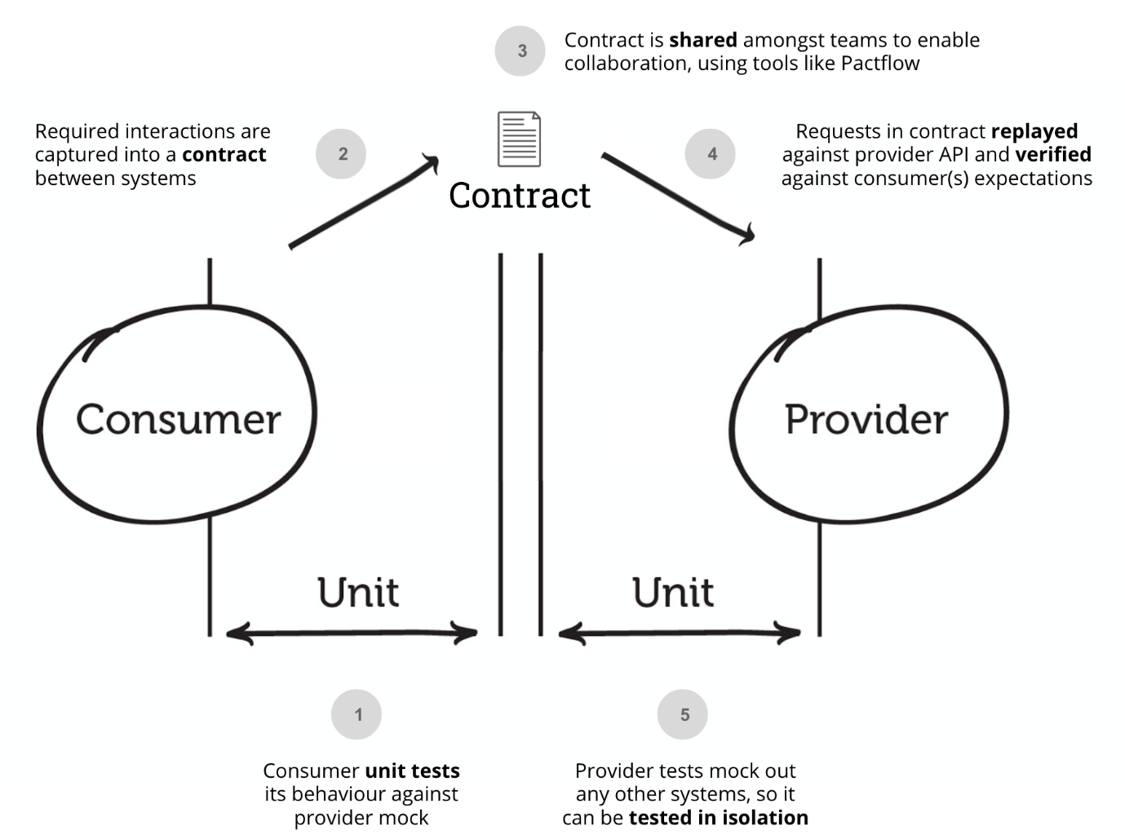

Insert your image….

Thus, Pact provides a powerful testing solution that offers numerous benefits for integration testing. The use of contracts ensures that tests run independently, reducing dependencies and complexities. Swift feedback is achieved through rapid verification of simulated requests against real providers, enabling prompt issue detection. The stability of tests is enhanced by comparing actual responses with expected ones, minimizing false positives and negatives. The clear and well-documented contracts facilitate easy maintenance, simplifying future updates and modifications. Pact instils confidence in the release process by guaranteeing that the simulated applications behave identically to their real counterparts, ensuring seamless communication and reliable integration in real-life scenarios.

### 3.1.2 Pact Broker and CI/CD integration

Once contract tests are established, an efficient process for managing contract testing becomes essential, and this is where the Pact Broker comes to picture. The Pact Broker is a tool designed for sharing consumer-driven contracts and verification results among different applications (Thirion 2019). The Pact Broker streamlines contract testing by enabling teams to share and collaborate on contracts, manage them across branches and environments, orchestrate builds for safe deployment, and seamlessly integrate into existing processes and tooling (‘Sharing Pacts with the Pact Broker | Pact Docs’ 2023). It serves as a central hub for efficient contract management, ensuring reliable integrations throughout the development and deployment lifecycle. Therefore, Pact Broker facilitates integration and automation of contract testing within your CI/CD release pipelines.

### 3.1.3 PACT JVM

(‘pact-foundation/pact-workshop-jvm-spring: Example Spring Boot project for the Pact workshop’ 2023)

(‘Overview | Pact Docs’ 2021)

(‘README | Pact Docs’ 2023)

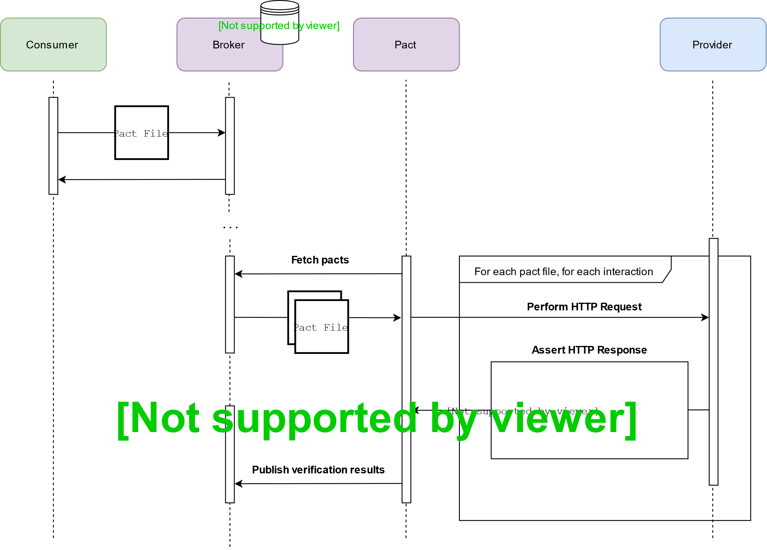

## 3.2. Dockerized Pact Broker

Docker is a software platform that expedites the building, testing, and deployment of applications by packaging them into standardized units called containers (‘What is Docker? | AWS’ 2023). These containers encapsulate all the essential components, such as libraries, system tools, code, and runtime, required for the software to run smoothly. With Docker, deploying and scaling applications in various environments becomes swift and dependable, ensuring the seamless execution of your code.

Docker operates by offering a standardized approach to execute your code. Acting as an operating system for containers, it enables the virtualization of a server's operating system, just as a virtual machine virtualizes server hardware, eliminating the need for direct management. Once Docker is installed on each server, it provides straightforward commands to build, start, or stop containers, streamlining the process of managing and running applications within isolated and portable environments.

(‘Dockerized Pact Broker | Pact Docs’ 2023)

### 3.2.1 Docker Compose

Compose is a powerful tool designed for defining and running multi-container Docker application that uses a YAML file to effortlessly configure your application's services. With a single command, you can then create and initiate all the services based on your specified configuration, simplifying the process of managing and launching multiple containers in a coordinated manner.

Compose can operate in various environments, including production, staging, development, testing, and CI workflows. It empowers users with a comprehensive set of commands to manage the entire lifecycle of their applications. These commands enable users to effortlessly start, stop, and rebuild services as needed. The tool also provides an easy way to view the status of running services and stream the log output in real-time.

A Dockerized Pact Broker refers to an instance of the Pact Broker application that is packaged and distributed as a Docker container. As mentioned, Pact Broker is the tool used for sharing consumer-driven contracts and verification results among different applications, facilitating seamless contract testing and integration management. Dockerizing the Pact Broker allows users to encapsulate the application and its dependencies within a Docker container, making it easy to deploy and run the Pact Broker in any environment that supports Docker. This approach ensures consistency and portability, as the containerized Pact Broker can be deployed across various systems with minimal setup and configuration, providing a reliable and efficient solution for managing contracts and verification results in a containerized environment. Also, Pact Broker is packaged as a Docker container allows it to be easily integrated into the CI/CD pipeline.

## 3.3. Jenkins CI/CDs Pipeline

Jenkins is a self-contained and open-source automation server that empowers users to automate a wide range of tasks associated with building, testing, delivering, and deploying software (‘Jenkins User Documentation’ 2023). Jenkins Pipeline is a collection of plugins that enables the implementation and integration of continuous delivery pipelines within the Jenkins automation server. These plugins provide robust support for defining and managing complex, end-to-end delivery pipelines, streamlining the process of building, testing, and deploying software in a continuous and automated manner.

The integration of the Pact Broker with Jenkins allows for seamless management of consumer-driven contracts and verification results within the Jenkins automation server. By leveraging plugins and scripts, Jenkins can interact with the Pact Broker to achieve various tasks related to contract testing and deployment.

The integration typically involves the following steps:

1. **Publishing Pacts**: During the CI/CD process, the consumer applications generate Pact files containing the contract information. These files are then published to the Pact Broker, making them available for other applications to use.
2. **Verification**: Once the Pact files are published, Jenkins can trigger the verification process. The provider applications fetch the relevant Pacts from the Pact Broker and execute contract tests against them to ensure compliance with the specified contracts.
3. **Reporting:** The results of the verification process can be captured and reported by Jenkins, allowing the team to monitor contract compliance and identify any issues that need attention.
4. **Integration with CI/CD Pipelines:** Pact Broker integration can be seamlessly incorporated into Jenkins CI/CD pipelines, ensuring that contract testing is an integral part of the development and deployment workflow.

By integrating the Pact Broker with Jenkins, teams can ensure that their applications adhere to the agreed-upon contracts, promoting better collaboration between teams and enhancing the reliability and confidence of application releases

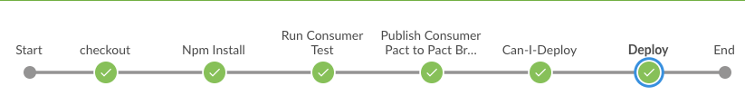

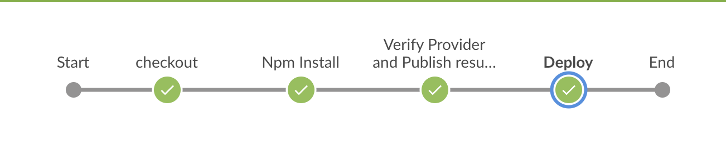

# Implementation

The implementation chapter may describe a case study, interviews, observations, combinations of technologies or code structure depending on the type of dissertation you wish to carry out.

The implementation should be presented succinctly. Clearly define how the system/algorithm/process works in practice showing the most important parts and how they relate to each other. Describe your specific contribution making it clear what is yours and what api’s you used from elsewhere.

Show snips of code/configuration/questionnaire or similar. This may include screengrabs of your implementation if a software or hardware artifact is involved. Relate the implementation elements to the sections described in the literature survey. Be very careful to end each second level heading with a statement showing how the section relates to the research question.

## Some Title with keyword from RQ

Some text.

## Some Title with keyword from RQ

Some text.

## Chapter Conclusions

Provide specific conclusions relating back to key words mentioned in the research questions and in the individual aims.

# Test Strategy, Results and Analysis

Test strategy and how it aligns to the problem statement and hypothesis should be provided. This can be integrated with the results chapter or can be separate. This depends on the type of dissertation. Results can be quantitative or qualitative. Discuss this using appropriate, high level terminology.

Results of tests carried out should be presented. Where extensive testing is carried out the majority of the results should be moved to the appendix. Each graph should include values on the axes and should be appropriately labelled. All graphs/tables must be referred to and explained within the main text. Refer to all graphs in the main text. See Figure 5.1

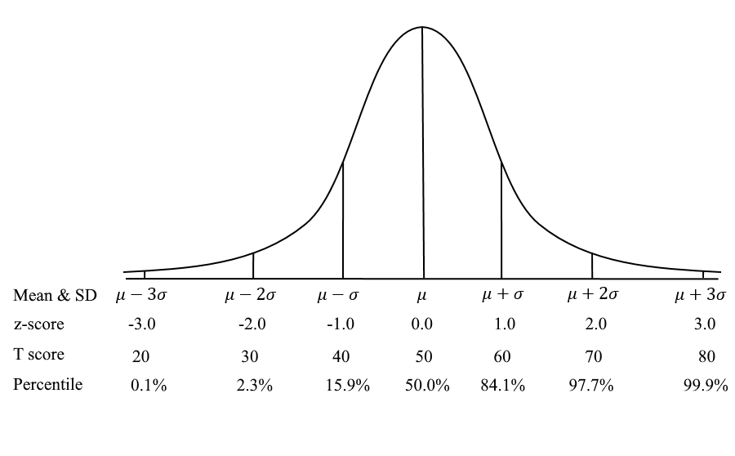

Figure . A graph showing Z score, t score and percentile information

## Test Strategy

Describe the type of tests that were selected as part of the test strategy. Why are these types of tests considered important?

Remember that these graphs cannot simply be the sum or average of figures obtained. You need to carry out detailed analysis and that takes time.

## Test Type 1 (Name linked to keyword in RQ/Aims)

Describe the type of test carried out. Say why it is an important type of test. What were the inputs and outputs. State how many times the test was run or the confidence factor for the test. State the facts drawn from the tests but do not give an opinion on the importance of the result. Repeat for each test type.

## Test Type 1 (Name linked to keyword in RQ/Aims)

Ensure that there is a dozen or so test types each with appropriate graphs or similar demonstration of practical tests. Include tables, graphs and screen shots as needed. Average is not sufficient as a mechanism to evaluate data.

## Chapter Conclusions

Describe how the test strategy included all appropriate test types as could be covered in the time allowed. Describe general observations on the results.

# Conclusions

Each week write at least one or two lines of notes to yourself as to what you might say in the conclusions chapter. You will forget when you get to the end, so it is really important to write this as you go along.

Conclusions should not introduce new material. The conclusions section should present your final thoughts in an organised manner. Try to organise your conclusions into logical paragraphs where points surround a given topic.

It could be argued that references should not appear in this chapter as that would indicate new material other than your own work. Similarly, it could be argued that images should not appear in the conclusions chapter.

Note that the number of pages in the conclusions should generally balance with the number of pages in the introduction. This is because the introduction is created to introduce the problem whilst the conclusions determine the validity of the hypothesis

## Conclusions on Theoretical Research

Try to organise your thoughts under headings as that will help you focus. Jot down your thoughts as you go along rather than waiting until the end to write the conclusions. You may find that you will forget a lot of the important conclusions if you don’t do this. The last statement on each of these topics should relate directly to the research question.

For example:

Bloggs, et al. showed that…indicating a need for research in this area…link to RQ

Smith, et al. described an experiment where…However, they did not consider…link to RQ

From the survey of existing literature has been found that a gap exists where….Link to RQ

## Conclusions on Practical Research

Focus on your practical element to test our hypothesis here. Focus strongly on why this is new.

### X Discussion (name linked to keyword 1 in RQ/Aim)

Discussion on how the theory from chapter 2 relates to the practical work in the remaining chapters. Show how your work agreed with, disagreed with or extended what was already known.

### X Discussion (name linked to keyword 2 in RQ/Aim)

Discussion on how the theory from chapter 2 relates to the practical work in the remaining chapters. Show how your work agreed with, disagreed with or extended what was already known.

### X Discussion (name linked to keyword 3 in RQ/Aim)

Discussion on how the theory from chapter 2 relates to the practical work in the remaining chapters. Show how your work agreed with, disagreed with or extended what was already known.

### Some other Technology Example Heading

Always relate the theory to the practical element when discussing conclusions.

## Limitations

Very short recap on limitations outlining any new discoveries on limitations. How would limitations be overcome if you had more time. Don’t just list the limits. Keep this very short as you don’t want the work to seem unfinished.

## Chapter Conclusions

Discussion on why this is so good there is some further work to be done. Relate your answer to why this can be applied in other domains. Relate to social/real world examples.

# References

10 Best Deployment Tools for DevOps in 2023 [online] (2023) available: https://www.knowledgehut.com/blog/devops/devops-deployment-tools [accessed 30 Jun 2023].

Agrawal, P. and Rawat, N. (2019) ‘Devops, A New Approach To Cloud Development & Testing’, in *2019 International Conference on Issues and Challenges in Intelligent Computing Techniques (ICICT)*, Presented at the 2019 International Conference on Issues and Challenges in Intelligent Computing Techniques (ICICT), GHAZIABAD, India: IEEE, 1–4, available: https://doi.org/10.1109/ICICT46931.2019.8977662.

Amrit, A., Akhil, P., Pranjal, Raj N, R., and Shylaja, B. (n.d.) ‘Microservices Evolving DevOps Pipeline’, *International Research Journal of Modernization in Engineering Technology and Science*.

Angara, J., Gutta, S., and Prasad, S. (2018) ‘DevOps with Continuous Testing Architecture and Its Metrics Model’, in *Recent Findings in Intelligent Computing Techniques*, Springer, Singapore, 271–281, available: https://doi.org/10.1007/978-981-10-8633-5_28.

Ayas, H.M., Fischer, H., Leitner, P., and De Oliveira Neto, F.G. (2022) ‘An Empirical Analysis of Microservices Systems Using Consumer-Driven Contract Testing’, in *2022 48th Euromicro Conference on Software Engineering and Advanced Applications (SEAA)*, Presented at the 2022 48th Euromicro Conference on Software Engineering and Advanced Applications (SEAA), Gran Canaria, Spain: IEEE, 92–99, available: https://doi.org/10.1109/SEAA56994.2022.00022.

Balalaie, A., Heydarnoori, A., and Jamshidi, P. (2016) ‘Microservices Architecture Enables DevOps: Migration to a Cloud-Native Architecture’, *IEEE Software*, 33(3), 42–52, available: https://doi.org/10.1109/MS.2016.64.

Bass, L., Weber, I., and Zhu, L. (2015) *A Software Architect’s Perspective, 2015.*, Addison-Wesley Professional.

Cito, J., Leitner, P., Fritz, T., and Gall, H.C. (2015) ‘The making of cloud applications: an empirical study on software development for the cloud’, in *Proceedings of the 2015 10th Joint Meeting on Foundations of Software Engineering*, ESEC/FSE 2015, New York, NY, USA: Association for Computing Machinery, 393–403, available: https://doi.org/10.1145/2786805.2786826.

Consumer-Driven Contracts: A Service Evolution Pattern [online] (2023) *martinfowler.com*, available: https://martinfowler.com/articles/consumerDrivenContracts.html [accessed 23 Jun 2023].

Dai, G., Bai, X., Wang, Y., and Dai, F. (2007) ‘Contract-Based Testing for Web Services’.

De Lauretis, L. (2019) ‘From Monolithic Architecture to Microservices Architecture’, in *2019 IEEE International Symposium on Software Reliability Engineering Workshops (ISSREW)*, Presented at the 2019 IEEE International Symposium on Software Reliability Engineering Workshops (ISSREW), Berlin, Germany: IEEE, 93–96, available: https://doi.org/10.1109/ISSREW.2019.00050.

‘Design, monitoring, and testing of microservices systems: The practitioners’ perspective’ (2021) *Journal of Systems and Software*, 182, 111061, available: https://doi.org/10.1016/j.jss.2021.111061.

DevOps for Microservices - Creating Change Together [online] (2021) *softwebsolutions*, available: https://www.softwebsolutions.com/resources/devops-and-microservices.html [accessed 12 Jun 2023].

Dhaduk, H. (2022) ‘A Guide on What Are Microservices: Pros, Cons, Use Cases, and More’, *Simform - Product Engineering Company*, available: https://www.simform.com/blog/what-are-microservices/ [accessed 19 May 2023].

Dockerized Pact Broker | Pact Docs [online] (2023) available: https://docs.pact.io/pact_broker/docker_images [accessed 21 Jul 2023].

EBay and Lastminute.Com Adopt Contract Testing to Drive Architecture Evolution [online] (2023) *InfoQ*, available: https://www.infoq.com/news/2023/05/ebay-contract-testing-evolution/ [accessed 3 Jun 2023].

Effective Test Automation Approaches for Modern CI/CD Pipelines [online] (2023) *InfoQ*, available: https://www.infoq.com/articles/test-automation-ci-cd/ [accessed 12 Jun 2023].

Fischer, H. (2021) ‘Testing in microservice systems: a repository mining study on open-source systems using contract testing’.

Fong, G. (2022) Contract Test — Spring Cloud Contract vs PACT [online], *Medium*, available: https://blog.devgenius.io/contract-test-spring-cloud-contract-vs-pact-420450f20429 [accessed 17 May 2023].

From Monolith to Microservices: A Dataflow-Driven Approach | IEEE Conference Publication | IEEE Xplore [online] (2023) available: https://ieeexplore.ieee.org/document/8305969 [accessed 27 Jun 2023].

Gluck, A. (2020) Introducing Domain-Oriented Microservice Architecture [online], *Uber Blog*, available: https://www.uber.com/en-VN/blog/microservice-architecture/ [accessed 27 Jun 2023].

Hasselbring, W. and Steinacker, G. (2017) ‘Microservice Architectures for Scalability, Agility and Reliability in E-Commerce’, in *2017 IEEE International Conference on Software Architecture Workshops (ICSAW)*, Presented at the 2017 IEEE International Conference on Software Architecture Workshops (ICSAW), Gothenburg, Sweden: IEEE, 243–246, available: https://doi.org/10.1109/ICSAW.2017.11.

How Contract Tests Improve the Quality of Your Distributed Systems [online] (2023) *InfoQ*, available: https://www.infoq.com/articles/contract-testing-spring-cloud-contract/ [accessed 17 May 2023].

IDC: The Premier Global Market Intelligence Firm. [online] (2023) *IDC: The premier global market intelligence company*, available: https://www.idc.com/ [accessed 7 Jul 2023].

Introduction | Pact Docs [online] (2022) available: https://docs.pact.io/ [accessed 21 Jul 2023].

Jenkins User Documentation [online] (2023) *Jenkins User Documentation*, available: https://www.jenkins.io/doc/ [accessed 21 Jul 2023].

Jokinen, O. (2020) ‘Software development using DevOps tools and CD pipelines : a case study’, available: https://helda.helsinki.fi/handle/10138/313590 [accessed 21 Jun 2023].

Keni, N.D. and Kak, A. (2020) ‘Adaptive Containerization for Microservices in Distributed Cloud Systems’, in *2020 IEEE 17th Annual Consumer Communications & Networking Conference (CCNC)*, Presented at the 2020 IEEE 17th Annual Consumer Communications & Networking Conference (CCNC), Las Vegas, NV, USA: IEEE, 1–6, available: https://doi.org/10.1109/CCNC46108.2020.9045634.

Larrucea, X., Santamaria, I., Colomo-Palacios, R., and Ebert, C. (2018) ‘Microservices’, *IEEE Software*, 35(3), 96–100, available: https://doi.org/10.1109/MS.2018.2141030.

Lehvä, J. (2019) ‘Testing Integrations with Consumer-Driven Contract Tests’, available: https://helda.helsinki.fi/handle/10138/304680 [accessed 6 Jun 2023].

Lehvä, J., Mäkitalo, N., and Mikkonen, T. (2019) ‘Consumer-Driven Contract Tests for Microservices: A Case Study’, in Franch, X., Männistö, T. and Martínez-Fernández, S., eds., *Product-Focused Software Process Improvement*, Lecture Notes in Computer Science, Cham: Springer International Publishing, 497–512, available: https://doi.org/10.1007/978-3-030-35333-9_35.

Lewis, J. and Fowler, M. (2023) Microservices [online], *martinfowler.com*, available: https://martinfowler.com/articles/microservices.html [accessed 27 Jun 2023].

Lightstep [online] (2018) available: https://go.lightstep.com/global-microservices-trends-report-2018.html [accessed 7 Jul 2023].

Mazlami, G., Cito, J., and Leitner, P. (2017) ‘Extraction of Microservices from Monolithic Software Architectures’, in *2017 IEEE International Conference on Web Services (ICWS)*, Presented at the 2017 IEEE International Conference on Web Services (ICWS), 524–531, available: https://doi.org/10.1109/ICWS.2017.61.

Microservices and Containers 101 - Learn All About Microservices [online] (2023) *Avi Networks*, available: https://avinetworks.com/what-are-microservices-and-containers/ [accessed 13 Jun 2023].

*Microservices at Netflix Scale: Principles, Tradeoffs & Lessons Learned • R. Meshenberg • GOTO 2016* [online] (2016) available: https://www.youtube.com/watch?v=57UK46qfBLY [accessed 27 Jun 2023].

Nagel, F. (n.d.) ‘Analysis of Consumer-driven contract tests with asynchronous communication between microservices’.

Newman, S. (2018) *BUILDING MICROSERVICES : Designing Fine-Grained Systems*, O’Reilly Media, Inc.

Newman, S. (2019) *Monolith to Microservices : Evolutionary Patterns to Transform Your Monolith*, Sebastopol: O’Reilly Media, Inc.

Nyman, R. (n.d.) ‘Consumer-Driven Contract Testing: A Framework and Pilot Implementation’.

Oberoi, A. (2023) What Is Continuous Deployment in DevOps? [online], available: https://insights.daffodilsw.com/blog/what-is-continuous-deployment-in-devops [accessed 30 Jun 2023].

Overview | Pact Docs [online] (2021) available: https://docs.pact.io/implementation_guides/jvm [accessed 21 Jul 2023].

Pact-Foundation/Pact-Workshop-Jvm-Spring: Example Spring Boot Project for the Pact Workshop [online] (2023) available: https://github.com/pact-foundation/pact-workshop-jvm-spring/tree/main [accessed 21 Jul 2023].

Pahl, C. (2015) ‘Containerization and the PaaS Cloud’, *IEEE Cloud Computing*, 2(3), 24–31, available: https://doi.org/10.1109/MCC.2015.51.

README | Pact Docs [online] (2023) available: https://docs.pact.io/implementation_guides/jvm/readme [accessed 21 Jul 2023].

Saboor, A., Hassan, M.F., Akbar, R., Shah, S.N.M., Hassan, F., Magsi, S.A., and Siddiqui, M.A. (2022) ‘Containerized Microservices Orchestration and Provisioning in Cloud Computing: A Conceptual Framework and Future Perspectives’, *Applied Sciences*, 12(12), 5793, available: https://doi.org/10.3390/app12125793.

Selleby, F. (n.d.) ‘Creating a Framework for Consumer-Driven Contract Testing of Java APIs’.

Sharing Pacts with the Pact Broker | Pact Docs [online] (2023) available: https://docs.pact.io/getting_started/sharing_pacts [accessed 21 Jul 2023].

Singh, S. and Singh, N. (2016) ‘Containers & Docker: Emerging roles & future of Cloud technology’, in *2016 2nd International Conference on Applied and Theoretical Computing and Communication Technology (ICATccT)*, Presented at the 2016 2nd International Conference on Applied and Theoretical Computing and Communication Technology (iCATccT), Bangalore, India: IEEE, 804–807, available: https://doi.org/10.1109/ICATCCT.2016.7912109.

Soldani, J., Tamburri, D.A., and Van Den Heuvel, W.-J. (2018) ‘The pains and gains of microservices: A Systematic grey literature review’, *Journal of Systems and Software*, 146, 215–232, available: https://doi.org/10.1016/j.jss.2018.09.082.

Testing Microservices - Contract Tests [online] (2023) *SoftwareMill*, available: https://softwaremill.com/testing-microservices-contract-tests/ [accessed 13 Jun 2023].

Testing Strategies in a Microservice Architecture [online] (2023) *martinfowler.com*, available: https://martinfowler.com/articles/microservice-testing/ [accessed 5 Jul 2023].

‘The Role of Containers in Your Microservice Architecture’ (2021) *JFrog*, available: https://jfrog.com/devops-tools/article/role-of-containers-in-your-microservice-architecture/ [accessed 13 Jun 2023].

Thirion, Y. (2019) Pact Broker : The Missing Piece of Your Consumer-Driven Contract Approach (Part 3/3) [online], *AgilePartner*, available: https://www.agilepartner.net/en/pact-broker-the-missing-piece-of-your-consumer-driven-contract-approach-part-3/ [accessed 21 Jul 2023].

Victor, A. (2023) All You Need To Know About The DevOps CI/CD Pipeline [online], available: https://insights.daffodilsw.com/blog/devops-ci-cd-pipeline [accessed 5 Jul 2023].

Vocke, H. (2023) The Practical Test Pyramid [online], *martinfowler.com*, available: https://martinfowler.com/articles/practical-test-pyramid.html [accessed 4 Jul 2023].

Waseem, M., Liang, P., Márquez, G., and Di Salle, A. (2020) ‘Testing Microservices Architecture-Based Applications: A Systematic Mapping Study’, available: https://doi.org/10.1109/APSEC51365.2020.00020.

What Are Containerized Microservices? – DreamFactory Software- Blog [online] (2023) available: https://blog.dreamfactory.com/what-are-containerized-microservices/ [accessed 13 Jun 2023].

What Is a Container Deployment? | VMware Glossary [online] (2023) *VMware*, available: https://www.vmware.com/topics/glossary/content/container-deployment.html [accessed 30 Jun 2023].

What Is Docker? | AWS [online] (2023) *Amazon Web Services, Inc.*, available: https://aws.amazon.com/docker/ [accessed 21 Jul 2023].

Wickramasinghe, S. (2023) The Role of Microservices in DevOps [online], *BMC Blogs*, available: https://www.bmc.com/blogs/devops-microservices/ [accessed 12 Jun 2023].

Wu, C.-F., Ma, S.-P., Shau, A.-C., and Yeh, H.-W. (2022) ‘Testing for Event-Driven Microservices Based on Consumer-Driven Contracts and State Models’, in *2022 29th Asia-Pacific Software Engineering Conference (APSEC)*, Presented at the 2022 29th Asia-Pacific Software Engineering Conference (APSEC), Japan: IEEE, 467–471, available: https://doi.org/10.1109/APSEC57359.2022.00064.

Yousif, M. (2016) ‘Microservices’, *IEEE Cloud Computing*, 3(5), 4–5, available: https://doi.org/10.1109/MCC.2016.101.

Zimmermann, O. (2016) ‘Microservices tenets: Agile approach to service development and deployment’, *Computer Science - Research and Development*, 32, available: https://doi.org/10.1007/s00450-016-0337-0.

# Appendices

# Appendix A: Code Listing Location

Some description or essential code snips can go here.

Code for this dissertation can be found in the repository listed below. To ensure that the code is accessible the repo must be a public repo.

<https://github.com/studentlnumber/reponame.git>