**Steps for integrating Sonarqube with Jenkins CI/CD pipeline**

Step1: Configuring sonarqube tool in jenkins:

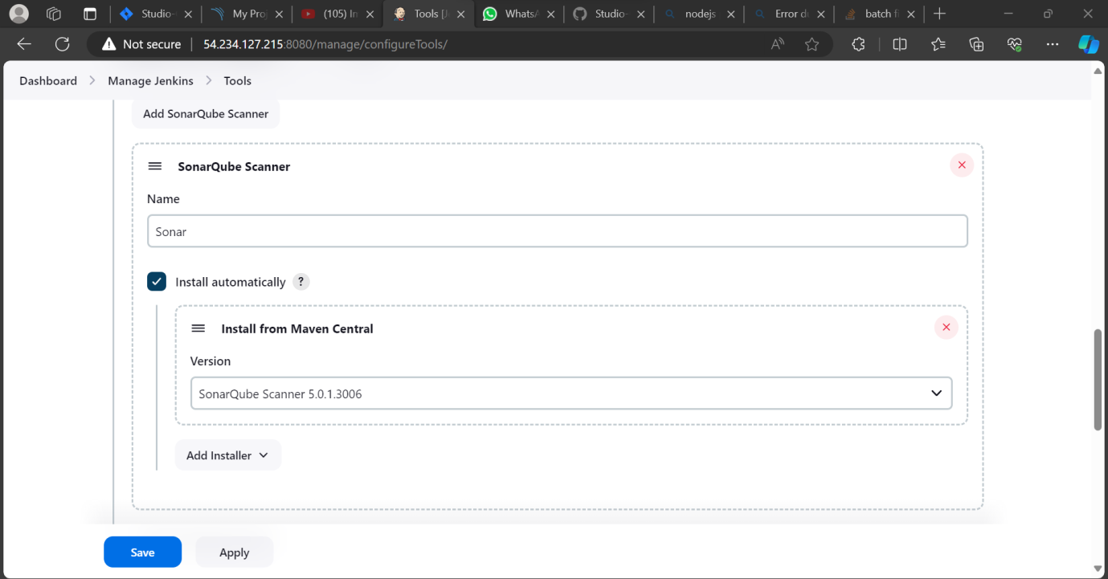

Step 2: System configuration for sonarqube:

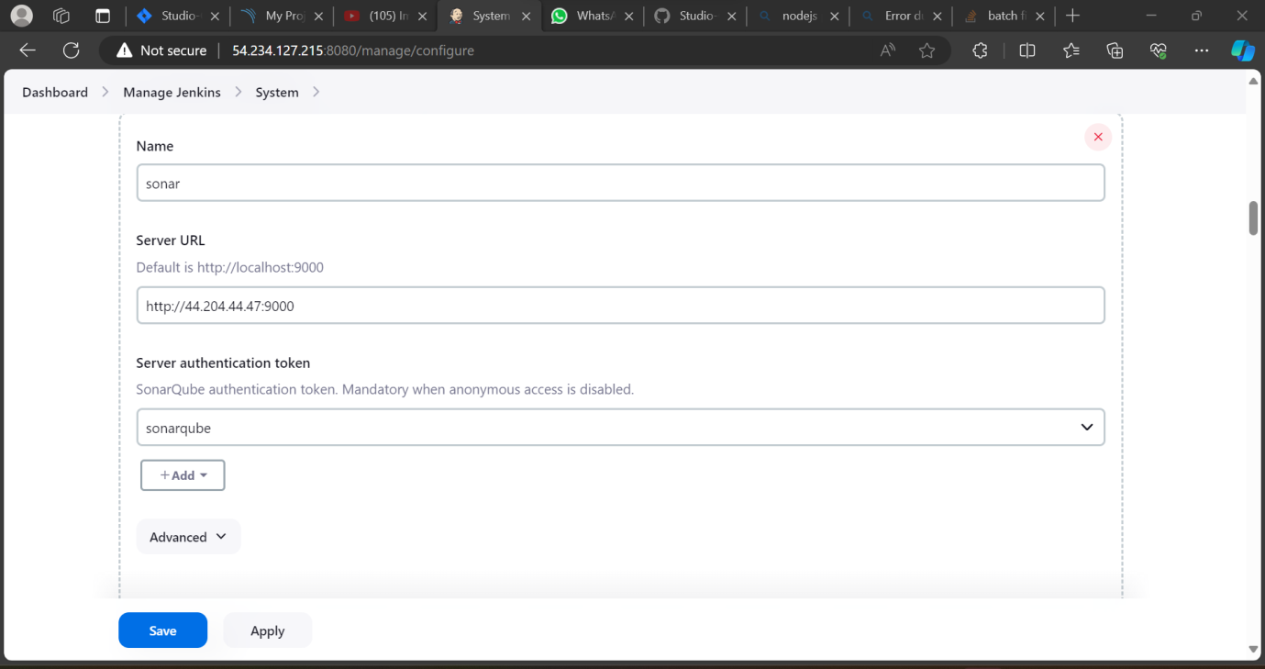

Step 3: Adding credentials for sonarqube:

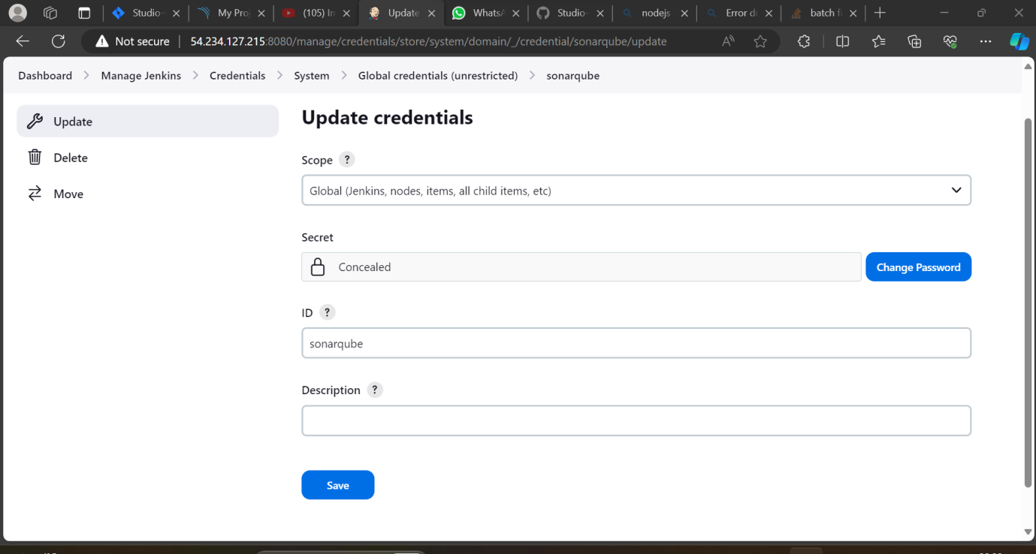

Step 4: Generating a token in Sonarqube:

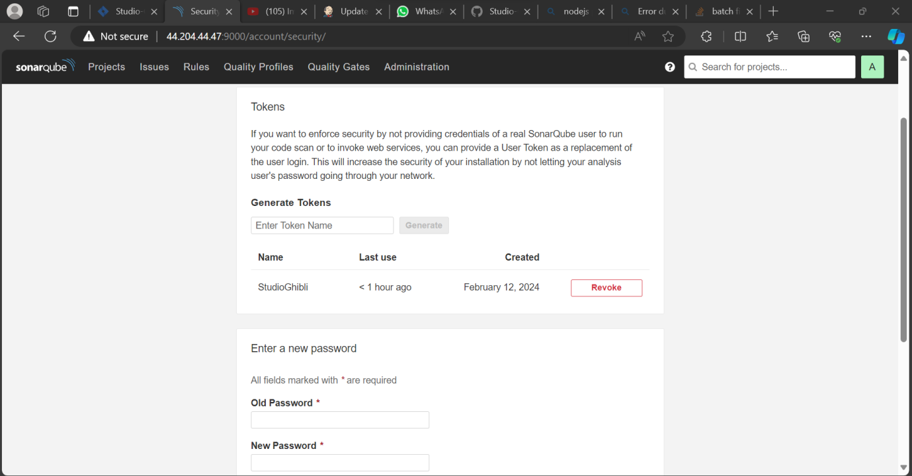

Step 5: Pipeline script in Jenkins:

pipeline {

agent any

tools {nodejs 'node'}

stages {

stage('Checkout from GitHub') {

steps {

checkout scmGit(branches: [[name: '*/development']], extensions: [], userRemoteConfigs: [[url: 'https://github.com/Vikx001/Studio-Ghibli.git']])

}

}

stage('Install dependencies'){

steps{

dir('frontend/studio-ghibli'){

sh ('npm install')

}

}

}

stage('Build'){

steps{

dir('frontend/studio-ghibli'){

sh ('npm run build')

}

}

}

stage('Static Code Analysis') {

environment {

SONAR_URL = "http://44.204.44.47:9000"

}

steps {

dir('frontend/studio-ghibli'){

script{

withCredentials([string(credentialsId: 'sonarqube', variable: 'SONAR_AUTH_TOKEN')]) {

withSonarQubeEnv('sonar') {

sh "npm install sonar-scanner"

sh "npm run sonar"

}

}

}

}

}

}

}

}

Step 6: Create Sonar-project.properties inside frontend/studio-ghibli (ie. Where package.json file is present):

# Required metadata

sonar.projectKey=my_project_key

sonar.projectName=My Project

sonar.projectVersion=1.0

# Path to source directories (comma-separated list)

sonar.sources=src

# Language

sonar.language=java

# Encoding of the source files

sonar.sourceEncoding=UTF-8

# Location of the sonarqube server

sonar.host.url=http://44.204.44.47:9000

sonar.login=015097e0d5bb02b5834b2132794024c9339099b4

Step 7: Modify package.json file:

{

"name": "studio-ghibli",

"version": "0.1.0",

"private": true,

"dependencies": {

"@emotion/react": "^11.11.3",

"@emotion/styled": "^11.11.0",

"@fortawesome/fontawesome-svg-core": "^6.5.1",

"@fortawesome/free-solid-svg-icons": "^6.5.1",

"@fortawesome/react-fontawesome": "^0.2.0",

"@mui/icons-material": "^5.15.6",

"@mui/material": "^5.15.6",

"@testing-library/jest-dom": "^5.17.0",

"@testing-library/react": "^13.4.0",

"@testing-library/user-event": "^13.5.0",

"react": "^18.2.0",

"react-dom": "^18.2.0",

"react-items-carousel": "^2.8.0",

"react-scripts": "5.0.1",

"styled-components": "^6.1.8",

"web-vitals": "^2.1.4"

},

"scripts": {

"start": "react-scripts start",

"build": "CI=false && react-scripts build",

"test": "react-scripts test",

"eject": "react-scripts eject",

"sonar": "node_modules/sonar-scanner/bin/sonar-scanner" **//changes**

},

"eslintConfig": {

"extends": [

"react-app",

"react-app/jest"

]

},

"browserslist": {

"production": [

">0.2%",

"not dead",

"not op_mini all"

],

"development": [

"last 1 chrome version",

"last 1 firefox version",

"last 1 safari version"

]

}

}