**Steps for creating tables in MySql**

1. Download the file ‘DBScripts.sql’ from github, Branch –> KAN-92.
2. Install MySql on your device.
3. Open MySql Workbench.
4. Click on file -> open sql script

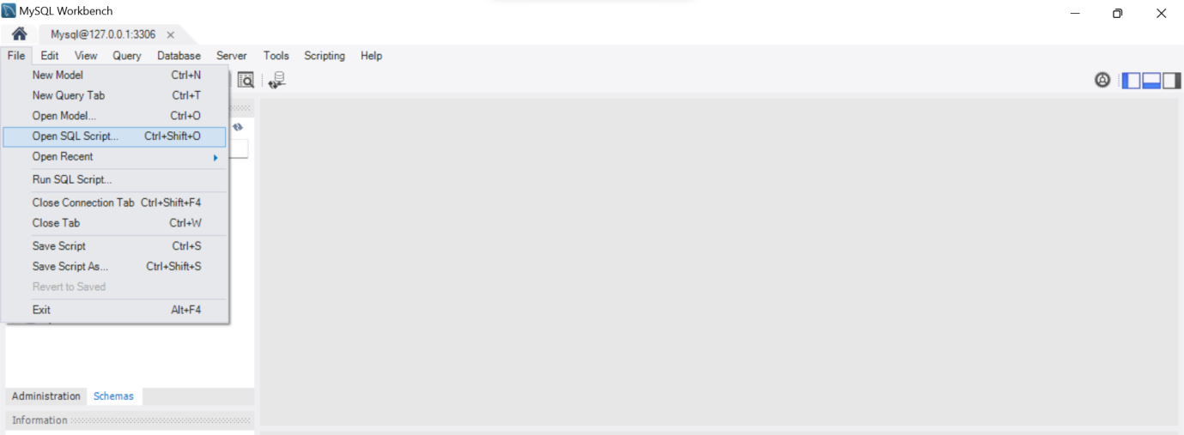

1. Browse and find DBscripts.sql file that you have just downloaded and click on Open.
2. To execute the script, go to Query -> Execute

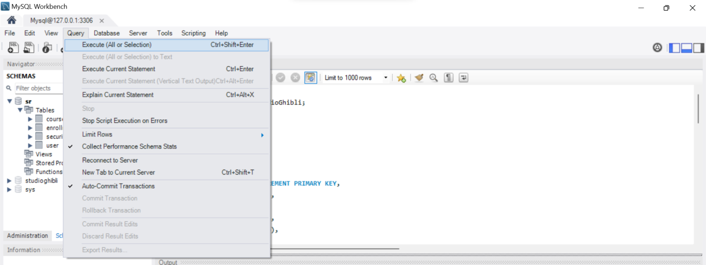

1. Post execution, you should see StudioGhibli database with tables on MySql Workbench.

