LECTURER | John ORaw
STUDENT NAME | Edmund Connolly
STUDENT NUMBER | L00194727
PROGRAMME | MSc Cloud
MODULE CODE | IaC
ASSIGNMENT TITLE | Week 5 DOS Submission
SUBMISSION DATE | 26/10/2025

Student Declaration
- I have accurately identified and included the sources of all facts, ideas, opinions, and viewpoints from others in the assignment references. All direct quotations, paraphrasing, and discussions of ideas from books, journal articles, internet sources, course materials, or any other sources used are properly acknowledged and cited in the assignment references.
- I have not used unauthorised artificial intelligence tools or aids.
- I understand and am compliant with ATU's policy and procedures regarding Academic Integrity and I am aware of the consequences of any violations.
- I have followed the referencing guidelines recommended in the assignment instructions and / or programme documentation.
- By signing this form or by submitting material online I confirm that this assignment, or any part of it, has not been previously submitted by me or any other person for assessment on this or any other programme of study.
- By signing this form or by submitting material for assessment online I confirm that I have read and understood AQAE022 Academic Integrity Policy

Student Signature | Date
Edmund Connolly | 26/10/2025

Contents
Description 3
Aims 3
Method 3
Demo1.bat 3
Demo2.bat 3
Demo3.bat 4
Demo4.bat 4
Demo5.bat 4
Demo6.bat 4
Demo7.bat 4
Demo8.bat 5
Demo9.bat 5
Demo10.bat 5
Demo11.bat 5
Results and Testing 6
Demo1.bat Results 6
Demo2.bat Results 6
Demo3.bat Results 6
Demo4.bat Results 6
Demo5.bat Results 6
Demo6.bat Results 6
Demo7.bat Results 7
Demo8.bat Results 7
Demo9.bat Results 7
Demo10.bat Results 7
Demo11.bat Results 7
Conclusions 7
References 8
Appendices 8

Description
In data centres, technicians must perform repetitive tasks on a regular basis, these tasks can be automated to improve productivity. To accomplish this on windows virtual machines we can use a windows scripting language called batch files, these batch are then executed in the windows terminal.

Aims
Windows batch files can be used to automate processes on windows virtual machine; thus we should become familiar with them, their scripting language and experiment with them by executing them and observing the results.
The primary aim of this work is:
- To become familiar with windows command prompt and file structure.
- Learn the windows batch file scripting language.
- Write and test windows batch files.
- Executing windows batch file.
- Observe the output from executing the windows batch files.

Method
A windows 11 machine was used to execute the Disk Operating System (DOS) batch scripts. To input the code for the scripts Notepad++ was used.
First a directory named BatchFiles was created, this directory would be used to store the batch files. In Notepad++ using the GUI we would create the appropriately named batch file e.g. Demo1.bat and enter the code using Notepad++ .
To run the batch file, in the windows console/terminal, we would navigate to the BatchFiles directory and enter the filename without the .bat extension e.g. to run demo2.bat we would type demo2 only.

Demo1.bat
The code for demo1.bat is shown in the appendix labelled as figure 1.
The following is explanation of the code:
@echo off - This makes windows not display the windows prompt which shows what directory and path we are in
CLS – This is used to clear the screen
Dir /w – This displays all the directories and files in the current directory, the /w is a “switch” that is used to specify that we want to display it in a wide format.

Demo2.bat
The code for demo2.bat is shown in the appendix labelled as figure 3. We can observe the following
:: is used at the start of line to specify what follows is comments
Title – is used to specify the windows command prompt or consoles title
Echo – is used to print to the console

Demo3.bat
The code for demo3.bat is shown in the appendix labelled as figure 5. We can observe the following
The demo3.bat script uses the PAUSE command, to make the console window pause and wait until the user presses a button

Demo4.bat
The code for demo4.bat is shown in the appendix labelled as figure 7. We can observe the following
In demo4.bat we introduce the use of variables, SETLOCAL and ENDLOCAL, are used to ensure that the variables we specify between SETLOCAL and ENDLOCAL can only exist between these two points. To create a variable, we use SET command. We specify a variable clonepath by the following
SET clonepath=VALUE – Sets variable clonepath to VALUE
Echo %clonepath% - Prints the clonepath value to the console

Calculations can also be done in scripts by using /A to perform “arithmetic calculations”
SET /A calculation=2+12/4, calculates 2+12/4 and sets it to the variable called calculation.

Demo5.bat
The code for demo5.bat is shown in the appendix labelled as figure 9. We can observe the following
To pass arguments to the Demo5.bat script we specify them after the filename e.g
demo5 Edmund Connolly. We then can access the argument using the percentage sign and its position e.g %2 will result in Connolly.

Demo6.bat
The code for demo6.bat is shown in the appendix labelled as figure 11.
In Demo6 we prompt the user for input and set the value entered into a variable, we then print this value
Set /p NAME=What is your name? – /p switch is used to specify prompt mode. It then prints the message What is your name? and sets the variable NAME to the entered value

Demo7.bat
The code for demo7.bat is shown in the appendix labelled as figure 13.
It sets 2 variables ospath and filename and then uses an if statement to check if the file specified by filename exists at Windows ospath, if it is there it prints a message saying it exists otherwise it prints No file named explorer.exe.

Demo8.bat
The code for demo8.bat is shown in the appendix labelled as figure 15.
It checks for a file that doesn’t exist. It then tries to copy this file to a TEMP location, because it doesn’t exist it throws an error.
The script then checks if the ERROR LEVEL is not equal to 0 which is true so it prints out that the error level was 1 and that did not work.

Demo9.bat
The code for demo9.bat is shown in the appendix labelled as figure 17.
The code tries to copy explorer.exe. Then because it uses && which means if the previous command is successful run what is after it, then to print a message saying copy of explorer.exe worked. It then prints 2 empty lines.
It then attempts to copy a file that doesn’t exist which it fails. It uses || which means if the previous command fails run what is after it, which is to print a message saying copy failed.

Demo10.bat
The code for demo10.bat is shown in the appendix labelled as figure 19.
It creates an empty file called SimpleBackup.log and put ***Demo10 Logfile ***.
It then prints a message 1. Copying explorer.exe into the file SimpleBackup.log
Then it attempts to copy the file explorer.exe which does exist, so the standard output is appended into the SimpleBackup.log
Then it attempts to copy the file DoesNotExist.exe file which doesn’t exist, so the standard output is appended into the SimpleBackup.log
The standard output is different for files that exist and doesn’t exist.

Demo11.bat
The code for demo11.bat is shown in the appendix labelled as figure 22.

The first loop iterates through all files in the current directory
%CD% - is a built=in variable that is the current directory path
FOR %%I In (*) DO – is a for loop to go through every file in the current folder, * means every file
%%I is the loop variable that stores each filename
It then echos each Filename (%%I)

The second for loop looks at directories in the users profile
%USERPROFILE% → environment variable that points to the user’s home directory, e.g.
C:\Users\Edmund
/D → tells the FOR loop to iterate only over directories.
%%I → represents each directory name found.
@ECHO %%I → displays the directory path.

Results and Testing
Briefly introduce the section and define the tests which are performed.
The results of the work must be presented here in an appropriate form. Any filtering or removal of data must be declared and explained. If a system is being created, the test procedure and result must be given. If many tables or diagrams are required, these diagrams should be individually labelled, included in appendix B, and referenced from here.
The results/testing section of a report should allow a peer to replicate and verify the results obtained.
Number every figure or table. Do not include any figure or table which you do not discuss.

Demo1.bat Results
In the appendix figure 2 we can see the result from running demo1.bat it shows a list of the files and directories displayed in a width form

Demo2.bat Results
In the appendix figure 4 shows the result, we can see statements have been printed to the screen and the prompt window has the title that was specified in the command

Demo3.bat Results
In the appendix figure 6 shows the result, when running the batch script it pauses and displays a message to user saying press any key to continue

Demo4.bat Results
In the appendix figure 8 shows the result, we can see that the value variables have been set to when we print them out. We also can see the value of calculation is arithmetic result of the specified equation.

Demo5.bat Results
In the appendix figure 10 shows the result, we can see that the values/arguments after the demo5.bat are printed out by the script in our demo, Edmund Connolly gets passed into the script and printed out.

Demo6.bat Results
In the appendix figure 12 shows the result, we can see that the values entered at the prompt for what is your name is printed out to the screen

Demo7.bat Results
Figure 14 in the appendix shows the results of Demo7.bat we can see it found the file explorer.exe in the windows directory

Demo8.bat Results
Figure 16 in the appendix shows the results of Demo8.bat. We can see that there was an error level because we tried to copy a file that doesn’t exist. Thus it printed a message to the screen saying there was an errorlevel and the copy didn’t work

Demo9.bat Results
Figure 18 in the appendix shows the results of Demo9.bat. We can see that there was an error level
We can see it successfully copied explorer.exe, and it failed to copy DoesNoteExist.exe file

Demo10.bat Results
Figure 20 shows the SimpleBackup.log was created and figure 21 in the appendix shows the results of Demo9.bat. We can see that output from copying a file that exists and a non-existent file has been put in the SimpleBackup.log file

Demo11.bat Results
Figure 23 in the appendix, shows all the files in the current directory and then shows all directories in the user’s profile.

Conclusions
A batch file is specified by giving a file the “.bat” extension, these batch files can be used to create useful scripts that can automate repetitive tasks, examples such as deleting temporary files, copying files from one location to another, they may also change settings, automate routines, and launch apps or web pages on your computer. These scripts may be scheduled to run when the machine starts up by placing the batch files in the startup folder or at regular intervals using the Task Scheduler Library.
During experimentation with batch files, I learnt how to pass parameter arguments to a script from the command line, using this method of passing data and batch files if statements. We can conditionally execute code based on what the user passes, thereby changing what the script does or how it does for example when using dir to list the contents of a directory, passing the argument /w will make the output go into a “wide” mode, whereas /p will make the output pause after a screen amount of data.
In Demo 10, I learnt about how to redirect output in the command line or using a batch script to for example the screen designated the standard output device or STDOUT=1 and the standard error device which is normally the screen but can be a printer or STDERR=2. In the script demo 10, it saves the output of copying a file that exists and doesn’t exist into a text file but also displays the result on the screen, this script could easily be modified to create a log file for system administrators.
In Demo 4 I experimented with creating local variables using SETLOCAL and ENDLOCAL, the advantage of local variables is that their scope where they exist is limited in between the SETLOCAL and ENDLOCAL statements, this has the main advantage that it prevents these variables from leaking into the wider script or system environment, this is good software engineering.
All my aims were achieved, I became more familiar with the windows command prompt, such as navigation and running of batch files. We learnt basic batch file scripting by writing simple scripts, executing them and observing the results in command prompt window. Batch scripts are useful and important because they allow an administrator the power and flexibility to create scripts that automate processes and that can be scheduled to run regularly or at startup if the administrator wishes.

References

Appendices
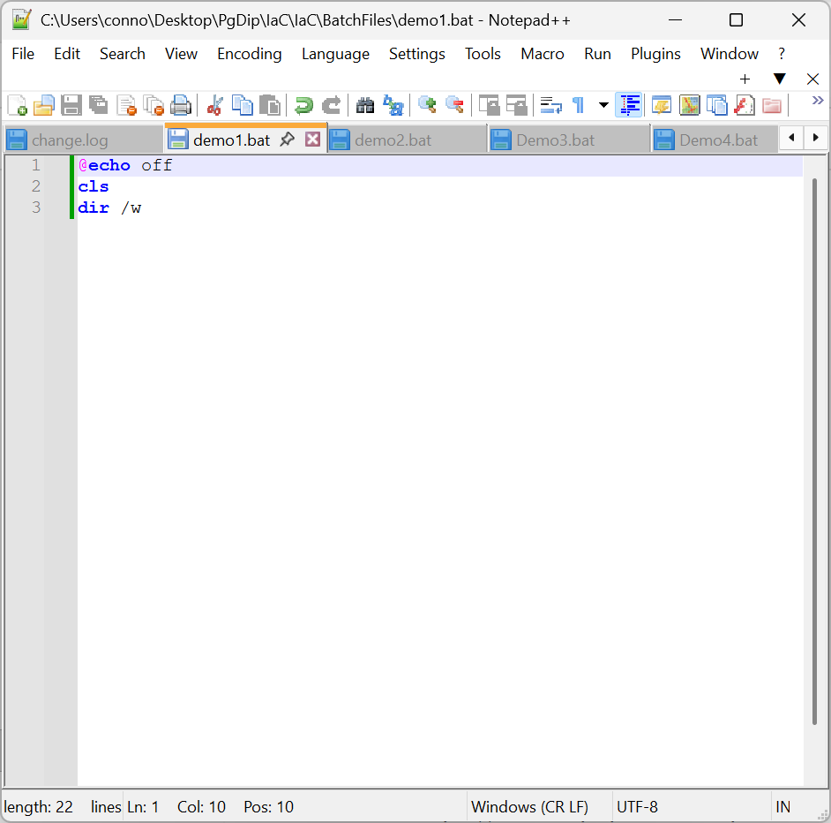
Figure 1 - Demo1.bat code screenshot

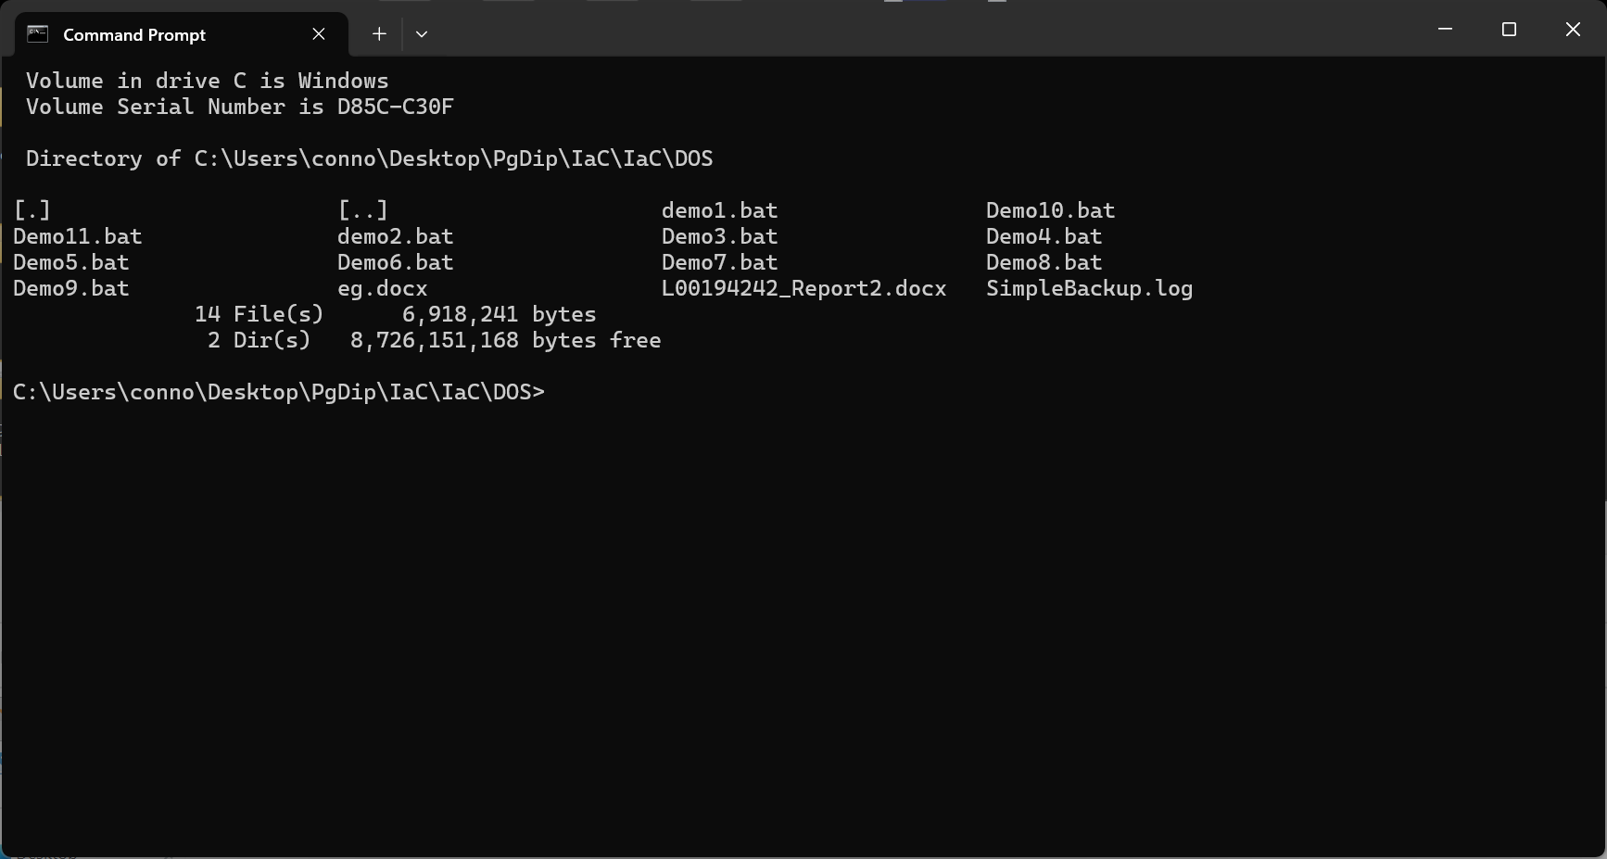
Figure 2 - Result of Demo1.bat
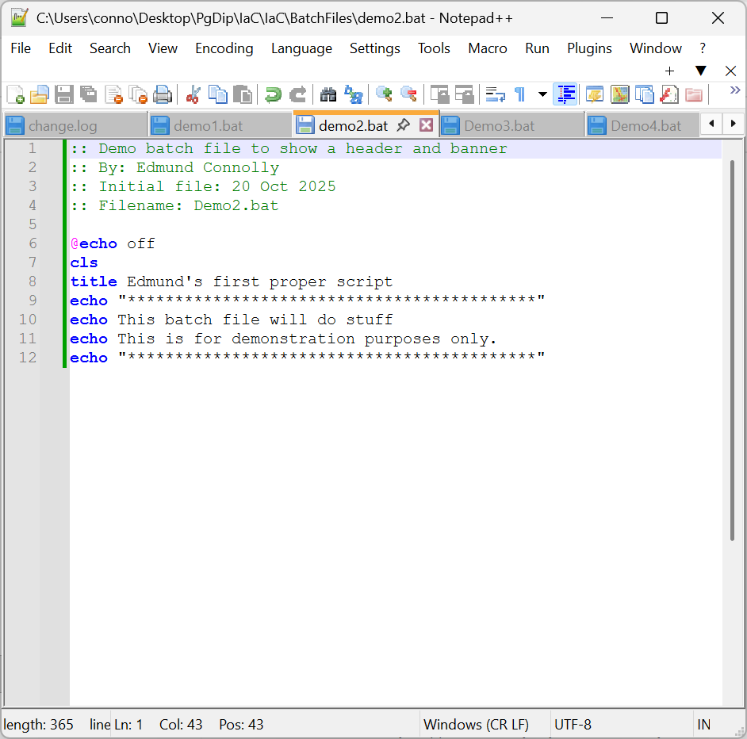
Figure 3 - Demo2.bat code screenshot

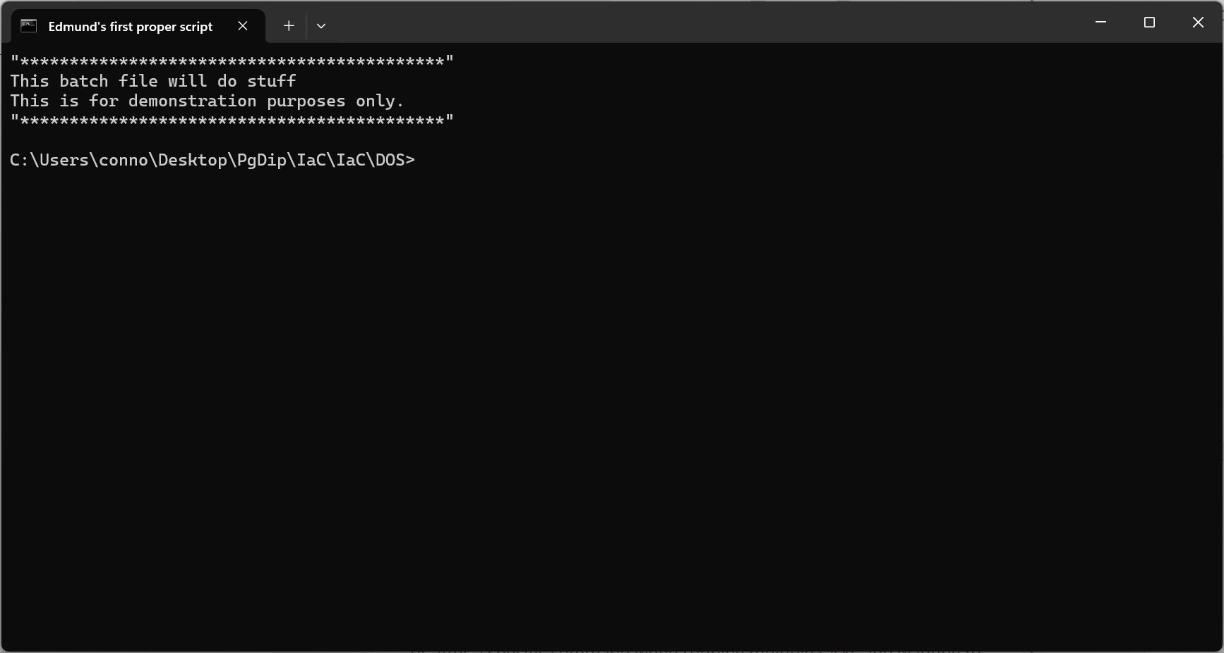
Figure 4 - Result of Demo2.bat
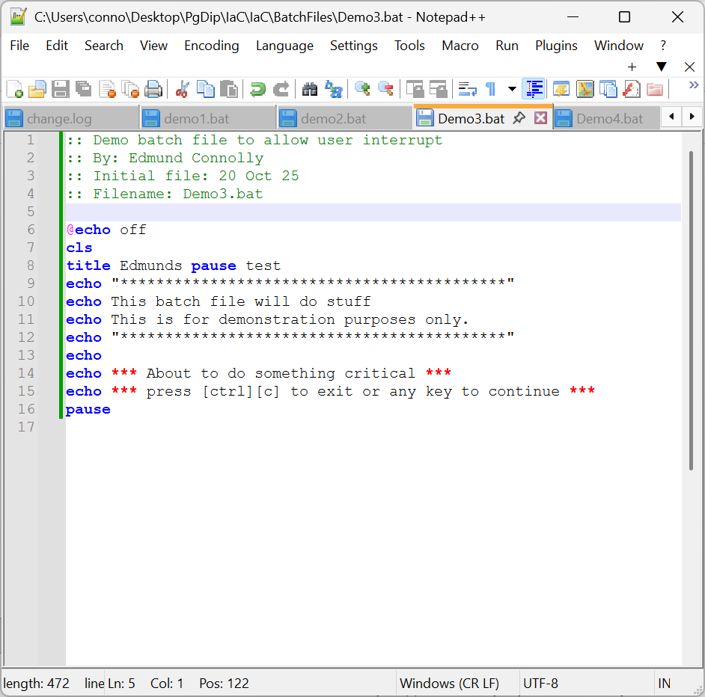
Figure 5 - Demo3.bat code screenshot

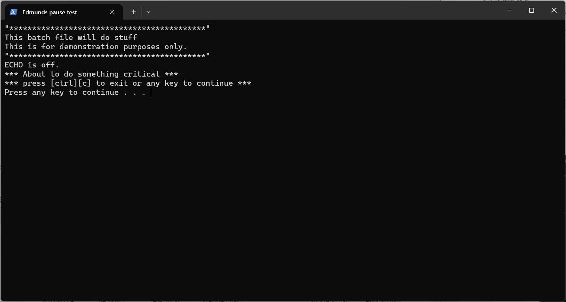
Figure 6 - Result of Demo3.bat
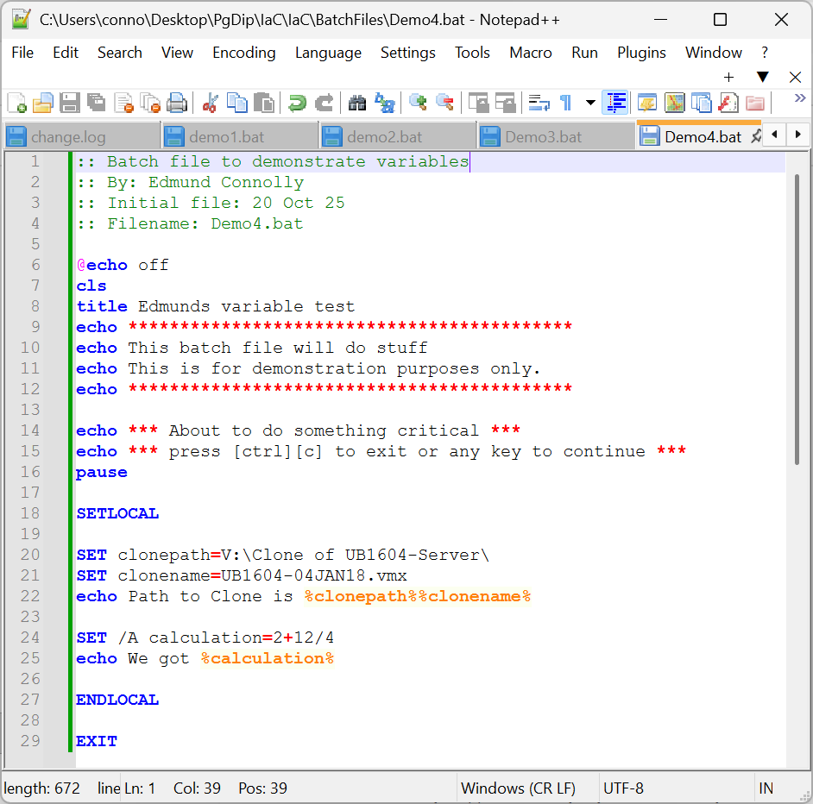
Figure 7 - Demo4.bat code screenshot

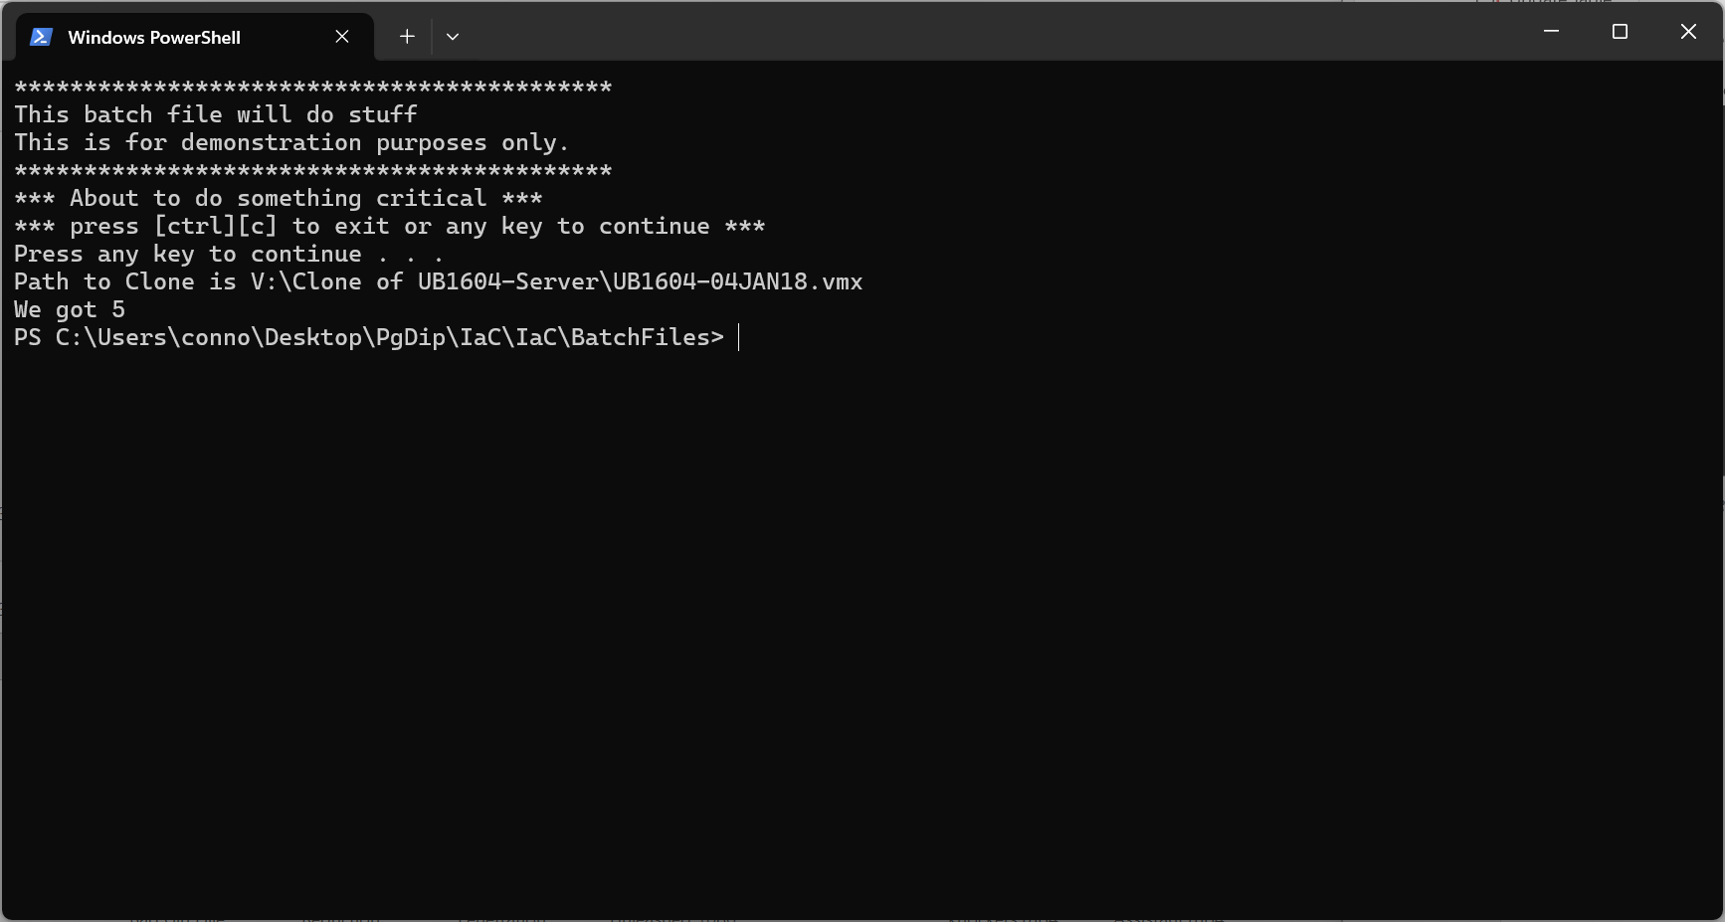
Figure 8 - Result of Demo4.bat
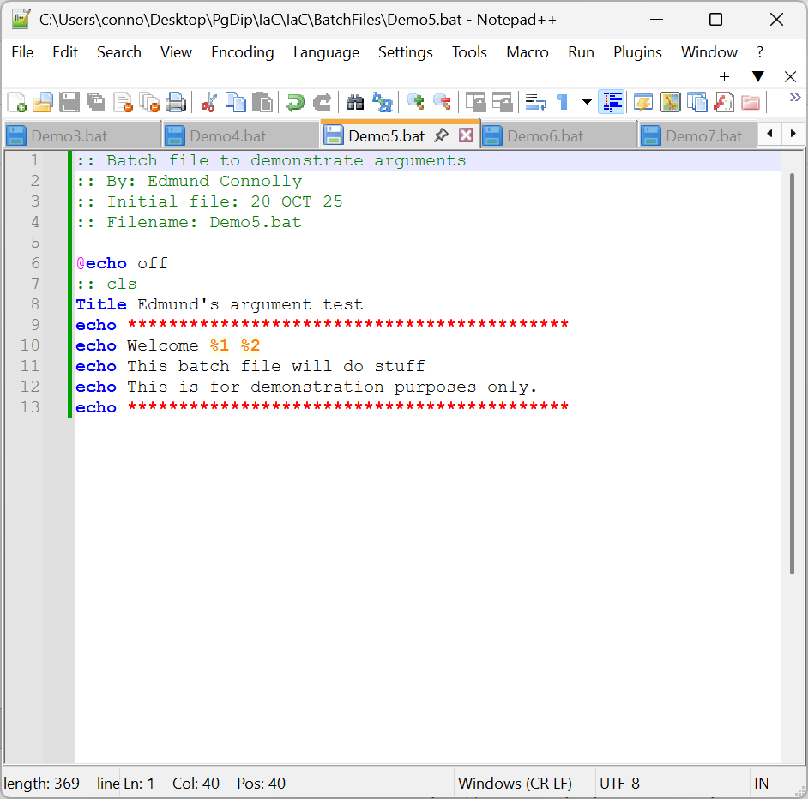
Figure 9 - Demo5.bat Code Screenshot
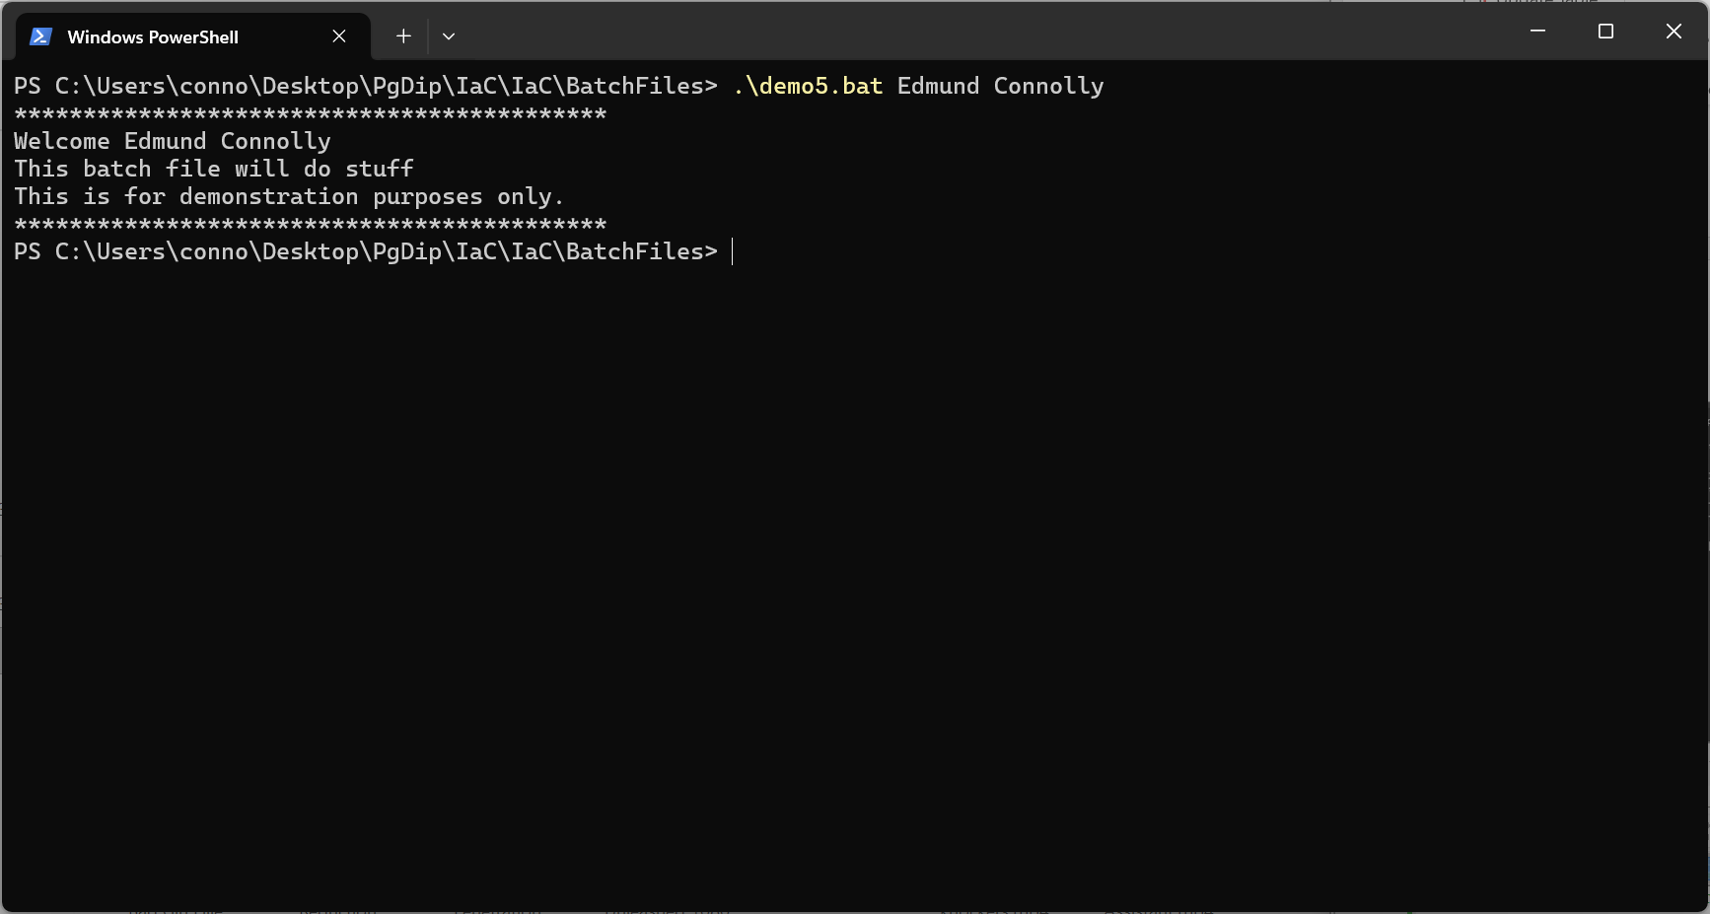
Figure 10 - Result of Demo5.bat

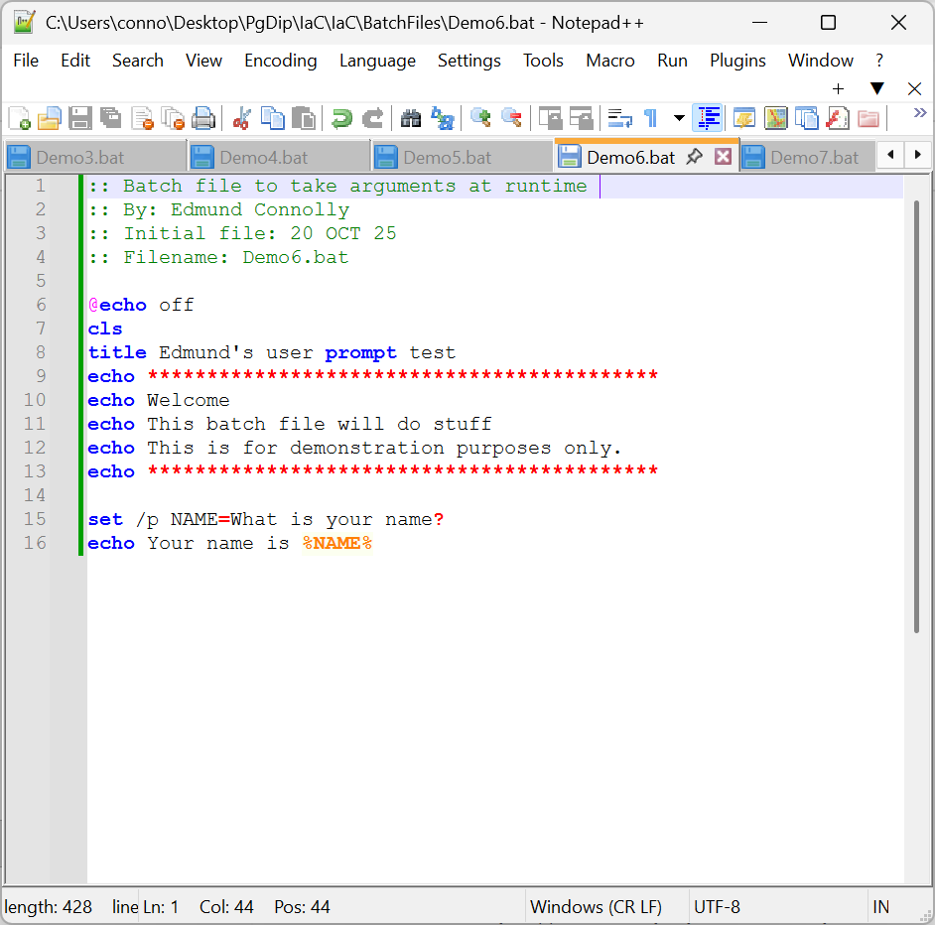
Figure 11 - Demo6.bat Code Screenshot

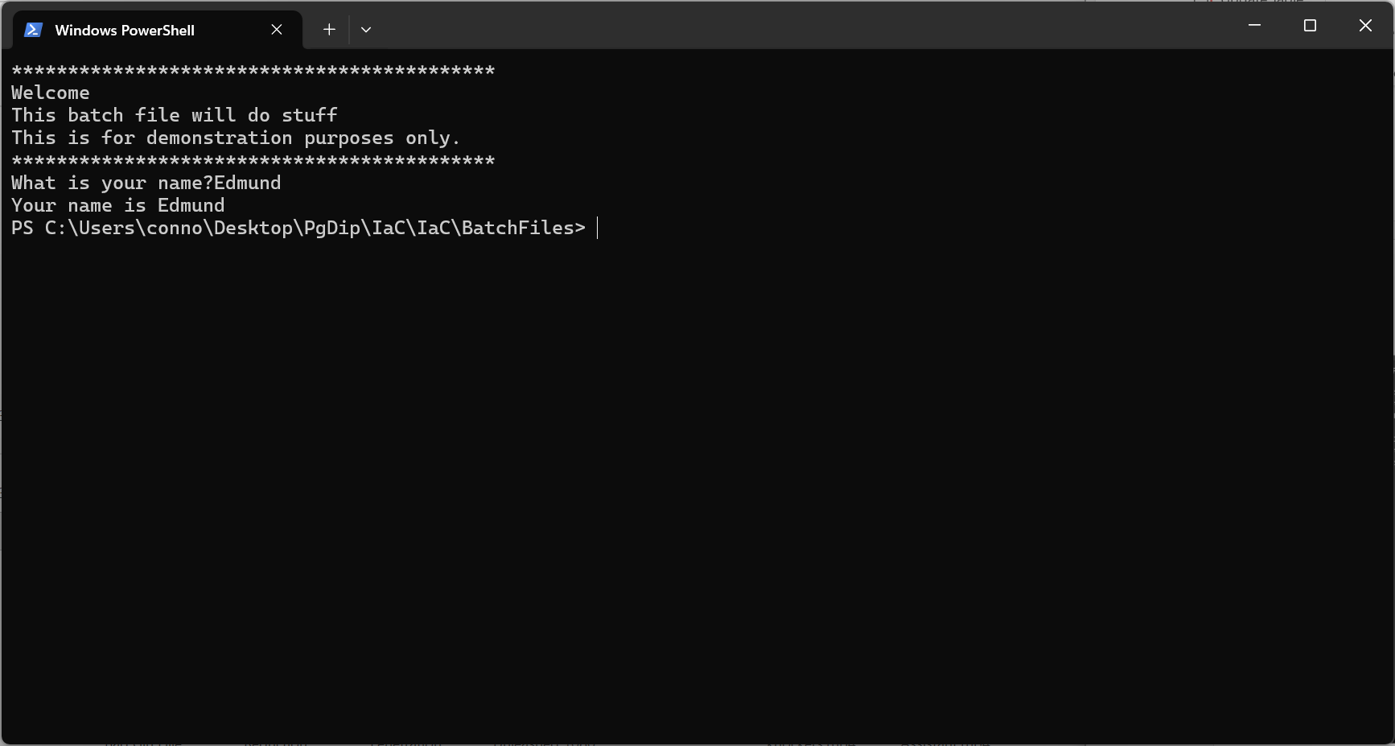
Figure 12 - Result of Demo6.bat

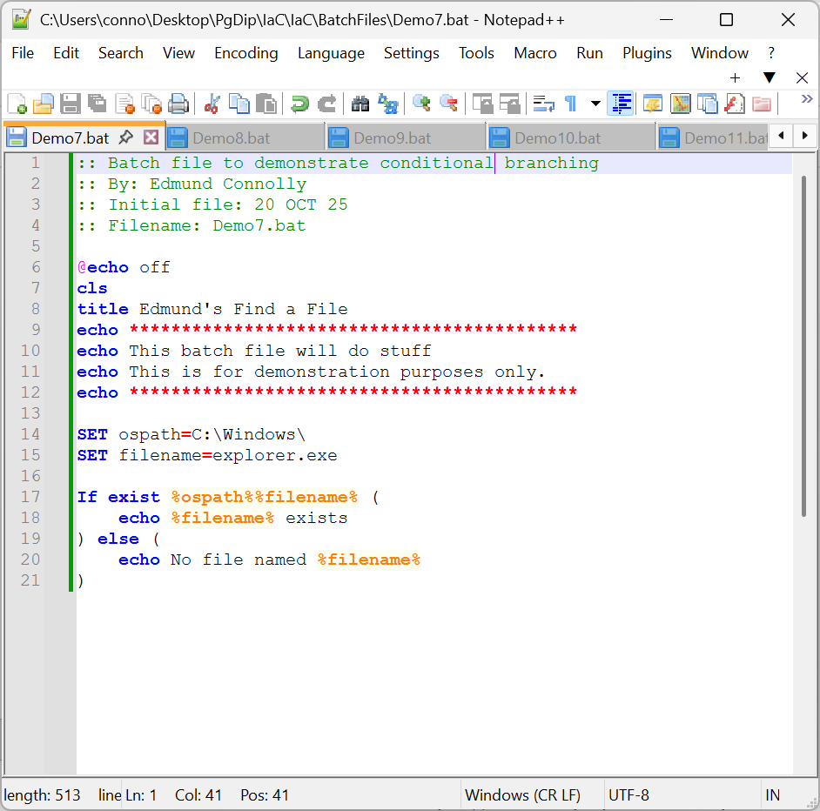
Figure 13 - Demo7.bat Code Screenshot
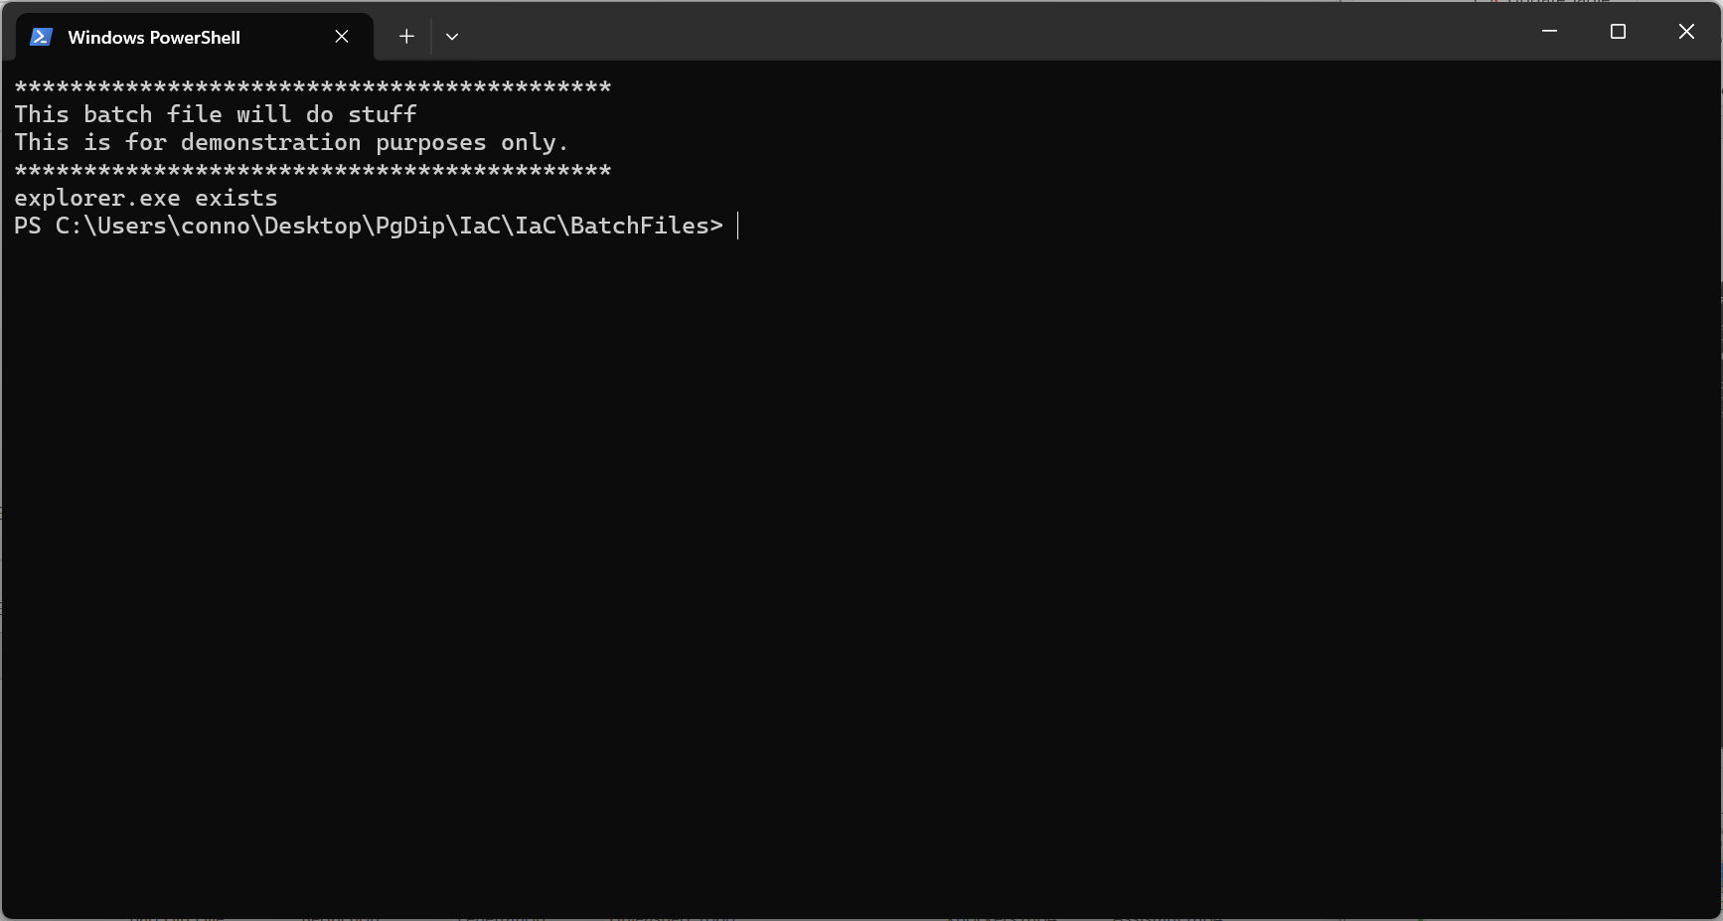
Figure 14 - Result of Demo7.bat

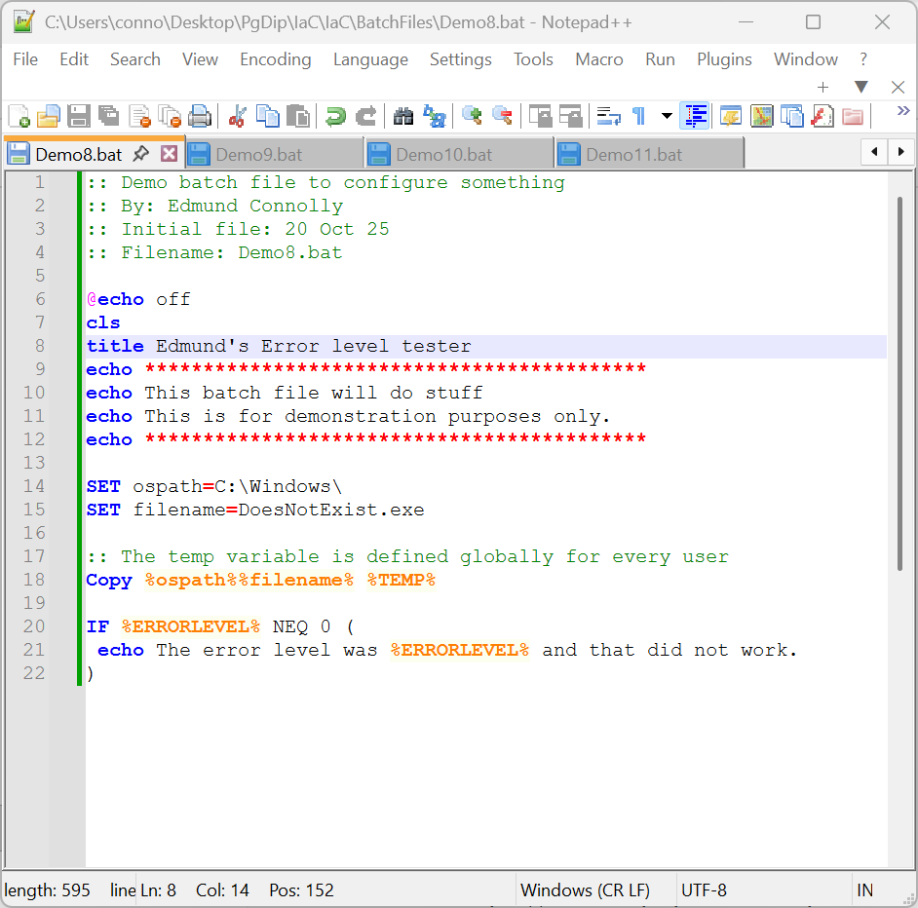
Figure 15 - Demo8.bat code screenshot

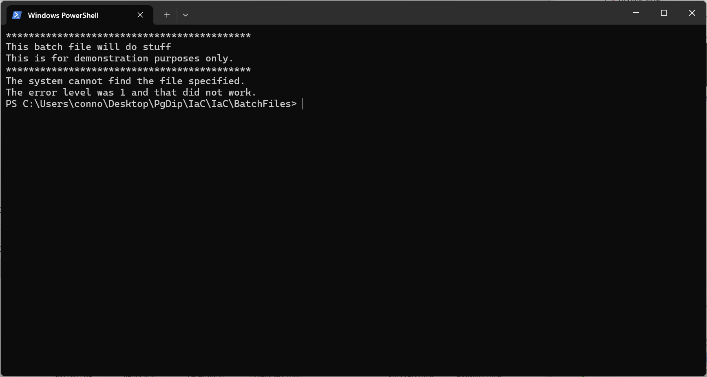
Figure 16 - Result of Demo8.bat
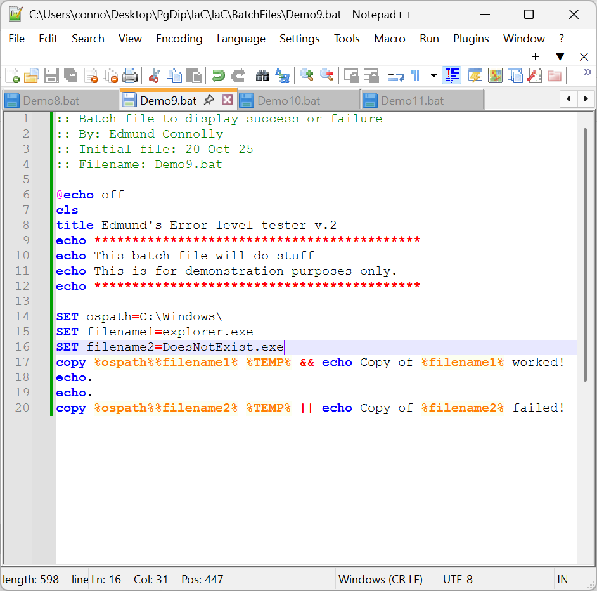
Figure 17 - Demo9.bat Code Screenshot
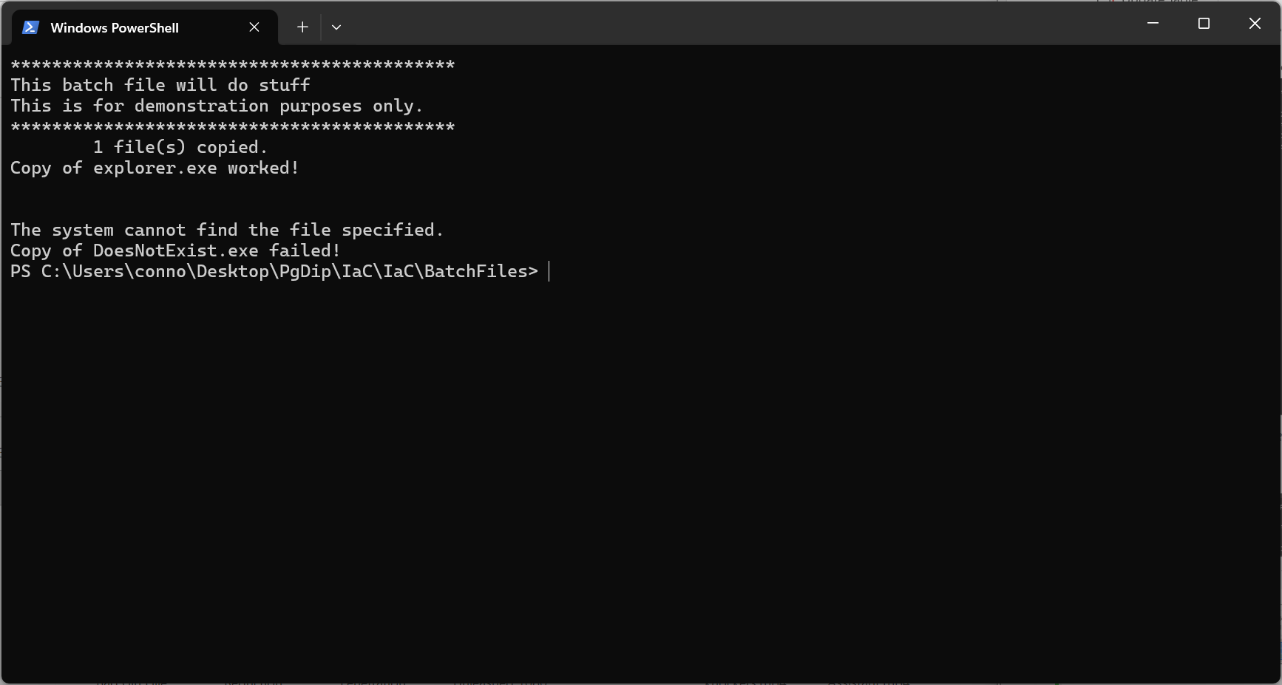
Figure 18- Result of Demo9.bat

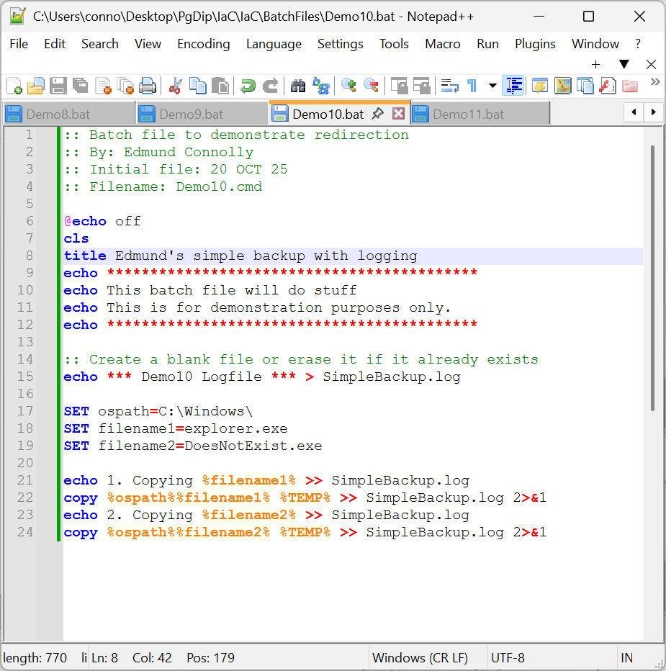
Figure 19 - Demo10.bat Code Screenshot
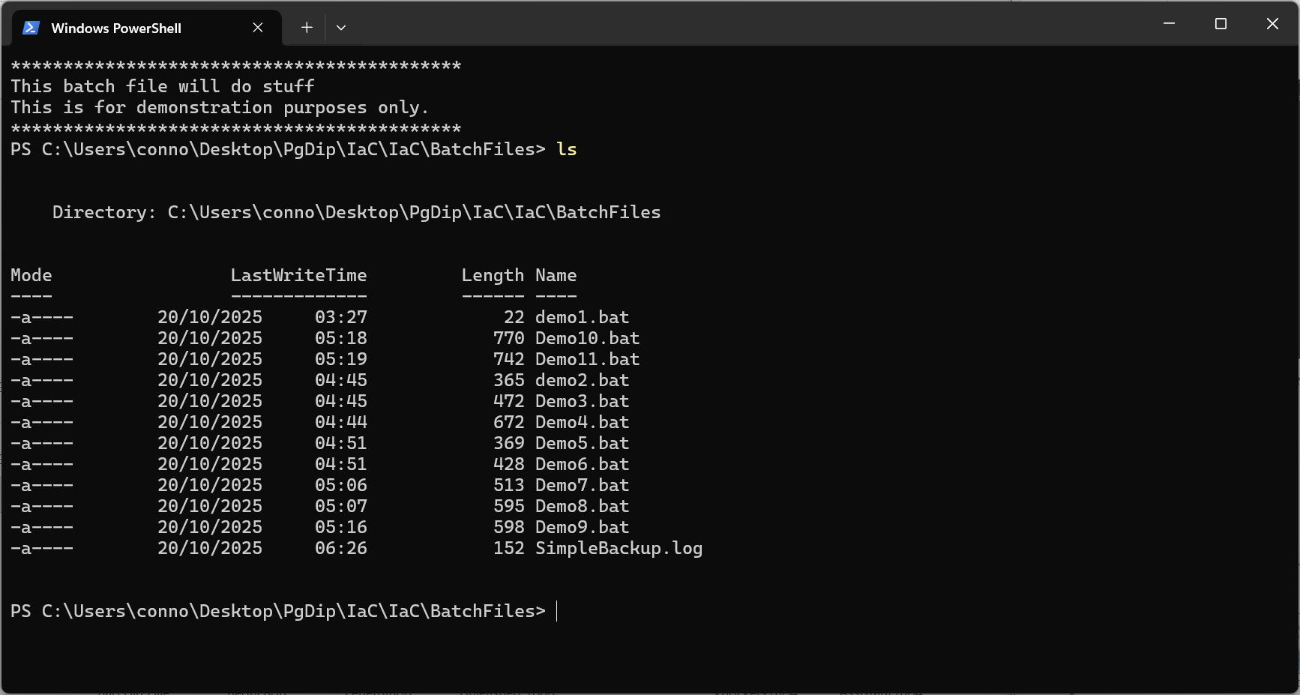
Figure 20 - Result of Demo10.bat
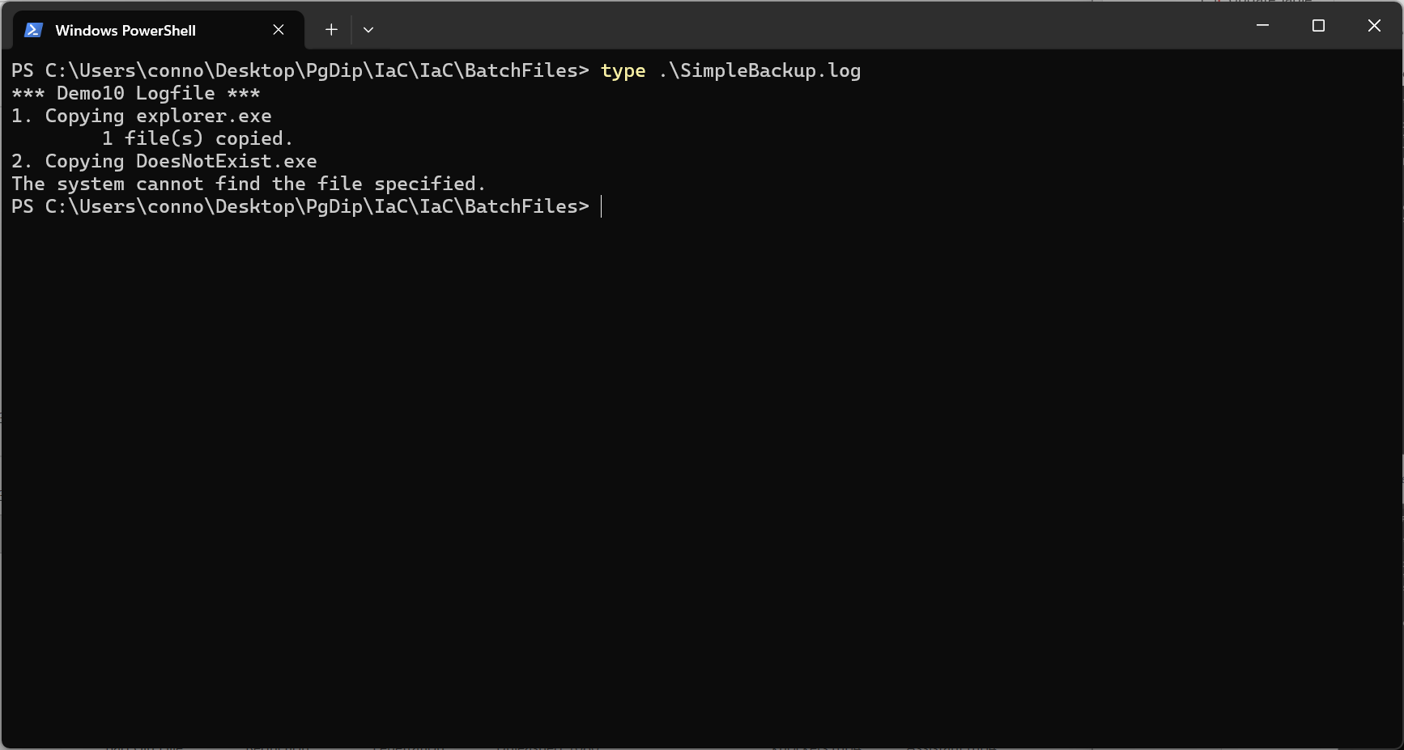
Figure 21 - Contents of SimpleBackup.log

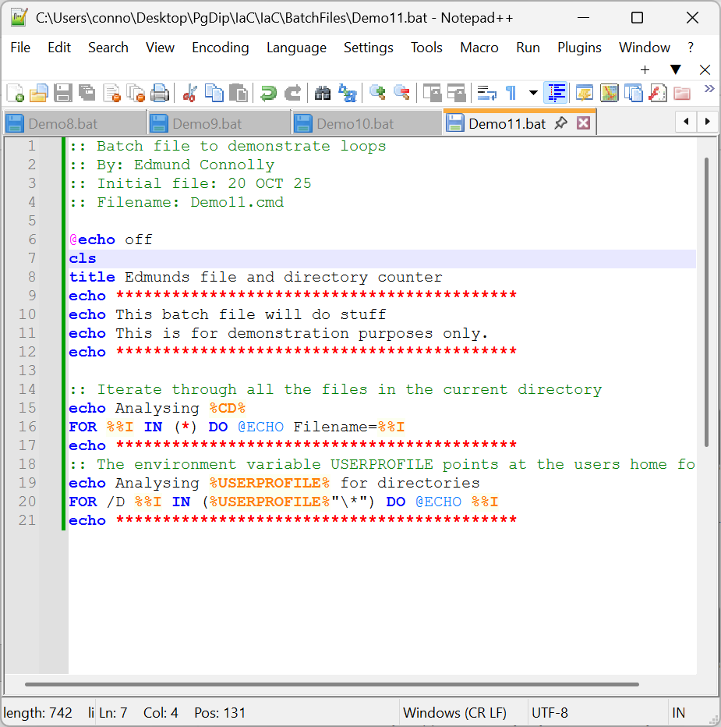
Figure 22 - Demo11.bat code screenshot

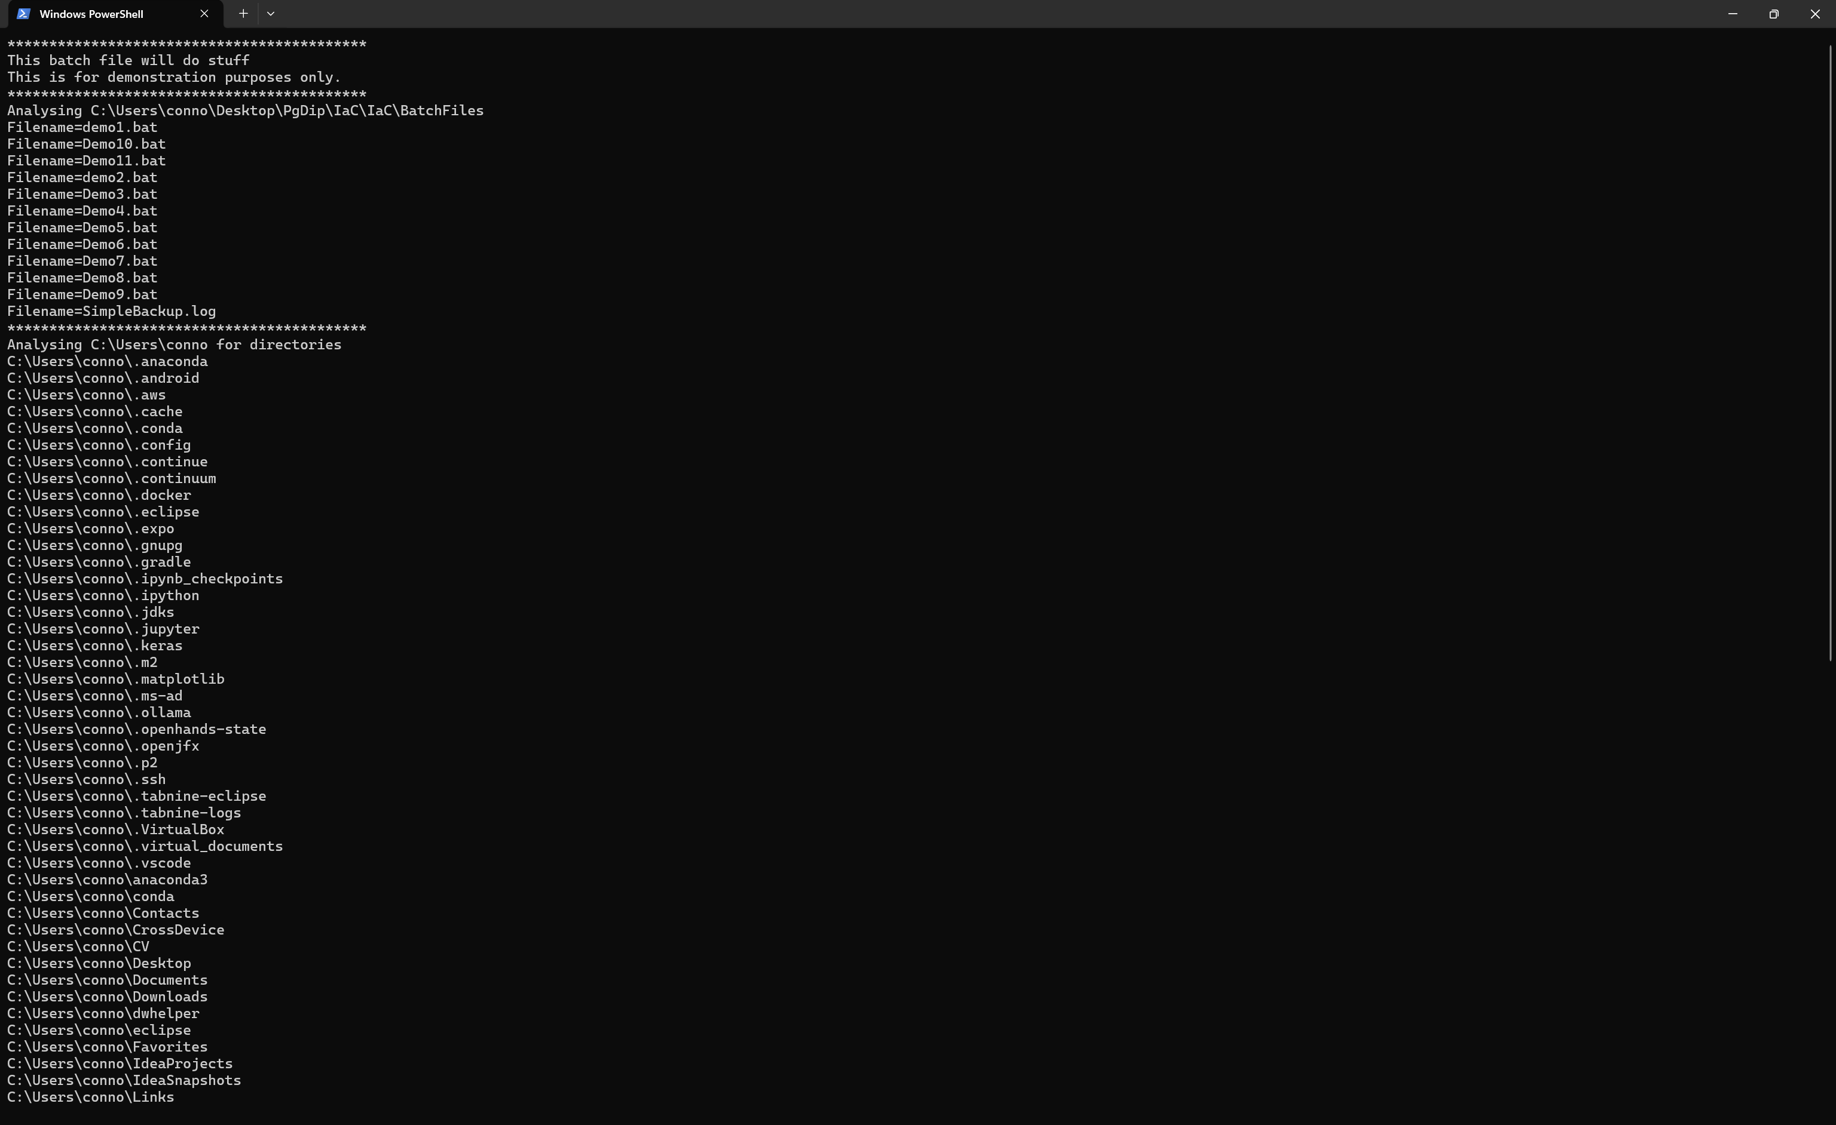
Figure 23 - Results of Demo11.bat

