LECTURER | John ORaw
STUDENT NAME | Edmund Connolly
STUDENT NUMBER | L00194727
PROGRAMME | MSc Cloud
MODULE CODE | IaC
ASSIGNMENT TITLE | Python Laboratory
SUBMISSION DATE

Student Declaration
- I have accurately identified and included the sources of all facts, ideas, opinions, and viewpoints from others in the assignment references. All direct quotations, paraphrasing, and discussions of ideas from books, journal articles, internet sources, course materials, or any other sources used are properly acknowledged and cited in the assignment references.
- I have not used unauthorised artificial intelligence tools or aids.
- I understand and am compliant with ATU's policy and procedures regarding Academic Integrity and I am aware of the consequences of any violations.
- I have followed the referencing guidelines recommended in the assignment instructions and / or programme documentation.
- By signing this form or by submitting material online I confirm that this assignment, or any part of it, has not been previously submitted by me or any other person for assessment on this or any other programme of study.
- By signing this form or by submitting material for assessment online I confirm that I have read and understood AQAE022 Academic Integrity Policy

Student Signature | Date
Edmund Connolly

Contents
Table of tables 2
Table of figures 2
Description 4
Aims 4
Method 4
Installation 4
Assignment of variables 4
Data Types 4
Floating Point Errors 4
None Keyword 4
Boolean Keyword 4
Dynamic Typing 5
Arithmetic Operators – Precedence 5
Arithmetic Operators – Mixing types 5
Results and Testing 5
Introduction 5
Assignment of variables 5
Data Types 6
Floating Point Errors 6
None Keyword 6
Boolean Keyword 6
Dynamic Typing 6
Arithmetic Operators – Precedence 6
Arithmetic Operators – Mixing types 6
Conclusions 6
References 6
Appendices 7

Table of tables
Table 1 – Python Built-in Keywords 7

Table of figures
Figure 1 – Python Version 6
Figure 2 – Assignment of variables 7
Figure 3 – Determining Type of Variables 8
Figure 4 – Floating Point Errors 8
Figure 5 - None keyword 9
Figure 6 - Boolean Types 9
Figure 7- Dynamic Typing 10

Description
Python is a powerful scripting language that is used to write scripts for Linux, Windows and Mac machines, we can use python scripts to do what DOS batch scripts, Linux Bash scripts and PowerShell scripts do. In this laboratory report we will become familiar with the basics of Python.

Aims
A short narrative followed by a numbered list of the individual aims which this report intends to address, as full sentences. Do not use bullet points, number your aims.
- To verify python version 3.x has been installed
- To write, execute and verify python code
- Become familiar with Python Enhancement Proposals (PEP’s)
- Learn about Pythons built-in keywords
- Learn about Python Data types
- Learn about precedence

Method
To execute python 3.x code, we must first install and verify that the python 3.x interpreter has been installed. Python was previously installed in the Week 4 laboratory exercise when we setup a base image with all necessary software.

Installation
To verify that python 3.x was installed, we opened a terminal window and entered the command python -V, -V is a flag to tell python to return its currently installed version, this resulted in Python 3.12.6 being echoed in the terminal confirming that python 3.12.6 is installed.

Assignment of variables
To assign a value to a variable I use the assignment operator which is =, on the left hand side of = is the variable to which we are going to assign the value which is on the right hand side of the operator. Thus a = 2, assigns the value 2 to the variable a. I can’t assign values to python’s built-in keywords which are shown in Table 1, this means I can’t use the built-in keywords as variable names

Data Types
Python variables have data types, some of the mainly used datatypes are strings which are used to represent alphanumeric characters, integers are used to represent whole numbers and floats are used to represent floating point numbers which are numbers with a decimal part.

Floating Point Errors
To test floating point errors, I preformed the following assignment of 0.1 + 0.1 + 0.1 then I look at the result, we can see that the result isn’t equal to exactly 0.3, theres a small error this is called a floating point error.

None Keyword
To investigate the None data type, I first assign a variable with the None key word, I then check its datatype. The None keyword is used to define a null value or no value, in python it is a datatype.

Boolean Keyword
To investigate the Boolean data type, I assign variable a to be True, then I check the variables data type, and it states it’s a bool type.

Dynamic Typing
Dynamic Typing is when it’s possible to change a variables datatype to a different datatype. To do dynamic typing I just assign a variable a new / different type from what it was before e.g. int to float.

Arithmetic Operators – Precedence
To examine how python deals with precedence, we used two similar formulas with the difference being we use brackets to change the precedence thereby giving two very different results.

Arithmetic Operators – Mixing types
To examine what happens when trying to mix types, we created a variable a and tried to assign it the string “JOR” and add the floating point value 3/2.

Arithmetic Operators – Modulus and Floor Division
For this part I perform 3 different operations. The first one is ordinary division and uses /, the second is modulus which returns the remainder from division i.e. the bit left over it is performed using %. The 3rd is floor division, which first divides and then the result is rounded down to the nearest whole number integer.

Comparison Operators
To test the result from the 6 different comparison operations we ran different statements in the python interpreter.
  - == is used to test two value are equal
  - != is used to test two value are not equal
  - > is used to check if a value is greater than the other value
  - < is used to check if a value is smaller than the other value
  - >= is used to check if a value is greater than or equal to another value
  - <= is used to check if a value is less than or equal to another value

Logical and Boolean Operators
To test Logical and Boolean operations, I gave the python interpreter 4 different instructions
  - The first used and which is True when both statements are True
  - The second used or which is True when either statement is True
  - Not inverts statements result
  - In returns True if a value is in the sequence

Coding with Operators
I first created a file in Notepad++ called add.py and then entered the code to add 2 + 1 together and assign the value to a, then I printed out the result, this code can be seen in figure 13.
In figure 14 we can see the code written in Notepad++ and the results for the arithmetic operations.
In figure 15 we can see the code for budget.py which uses arithmetic operations to calculate a budget.

Coding with Strings
To test string splicing I wrote a small script as shown in figure 16 it initialises the variable a with the string “Greetings!”. I then do 3 different splices. I splice from the start which is 0 to the 3rd character, and go up in steps of 1 character. I then do a new slice this time in reverse starting at the end which is -1 to the -4th character and decrease in steps of 1. Finally, I slice out an individual character which is the 5th
In figure 17, I created a new string using splicing from another string with value “John” and string concatenation. I first took the first two letters of “John”, then I concatenate that with the letter a and finally I concatenate with the last letter of “John” the n the result is “Joan”. Then I concatenate the letters l and 4 which are both strings and get “l4” finally I use + on ints but this time I get the sum as our result.

Coding with Strings – String Interpolation
In figure 18 I have coded different String features, the first is simple concatenation of a string with a variable. Then I create strings and use the format function to say what variable I want to insert then I use curly brackets {} to indicate where in the string to insert the variables value. We can specify how many decimal points a variable should be displayed by providing a float and declaring the value:width.precision in the curly {}. Finally we make a f-string, this is where we declare a string with f at the start and variable names in the curly brackets e.g. f”hello {name}”.

Coding with Strings – Escape Sequences
Figure 19’s code is used to explore escape sequences. I look at the default behaviour of the print function, I turn off the default behaviour of using a newline and finally I add an escape sequence for a new line.

Coding with Strings – String Functions
Figure 20 has code related to string functions, first I declare a string and then use the len function to find out how long the string is. Then I use the string function upper and lower to convert the string to upper and lower case strings. Then I declare a string with leading and trailing spaces, to remove the spaces I use the string strip function. Lastly I declare a string with brackets ( ) and use the strip function to remove the ( and ) brackets.

Results and Testing
Briefly introduce the section and define the tests which are performed.
The results of the work must be presented here in an appropriate form. Any filtering or removal of data must be declared and explained. If a system is being created, the test procedure and result must be given. If many tables or diagrams are required, these diagrams should be individually labelled, included in appendix B, and referenced from here.
The results/testing section of a report should allow a peer to replicate and verify the results obtained.
Number every figure or table. Do not include any figure or table which you do not discuss.

Introduction
The result of running python -V is shown in figure 1, we can see the currently installed python version is 3.12.6

Assignment of variables
The result of assigning a value to the variable a is shown figure 2, I perform a sum of 2 + 1 and assign it to a, when I print out the value of a I get the result of 2 + 1 which is 3.

Data Types
The results of executing code to demonstrate different variables data types are shown in figure 3. It first assigns a whole number of 300 to the variable a, it then prints its type which is an integer as it’s a whole number. It then creates a new variable of b =2.134 which has a decimal part and thus is stored in a float.

Floating Point Errors
Figure 4 shows the results of adding 3 floating point values 0.1 + 0.1 + 0.1 shows an incorrect value, this is because a computer is fundamentally an integer machine and some floating-point numbers it cannot accurately represent; thus I get a small incorrect fractional part.

None Keyword
In figure 5, I assign a variable using the keyword None, I then check its type its reported as the None type.

Boolean Keyword
In figure 6, I set the variable a to be True, True is a Boolean object, when I look at the data type of a it says its it is of class bool.

Dynamic Typing
In figure 7, I preform dynamic typing, initially dog is a int type, but later I change it to a string type.

Arithmetic Operators – Precedence
In figure 8, the result is changed by adding brackets which changes the precedence of how the result is calculated. For 10 * 2 + 3 * 5, the multiplications are first carried out than the addition, so I get 20 + 15 then when we add this and get 35. For 10 * (2 + 3) * 5, the addition in the brackets is carried out first so I get 10 * 5 * 5, then I multiply and get 50 * 5 and 1 last multiplication gives 250. This proves precedence is important for how python performs calculations.

Arithmetic Operators – Mixing types
In figure 9, I see the result of trying to add a float type to a string type, this results in an error message saying you can only concatenate str (not float) to str.

Arithmetic Operators – Modulus and Floor Division
In figure 10, I have the results for performing 3 different operations. The first one is ordinary division and uses /, the second is modulus which returns the remainder from division i.e. the bit left over it is performed using %. The 3rd is floor division, which first divides and then the result is rounded down to the nearest whole number integer.

Comparison Operators
In figure 11 I can see the result from performing 6 different comparison operators.

Logical and Boolean Operators
In figure 12 are the results from performing 4 different Logical and Boolean Operations

Coding with Operators
In figure 13 is the result from adding 1+2 and assigning it to a variable called a and then print it out, it can be seen that the result is 3 which is correct.
In figure 14 after running the code I can see the results for arithmetic operations
In figure 15 I can see the budget says I have 170 left over after running it.

Coding with Strings
In figure 16 are the results for string splicing the String “Greetings!”
  - For a[0:4:1] – the result is Gree
  - For a[-1:-5:-1] – the result is !sgn
  - For a[5] the result is i
In figure 17 are the results for concatenating strings using +, and for adding ints using +.

Coding with Strings – String Interpolation
In figure 18 I can see the results from execution of code written in Notepad++ also shown in figure 18. I print a string using standard concatenation, then we use the format function to print out strings, Finally I looked at f-strings

Coding with Strings – Escape Sequences
Figure 19 has the results for using escape sequences I see the default operation of the print function is to use a newline at the end, this can be turned off by using end = “ “ in the print function. Finally I can add a newline by using the escape sequence \n in the string.

Coding with Strings – String Functions
Figure 20 shows the results of various string functions, it shows the length of the string passed to the len function is 39. It then takes the original string all converts it to all uppercase and lowercase. Using the strip function its default is to strip whitespace, finally I use strip to remove brackets ( and ) by passing it to the strip function.

Conclusions
It should be confirmed if the aims have been met, based on the results or testing. Evidence of independent research should be provided and cited from the text. The conclusion should show an understanding of why the work was significant. Most marks go for the conclusion, this section should be substantial.
ASCII

References
Any external research referenced should be documented here, in an accepted format. The Institute standard is Harvard, I prefer IEEE referencing for short papers and reports. Either is acceptable but be consistent.

Appendices
Each The appendix will contain numbered and labelled diagrams and tables. You must cite any figure or table from the text of the report.
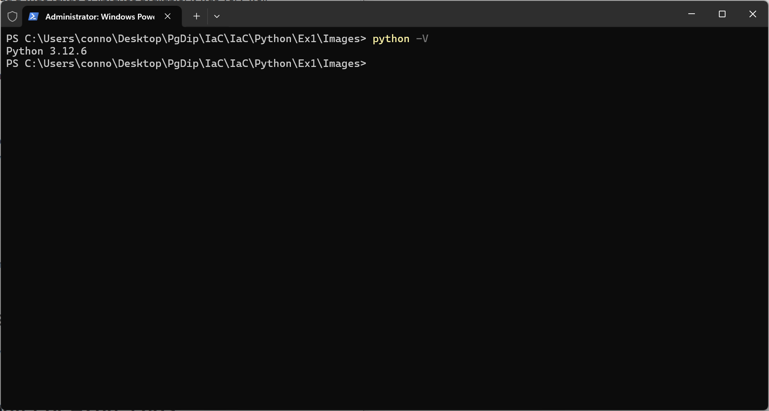
Figure 1 – Python Version
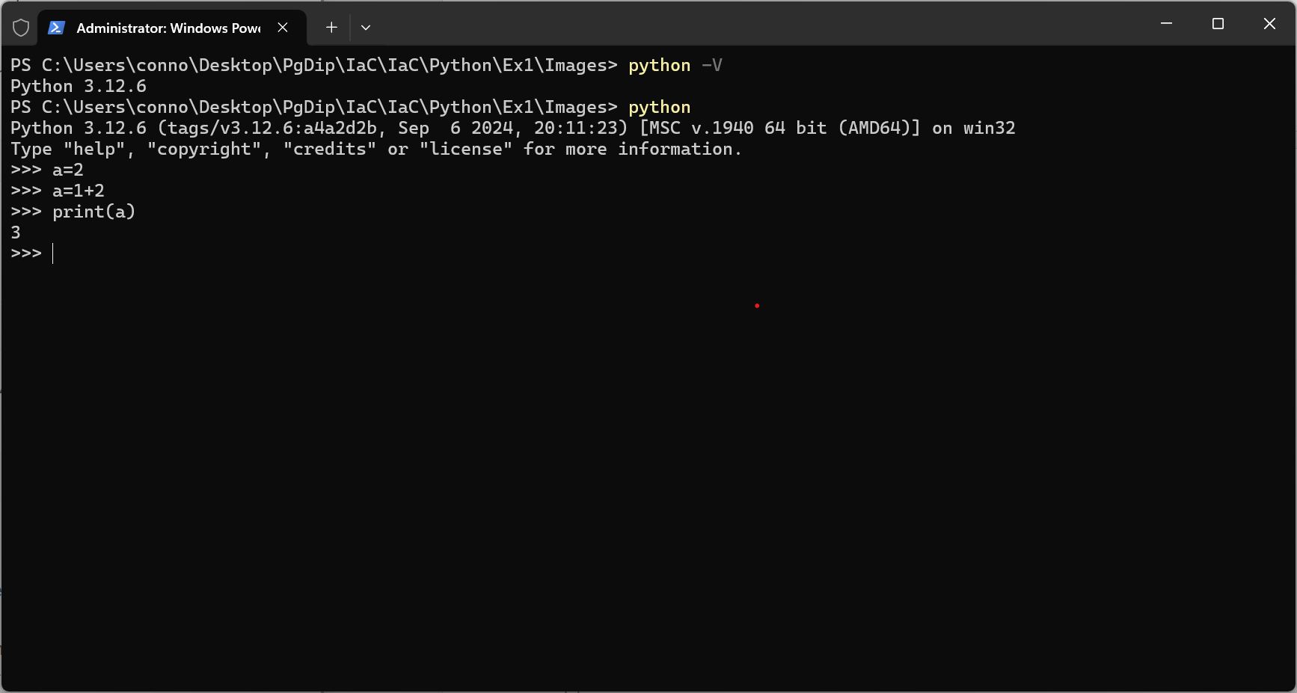
Figure 2 – Assignment of variables

False | await | else | import | pass
None | break | except | in | raise
True | class | finally | is | return
and | continue | for | lambda | try
as | def | from | nonlocal | while
assert | del | global | not | with
async | elif | if | or | yield
Table 1 – Python Built-in Keywords

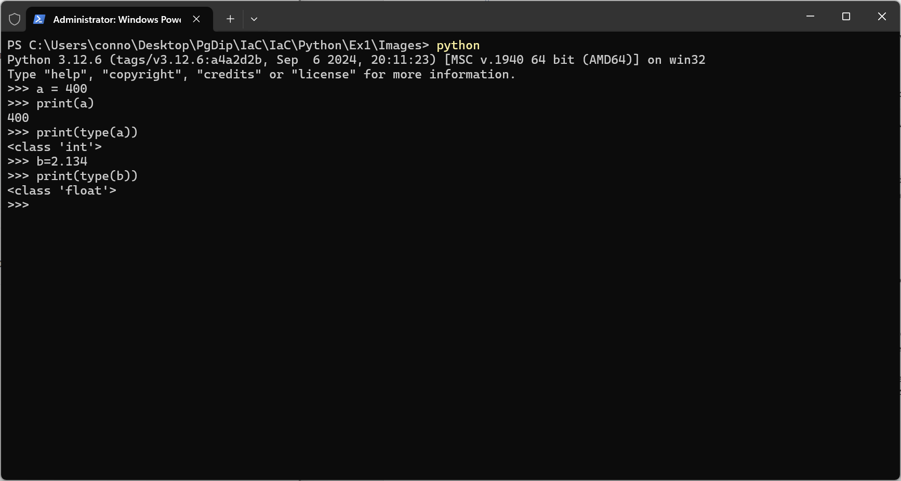
Figure 3 – Determining Type of Variables
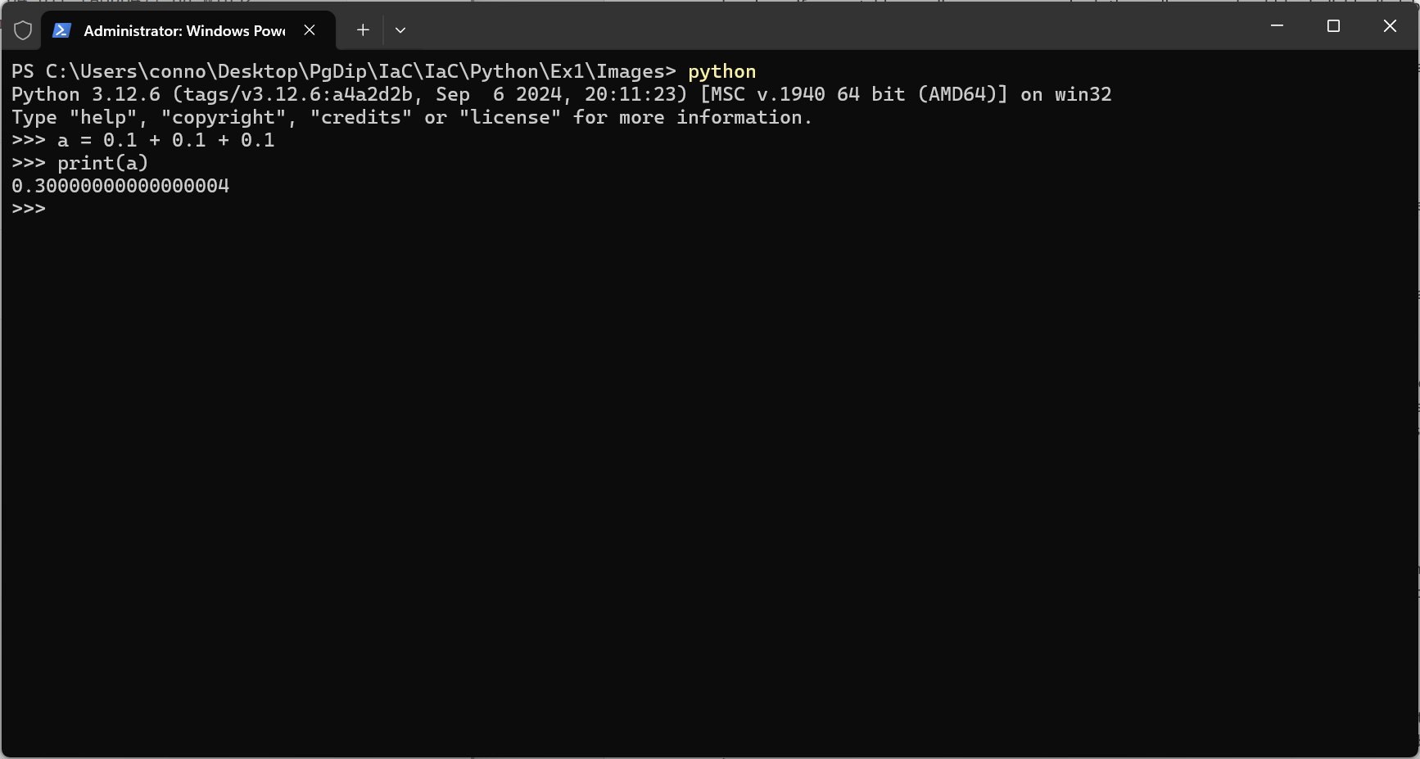
Figure 4 – Floating Point Errors

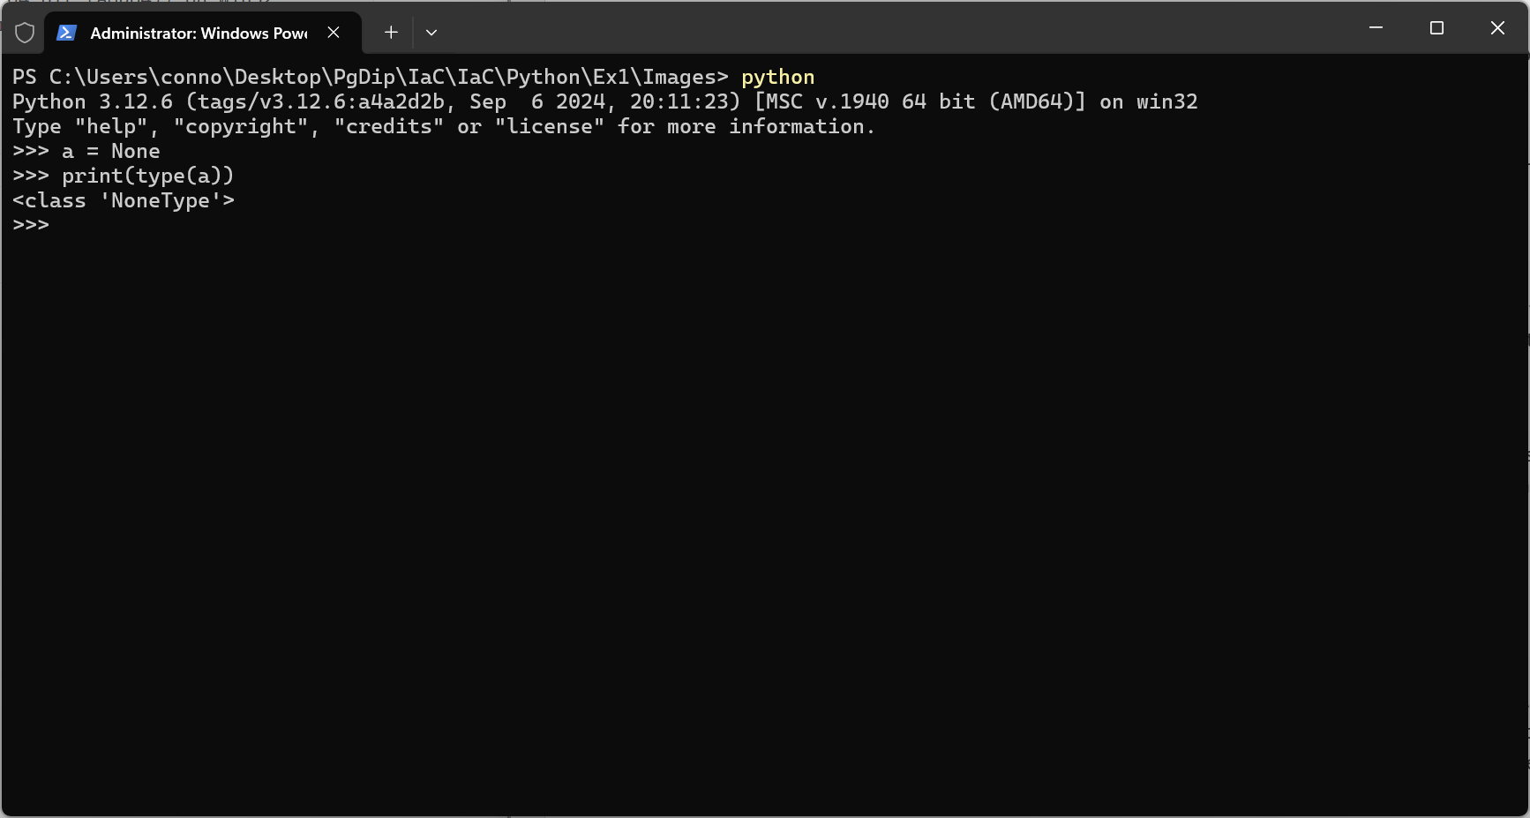
Figure 5 - None keyword
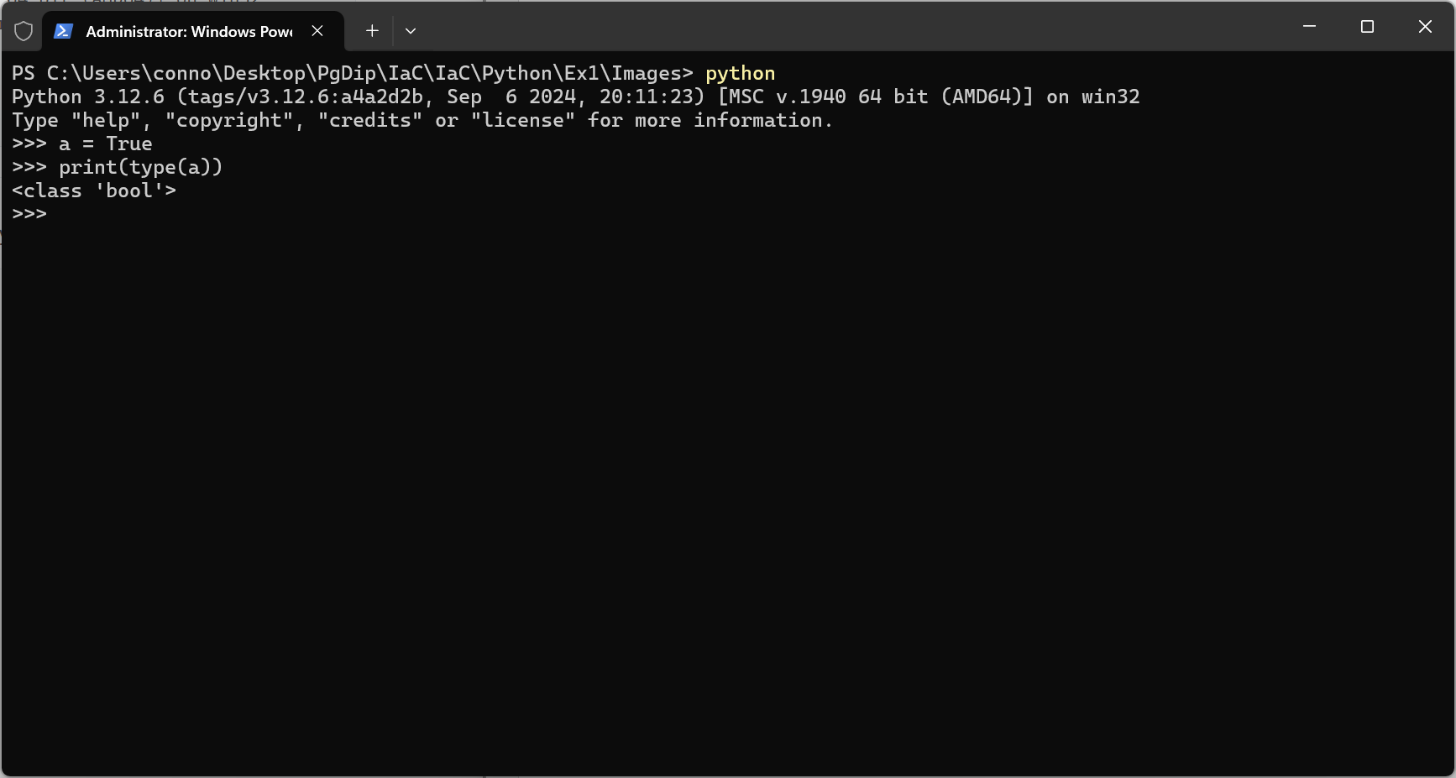
Figure 6 - Boolean Types

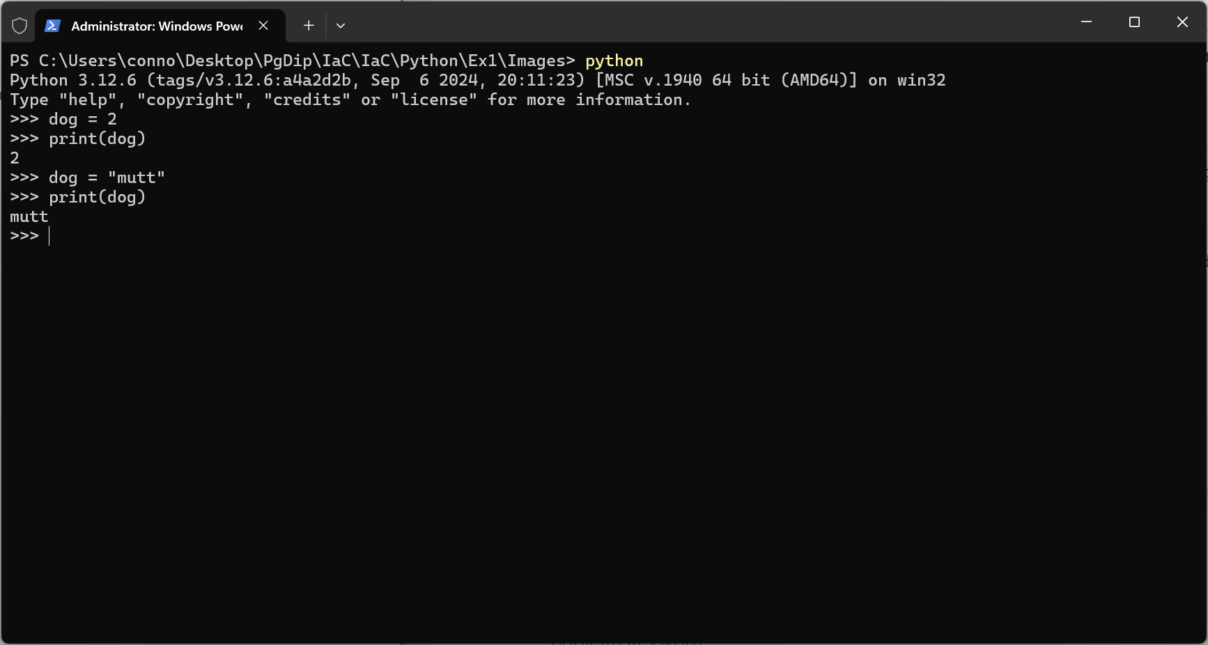
Figure 7- Dynamic Typing
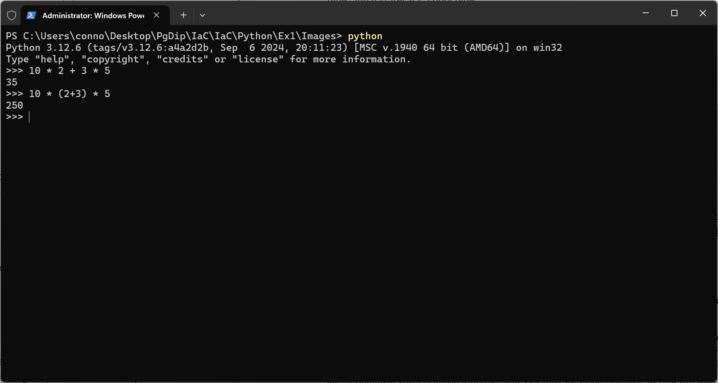
Figure 8 – Precedence

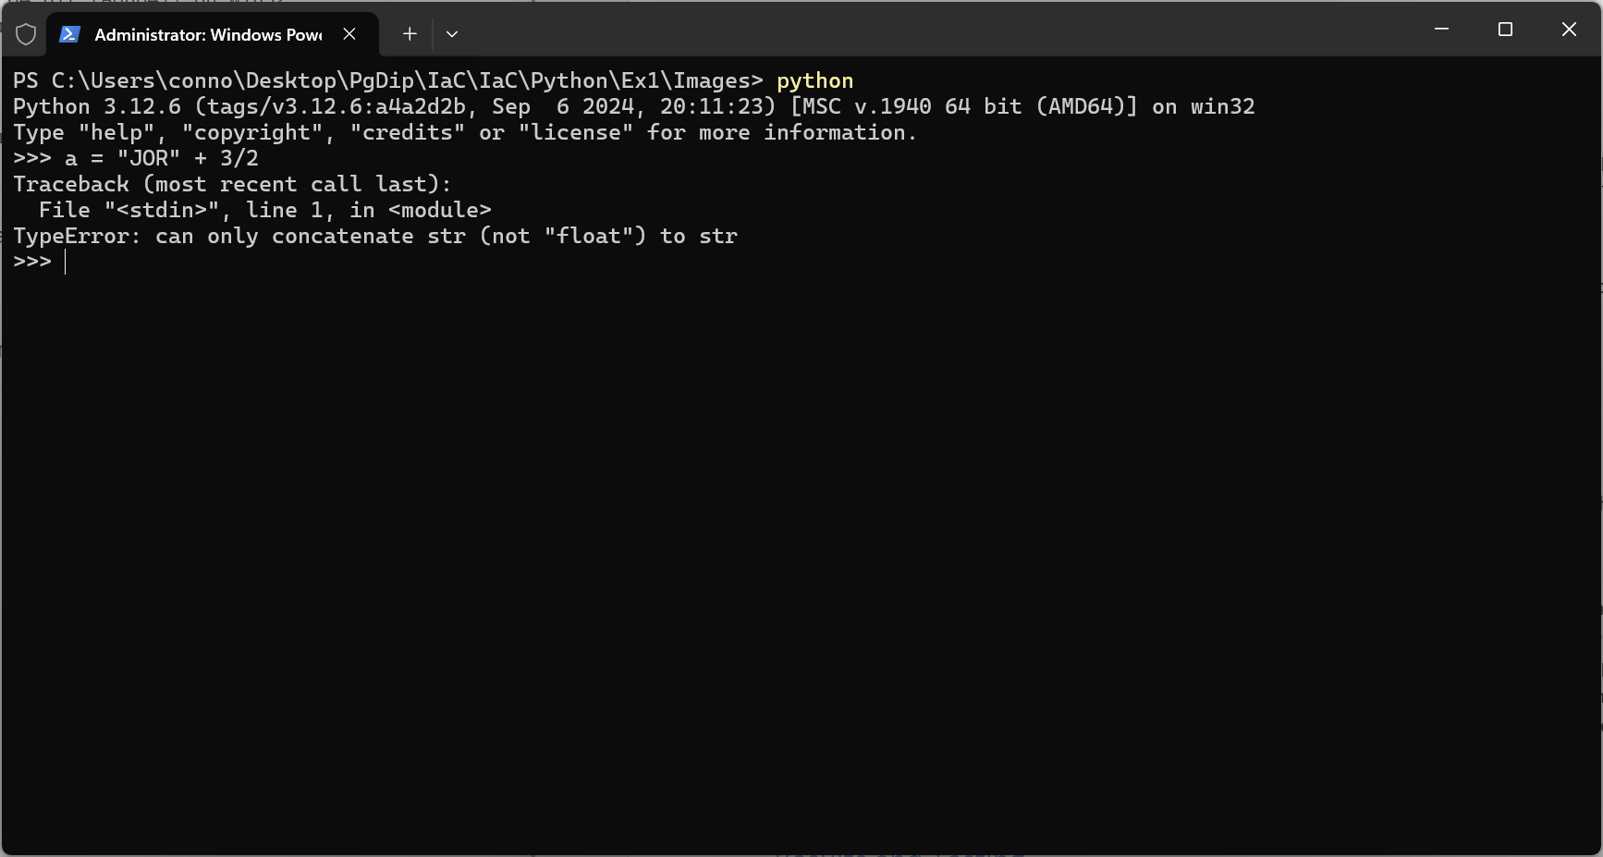Figure 9 - Mixing Types
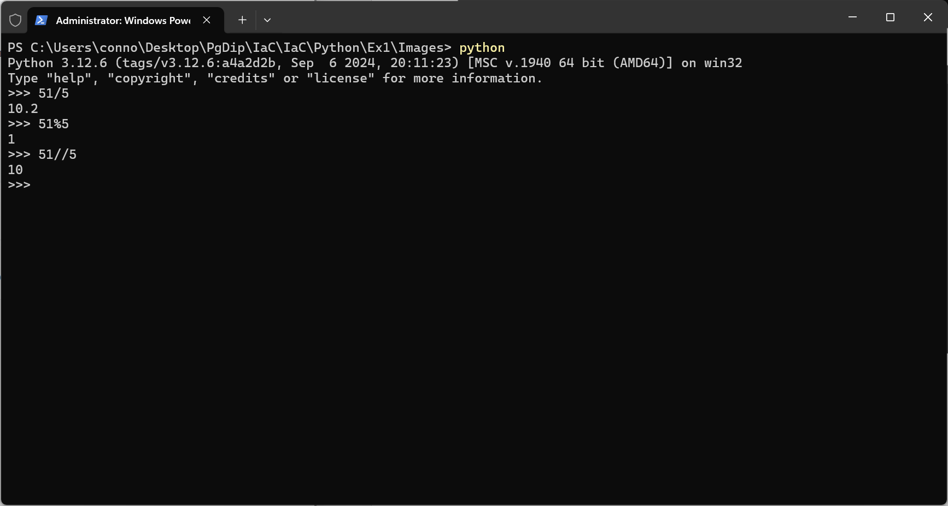
Figure 10 - Modulus and Floor Division

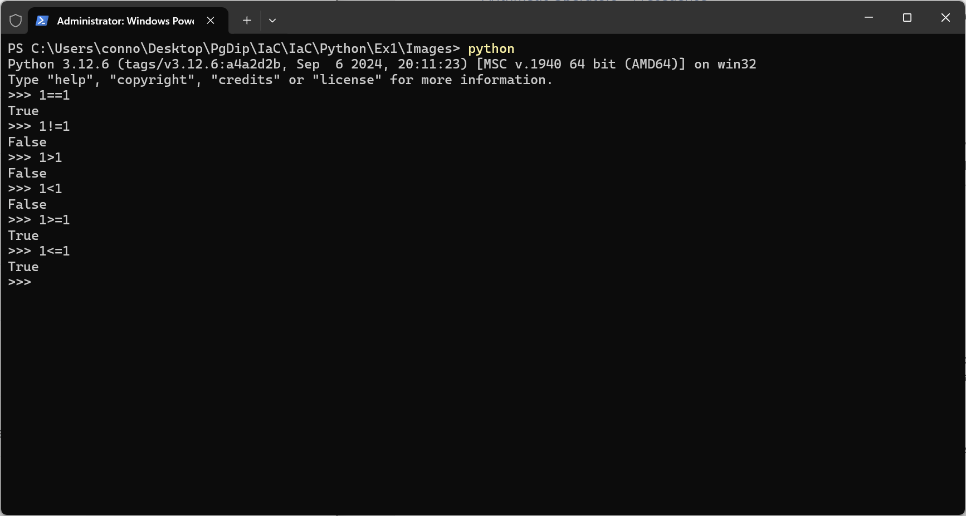
Figure 11- Comparison Operators
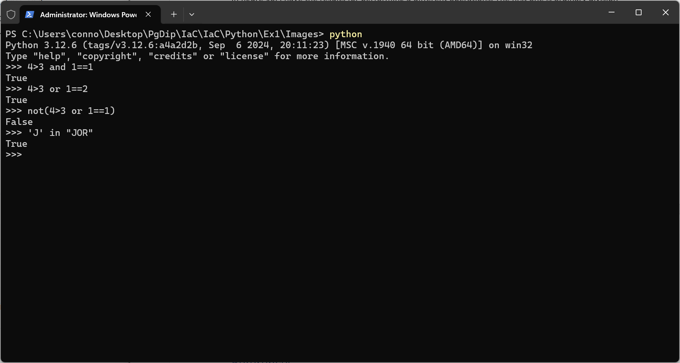
Figure 12 - Logical and Boolean Operators

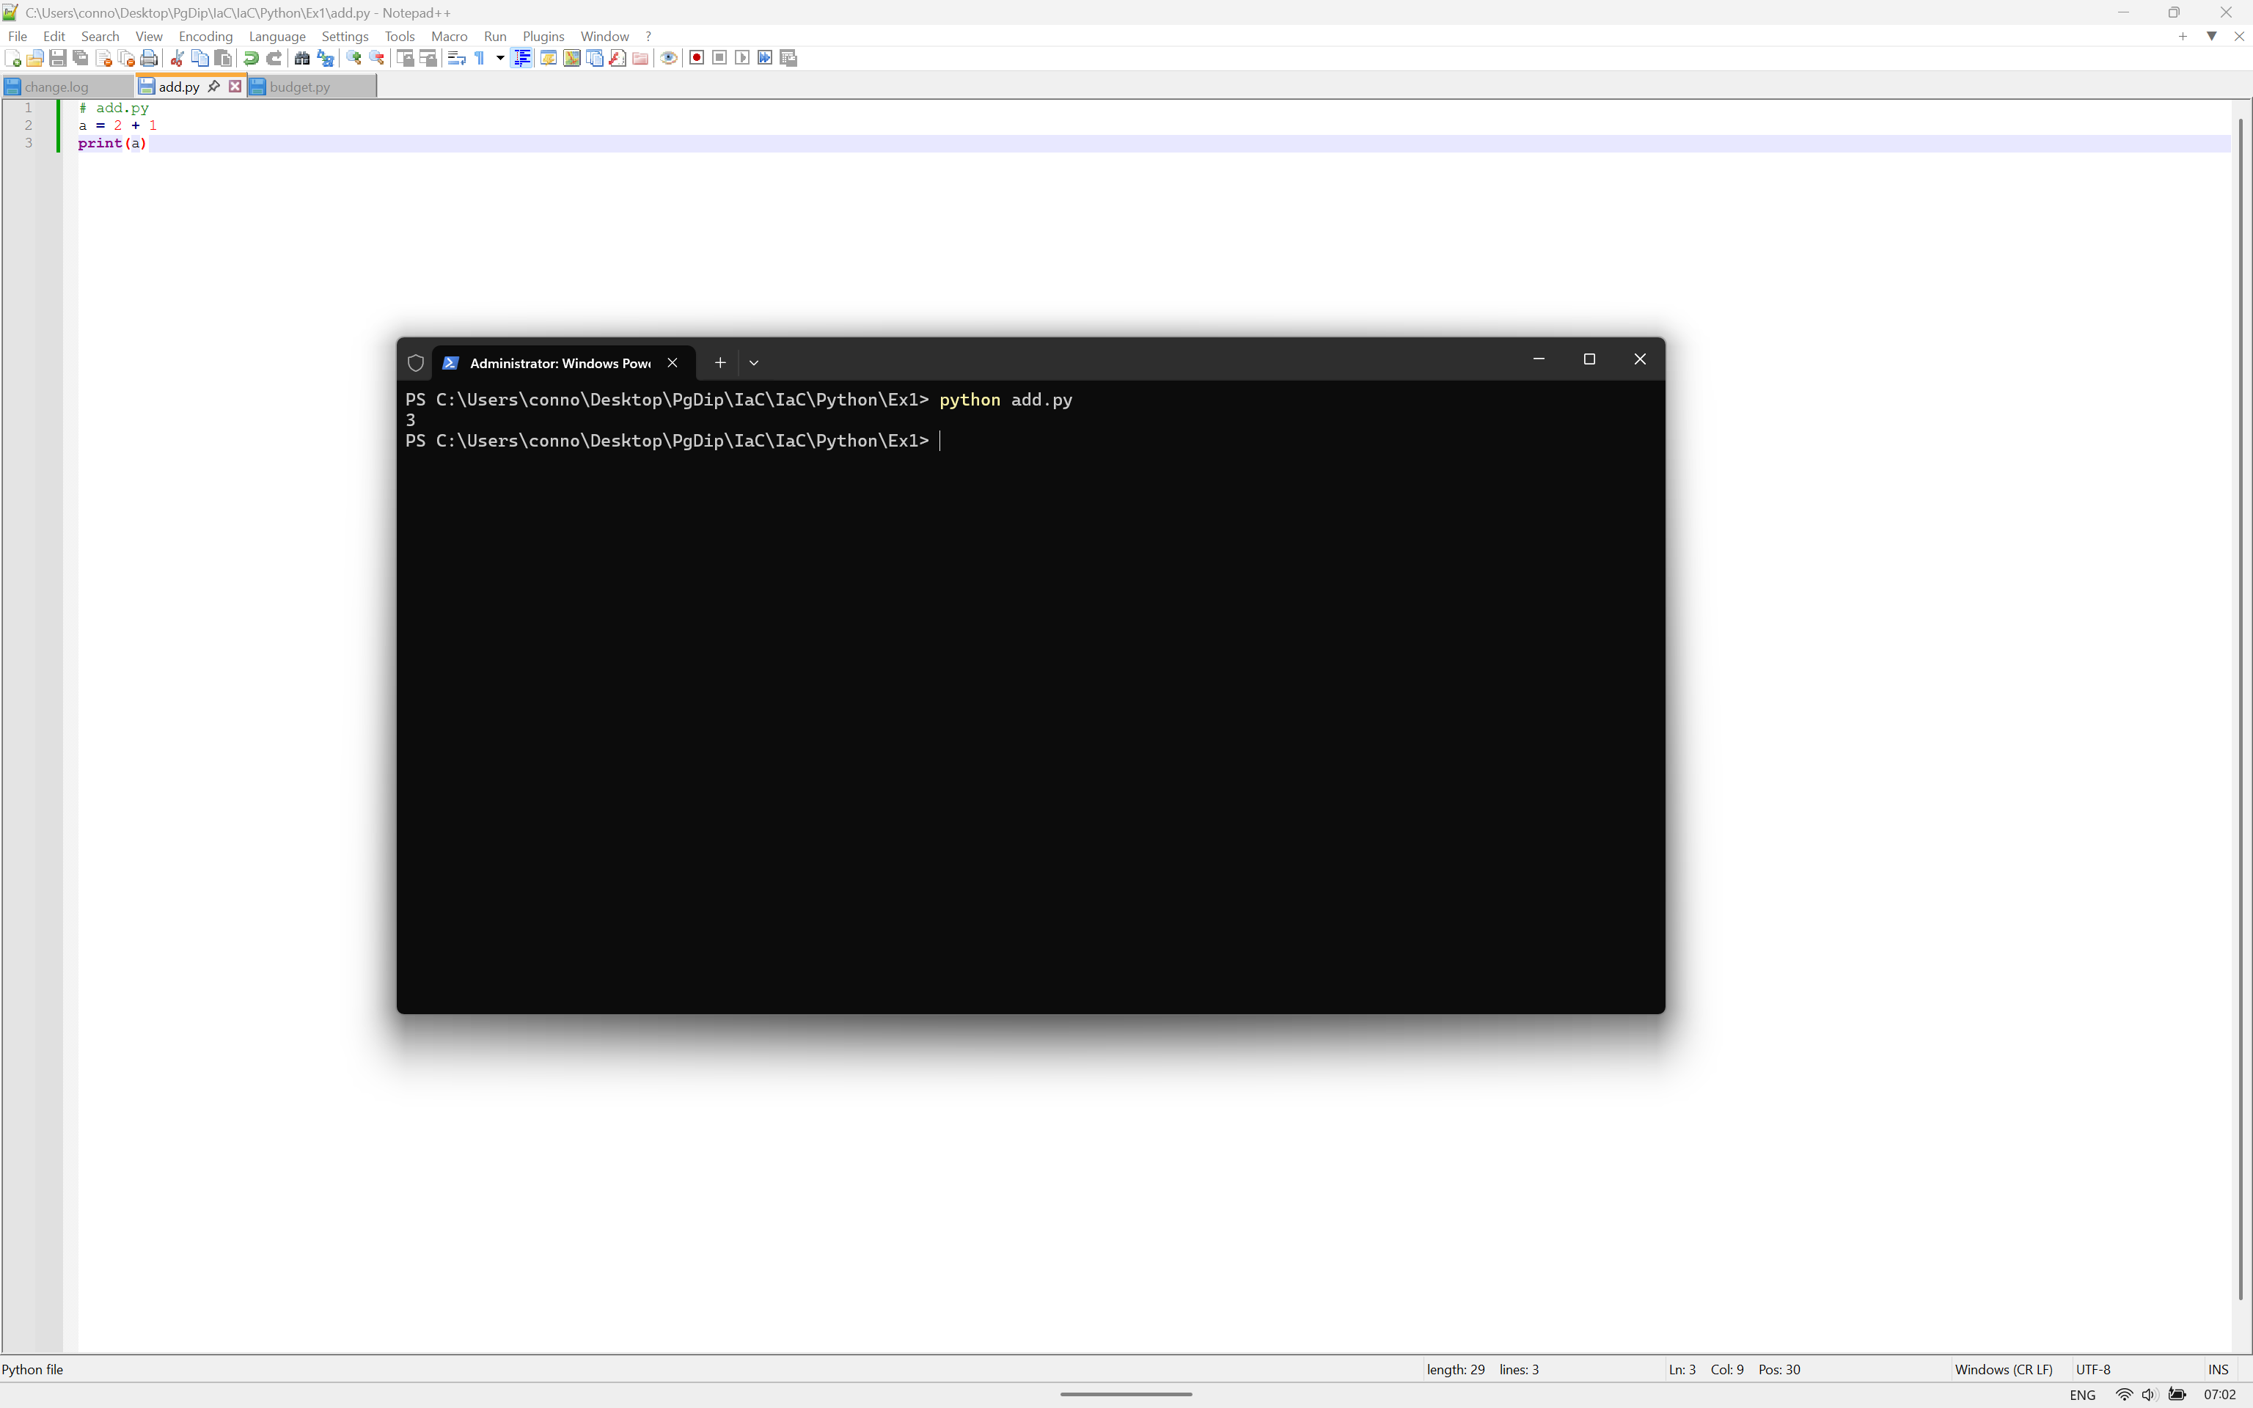
Figure 13 - add.py
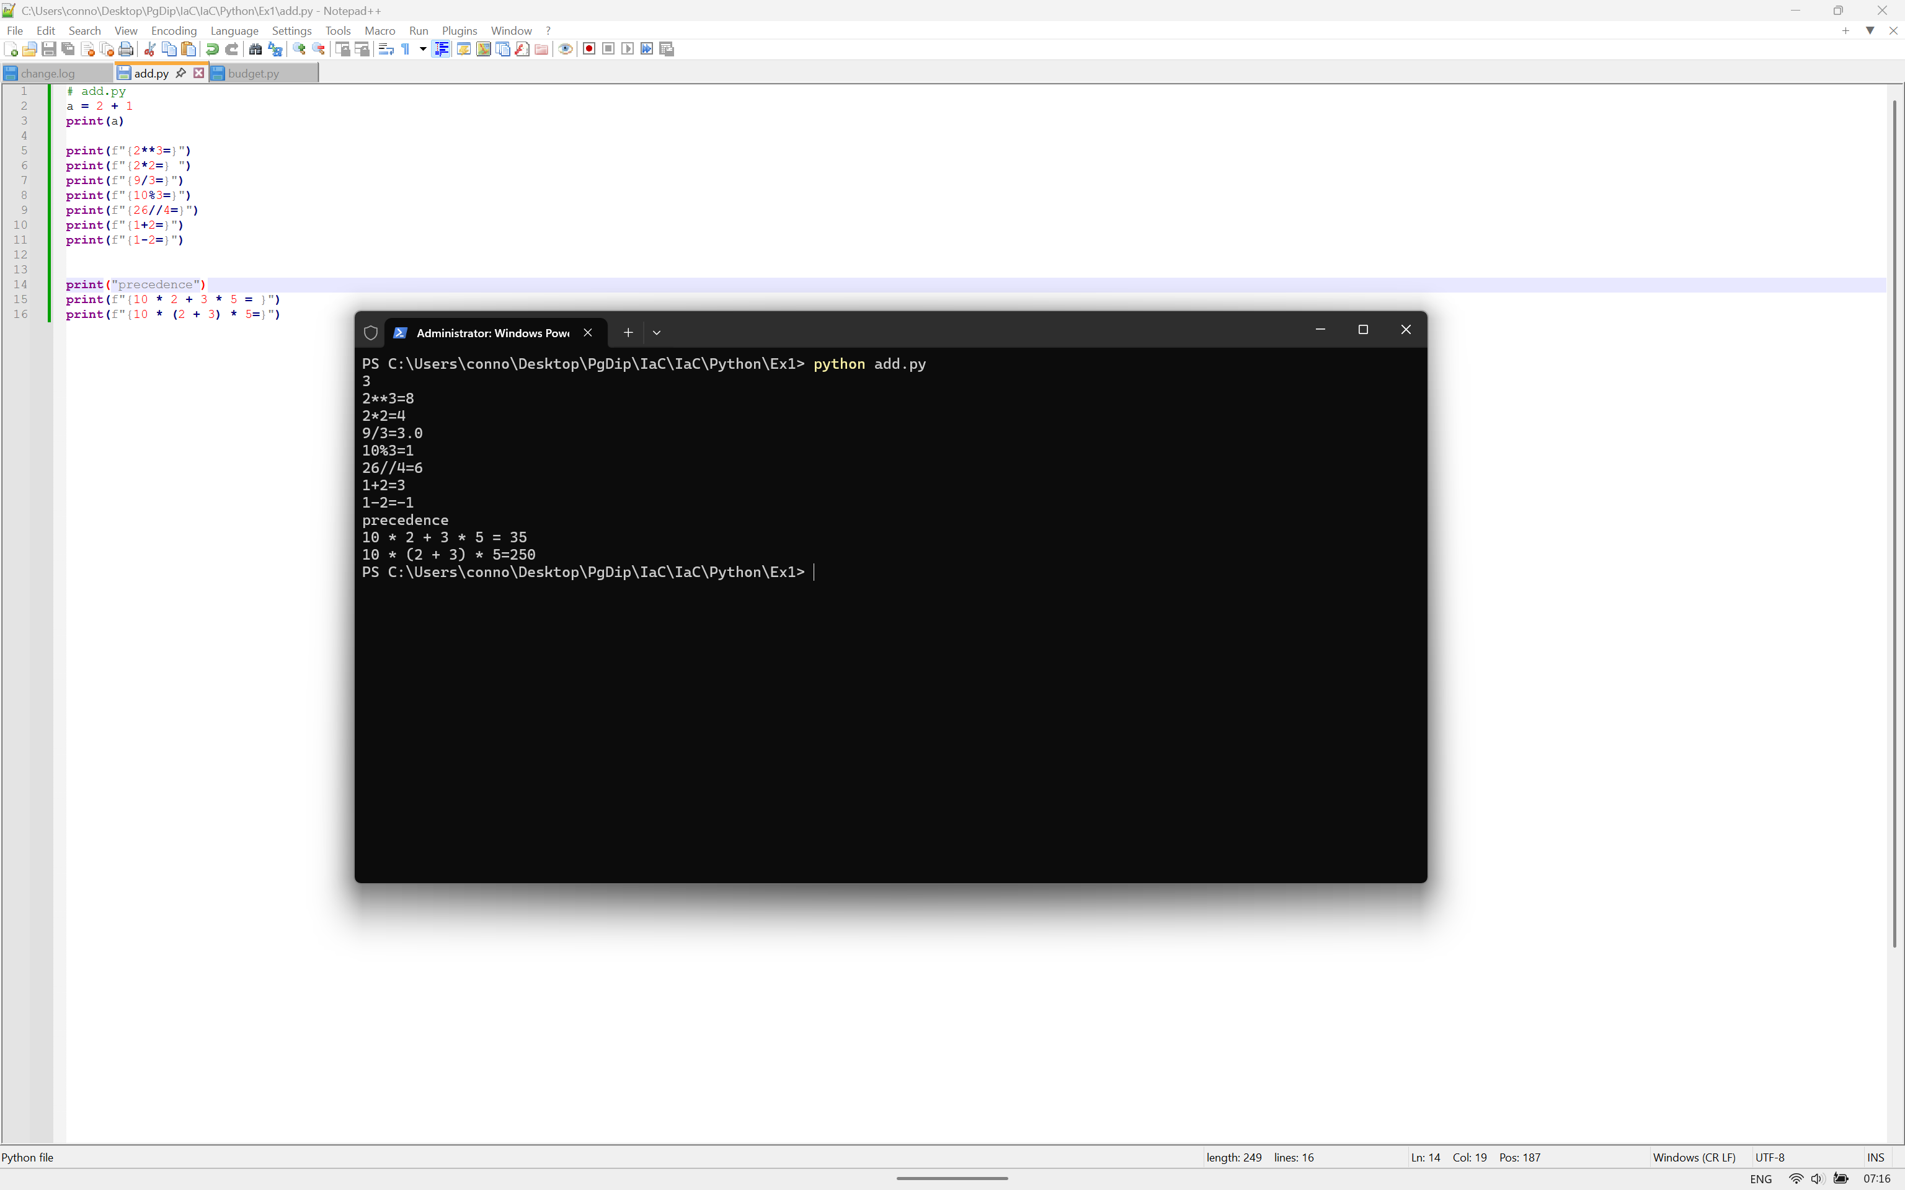
Figure 14 - Arithmetic Operations

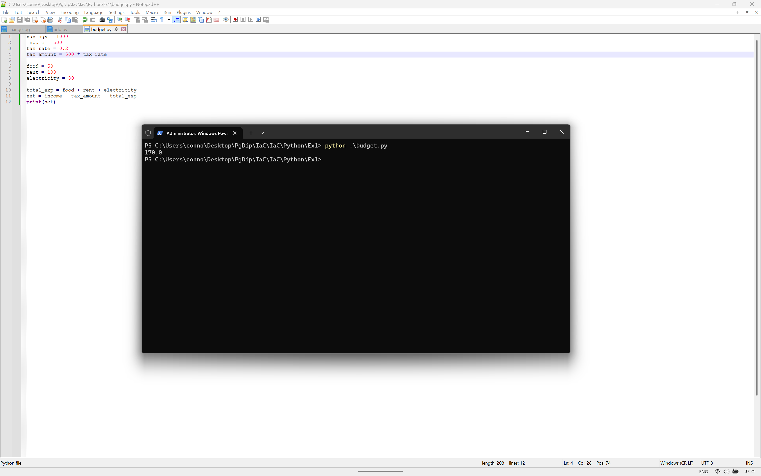
Figure 15 - Budget.py

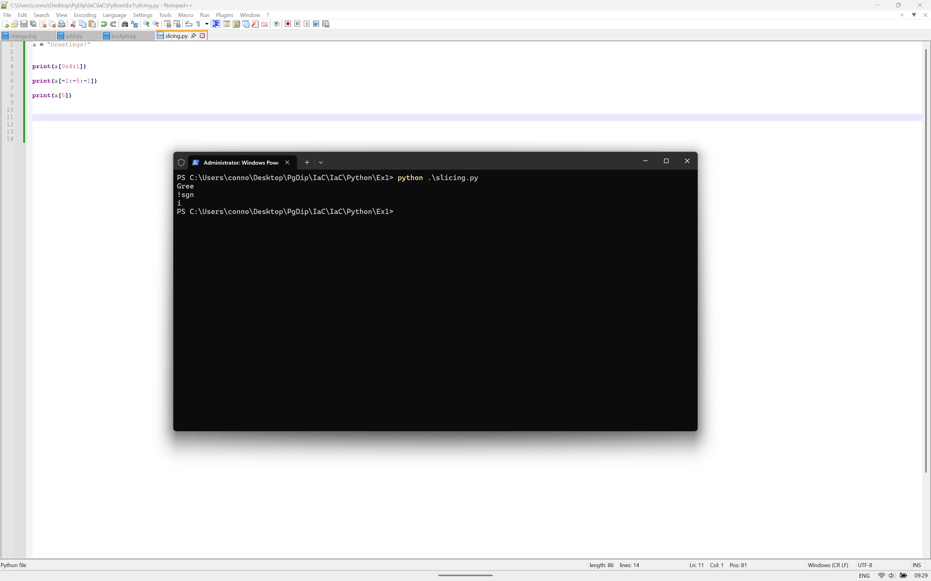
Figure 16 - String Slicing

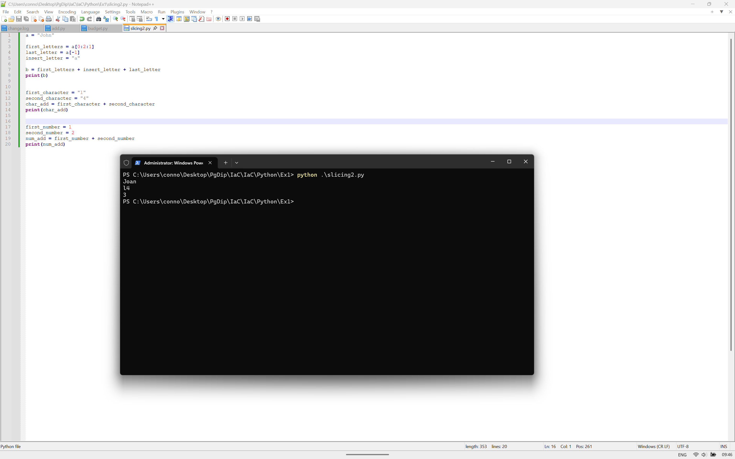
Figure 17 - String Slicing 2
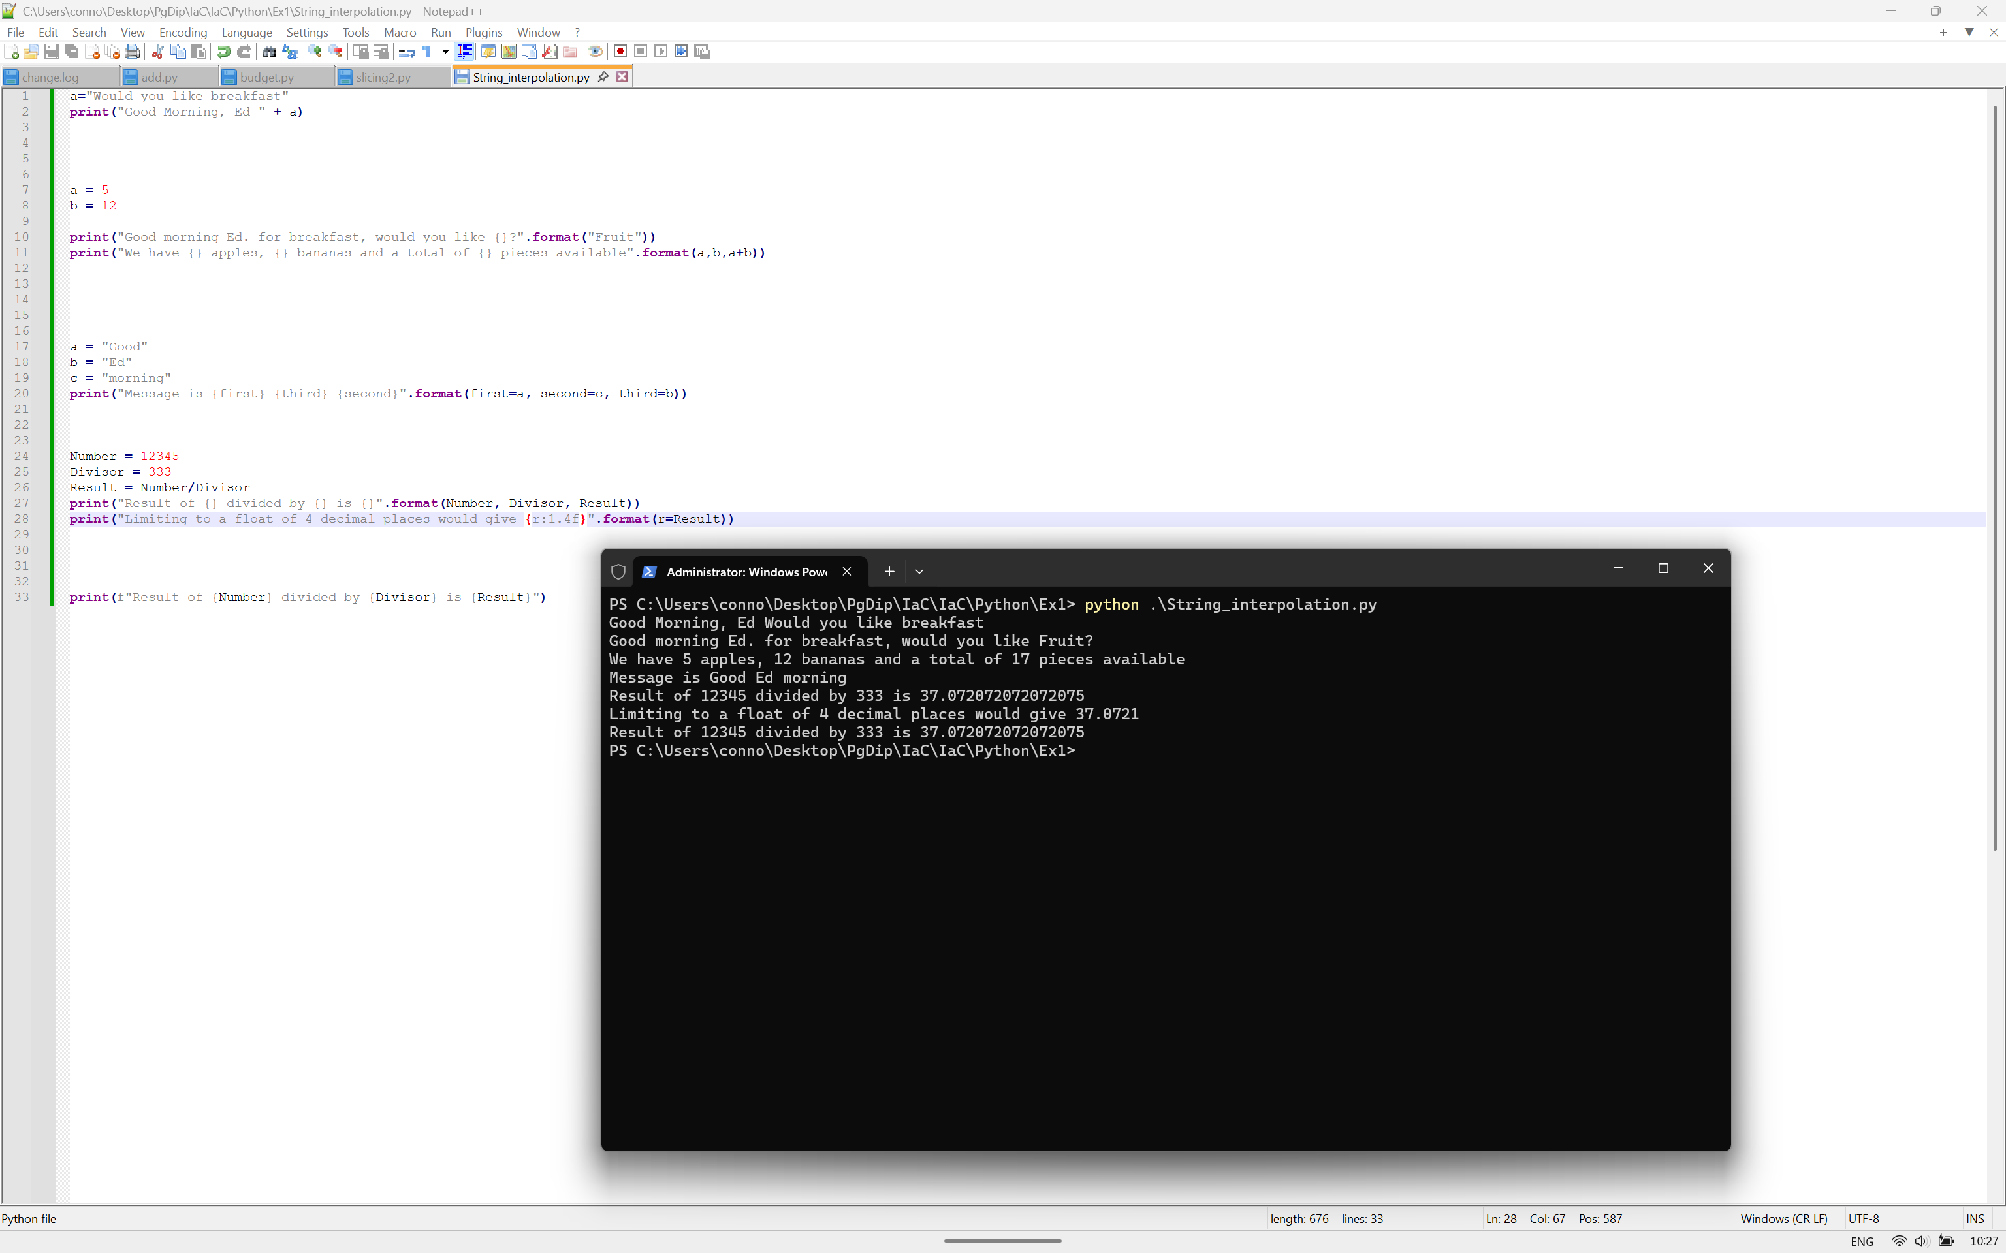
Figure 18 - String Interpolation
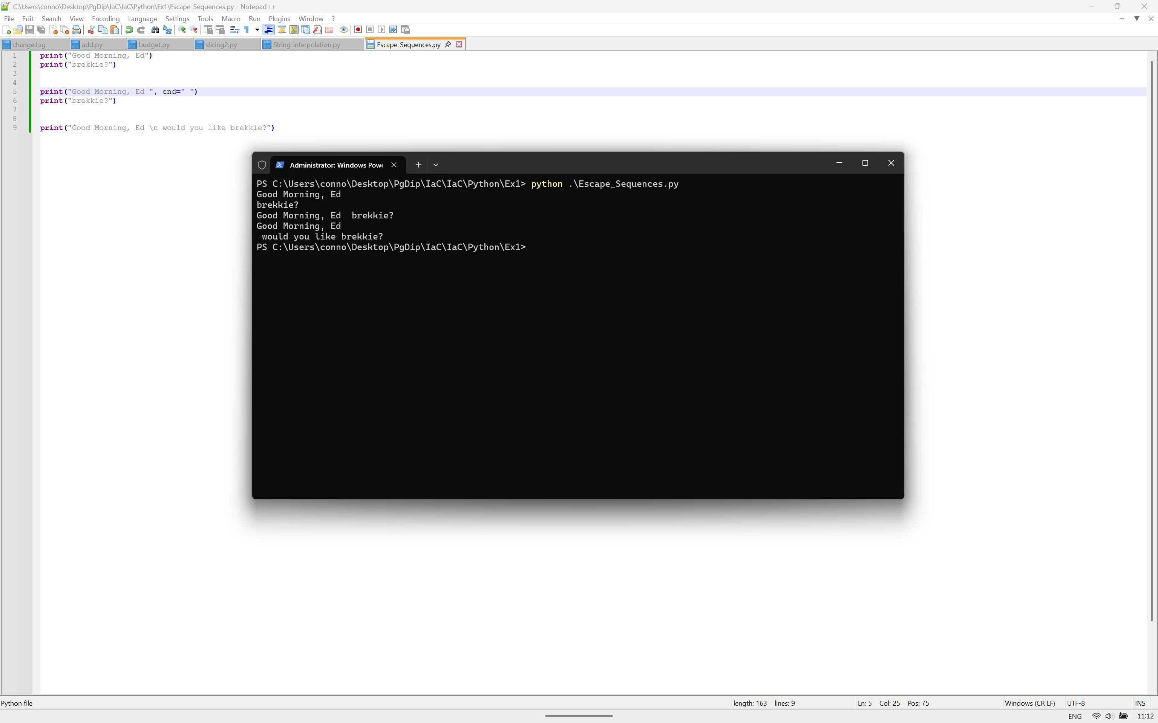
Figure 19 - Escape Sequences
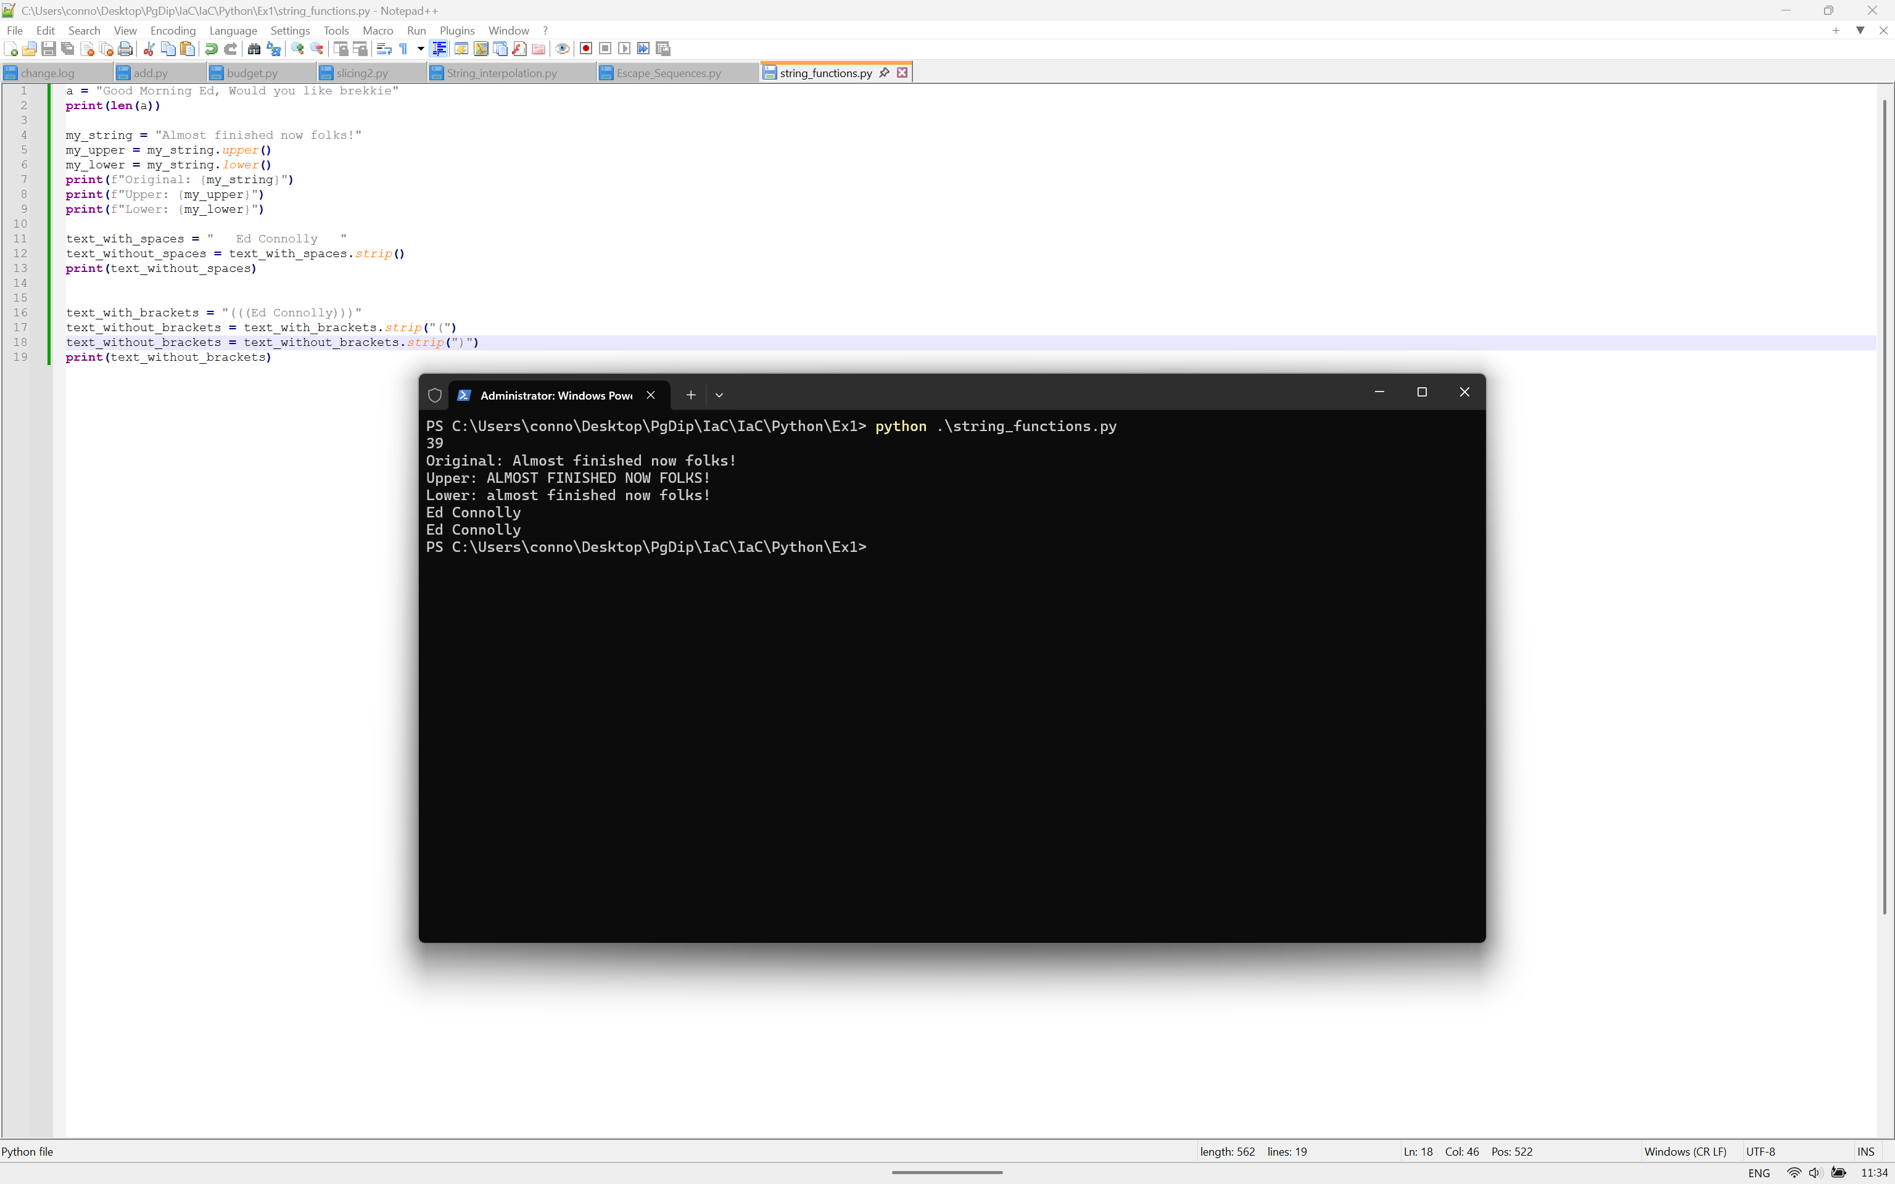
Figure 20 - String Functions

