Notes:
1. Each block is 10m x 10m
2. Site is minimum 400m x 200m
3. Campus Distributor 
4. Ducting for data, LAN
5. Approximate distance between two points
6. Ducting for carrier
7. Number of the carrier
8. Duct Specification
a. 120mm
b. Subduct * 4
9. Trench Specifications 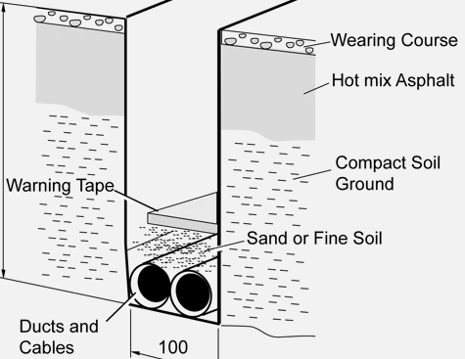
10. Maximum cable pull depending on the manufacturer
Notes:
1. Buildings are 40m x 70m
2. Grid is 10m x 10m
3. Floor distributor
4. Building distributor
5. Campus distributor 
6. POS – 4 x 13A, 2 TO
7. Security Camera
8. Point of sales
9. Access points
10. Cable tray

