LECTURER | John ORaw
STUDENT NAME | Quentin Ricart
STUDENT NUMBER | L00196812
PROGRAMME | MSc Cloud
MODULE CODE | NETW_IT902
ASSIGNMENT TITLE | CA1
SUBMISSION DATE | 05/02/2026

Student Declaration
- I have accurately identified and included the sources of all facts, ideas, opinions, and viewpoints from others in the assignment references. All direct quotations, paraphrasing, and discussions of ideas from books, journal articles, internet sources, course materials, or any other sources used are properly acknowledged and cited in the assignment references.
- I have not used unauthorised artificial intelligence tools or aids.
- I understand and am compliant with ATU's policy and procedures regarding Academic Integrity and I am aware of the consequences of any violations.
- I have followed the referencing guidelines recommended in the assignment instructions and / or programme documentation.
- By signing this form or by submitting material online I confirm that this assignment, or any part of it, has not been previously submitted by me or any other person for assessment on this or any other programme of study.
- By signing this form or by submitting material for assessment online I confirm that I have read and understood AQAE022 Academic Integrity Policy

Student Signature | Date
Quentin Ricart | 05/02/2026

Campus drawing

Notes:  1. Each block is 10m x 10m  2. Site is minimum 400m x 200m  3. Campus Distributor   4. Ducting for data, LAN  5. Approximate distance between two points  6. Ducting for carrier  7. Number of the carrier  8. Duct Specification  a. 120mm  b. Subduct * 4  9. Trench Specifications 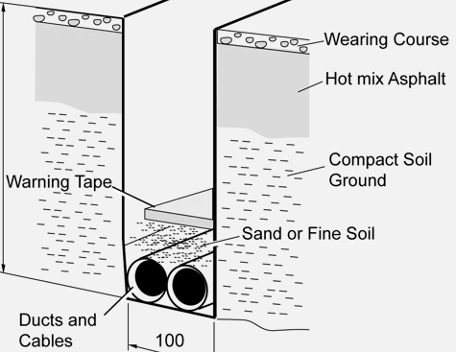  10. Maximum cable pull depending on the manufacturer | 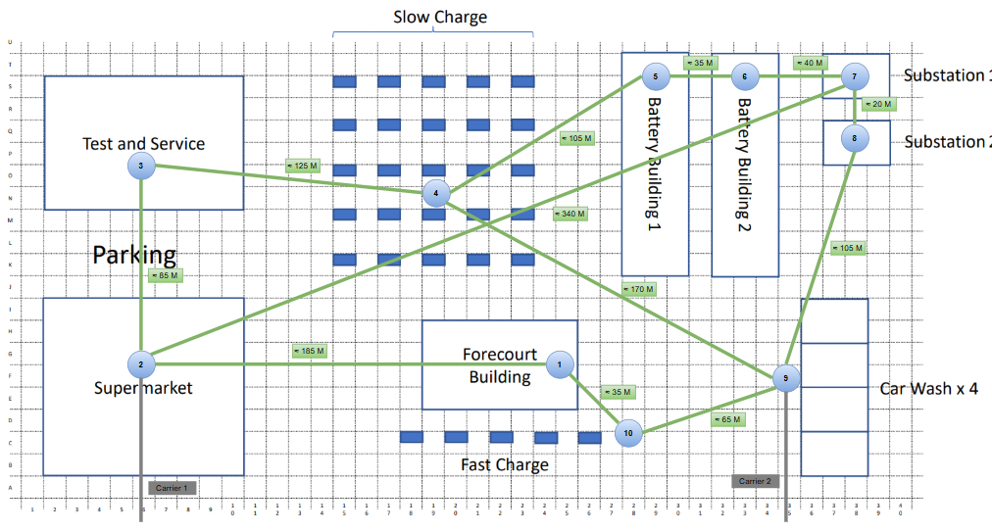

Link for trench specification: https://www.hexatronic.com/en/blog/fiber-optic-network-installation-in-ground

Shop drawing

Notes:  1. Buildings are 40m x 70m  2. Grid is 10m x 10m  3. Floor distributor  4. Building distributor  5. Campus distributor   6. POS  7. Credit card machine  8. Security Camera  9. Fire Alam  10. Office (Computer, Phone)  10. Burglar alarm  11. Access points  12. Cable tray | 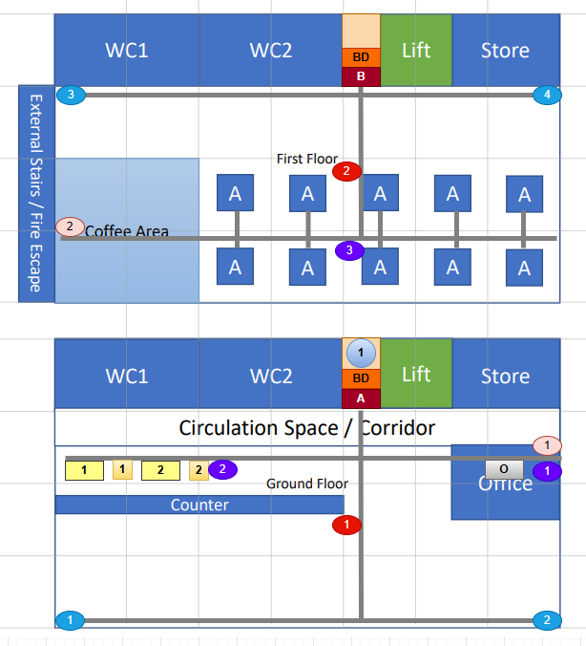
  13. 8 persons seated  40 13A sockets  20 TO CAT6 | 

