Function List

Function | Argument | Return
Getter
listForms |  | List[Form] : form_list
listSubjects |  | List[Subject] : Suject_list
getForm | Integer : form_id | Form : form
getsubject | Integer : subject_id | Subject : subject
simpleGraph | Integer : form_id | SimpleGraph : simple_graph
organizationalGraph | Integer : form_id | OrganizationalGraph : organizational_graph
fourCasesTables | Integer : form_id | fourCasesTables : four_cases_tables
socialComparison | Integer : form_id | SocialComparison : social_comparison
socialRepImport | Path : path | Form : form
Setter
saveForm | Form : form
saveSubject | Subject : subject
deleteForm | Integer : form_id
deleteSubject | Integer : subject_id

*Italics: variable name
*Underline : Type name

Call Function

Model 1 : Create Form

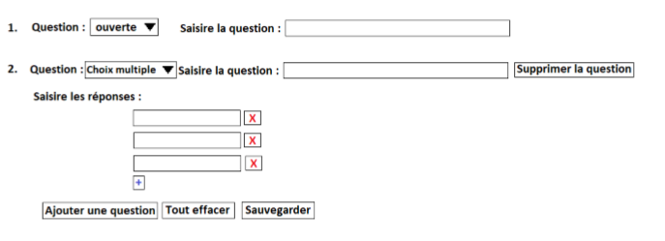
Call Function list :

Function Name | Reason of call
getForm() | for display the form
saveForm() | when the edition is finish

Model 2 : Delete Form

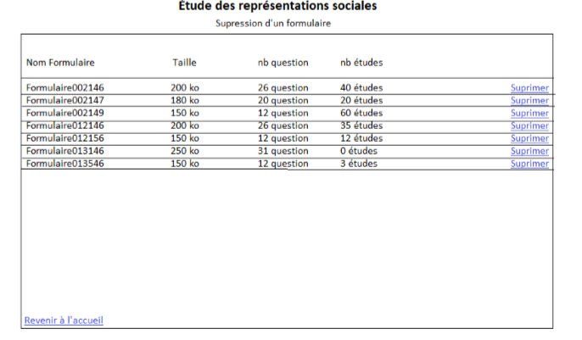

Call Function list :

Function Name | Reason of call
listForms() | for display forms list
deleteForm() | when the form to edit is chosen

Model 3 : Load Form

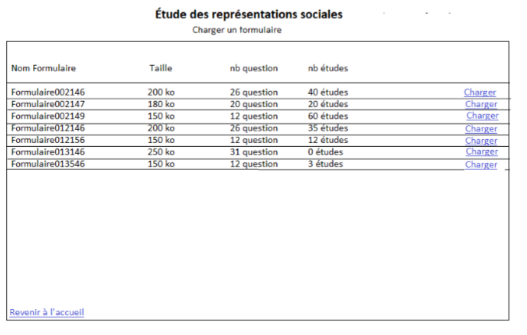
Call Function list :

Function Name | Reason of call
listForms() | for display forms list
saveForm() | when the form to edit is chosen

Model 4 : Edit form

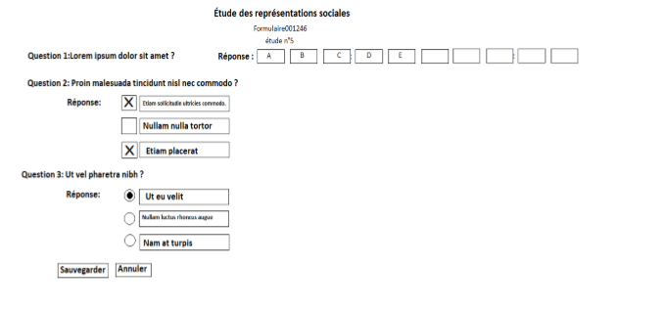

Call Function list :

Function Name | Reason of call
getSubject() | for display subject
saveSujet() | when the edition is finish

