**EXP : 2**

SQL> create table SUPPLIER(s_no varchar(10) not null,sname varchar(15) not null,age int not null,city varchar(15) not null,primary key(s_no));

SQL> insert into SUPPLIER values('s001','ivan bayross',35,'bombay');

SQL> insert into SUPPLIER values('s002','nirmala agarwal',35,'madaras');

SQL> insert into SUPPLIER values('c003','susmitha',55,'bombay');

SQL> insert into SUPPLIER values('c004','basu navindgi',45,'bombay');

SQL> insert into SUPPLIER values('c005','ravi sreedharan',25,'delhi');

SQL> insert into SUPPLIER values('c006','nanda gopal',25,'madaras');

SQL> select * from supplier;

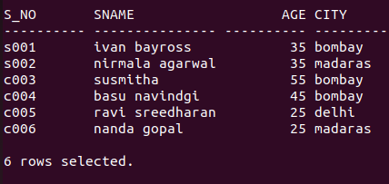

SQL> create table CUSTOMER(cust_no varchar(15) not null,name varchar(15) not null,age int not null,city varchar(15) not null,pincode int not null,state varchar(15) not null,primary key(cust_no));

SQL> insert into CUSTOMER values('c00001','ivan bayross',35,'bombay',400054,'maharastra');

SQL> insert into CUSTOMER values('c00002','vandana saitval',35,'madras',780001,'tamil nadu');

SQL> insert into CUSTOMER values('c00003','pramada jaguste',55,'bombay',400057,'maharastra');

SQL> insert into CUSTOMER values('c00004','basu navindgi',45,'bombay',400056,'maharastra');

SQL> insert into CUSTOMER values('c00005','ravi sreedharan',25,'delhi',100001,'delhi');

SQL> insert into CUSTOMER values('c00006','rukmini',25,'madras',780001,'tamil nadu');

CUST_NO NAME AGE CITY PINCODE STATE

--------------- --------------- - --------- -------------- -------------- -----------

c00001 ivan bayross 35 bombay 400054 maharastra

c00002 vandana saitval 35 madras 780001 tamil nadu

c00003 pramada jaguste 55 bombay 400057 maharastra

c00004 basu navindgi 45 bombay 400056 maharastra

c00005 ravi sreedharan 25 delhi 100001 delhi

c00006 rukmini 25 madras 780001 tamil nadu

SQL> create table PRODUCT(prod_no varchar(15) not null,description varchar(15) not null,company varchar(15) not null,price int not null,primary key(prod_no));

SQL> insert into product values('p00001','12W flood light','wipro',5000);

SQL> insert into product values('p00002','laptop adaptor','dell',1560);

SQL> insert into product values('p00003','tablet','hcl',11000);

SQL> insert into product values('p00004','garnet 50W led','wipro',999);

SQL> insert into product values('p00005','laptop charger','hcl',1690);

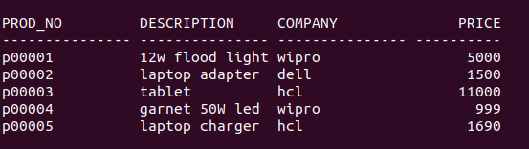

SQL> create table purchase(order_no varchar(15) not null, cust_no varchar(15) not null, prod_no varchar(15) not null, quantity int not null, orderdate date, primary key(order_no), foreign key(cust_no) references customer(cust_no) on delete cascade, foreign key(prod_no) references product(prod_no) on delete cascade);

SQL> insert into purchase values('o00001','c00002','p00003',2,'20-jan-16');

SQL> insert into purchase values('o00002','c00003','p00002',1,'22-jan-16');

SQL> insert into purchase values('o00003','c00006','p00001',3,'20-feb-16');

SQL> insert into purchase values('o00004','c00003','p00005',4,'02-apr-16');

SQL> insert into purchase values('o00005','c00004','p00002',2,'22-may-16');

SQL> insert into purchase values('o00006','c00005','p00004',1,'26-may-16');

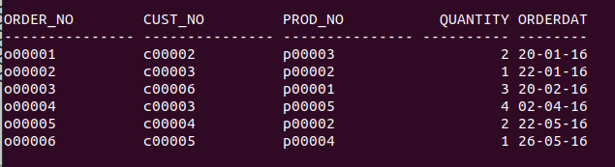

**QUESTIONS :**

1. SQL> SELECT name from customer where city='madras';

NAME

---------------

vandana saitval

rukmini

1. SQL> select cust_no as jan_cust from purchase where orderdate like '%-01-%';

JAN_CUST

---------------

c00002

c00003

1. SQL> select company from product where price>5000;

COMPANY

---------------

hcl

1. SQL> select name from customer where name not like 'r%';

NAME

---------------

ivan bayross

vandana saitval

pramada jaguste

basu navindgi

1. SQL> alter table customer add email varchar(20);

Table altered.

1. SQL> select name from customer where age>40 and state='maharastra';

NAME

---------------

pramada jaguste

basu navindgi

1. SQL> select company from product order by price;

COMPANY

---------------

wipro

dell

hcl

wipro

hcl

1. SQL> select avg(age) from customer;

AVG(AGE)

----------

36.6666667

1. SQL> select distinct city from customer where state='maharastra' or state='tamil nadu';

CITY

---------------

madras

bombay

1. SQL> select avg(price) from product ;

AVG(PRICE)

----------

4037.8

1. SQL> select cust_no,quantity from purchase order by quantity;

CUST_NO QUANTITY

--------------- ----------

c00003 1

c00005 1

c00002 2

c00004 2

c00006 3

c00003 4

1. SQL> update purchase set prod_no='p00003' where

cust_no='c00003';

2 rows updated.

ORDER_NO CUST_NO PROD_NO QUANTITY ORDERDATE

--------------- --------------- --------------- ---------- --------

o00001 c00002 p00003 2 20-01-16

o00002 c00003 p00003 1 22-01-16

o00003 c00006 p00001 3 20-02-16

o00004 c00003 p00003 4 02-04-16

o00005 c00004 p00002 2 22-05-16

o00006 c00005 p00004 1 26-05-16

1. SQL> select count(cust_no) from customer where city='delhi';

COUNT(CUST_NO)

--------------

1

1. SQL> select cust_no from purchase where quantity>3;

CUST_NO

---------------

c00003

1. alter table purchase modify orderdate varchar(15);
2. SQL> select min(price),max(price) from product;

MIN(PRICE) MAX(PRICE)

---------- ----------

999 11000

1. SQL> select count(prod_no),company from product group by company having company=’hcl’ or company=’wipro’;

COUNT(PROD_NO) COMPANY

-------------- ---------------

2 hcl

2 wipro

1. SQL> select * from customer order by name;

CUST_NO NAME AGE CITY PINCODE STATE EMAIL

--------------- --------------- ---------------- ---------- -------------- - ---------- ----------

c00004 basu navindgi 45 bombay 400056 maharastra

c00001 ivan bayross 35 bombay 400054 nmaharastra

c00003 pramada jaguste 55 bombay 400057 maharastra

c00005 ravi sreedharan 25 delhi 100001 delhi

c00006 rukmini 25 madras 780001 tamil nadu

c00002 vandana saitval 35 madras 780001 tamil nadu

1. SQL> select * from purchase order by orderdate desc;

ORDER_NO CUST_NO PROD_NO QUANTITY ORDERDATE

-------------- --------------- --------------- ---------- --------

o00006 c00005 p00004 1 26-05-16

o00005 c00004 p00002 2 22-05-16

o00004 c00003 p00003 4 02-04-16

o00003 c00006 p00001 3 20-02-16

o00002 c00003 p00003 1 22-01-16

o00001 c00002 p00003 2 20-01-16

1. SQL> delete from product where prod_no='p00003';

1 row deleted.

PROD_NO DESCRIPTION COMPANY PRICE

--------------- --------------- --------------- ----------

p00001 12w flood light wipro 5000

p00002 laptop adapter dell 1500

p00004 garnet 50W led wipro 999

p00005 laptop charger hcl 1690

1. SQL> create table orders as ( select order_no,orderdate from purchase);

ORDER_NO ORDERDATE

--------------- --------

o00001 20-01-16

o00002 22-01-16

o00003 20-02-16

o00004 02-04-16

o00005 22-05-16

o00006 26-05-16

1. SQL> drop table orders;

Table dropped.

1. SQL> create view cuss as select * from customer;

View created.

CUST_NO NAME AGE CITY PINCODE STATE EMAIL

--------------- --------------- ---------------- ---------- -------------- - ---------- ----------

c00004 basu navindgi 45 bombay 400056 maharastra

c00001 ivan bayross 35 bombay 400054 nmaharastra

c00003 pramada jaguste 55 bombay 400057 maharastra

c00005 ravi sreedharan 25 delhi 100001 delhi

c00006 rukmini 25 madras 780001 tamil nadu

c00002 vandana saitval 35 madras 780001 tamil nadu

1. SQL> select name from customer where cust_no in (select cust_no from purchase group by cust_no having count(*)>1);

NAME

---------------

pramada jaguste

1. SQL> select purchase.*, customer.city from purchase inner join customer on purchase.cust_no=customer.cust_no where customer.city in (select city from customer group by city having count(*)>1 );

ORDER_NO CUST_NO PROD_NO QUANTITY ORDERDATE CITY

--------------- -------------- ------------- -- ---------- --------

o00003 c00006 p00001 3 20-02-16 madaras

o00005 c00004 p00002 2 22-05-16 bombay

1. SQL> select name from customer where name like'r%';

NAME

--------------

ravi sreedharan

rukmini

1. SQL> select sname as name from supplier union select name from customer;

NAME

---------------

basu navindgi

ivan bayross

nanda gopal

nirmala agarwal

pramada jaguste

ravi sreedharan

rukmini

susmitha

vandana saitval

.