Guide to setting up your sensor systems

First things first, download Arduino IDE at https://www.arduino.cc/en/software/
Once you have installed the software, you must do the following to add ESP32 support. This library allows you to use the ESP32 like an Arduino, which simplifies coding.
https://randomnerdtutorials.com/installing-esp32-arduino-ide-2-0/
Pay attention, if Arduino IDE does not recognize the device when you plug it in and/or you get the error “COM Port not found/not available”, you might need to install the CP210x Drivers. Install USB Drivers – CP210x USB to UART Bridge (Windows PC). ArduinoIDE treats the microcontroller as a serial device.
Also, if you ever get stuck with something, do check out the tutorials on the left side column on the website. There are various tutorials that might help you if you get stuck or if you feel like you want to try things out for yourself!
Now, we can do the setup for coding.
First, download the library called “ArduinoJSON” and “PubSub Client” from the library manager in Arduino IDE. Install the newest version for both.
These make it very easy to package data into a JSON (Human and machine-readable text data) and PubSub client will handle MQTT. MQTT is a messaging protocol that allows a device to publish the JSON data into a “topic” to which readers can dynamically subscribe to. This makes it very easy to send data over the internet.
You can test that they were correctly installed by opening the code and importing the C header files
#include <ArduinoJson.h>
#include <PubSubClient.h>
The IDE will display an error message when you hover over them if the installation was unsuccessful.
For this course, we will give you some basic code to get started, but you must build the “software architecture” yourself :). There are various sensors you can use, but only the basic ones will be covered by this tutorial.
The logic for getting other sensors to work is the same, if you want to test something new. Look at the sensor, find out its model name and maker, google for the library and usually you find instructions on how to set it up. In some cases, you can even just use the name in the Arduino IDE library manager to search for it and get started immediately. Many libraries come packaged with example code, which will show you how to use the library. You can find them by opening “File -> Examples” and scrolling down.
We have many basic sensors that you can use with analog reading or digital reading. In this guide I will provide you with the code to publish the data to MQTT that is connected to a MongoDB database that we have set up.
However, you are responsible for configuring your own sensors!!
On to the main project!

Car acceleration analytics

In this project you will use an ADXL345 accelerometer to analyze the acceleration of the car you built previously. You will be hooking in the ESP32 on top of the car and powering it through the battery and setting it to log data into the database. You can then use this data to do basic analytics.
Go to the Arduino IDE library manager and download the “Adafruit ADXL345” library.
The accelerometer board uses I2C protocol to communicate with the ESP32.
Of course, your board has a handy grove plug. You just need to connect the wires to the ESP32 like in the picture. The picture’s ESP differs from the NodeMCU esp32 you are using. Make sure to check that you have connected the right pin! (GND to GND, 3V3 to 3V3!)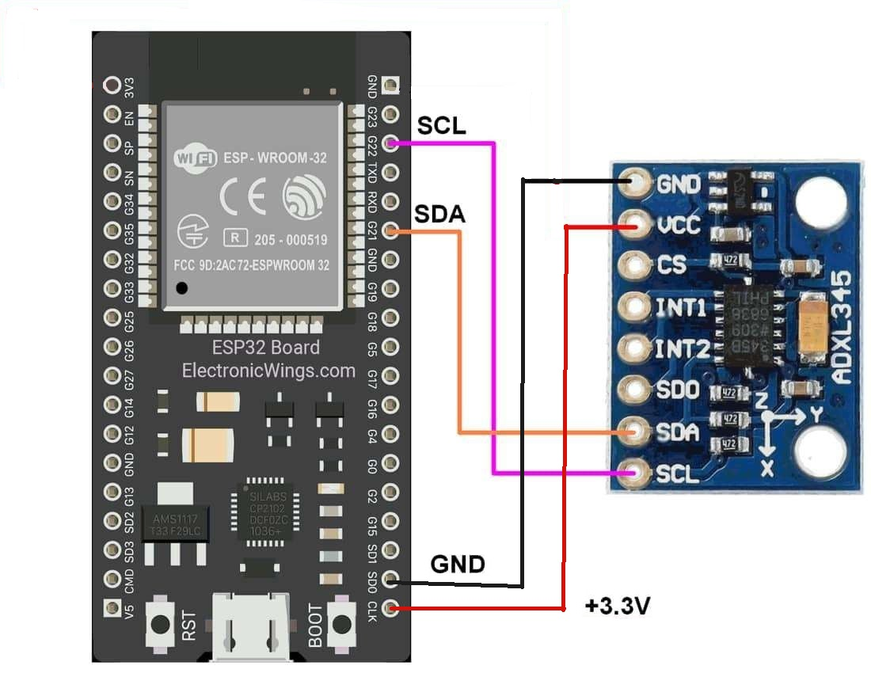
Sometimes, the code might have issues flashing. In that case, try unplugging the accelerometer, then flashing the code to the ESP32 and plugging the module back in afterwards.
When you put the accelerometer on the car, make sure it’s at a flat as possible angle. You can use the example code to read and figure out when it’s properly aligned, or you can use an angle measurer to make sure it’s laid flat. The device will not report exactly 0 for X and Y when it’s flat, because there are some inaccuracies. However, you can see Earth’s gravity being reported by the Z axis (Roughly close to 9.81 m/s^2). If you have the accelerometer at an angle, this acceleration will be split between the different axis, and you will not get good reading.

CODES

Here is the code to use to read and publish data into mqtt:
#include <Arduino.h>
#include <ArduinoJson.h>
#include <PubSubClient.h>
#include <WiFi.h>
#include <string.h>

// Include sensor libraries that you need! A temperature sensor works as an example, remove it if you don’t use it
#include <DHT.h>

// WiFi credentials
const char* ssid = "";
const char* password = "";

// --- MQTT Broker ---
const char* mqtt_server = ""; // Address of broker
const int mqtt_port = 1883; // Broker port
const char* mqtt_user = "";
const char* mqtt_pass = "";
const char* topic = ""; // You will be given a topic name. This must match the given name!

// --- Clients ---
WiFiClient espClient;
PubSubClient mqttClient(espClient);

// --- Sensor, pin, etc. definitions ---
#define DHTPIN 5 // Physical pin on the ESP32, needs to match your setup
#define DHTTYPE DHT11 // We are using DHT in this course
DHT dht(DHTPIN, DHTTYPE); // Initiate class

// --- Sensor Functions ---

// Example function for DHT, add more sensors if you need. Check void loop() for how to use!
String ReadSensor1()
{
float h = dht.readHumidity();
float t = dht.readTemperature();
//Set both values to zero if the sensor is faulty
if (isnan(h) || isnan(t)) {
h = 0; t = 0;
}
//Output contains both humidity and temperature values in JSON-compatible format
String sensor1 = "H:" + String(h) + "," + "T:" + String(t);

return sensor1;
}

// Other example functions, make sure you have the correct data type for the value you get back! int = whole number, float = decimals, etc.
// Make sure the functions in void loop() match this
// int ReadSensor2()
// {

// }

// float ReadSensor3()
// {

// }

// --- CONNECTION FUNCTIONS ---
void setup_wifi() {
WiFi.mode(WIFI_STA);
Serial.println();
Serial.print("Connecting to WiFi: ");
Serial.println(ssid);

WiFi.begin(ssid, password);

// Wait for connection with feedback
while (WiFi.status() != WL_CONNECTED) {
delay(1000);
Serial.print(".");
}

Serial.println();
Serial.println("WiFi connected!");
Serial.print("IP address: ");
Serial.println(WiFi.localIP());
}

void reconnect() {
// Loop until we're reconnected
while (!mqttClient.connected()) {
Serial.print("Attempting MQTT connection...");

// Attempt to connect
if (mqttClient.connect("ESP32Client", mqtt_user, mqtt_pass)) {
Serial.println("connected!");
} else {
Serial.print("failed, reason=");
Serial.print(mqttClient.state());
Serial.println(", trying again in 3 seconds");
delay(3000);
}
}
}

// --- Publish Data ---
template<typename T> // Advanced template function that accepts any datatype
void publishData(const char* sensor_name, T sensor_value) {
// Create JSON document
JsonDocument doc;

// Add the sensor state to the JSON document
doc["sensor_name"] = sensor_name;
doc["sensor_value"] = sensor_value;

// Create a buffer to hold the serialized JSON string
char jsonBuffer[128];

// Convert the JSON document to a string
serializeJson(doc, jsonBuffer);

// Publish the JSON string to the MQTT topic
boolean success = mqttClient.publish(topic, jsonBuffer);

// Print to Serial Monitor for debugging
if (success) {
Serial.print("Published JSON: ");
Serial.println(jsonBuffer);
} else {
Serial.println("✗ Failed to publish message!");
Serial.print("Client state: ");
Serial.println(mqttClient.state());
}
}

// --- MAIN PROGRAM ---

void setup() {
// Start Serial FIRST before anything else
Serial.begin(19200); // Check that your terminal monitor matches this rate
delay(1000); // Give Serial time to initialize
// Connect to WiFi
setup_wifi();
// Configure MQTT
mqttClient.setServer(mqtt_server, mqtt_port);
// Set a larger buffer size for PubSubClient if needed
// Default is 256 bytes, increase if you have larger messages (More sensors)
mqttClient.setBufferSize(512);
Serial.println("Setup complete!");
}
void loop() {
// Ensure MQTT connection is maintained
if (!mqttClient.connected()) {
Serial.println("MQTT disconnected! Reconnecting...");
reconnect();
}
// Process incoming MQTT messages and maintain connection
// This MUST be called regularly to keep the connection alive
mqttClient.loop();
String sensor_value = ReadSensor1();
// Publish the sensor data via MQTT, you need to add a new one for each sensor! Remember to change the name of the sensor!
publishData("dht_sensor", sensor_value);
// Delay to avoid flooding the MQTT broker
// DO NOT set this under 0.5 seconds
delay(500);
}
Now, here is the test code to get the Accelerometer up and running. Note that your first task is to figure out how to integrate the code with the above publisher code! You need to take the core functionality of the accelerometer code and try and get the variables holding the acceleration values published into mqtt!
#include <Wire.h>
#include <Adafruit_Sensor.h>
#include <Adafruit_ADXL345_U.h>

/* Assign a unique ID to this sensor at the same time */
Adafruit_ADXL345_Unified accel = Adafruit_ADXL345_Unified(12345);

void displaySensorDetails(void)
{
sensor_t sensor;
accel.getSensor(&sensor);
Serial.println("------------------------------------");
Serial.print ("Sensor: "); Serial.println(sensor.name);
Serial.print ("Driver Ver: "); Serial.println(sensor.version);
Serial.print ("Unique ID: "); Serial.println(sensor.sensor_id);
Serial.print ("Max Value: "); Serial.print(sensor.max_value); Serial.println(" m/s^2");
Serial.print ("Min Value: "); Serial.print(sensor.min_value); Serial.println(" m/s^2");
Serial.print ("Resolution: "); Serial.print(sensor.resolution); Serial.println(" m/s^2");
Serial.println("------------------------------------");
Serial.println("");
delay(500);
}

void displayDataRate(void)
{
Serial.print ("Data Rate: ");

switch(accel.getDataRate())
{
case ADXL345_DATARATE_3200_HZ:
Serial.print ("3200 ");
break;
case ADXL345_DATARATE_1600_HZ:
Serial.print ("1600 ");
break;
case ADXL345_DATARATE_800_HZ:
Serial.print ("800 ");
break;
case ADXL345_DATARATE_400_HZ:
Serial.print ("400 ");
break;
case ADXL345_DATARATE_200_HZ:
Serial.print ("200 ");
break;
case ADXL345_DATARATE_100_HZ:
Serial.print ("100 ");
break;
case ADXL345_DATARATE_50_HZ:
Serial.print ("50 ");
break;
case ADXL345_DATARATE_25_HZ:
Serial.print ("25 ");
break;
case ADXL345_DATARATE_12_5_HZ:
Serial.print ("12.5 ");
break;
case ADXL345_DATARATE_6_25HZ:
Serial.print ("6.25 ");
break;
case ADXL345_DATARATE_3_13_HZ:
Serial.print ("3.13 ");
break;
case ADXL345_DATARATE_1_56_HZ:
Serial.print ("1.56 ");
break;
case ADXL345_DATARATE_0_78_HZ:
Serial.print ("0.78 ");
break;
case ADXL345_DATARATE_0_39_HZ:
Serial.print ("0.39 ");
break;
case ADXL345_DATARATE_0_20_HZ:
Serial.print ("0.20 ");
break;
case ADXL345_DATARATE_0_10_HZ:
Serial.print ("0.10 ");
break;
default:
Serial.print ("???? ");
break;
}
Serial.println(" Hz");
}

void displayRange(void)
{
Serial.print ("Range: +/- ");

switch(accel.getRange())
{
case ADXL345_RANGE_16_G:
Serial.print ("16 ");
break;
case ADXL345_RANGE_8_G:
Serial.print ("8 ");
break;
case ADXL345_RANGE_4_G:
Serial.print ("4 ");
break;
case ADXL345_RANGE_2_G:
Serial.print ("2 ");
break;
default:
Serial.print ("?? ");
break;
}
Serial.println(" g");
}

void setup(void)
{
Serial.begin(9600);
Serial.println("Accelerometer Test"); Serial.println("");

/* Initialise the sensor */
if(!accel.begin())
{
/* There was a problem detecting the ADXL345 ... check your connections */
Serial.println("Ooops, no ADXL345 detected ... Check your wiring!");
}

/* Set the range to whatever is appropriate for your project */
accel.setRange(ADXL345_RANGE_16_G);
// accel.setRange(ADXL345_RANGE_8_G);
// accel.setRange(ADXL345_RANGE_4_G);
// accel.setRange(ADXL345_RANGE_2_G);

// Set the device to power up, otherwise it will stay in standby mode
accel.writeRegister(ADXL345_REG_POWER_CTL, 0x08);

/* Display some basic information on this sensor */
displaySensorDetails();

/* Display additional settings (outside the scope of sensor_t) */
displayDataRate();
displayRange();
Serial.println("");
}
// Your task is to take this code and make it work in the mqtt publisher code. Its up to you to read the data and pass the variables into the publisher!
void loop(void)
{
/* Get a new sensor event */
sensors_event_t event;
accel.getEvent(&event);

/* Display the results (acceleration is measured in m/s^2) */
Serial.print("X: "); Serial.print(event.acceleration.x); Serial.print(" ");
Serial.print("Y: "); Serial.print(event.acceleration.y); Serial.print(" ");
Serial.print("Z: "); Serial.print(event.acceleration.z); Serial.print(" ");Serial.println("m/s^2 ");
delay(500);
}

