

Report on the performance of the MFSK algorithm implemented in the UNET modems and results from the UNET2015 experiments

*Prepared by*

Anshu

Version 1.0

January 7, 2016

Contents

**1. Introduction 1**

**2. Design of MFSK Algorithm 1**

2.1 MFSK Basics .................................................................. 1

2.2 Design of MFSK implemented in UNET Modems ........... 2

2.3 Commands to setup MFSK in UNET modems ................ 3

**3. Results and Discussion 4**

**4. Summary 6**

1. Introduction

The M-ary Frequency Shift Keying (MFSK) algorithm was implemented as modulation scheme in the UNET modems and the performance of the implemented algorithms were tested during the UNET2015 experiments. This report details the design of the MFSK algorithm implemented in the UNET modems and presents the results of the performance of the algorithm for various ranges.

In Chapter 1, a brief introduction of MFSK algorithm is provided and the design of the implementation of the MFSK algorithm is detailed. In Chapter 2, the results from the tests are presented.

1. Design of MFSK Algorithm
   1. MFSK Basics

Frequency Shift Keying (FSK) is a digital modulation scheme on which the digital information is transmitted by changing the frequency of the carrier signal. The most basic version of the FSK in Binary FSK in which all the 1 bits are transmitted at a frequency *fc+f1* and all 0 bits are transmitted at a frequency *fc+f0* where fc is the carried frequency.

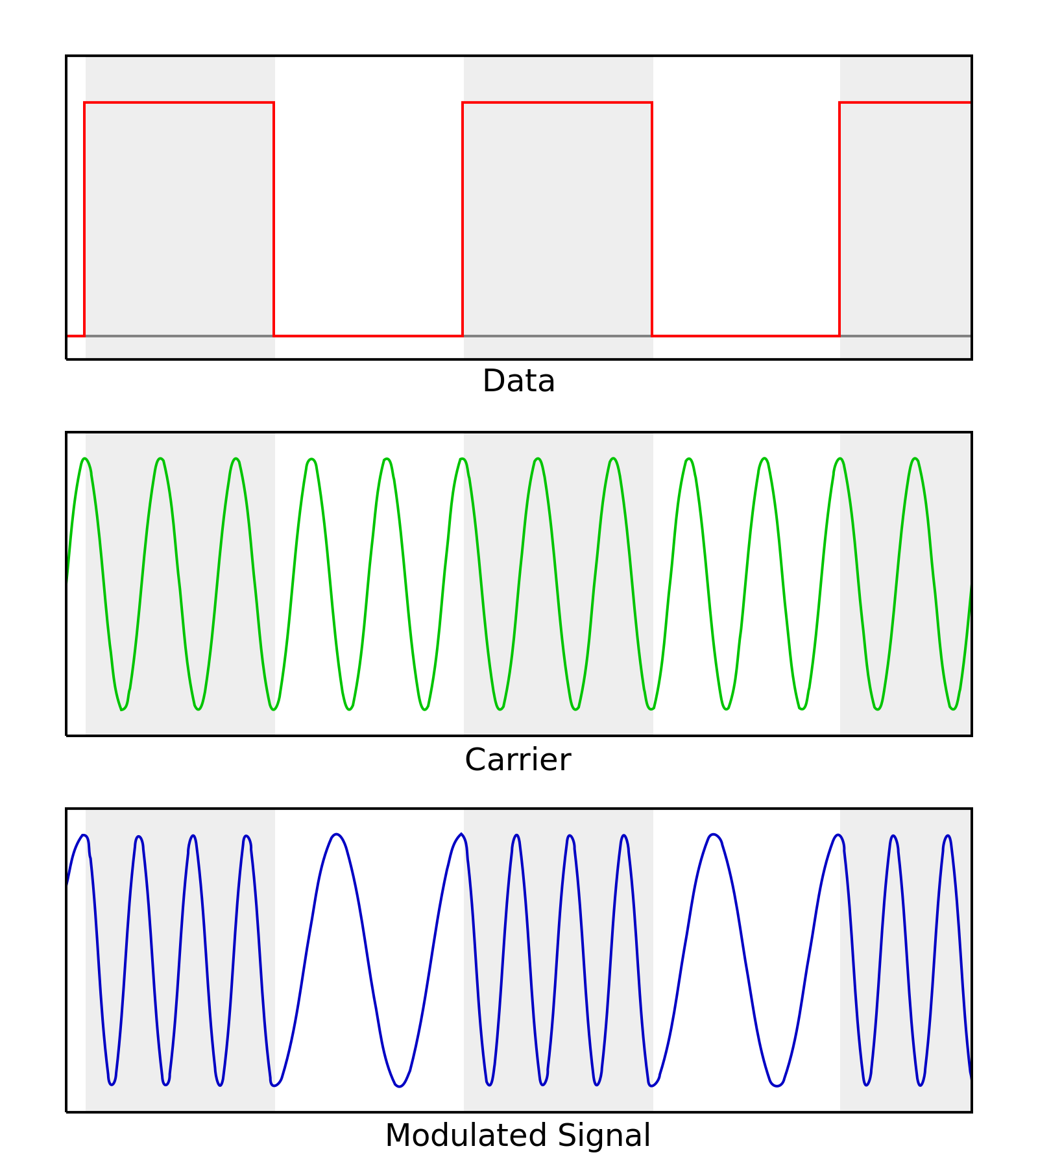

Fig.1: Frequency Shift Keying signals

1

MFSK is uses the same basic concepts of BFSK but information of M bits are transmitted on a frequency *fc+fM* where *fM* is one of 2M frequencies and is selected based on the M bits sequence.

* 1. Design of MFSK implemented in UNET

Modems

The MFSK algorithm implemented in UNET modems in based on 4 configurable parameters as follows:

1. **Bits per frequency tone (M)**

This basically refers to the “M” in MFSK and is related the number of bits whose information is being transmitted per frequency tone.

1. **Bandwidth (BW)**

This parameter is to set the total bandwidth that would be used for the acoustic communication channel.

1. **Symbol Rate (S)**

This parameter is set to the number of symbols that would be transmitted per second. The symbol rate effectively affects the number of samples that would be generated per symbol.

1. **Frequency Gap (F)**

This parameter is set to the gap between the two consecutive frequency tones that be used for transmission.

The design is also designed as multi-carrier system where multiple sets of M bits are transmitted per symbol. The number of carrier bands (i.e. the number of M bit sets that would be transmitted per symbol) that would be transmitted is calculated by the algorithm as

Nb = BW/(F * 2M)

2

The number of samples generated for a M bits set for each of the carrier bands is   
  
 Ns = Fs/S

where Fs is the sampling frequency used which in the case of UNET modems is 18 KHz.

The Ns samples generated for each of the Nb bands are then added up together to generate a single symbol. Based on the number of bits being transmitted, multiple such symbols are generated and transmitted.

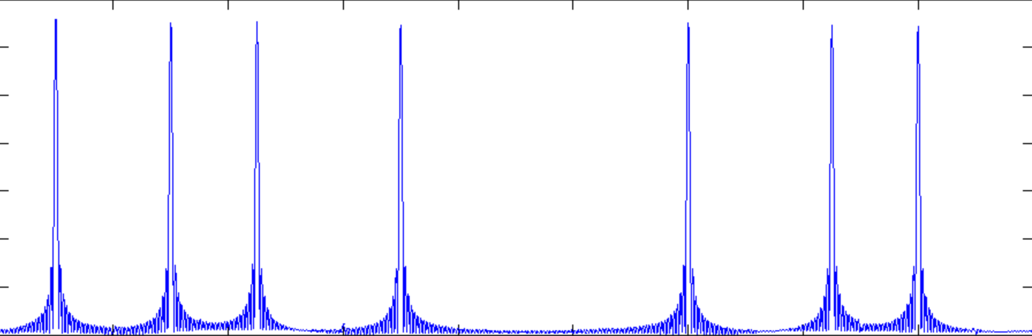

Fig.2: Power spectrum, of a single MFSK symbol

* 1. Commands to setup MFSK in UNET modems

To setup all a scheme (e.g. scheme 1) to use MFSK, the following command is used

> scheme[1].modulation = 5

5

The MFSK parameters M, BW, F and S (as mentioned in section 2.2) are setup in the UNET modems as

Bandwidth (BW) - bandwidth

Bits per frequency tone (M) - bitsPerFreqTone

Frequency Gap (F) - freqStep

Symbol Rate (S) - symbolRate  
  
The parameters are assigned values as per the configuration requires. For example to setup scheme 1 of the modem to use the MFSK configuration of bandwidth of 14 Khz, 2 bits per frequency tone, frequency gap of 500 Hz and symbol rate of 50, the following set of commands is used:

3

> scheme[1].modulation = 5

5

> scheme[1].bandwidth = 14000

14000

> scheme[1].bitsPerFreqTone = 2

2

> scheme[1].freqStep = 500

500

> scheme[1].symbolRate = 50

50

1. Results and Discussion

Tests were conducted using two surface modems over two days at two different ranges on each day.

Day 1:   
 Test 1 at range of 1923 mtrs  
 Test 2 at range of 753 mtrs  
Day 2:

Test 1 at range of 1923 mtrs  
 Test 2 at range of 2300 mtrs

Different configurations for parameters M, BW,S and F were used for testing. The parameters were configured so that resultant signal transmitted in each case was between 900 milliseconds to 1 second. The different configurations used for each test are tabulated below:

4

|  |  |  |  |  |  |  |
| --- | --- | --- | --- | --- | --- | --- |
| **Day** | **Range (mtrs)** | **M** | **BW (Hz)** | **S** | **F (Hz)** | **Packet Size (bits)** |
| 1 | 1923 | 2 | 14000 | 50 | 500 | 640 |
| 1 | 1923 | 2 | 14000 | 80 | 400 | 1120 |
| 1 | 1923 | 2 | 14000 | 100 | 300 | 1920 |
| 1 | 753 | 2 | 14000 | 50 | 500 | 640 |
| 1 | 753 | 2 | 14000 | 80 | 400 | 1120 |
| 2 | 1923 | 2 | 14000 | 50 | 500 | 640 |
| 2 | 1923 | 2 | 14000 | 40 | 400 | 600 |
| 2 | 1923 | 2 | 14000 | 110 | 500 | 1440 |
| 2 | 1923 | 2 | 14000 | 200 | 500 | 2460 |
| 2 | 1923 | 2 | 14000 | 250 | 500 | 3200 |
| 2 | 2300 | 2 | 14000 | 50 | 500 | 640 |
| 2 | 2300 | 2 | 14000 | 250 | 500 | 3200 |

The following plot shows the BER noticed for each of the tests conducted for all different configurations.

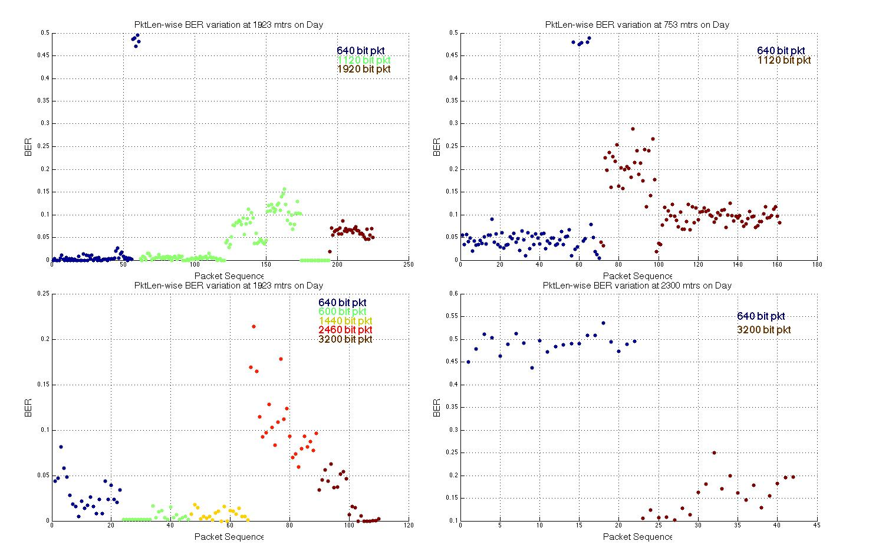

Fig.3: BER for all tests at different ranges

5

Based on the BER detected, the FEC that should be used for an error free transmission is estimated and the effect data link rate is determined based on that. Also based on the BER, the effective packet delivery rate (PDR) is determined where a BER of 0.001 is estimated to be of PDR > 75%. The following plot shows the effective link rate that can be expected during each of the tests for all packets where PDR is expected to be greater than 50%.

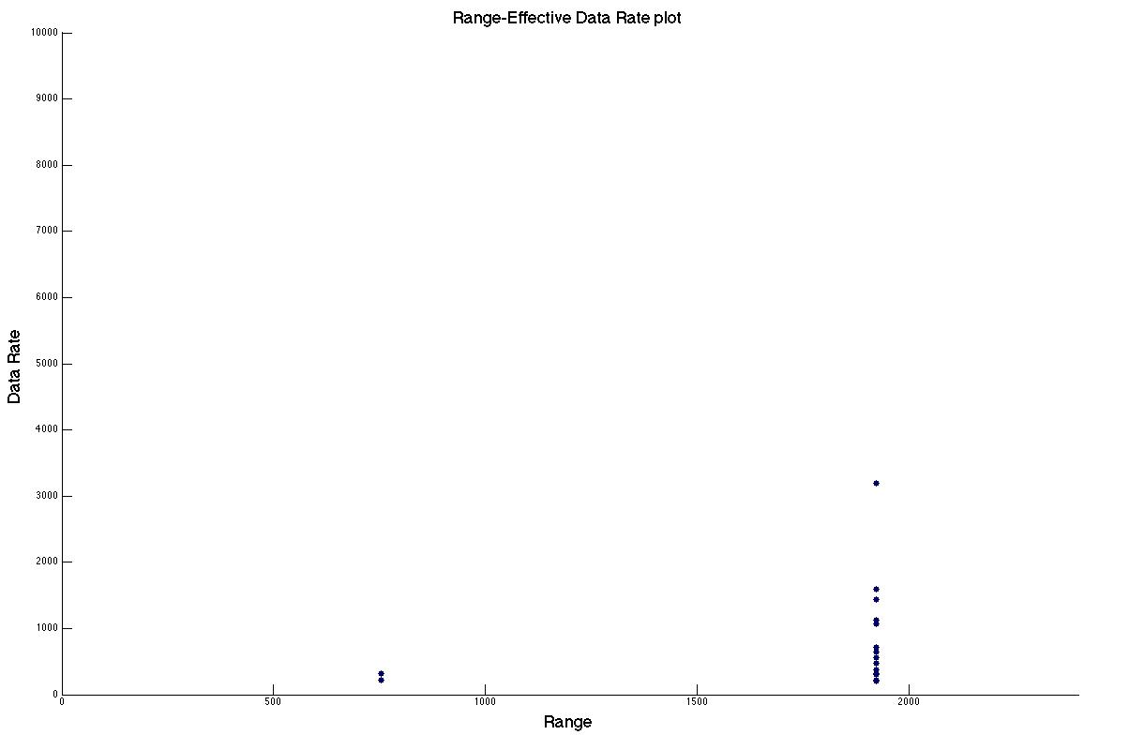

Fig.4: Effective link rates estimated for PDR > 50%

1. Summary

The tests showed that MFSK can be effectively used for acoustic communication in the UNET modems. Effective data rate of up to 3200 bits per second were observed over a range of 1923 mtrs. Further ways to improve the performance of the MFSK algorithm using square root raised cosine windowing is being looked into amd would be tested for in future experiments.

6