**UNDERWATER ACOUSTIC IMAGES AND VIDEOS IN REAL-TIME**

**BLURB :**

Remotely Operated Mobile Ambient Noise Imaging System (ROMANIS) is a 2D acoustic camera built by the Acoustic Research Laboratory of the National University of Singapore, for imaging underwater objects. Sampling at 200 kHz per channel and with more than 500 channels, this system spits out data at an astonishing rate of 1.6 Gbps. Complex, yet innovative beamforming and image processing algorithms operating under CUDA-capable GPU environment, have helped to produce acoustic images and videos from this camera in near real-time.

**DETAILED WRITE UP :**

ROMANIS is a passive broadband (25 to 85 kHz bandwidth) acoustic camera system with an aperture size of 1.3 m. It can image underwater objects using ambient noise as the source of “illumination”. In most tropical coastal waters, the major contributor to high frequency noise are snapping shrimp. The first ROMANIS system was completed in 2003. At that point in time, there was no off-the-shelf portable solution to process the high volume of data from it in real-time to meet the required 300 GFLOPS. The data were recorded on fibre channel hard drives and post-processed. Every 2 seconds of data required about 11 hours of processing time to generate static images on a desktop computer with Pentium V processor and 2 GB RAM. As the deployment and recovery operations of ROMANIS were highly resource intensive, there was a need to test and analyse the data in the field. A system based on a 36-CPU cluster was initially developed to allow processing of 2 seconds of data in about a minute. While this was a large improvement, it did not provide real-time performance, nor was the system portable enough to take out for field operations. In 2010, we explored the use of CPU-GPU based processing architecture to run our algorithms. We ported all our algorithms to work under CUDA environment.

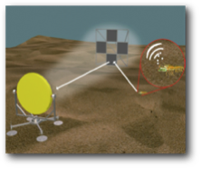

The first version of the algorithm was run on dual GPU processor, nVidia Tesla C1060. Even though the we were not able to run the algorithms in real-time, the approach resulted in an 8-fold increase in the speed of processing and we could test out samples of data in the field while it was being acquired. As ROMANIS generated data at 1.6 Gbps, to facilitate near real-time processing computation, speed and efficiency were required to be improved further.

To improve the speed of processing, the system was upgraded with nVidia Tesla C2050 GPU and another nVidia GeForce GT-730 was employed for preprocessing of the image frames generated from beamforming. The resulting images were displayed in real-time using OpenGL. Every single set of 508 data samples from each of the hydrophone sensors, was essentially data corresponding to a single frame of image that would be produced after the beamforming was completed. Data were collected for about 350 ms from ROMANIS and then transferred to the processing device, which is a computer running a conventional CPU, a Tesla C2050 GPGPU and a GeForce GT-730 GPU. The beamforming algorithm was run for multiple blocks and threads on the GPU to process the data in real-time with each block processing an equal fraction of frame data and then producing a series of frames in order. The beamformed 3-dimensional (azimuthal angle, elevation angle and frequency) data frames were then transferred to GeForce GT-730 where preprocessing of the image frames (frame compression in the space and frequency dimensions, interpolation etc.) was performed using a separate CUDA kernel running on it. The final frame was then displayed using CUDA-OpenGL inter-operatability module using the GeForce GT-730.

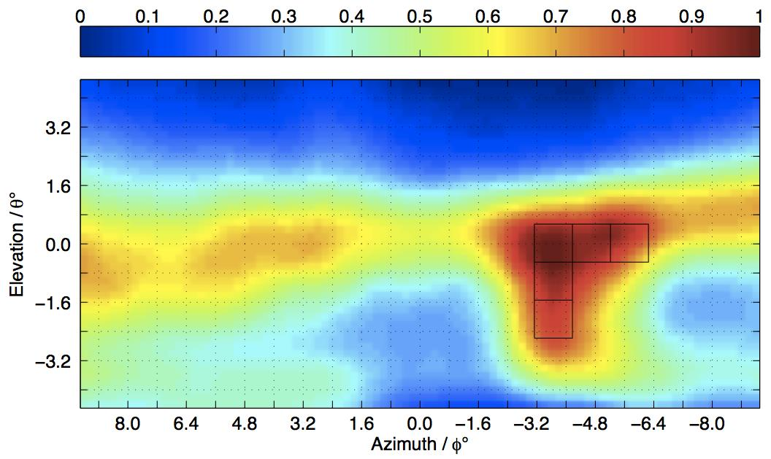 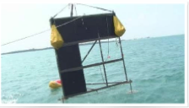

**A sample image from beam formed ROMANIS output**

**(Left : intended target , Right : image of the target as generated from ROMANIS)**