CONFIDENTIAL



Butter Family Farms

PENETRATION TEST REPORT

EMEA-<>

October 17, 2027

CONFIDENTIAL - TLP : RED

Confidentiality and Privacy Statement

This document is the exclusive property of Butter Family Farms and EMEA-<>. It contains proprietary and highly sensitive information. Any duplication, redistribution, or utilization of this document, in whole or in part, is strictly prohibited without prior written consent from both parties.
- EMEA-<> disclaims all liability for any incidental, collateral, or consequential damages arising from the use of this information.
- This document and all information contained herein are classified as confidential and proprietary to EMEA-<> and Butter Family Farms. Unauthorized access, use, or disclosure of this information is strictly prohibited and may result in legal repercussions.
The contents of this document include critical insights into the computer security environment, practices, and current vulnerabilities within the client's security infrastructure. Reproduction or distribution of this document requires explicit written approval from the client, in consultation with EMEA-<>. Unauthorized access or dissemination of this information will be regarded as a serious breach of trust and may result in legal action.

Legal disclaimer
All information presented in this document is provided ‘as-is’ and without warranty. A penetration test represents a snapshot in time; the findings and recommendations are based solely on the data collected during the assessment and do not account for any subsequent changes or modifications.
Due to the time-limited nature of these engagements, a comprehensive evaluation of all security controls may not be feasible. EMEA-<> has prioritized the assessment to identify the most vulnerable security controls that could be exploited by an attacker.
To ensure the ongoing effectiveness of security measures, EMEA-<> strongly recommends conducting similar assessments on an annual basis, either by internal teams or qualified third-party assessors.

________________________________________ Table of Contents
Confidentiality and Privacy Statement 2
Legal disclaimer 2
1. Report Overview 3
1.1. Executive Summary 4
1.2. Assessment Summary 4
1.2.1. Important Observations 4
1.2.2. Vulnerability Findings Summary 5
1.2.3. Vulnerability Response Plan 6
2. Engagement Overview 7
2.1. Objectives 7
2.2. Scope and Network Topology 8
2.3. Penetration Testing Methodology 8
2.4. Technical Impact Metric 9
2.5. Business Impact Metric 11
2.6. Response Plan 12
2.7. Summary Timeline of Engagement 13
3. Attack Narrative 14
3.1. Critical Vulnerabilities 14
3.1.1. <Unauthenticated Guest Account With Administrator Privileges> 14
3.1.3. Kerberos Service Ticket Roasting 15
3.2. High Vulnerabilities 16
3.2.1. LSA Dump 16
3.3. Medium Vulnerabilities 18
3.3.1. Unauthenticated LDAP Service Exposed by Domain Controller 18
4. Tools and Services 19
4.1. Tools Utilized 19

1. Report Overview

1.1. Executive Summary

CRITICAL | HIGH | MEDIUM | LOW

1.2. Assessment Summary

1.2.1. Important Observations

EMEA-<> completed the requested penetration testing assessment and consequently, presents the following general observations regarding APT infrastructure.

- <Improper Network Segregation for OT infrastructure>
<Text>.
- <Weak Password Policy>
<Text>.

1.2.2. Vulnerability Findings Summary

The following table summarizes vulnerability findings in the engagement scope of the APT infrastructure.

No. | Description | Host | CVSS | Risk Level
1 |  |  |  | Colour coded
2
3
4
5
6

1.2.3. Vulnerability Response Plan

Based on the prioritization matrix, EMEA-<> recommends the following response priority plan. The response plan presents a categorized table of which vulnerabilities should be placed as a priority and addressed first based on their technical impact on business operations and likelihood of occurrence. This response plan is the professional opinion based on the varied experience of EMEA-<> and not a definitive solution.

Mitigation Priority level |  | Vulnerability
CAT-4
CAT-3
CAT-2
CAT-1

2. Engagement Overview

2.1. Objectives

The penetration test was performed on October 17th, 2026. In line with the highlighted areas of security interest, EMEA-<> focused on the following security evaluations:

- <Text>

2.2. Scope and Network Topology

In accordance with the provided rules of engagement, the scope of the operation consisted of <>:
● <>

Target Network Scope - <>

Network Topology
<Add Figure>

2.3. Penetration Testing Methodology

EMEA-<> will execute the penetration test in accordance with the National Institute of
Standards and Technology (NIST) Special Publication 800-115. Under the United States Department of Commerce, NIST guides organizations through providing various standard guidelines to follow such as the Information Security Testing and Assessment guide.

NIST 800-115 presents a five step approach for penetration tests:
Planning, Discovery, Attack, Additional Discovery, and Reporting.
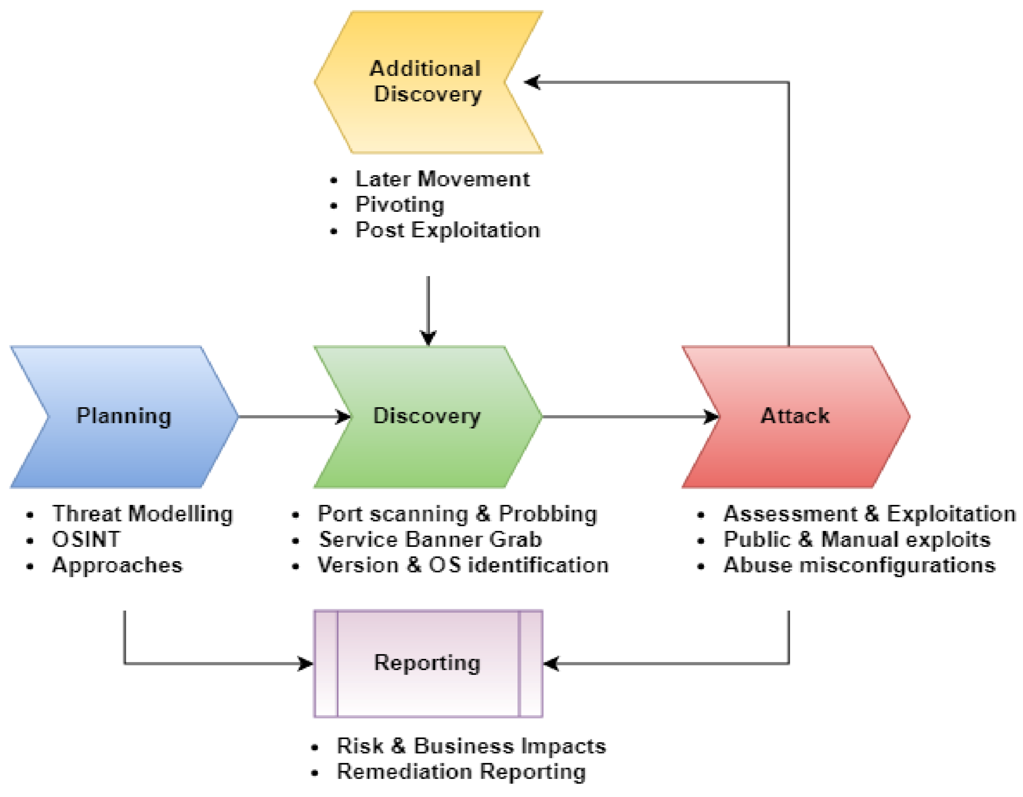

https://nvlpubs.nist.gov/nistpubs/Legacy/SP/nistspecialpublication800-115.pdf

2.4. Technical Impact Metric

For Evaluation of technical impact of discovered vulnerabilities or misconfigurations, EMEA-<> will utilize the Common Vulnerability Scoring System Version 3.1 which is a universally accepted open NIST standard for evaluation of vulnerability impacts to provide qualitative risk ratings. CVSS measures a vulnerability’s impact through assessing the Attack Vector, Complexity, Privileges, User Interaction, Scope, and C.I.A. impact.

The translation of Base Score Rating to a specified Impact level is based upon the NVD NIST guidelines. A CVE string will be provided to its respective vulnerability to provide Butter Family Farms with further technical context and how the vulnerability was rated. CVSS ratings assigned are based on the collective experience of EMEA-<> and may not reflect the exact official assigned score in the NVD.

CVSS Scoring to Impact Severity Level
Base Score Rating | Impact Level
9.0 - 10.0 | Critical
7.0 - 8.9 | High
4.0 - 6.9 | Medium
0.1 - 3.9 | Low
0.0 | Informational

2.5. Business Impact Metric

Technical impacts from vulnerabilities translate to business impacts and most often costs. The risk matrix is an industry standard method to determine the risk level from exploiting a given vulnerability. By considering the likelihood that the exploit occurs and the impact resulting from the exploitation, a severity level can be determined.

In accordance with NIST guidelines for risk assessment specified in NIST Special Publication 800-30, table I-2 provides a standard for risk matrix evaluation based on likelihood and associated impact from a risk.

LIKELIHOOD |  |  | THREAT IMPACT
LIKELIHOOD | Very Low | Low | Moderate | High | Very High
Very High | V. Low | Low | Moderate | High | Critical
High | V. Low | Low | Moderate | High | Critical
Moderate | V. Low | Low | Moderate | Moderate | High
Low | V. Low | Low | Low | Low | Moderate
Very Low | V. Low | V. Low | V. Low | Low | Low

______________________________________________________________
https://nvlpubs.nist.gov/nistpubs/legacy/sp/nistspecialpublication800-30r1.pdf

2.6. Response Plan

The prioritization metric table provides a simplified outline for clients to prioritize reported vulnerabilities based on several factors. Technical and business impacts are factors for categorization of vulnerabilities and following the priority order in terms of remediation is the most efficient approach.

Remediation Priority |  | Potential Factors
Category-4
(CAT-4)
Category-3
(CAT-3)

Category-2
(CAT-2)

Category-1
(CAT-1)

2.7. Summary Timeline of Engagement
This section offers a chronological timeline of major actions performed during the penetration testing engagement. It provides a general sequence of events, such as network scans and exploit attempts to provide full transparency in the testing process's progression and timing.
Activity | Timestamp (GST) | Source(s)

3. Attack Narrative

3.1. Critical Vulnerabilities

3.1.1. <Unauthenticated Guest Account With Administrator Privileges>
3.1.2.

System Logs Exposure |  | CVSS SCORE | PRIORITIZATION
Risk
Impact
Likelihood
CVSS String | < >
Affected Host(s)

Business Impact:
<Text>

Details:
<Text>

Remediations:
<Remove administrative privileges from the guest account immediately or disable the account entirely if not required>

3.1.3. Kerberos Service Ticket Roasting
System Logs Exposure |  | CVSS SCORE | PRIORITIZATION
Risk
Impact
Likelihood
CVSS String
Affected Host(s)

Business Impact:

Details:

Remediations:

3.2. High Vulnerabilities

3.2.1. LSA Dump

System Logs Exposure |  | CVSS SCORE | PRIORITIZATION
Risk
Impact
Likelihood
CVSS String
Affected Host(s)

Business Impact:
<Text>

Details:
(Text).

Remediations:
<Enable LSA Protection or Microsoft Credential Guard to isolate LSASS from unauthorized access>

3.3. Medium Vulnerabilities

3.3.1. <Unauthenticated LDAP Service Exposed by Domain Controller>

System Logs Exposure |  | CVSS SCORE | PRIORITIZATION
Risk
Impact
Likelihood
CVSS String
Affected Host(s)

Business Impact:
<Text>
Details
<Text>

Remediations:

4. Tools and Services

4.1. Tools Utilized

Tool | Description
whatweb | next-generation web scanner used to identify what technologies (CMS, libraries, server versions) a website is built with
nmap | open-source utility for network discovery, port scanning, and security auditing
curl | command-line tool to transfer data with URLs, crafting raw HTTP requests and scripting web interactions
Crackmap exec | Post-exploitation tool for Windows networks. Automates large-scale SMB/WinRM/LDAP/RDP credential validation, enumeration, and remote command/module execution
netexec | Automates large-scale service enumeration, credential testing, lateral movement, and remote command/module execution for Active Directory environments
kerbrute | Fast Kerberos-focused tool for Active Directory that performs username enumeration and password-spraying via Kerberos AS-REQ/AS-REP interactions
bloodhound | Graph-based tool mapping relationships and automatically find privilege-escalation and lateral-movement attack paths
ldapsearch | Command-line LDAP query utility used to search and retrieve directory entries from an LDAP server
Burp Suite | Web-application security testing platform for scanning, spidering, manipulating and replaying
smbclient | SMB/CIFS client for browsing, uploading, downloading, and interacting with Windows shares and printers over the network
wappalyzer | Technology profiler that analyzes websites to systematically detect and categorize the underlying software stack
gobuster | Fast command-line enumeration tool to brute-force web paths, DNS subdomains, and virtual hosts over HTTP(S)/DNS to discover hidden endpoints
sqlmap | Detects and exploits SQL injection vulnerabilities to enumerate databases, extract data, and gain interactive DBMS/filesystem or OS-level access.
dirb | Web content scanner that brute-forces URLs and file paths using wordlists to discover hidden directories, files, and common web resources on a target web server
enum4linux | Linux-based tool for enumerating information from Windows and Samba systems, including users, shares, groups, and password policies via SMB and NetBIOS protocols
ping | Network utility that sends ICMP Echo Request packets to a host to verify reachability and measure round-trip time (latency) for simple connectivity diagnostics

