DISTRIBUTED SYSTEM DESIGN

Concordia University


Final Project

Software Failure Tolerant and Highly Available
Distributed Vehicle Reservation Management System

Team Members

Role | Name | Student ID | Module
Student 1 | Xueming Zhao | 40347760 | Front End (FE)
Student 2 | Chen Qian | 27867808 | Replica Manager (RM)
Student 3 | Anusha Gairola | 40347249 | Sequencer
Student 4 | Yichen Huang | 40167688 | Test Cases & Client

Revision History
Version | Date | Changes
3.1 | 2026-02 | Initial design draft
3.2 | 2026-03 | Complete design document with full sections, UML diagrams, test scenarios
3.3 | 2026-03 | Alignment Addendum: canonical message contracts, PUML fixes
3.4 | 2026-04-01 | Incorporates all NCN deviations (NCN-FE-1/2, NCN-RM-1–6, D1); 18-message contracts; T1–T21 test table; normalized deployment model
3.5 | 2026-04-01 | Updated design doc based on v3.4 reference: NCN consolidated, A3 business rules, updated component specs, local deployment model

1. Requirements Analysis

1.1 Project Selection: Project 2 (Team of 4)
This project extends the Assignment 3 JAX-WS implementation of DVRMS to be both software failure tolerant AND highly available under simultaneous Byzantine and crash failures, using active replication with 4 replicas. We chose JAX-WS over CORBA because the A3 codebase is already complete, deployment is self-contained (no external orbd), and the FE can expose the same SOAP interface transparently to existing clients.

1.2 Functional Requirements
# | Requirement | Owner
R1 | Tolerate simultaneous 1 non-malicious Byzantine + 1 crash fault | Team
R2 | 4 replicas, each a different implementation, on different hosts | Each Student
R3 | Replica Manager (RM) per replica for failure detection/recovery | Student 2
R4 | Front End (FE) receives client requests, forwards to Sequencer | Student 1
R5 | Sequencer assigns unique seq#, reliably multicasts request + seq# + FE info to all replicas | Student 3
R6 | Replicas execute in total order by sequence number | All Students
R7 | FE returns correct result as soon as 2 identical results received | Student 1
R8 | FE informs all RMs when a replica produces incorrect result (see NCN-FE-1/2) | Student 1
R9 | 3 consecutive incorrect results from same replica triggers replacement | Student 2
R10 | FE detects crash via timeout (2× slowest response), informs RMs | Student 1
R11 | RMs verify crash via heartbeat, reach consensus, then replace (NCN-RM-6: heartbeat is monitoring-only; FE/Sequencer trigger detection) | Student 2
R12 | Replaced replica receives state from a healthy replica | Student 2
R13 | All server-side communication uses UDP (made reliable via ReliableUDPSender) | Team
R14 | Proper test cases for all failure scenarios (T1–T21) | Student 4
R15 | Deployed locally with all components on localhost (port-based isolation) | Team

1.3 Preserved Business Logic (from Assignment 3)
All Assignment 3 business rules are preserved. The table below lists each rule and how it is maintained within the P2 replication layer:

A3 Rule | Preservation Mechanism in P2
3 offices (MTL, WPG, BNF) | Each replica runs 3 independent VehicleReservationWS instances
$1,000 shared customer budget | Enforced in VehicleReservationWS.reserveVehicle(); tracked per customer per replica
Max 1 cross-office reservation per remote office | crossOfficeCount map enforced in RESERVE path; verified by T3
FIFO waitlist with 5-check auto-assignment | WaitlistEntry + WaitlistQueries; auto-assign on CANCEL; verified by T5
Date overlap conflict detection | DateRules.datesOverlapInclusive() (inclusive range semantics per A3 spec)
Manager/customer role authorization | ServerIdRules.checkAuthorization() validates office prefix + role prefix
Cross-office reservation uses customer budget | Budget deducted in customer home office regardless of vehicle office

2. System Architecture

2.1 Active Replication Model
The system uses active replication (state machine replication). All 4 replicas start from the same initial state, execute the same deterministic operations, and process requests in the same total order. This follows state-machine properties: deterministic state transition and identical ordered execution across replicas.

Active replication provides sequential consistency. The total order imposed by the Sequencer ensures all correct replicas execute the same operations in the same order. All clients interact through a single FE, which serializes requests naturally.

Fault tolerance rationale: For simultaneous 1 crash + 1 Byzantine fault (f = 1): from 4 replicas, 3 respond (1 crashed), and at most 1 of those 3 is Byzantine, leaving 2 correct replicas that match. Therefore f+1 = 2 identical responses can always be obtained.

2.2 Kaashoek's Sequencer-Based Total Order
The project specification requires Kaashoek's variant of the Sequencer-based total order protocol, where the FE sends each request only to the Sequencer, and the Sequencer multicasts the request with its sequence number to all replicas:

 | Standard Sequencer | Kaashoek's Variant (Our Design)
Step 1 | FE multicasts request to all replicas + Sequencer | FE sends request only to Sequencer
Step 2 | Sequencer multicasts only the seq# to replicas | Sequencer multicasts request + seq# to all replicas
Advantage | RMs already have the request; seq# is lightweight | Simpler: FE sends once; Sequencer is the single relay

2.3 Five Phases of Active Replication
Phase | Name | Our Implementation
1 | Request | FE attaches unique requestID, forwards request to Sequencer via UDP (REQUEST:reqID:feHost:fePort:op:params)
2 | Coordination | Sequencer assigns seq# (AtomicInteger), reliably multicasts (EXECUTE:seqNum:reqID:feHost:fePort:op:params) to all 4 replicas. Guarantees total order delivery
3 | Execution | Each replica executes the request using its ExecutionGate holdback queue (TreeMap). Same order = same result. Business logic from A3 is unchanged
4 | Agreement | No agreement phase needed. Total order from the Sequencer guarantees all correct replicas execute the same operations in the same order
5 | Response | Each replica sends RESULT:seqNum:reqID:replicaID:resultString to FE. FE collects f+1=2 identical results and returns to client. If Byzantine or crash detected, FE reports to RMs

2.4 Communication Protocols
Client-to-FE communication is SOAP/HTTP (JAX-WS). All server-side communication is UDP with an explicit reliability layer (ReliableUDPSender). Reliability contract for every UDP channel:

- 1. Initial timeout = 500 ms; backoff multiplier ×2 per retry; max 5 retries (~15.5 s total).
- 2. Receiver replies with ACK:<context> after validation.
- 3. Sender retransmits after timeout using bounded exponential backoff.
- 4. Receiver is idempotent: duplicates are ACKed but never re-executed.
- 5. Sequencer maintains historyBuffer (ConcurrentHashMap<seqNum, executeMsg>) for NACK replay.
- 6. Replica detecting sequence gap sends NACK:replicaID:seqStart:seqEnd to Sequencer.
- 7. If retries exhausted, sender emits CRASH_SUSPECT or alert to RMs.

2.5 Port Assignment
All ports are centralized in PortConfig.java.

Component | Port | Purpose
FrontEnd | 8080 | SOAP endpoint (client entry)
FrontEnd | 9000 | UDP RESULT listener
Sequencer | 9100 | UDP — REQUEST, NACK, REPLICA_READY
Replica 1 | 6001 | UDP — EXECUTE, heartbeat, state msgs
Replica 2 | 6002
Replica 3 | 6003
Replica 4 | 6004
ReplicaManager 1 | 7001 | UDP — fault notifications, votes, state
ReplicaManager 2 | 7002
ReplicaManager 3 | 7003
ReplicaManager 4 | 7004
Replica N — MTL inter-office | 5001+(N-1)×10 | Inter-office UDP (A3 compatibility)
Replica N — WPG inter-office | 5002+(N-1)×10
Replica N — BNF inter-office | 5003+(N-1)×10

Replica identity: Replicas use numeric IDs 1–4 in all message fields. The R+port format is not used.

3. Component Design

3.1 Front End (FE) — Student 1

Responsibilities
The FE is the single point of contact for all clients (replication transparency). It publishes a JAX-WS SOAP endpoint with the same interface as A3's VehicleReservationWS. Each @WebMethod internally: (a) attaches a unique requestID, (b) sends the request to the Sequencer via UDP, (c) collects results from replicas and applies voting, (d) returns the single correct result.

Key Data Structures & Responsibilities
Responsibility | Detail
SOAP interface | 9 @WebMethods: addVehicle, removeVehicle, listAvailableVehicle, reserveVehicle, updateReservation, cancelReservation, findVehicle, listCustomerReservations, addToWaitList
Request dispatch | forwardAndCollect(): generates reqID, sends REQUEST via ReliableUDPSender, blocks until majority
Result collection | listenForResults(): background UDP listener on port 9000; guarded by dvrms.disable.udp system property for test isolation
Voting | 2 identical RESULT values → majority; adaptive timeout = 2 × slowest response (AtomicLong slowestResponseTime)
Byzantine reporting | Strike counter per replica (byzantineCount ConcurrentHashMap); at ≥ 3 strikes → REPLACE_REQUEST; per strike → INCORRECT_RESULT to all RMs
Crash reporting | Timeout with no response → CRASH_SUSPECT:reqID:seqNum:replicaID to all RMs

NCN-FE-1: findVehicle routes to the customer's home office only (not all 3). Prevents inter-replica UDP loops.
NCN-FE-2: listCustomerReservations routes to home office only. Same reason.

3.2 Replica Manager (RM) — Student 2

Responsibilities
Each replica has one co-located RM. The RM: (1) creates and initializes its replica at startup via ProcessBuilder, (2) monitors health via periodic HEARTBEAT_CHECK (monitoring-only, NCN-RM-6), (3) participates in consensus voting with other RMs, (4) replaces its replica on confirmed failure using the 5-step replaceReplica() procedure, and (5) coordinates state transfer.

Key Responsibilities
Responsibility | Detail
Replica lifecycle | launchReplica() via ProcessBuilder (ReplicaLauncher <replicaID>); killReplica() via destroyForcibly() on subprocess (NCN-RM-4)
Heartbeat | heartbeatLoop(): HEARTBEAT_CHECK every 3 s to managed replica; monitoring-only — does NOT trigger replacement (NCN-RM-6)
Byzantine vote | On REPLACE_REQUEST: broadcasts VOTE_BYZANTINE:targetReplicaID:voterRmID to all peer RMs
Crash vote | On CRASH_SUSPECT: sends HEARTBEAT_CHECK; if no HEARTBEAT_ACK within 2 s → VOTE_CRASH:targetID:CRASH_CONFIRMED:myRmID; else VOTE_CRASH:targetID:ALIVE:myRmID
Vote window | VOTE_WINDOW_MS = 2000 ms — RM waits for votes, then decides by majority; replaces VOTE_ACK/VOTE_NACK pattern (NCN-RM-3)
Replacement guard | replacementInProgress set — prevents concurrent replacement of the same replica
State acquisition | Sends STATE_REQUEST to lowest-ID healthy replica; receives STATE_TRANSFER:sourceReplicaID:snapshot
Readiness broadcast | After INIT_STATE + ACK:INIT_STATE: broadcasts REPLICA_READY:replicaID:host:port:lastSeqNum to Sequencer, FE, and all RMs (NCN-RM-5)

State Transfer
The replacing RM sends STATE_REQUEST to the lowest-ID healthy replica. The healthy replica creates a serialized snapshot (vehicleDB, reservations, waitList, customerBudget, crossOfficeCount, lastSequenceNumber). The new replica loads the snapshot, sets nextExpectedSeq = lastSequenceNumber + 1, then processes any buffered holdback messages in order.

3.3 Sequencer — Student 3

Responsibilities
The Sequencer is failure-free per the project specification. Following Kaashoek's protocol, it receives requests from the FE (port 9100), assigns monotonically increasing sequence numbers via AtomicInteger (s_g), and reliably multicasts EXECUTE messages to all 4 replicas. It also handles crash notification (D1) when multicast retries are exhausted.

Responsibility | Detail
Sequence assignment | sequenceCounter (AtomicInteger) assigned monotonically per REQUEST; this is s_g in notation
Multicast | multicast(): sends EXECUTE:seqNum:reqID:feHost:fePort:op:params to all 4 replica ports via ReliableUDPSender
History buffer | historyBuffer (ConcurrentHashMap<seqNum, executeMsg>) — kept for NACK replay and recovery catch-up
Gap recovery | handleNack(): replays EXECUTE messages for [seqStart..seqEnd] from history to requesting replica
Replica registration | handleReplicaReady(): updates replica address in multicast list; replays from lastSeq+1; sends ACK:REPLICA_READY:replicaID
Crash notification (D1) | On multicast retry exhaustion: sends CRASH_SUSPECT:reqID:seqNum:replicaID to all RMs

3.4 Test Cases & Client — Student 4

Responsibilities
Student 4 designs comprehensive test scenarios (T1–T21) covering all failure situations and implements ReplicationIntegrationTest.java using @TestMethodOrder(OrderAnnotation.class).

Failure Simulation
Byzantine simulation: TestClient sends SET_BYZANTINE:true via UDP to a replica. The replica returns random/incorrect results instead of executing business logic. SET_BYZANTINE:false restores normal operation.

Crash simulation: Kill the replica process directly (per project spec: "simulate a process crash by killing that process while the application is running"). The RM detects the crash via heartbeat failure.

3.5 Replica Modifications — All Students
Each student modifies the A3 server to work as a replica state machine. Key changes from A3:

# | Change | Details
1 | Remove direct SOAP endpoint | No more Endpoint.publish(); replica no longer accepts client connections directly
2 | Add Replica UDP listener | Receives EXECUTE(seqNum, request, FE_addr) from Sequencer, sends ACK, returns RESULT:seqNum:reqID:replicaID:result to FE
3 | Holdback queue + total order | Maintain nextExpectedSeq (r_g) and holdbackQueue (TreeMap by seqNum). On receive: if seqNum == nextExpectedSeq execute and increment; if seqNum > nextExpectedSeq buffer + NACK; if seqNum < nextExpectedSeq duplicate — ACK but do not re-execute
4 | State snapshot support | getStateSnapshot() serializes all data; loadStateSnapshot() restores. Used for recovery via INIT_STATE
5 | Heartbeat response | Reply to HEARTBEAT_CHECK from RM with HEARTBEAT_ACK:replicaID:nextExpectedSeq
6 | Byzantine mode toggle | SET_BYZANTINE flag returns random results (testing only); toggle via SET_BYZANTINE:true|false
7 | Preserve all A3 logic | Vehicle management, reservations, waitlists, budgets, cross-office UDP: unchanged

Replica (ReplicaLauncher + VehicleReservationWS)
Files: ReplicaLauncher.java, VehicleReservationWS.java | Ports: UDP 6001–6004 (main); 5001–5033 (inter-office)

Responsibility | Detail
Total-order execution | ExecutionGate with holdback queue (TreeMap<seqNum, PendingExecute>)
Execution gate logic | seqNum == nextExpected: execute + drain queue; seqNum > nextExpected: holdback + send NACK; seqNum < nextExpected: ACK (duplicate, no re-execute)
Business logic | 3 VehicleReservationWS instances (MTL, WPG, BNF); each holds full vehicle/reservation/waitlist state
Operation routing | RESERVE/CANCEL/UPDATE → customer home office; ADD/REMOVE/LIST → manager's office; FIND/LISTRES → MTL default (NCN-FE-1/2)
State snapshot | getStateSnapshot() / loadStateSnapshot() — Base64-serialized Java objects; includes lastSeqNum
Post-init reset | After INIT_STATE: sets nextExpectedSeq = lastSeqNum + 1; drains buffered contiguous messages from holdback queue
Byzantine mode | byzantineMode flag toggled via SET_BYZANTINE:true|false; when true, sends random garbage instead of real result
Budget/slot (NCN-RM-1) | RESERVE/CANCEL/UPDATE enforce $1,000 budget + 1 cross-office slot limit per remote office within the local replica instance
Waitlist (NCN-RM-2) | Waitlist FIFO + 5-check auto-assignment runs locally per replica on CANCEL

4. Protocols and Algorithms

4.1 Total Order Multicast (Kaashoek's Sequencer Protocol)
In Kaashoek's variant, the FE sends each request only to the Sequencer. The Sequencer multicasts the request with its sequence number to the replicas, which execute the request in sequence number order. This provides total ordering because sequence numbers are assigned by a single Sequencer.

Algorithm for Sequencer:
On receive REQUEST <reqID, feAddr, op, params> from FE: assign s_g to the message, multicast EXECUTE <seqNum=s_g, reqID, feAddr, op, params> to all replicas, increment s_g, send ACK:reqID to FE.

Algorithm for Replica i (r_g = nextExpectedSeq, initially 0):
On receive EXECUTE <seqNum=S, reqID, feAddr, op, params>: if S == r_g → execute, send RESULT to FE, r_g++, drain holdback queue for r_g, r_g+1, …; if S > r_g → place in holdback TreeMap, send NACK; if S < r_g → duplicate, send ACK but do not re-execute.

4.2 Reliable Multicast
Reliable group communication is implemented over UDP using ACK/NACK, retransmission, duplicate suppression, and sequencer history replay (ReliableUDPSender).

Integrity: duplicate suppression via seqNum tracking; at-most-once delivery at each correct receiver.
Validity: sender retransmits until ACK or bounded failure decision (5 retries, exponential backoff).
Agreement: gap detection (NACK) + sequencer replay from historyBuffer; if one correct replica delivers sequence S, all correct replicas eventually receive and deliver S in total order.

4.3 Failure Detection and Recovery
Deployment is local (localhost) with no long-lived partition and eventually timely communication. Timeout-based suspicion can be false under transient delay/loss. Therefore, replacement is executed only after RM majority consensus (>50% VOTE_CRASH:CRASH_CONFIRMED votes within the 2000 ms VOTE_WINDOW_MS). This keeps failure handling safe under uncertain timing while still supporting practical detection.

4.4 Message Contracts — Full Table (18 Messages)
Transport key: R = Reliable (ReliableUDPSender, 500 ms / ×2 backoff / 5 retries); U = Raw UDP

# | Message | Wire Format | Producer | Consumer | T
1 | REQUEST | REQUEST:reqID:feHost:fePort:op:params | FrontEnd | Sequencer | R
2 | EXECUTE | EXECUTE:seqNum:reqID:feHost:fePort:op:params | Sequencer | Replica | R
3 | RESULT | RESULT:seqNum:reqID:replicaID:resultString | Replica | FrontEnd | R
4 | NACK | NACK:replicaID:seqStart:seqEnd | Replica | Sequencer | U
5 | ACK | ACK:<context> | Various | Various | U
6 | INCORRECT_RESULT | INCORRECT_RESULT:reqID:seqNum:replicaID | FrontEnd | All RMs | R
7 | CRASH_SUSPECT | CRASH_SUSPECT:reqID:seqNum:replicaID | FE / Sequencer | All RMs | R
8 | REPLACE_REQUEST | REPLACE_REQUEST:replicaID:BYZANTINE_THRESHOLD | FrontEnd | All RMs | R
9 | VOTE_BYZANTINE | VOTE_BYZANTINE:targetReplicaID:voterRmID | ReplicaManager | All RMs | R
10 | VOTE_CRASH | VOTE_CRASH:targetID:ALIVE|CRASH_CONFIRMED:voterRmID | ReplicaManager | All RMs | R
11 | STATE_REQUEST | STATE_REQUEST:replicaID | ReplicaManager | Replica | R
12 | STATE_TRANSFER | STATE_TRANSFER:sourceReplicaID:snapshot | Replica | ReplicaManager | R
13 | INIT_STATE | INIT_STATE:mtlSnapshot|wpgSnapshot|bnfSnapshot | ReplicaManager | Replica | R
14 | ACK:INIT_STATE | ACK:INIT_STATE:replicaID:lastSeqNum | Replica | ReplicaManager | U
15 | REPLICA_READY | REPLICA_READY:replicaID:host:port:lastSeqNum | ReplicaManager | Seq, FE, all RMs | R
16 | HEARTBEAT_CHECK | HEARTBEAT_CHECK:replicaID | ReplicaManager | Replica | U
17 | HEARTBEAT_ACK | HEARTBEAT_ACK:replicaID:nextExpectedSeq | Replica | ReplicaManager | U
18 | SHUTDOWN | SHUTDOWN:replicaId | ReplicaManager | Replica | U
— | SET_BYZANTINE | SET_BYZANTINE:true|false | Test client | Replica | U (test)

ACK variants used in context:
- ACK:reqID — Sequencer acknowledges REQUEST from FE
- ACK:seqNum — Replica acknowledges EXECUTE from Sequencer
- ACK:REPLICA_READY:replicaID — Sequencer acknowledges REPLICA_READY from RM
- ACK:SET_BYZANTINE:true|false — Replica confirms byzantine-mode toggle

5. Test Scenarios
All tests are in ReplicationIntegrationTest.java, ordered via @TestMethodOrder(OrderAnnotation.class). Test status (2026-03-25): 49 tests run, 0 failures, 7 skipped (@Disabled placeholders).

5.1 Normal Operation Tests
# | Method | Scenario | Fault Injected | Pass Criterion
T1 | t1_vehicleCrud | Vehicle add / list / remove | None | SUCCESS on each step
T2 | t2_localReservation | Local reserve + budget deduction + cancel + refund | None | Budget = $1,000 after cancel
T3 | t3_crossOfficeReservation | Cross-office reserve; slot limit; NCN-FE-1/2 | None | FAIL on 2nd WPG; NCN assertions pass
T4 | t4_concurrentRequests | 2 threads reserve simultaneously | None | Both succeed
T5 | t5_waitlist | Waitlist add + auto-assign on cancel | None | "auto-assigned from waitlist" in cancel response

5.2 Byzantine Failure Tests
# | Method | Scenario | Fault Injected | Pass Criterion
T6 | t6_byzantineFirstStrike | Byzantine R3, request 1 | R3 Byzantine ON | Correct result from R1/R2/R4 majority
T7 | t7_byzantineSecondStrike | Byzantine R3, request 2 | R3 Byzantine | Correct majority result
T8 | t8_byzantineThirdStrikeReplace | 3rd strike → REPLACE_REQUEST | R3 Byzantine | System functions after 8 s recovery
T9 | t9_afterReplacement | Post-replacement write operations | None (R3 replaced) | Read + write succeed
T10 | t10_byzantineCounterReset | Strike counter reset after replacement | R3 Byzantine OFF | Correct result

5.3 Crash Failure Tests
# | Method | Scenario | Fault Injected | Pass Criterion
T11 | t11_crashDetection | Kill R2 directly | R2 killed | Correct result from 3 remaining replicas
T12 | t12_crashRecovery | CRASH_SUSPECT → vote → replace R2 | R2 crashed | System functions after 8 s recovery
T13 | t13_stateTransfer | New R2 has correct state after transfer | None (R2 replaced) | Read + write succeed
T14 | t14_operationDuringRecovery | Reserve + cancel after crash recovery | None | Both succeed

5.4 Simultaneous Failure Tests
# | Method | Scenario | Fault Injected | Pass Criterion
T15 | t15_crashPlusByzantine | R2 crashed + R3 Byzantine simultaneously | R2 killed + R3 Byz | R1/R4 provide correct majority
T16 | t16_dualRecovery | Both R2 + R3 replaced | R2 crash + R3 Byz | System responds after 10 s
T17 | t17_stateConsistencyAfterRecovery | All 4 replicas operational after dual recovery | None | Reserve + cancel succeed

5.5 Edge Case Tests
# | Method | Scenario | Fault Injected | Pass Criterion
T18 | t18_packetLossRetransmit | ReliableUDPSender retry coverage | None (implicit) | Add + remove succeed
T19 | t19_outOfOrderDelivery | Rapid sequential requests; holdback queue | None | Both vehicles visible in list
T20 | t20_threeSimultaneousClients | 3 threads send simultaneously | None | All 3 succeed
T21 | t21_fullCrossOfficeFlow | Cross-office: reserve → update → cancel | None | All steps SUCCESS

6. UML Diagrams
D1: System Architecture (Kaashoek's data flow with 4 replicas)
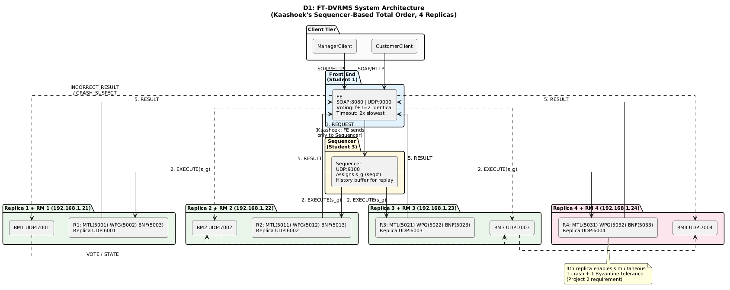

D2: Normal Request Flow — 5 Phases of Active Replication
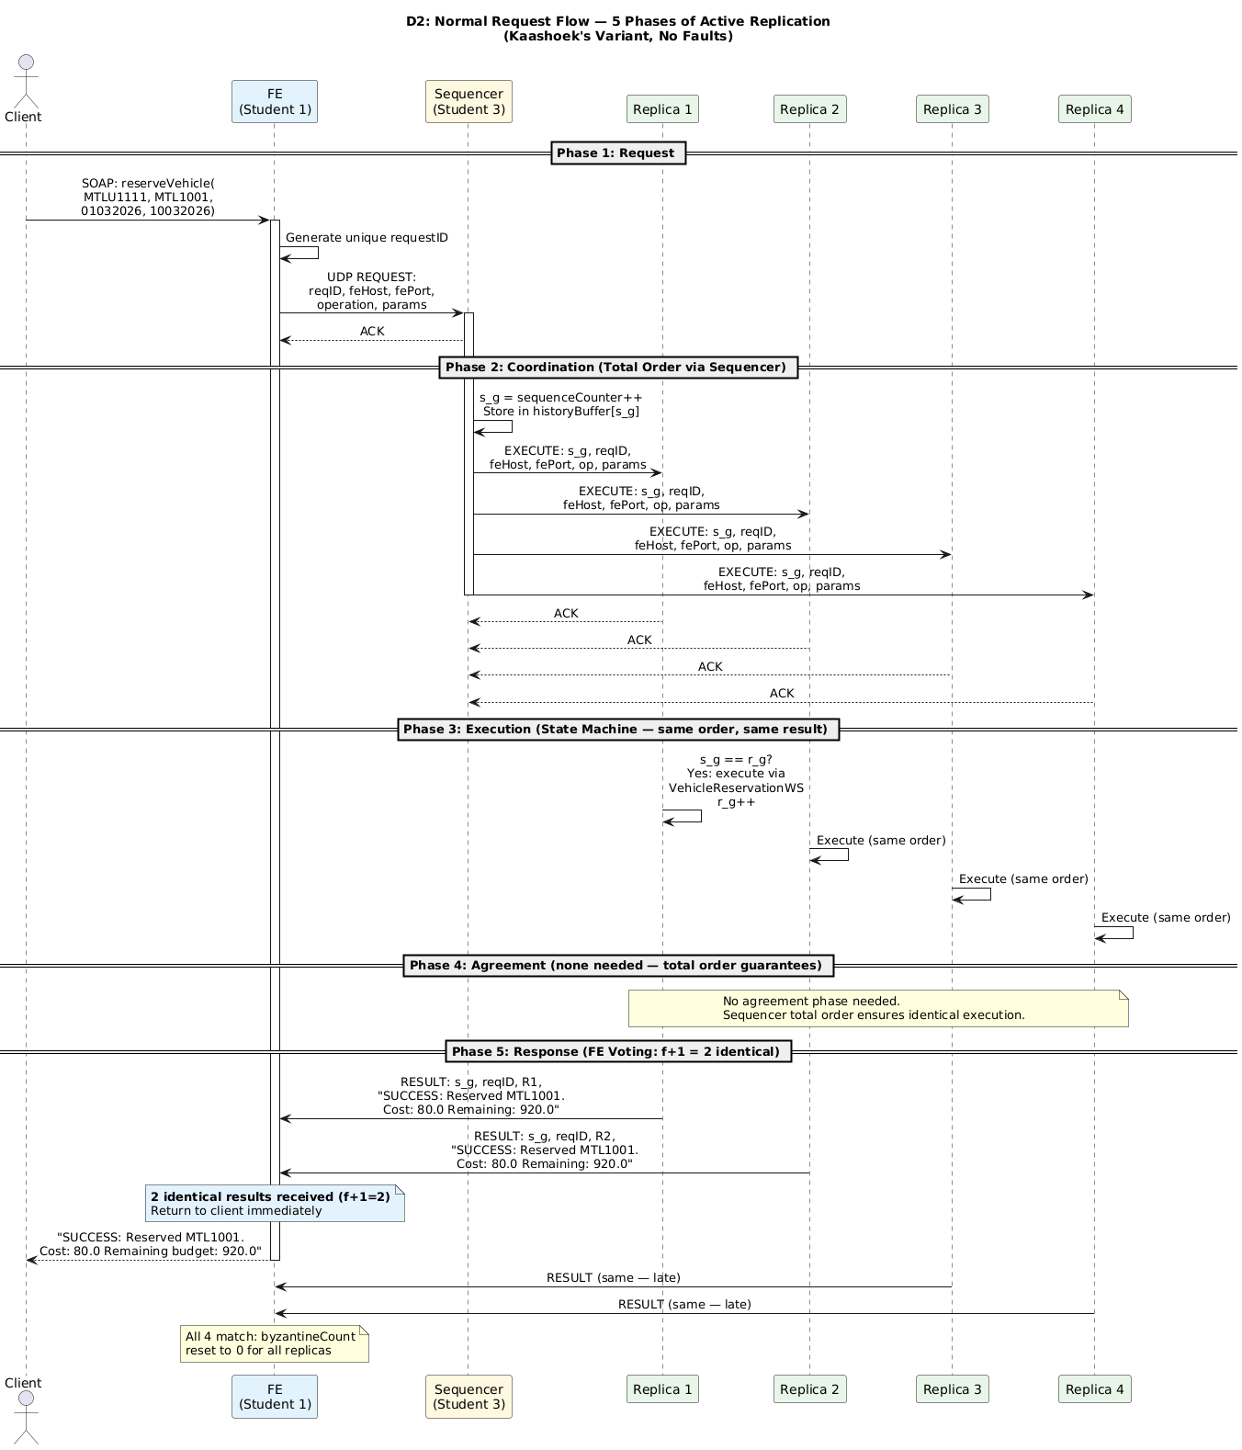

D3: Byzantine Failure — 3 Consecutive Incorrect, Replacement, State Transfer
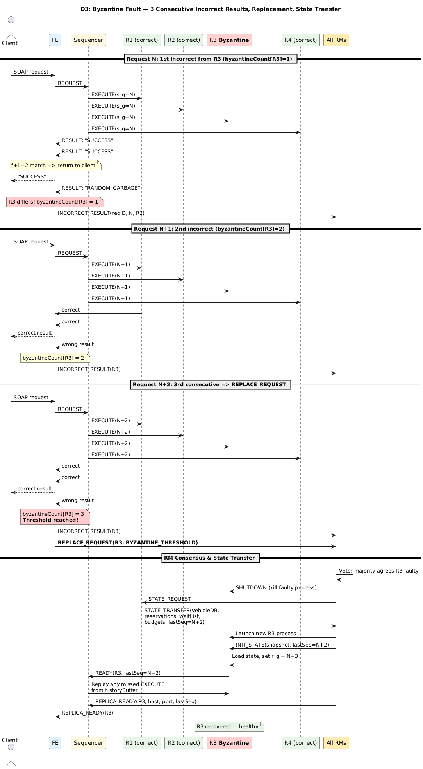

D4: Crash Failure — Timeout, Heartbeat, Consensus, Recovery
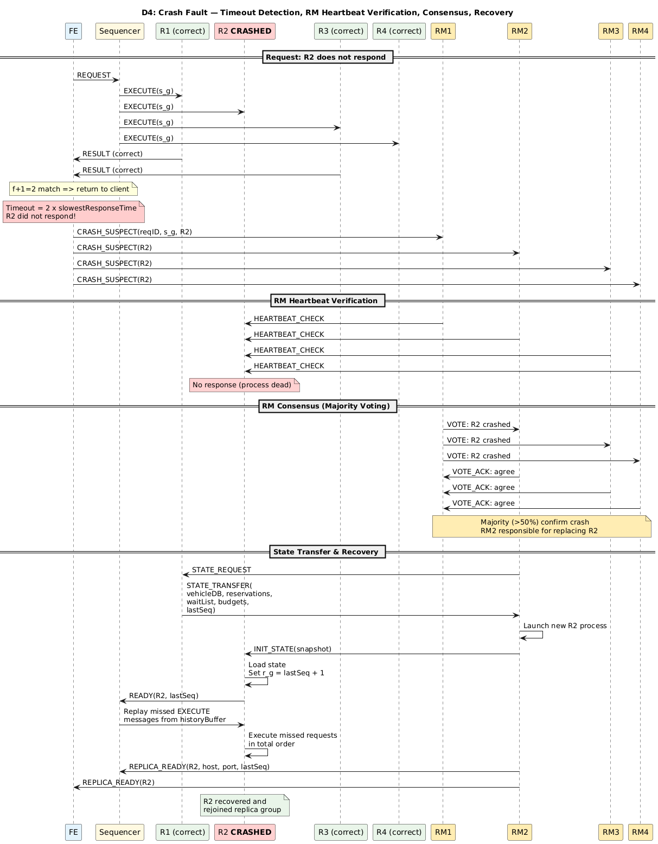

D5: Simultaneous Crash + Byzantine (Core Project 2 Scenario)
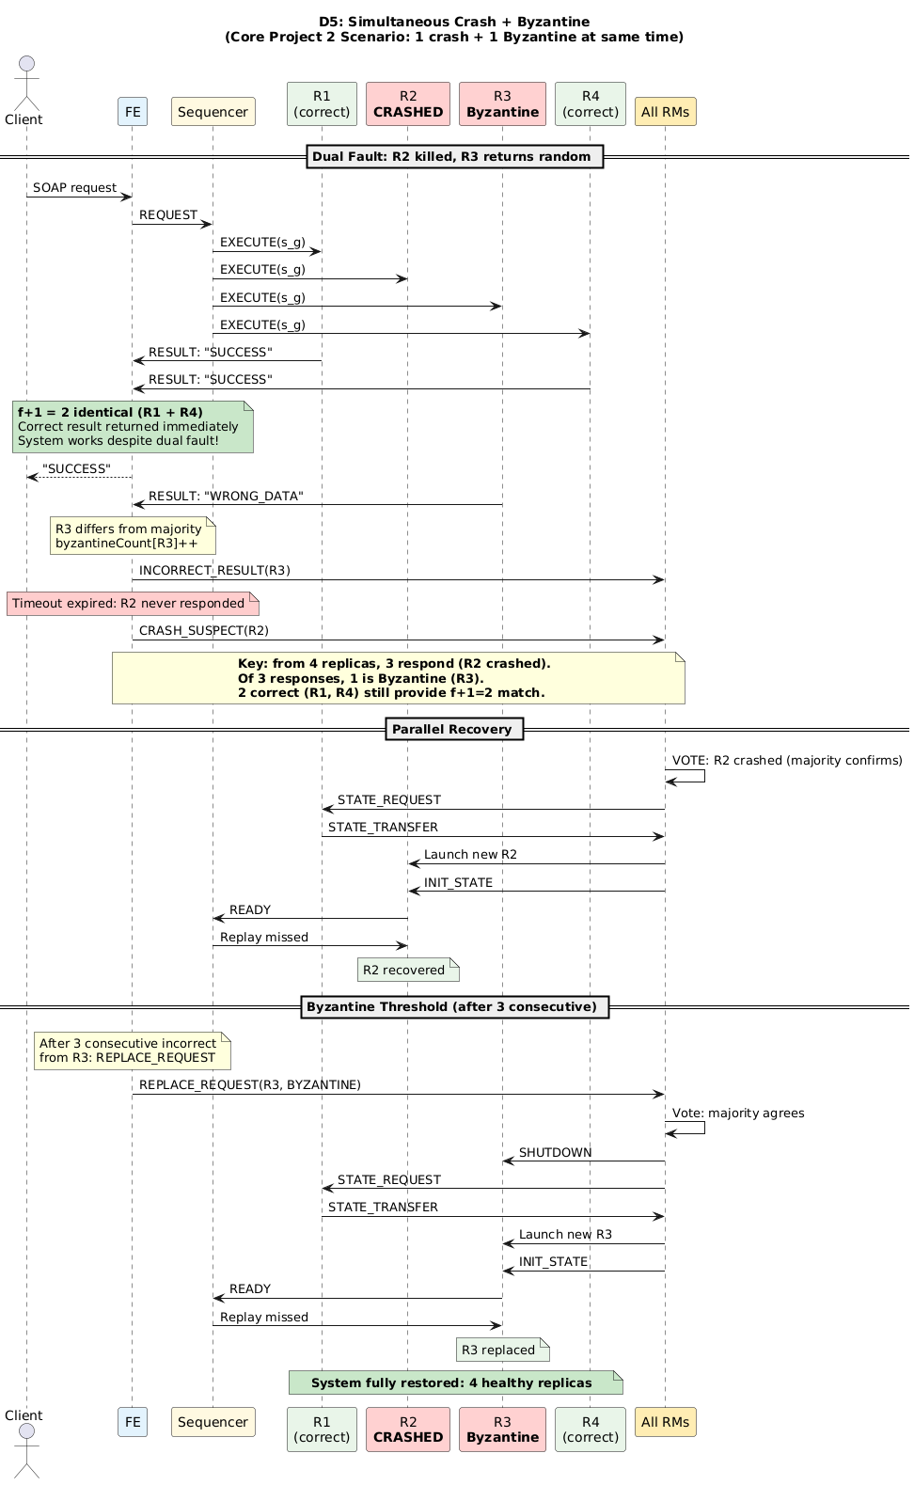

D6: Class Diagram — FE, Sequencer, RM, Replica
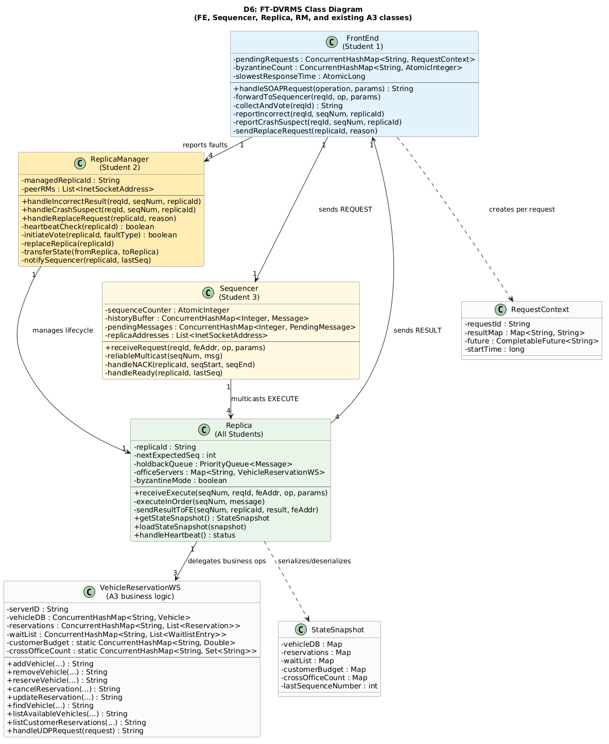

D7: Local Deployment Diagram
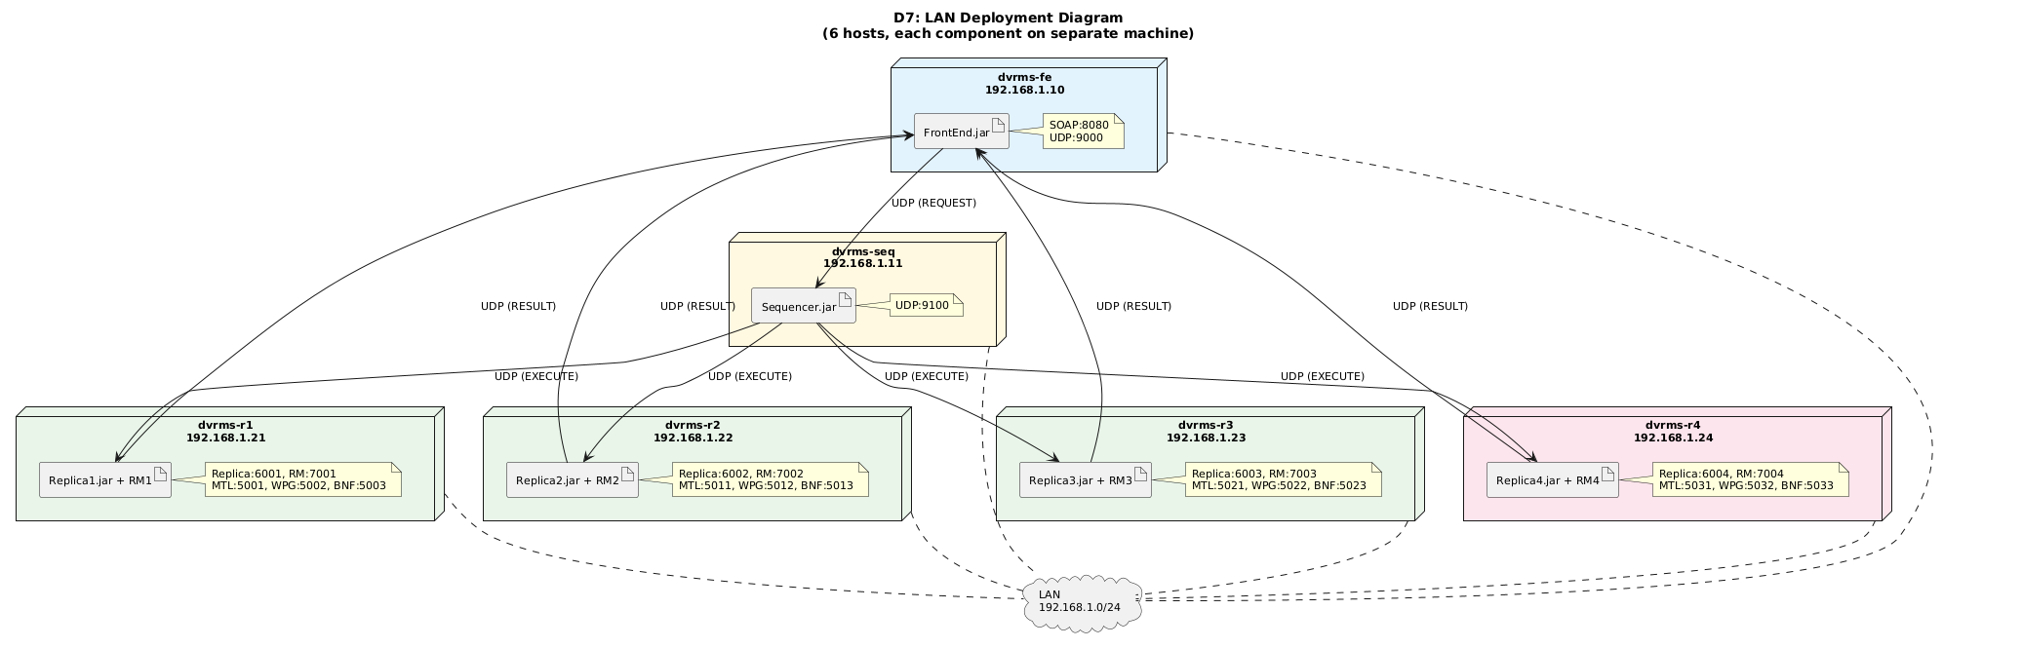

7. A3 Business Rule Preservation
A3 Rule | Preservation Mechanism in P2
3 offices (MTL, WPG, BNF) | Each replica runs 3 independent VehicleReservationWS instances
$1,000 shared customer budget | Enforced in VehicleReservationWS.reserveVehicle(); budget tracked per customer per replica
Max 1 cross-office reservation per remote office | crossOfficeCount map enforced in RESERVE path; verified by T3
FIFO waitlist with 5-check auto-assignment | WaitlistEntry + WaitlistQueries; auto-assign on CANCEL; verified by T5
Date overlap conflict detection | DateRules.datesOverlapInclusive() (inclusive range semantics per A3 spec)
Manager/customer role authorization | ServerIdRules.checkAuthorization() validates office prefix + role prefix
Cross-office reservation uses budget | Budget deducted in customer's home office regardless of vehicle office

8. Necessary-Change Notes (NCN) — Consolidated
The following table documents deviations from the v3.3 design that were incorporated in v3.4 and carried forward to v3.5:

ID | Scope | v3.3 Behavior | v3.4/v3.5 Behavior | Justification | Validation
NCN-FE-1 | FE | findVehicle: all 3 offices | Home office only | Prevents inter-replica loops | T3 assertion
NCN-FE-2 | FE | listCustomerReservations: all offices | Home office only | Same as NCN-FE-1 | T3 assertion
NCN-RM-1 | Replica | Cross-office budget/slot invariants | Home-office routing; local invariants | Each replica holds full 3-office state | Unit test + T2/T3
NCN-RM-2 | Replica | Cross-office waitlist coordination | Local FIFO auto-assign | Scope of replication | T5
NCN-RM-3 | RM | VOTE_ACK / VOTE_NACK | 2000 ms vote window (VOTE_WINDOW_MS) | Equivalent quorum; simpler | T8, T12, T15
NCN-RM-4 | RM | SHUTDOWN before kill | destroyForcibly() | Byzantine replica may ignore SHUTDOWN | T8, T15
NCN-RM-5 | RM | Replica-originated READY | RM-originated REPLICA_READY | RM owns recovery lifecycle | T8, T12
NCN-RM-6 | RM | Heartbeat triggers replacement | Monitoring-only; FE/Sequencer trigger | Design §3.2 explicit | T11–T12
D1 | Sequencer | Silent on multicast failure | Sends CRASH_SUSPECT to all RMs | Design §3.3 requirement | T11, T15

9. Deployment and Challenges

9.1 Local Demo Deployment
All components (FrontEnd, Sequencer, ReplicaManagers, Replicas) run on localhost with port-based process isolation. There is no enforced startup order — each component binds its UDP port passively on start. RMs launch and monitor their respective replicas via ProcessBuilder.

Component | Launch Command
Sequencer | java server.Sequencer
ReplicaManager N (N=1..4) | java server.ReplicaManager N (launches Replica N via ProcessBuilder)
FrontEnd | java server.FrontEnd (publishes SOAP on 8080, listens UDP on 9000)

9.2 Build and Test
mvn test
Expected output: 49 tests, 0 failures (7 skipped @Disabled placeholders).

9.3 Most Important/Difficult Parts
Voting with Simultaneous Failures
The FE must correctly handle the case where 1 replica crashes (no response) and another produces incorrect results simultaneously. With only 2 correct replicas responding among 3 total, the FE must still identify and return the correct result (2 matching = f+1 identical). The voting logic must distinguish between absence (crash) and presence of wrong data (Byzantine), triggering independent recovery paths.

State Transfer During Active Requests
When a replica is being replaced, the Sequencer continues sending new requests to the remaining replicas. The new replica must receive a consistent snapshot and then process any requests buffered in its holdback queue during the transfer. The sequence numbering (nextExpectedSeq = lastSeqNum + 1) ensures no messages are lost or duplicated.

Deterministic Execution Across Different Implementations
Since each replica runs a different implementation (per requirement R2), all must produce identical results for identical inputs in the same order. The A3 business logic is deterministic (no timestamps or randomness affect results), but each student must ensure their implementation follows the exact same business rules, edge cases, and response format. This is the state machine property: state is a deterministic function of initial state and operations applied.

Appendix A: Reliable UDP Sender Parameters
ReliableUDPSender.java — used on all channels marked R in §4.4.

Parameter | Value
Initial timeout | 500 ms
Backoff multiplier | ×2 per retry
Max retries | 5
Max total wait (approx.) | ~15,500 ms (~15.5 s)
ACK recognition | Response starts with "ACK:"
Return value | true if ACKed; false if retries exhausted

