**Java Lab Sheet 2**

**-Mohith LS  
AM.SC.U3CSC21036**

1. Write a program to create a class Student and...

public class L2Q1

{

    public static void main(String args[])

    {

        Student S1 = new Student();

        Student S2 = new Student();

        S1.name = "Mohith";

        S1.place = "Ooty";

        S1.mobnum = "97429834197";

        S1.age = 19;

        S2.name = "Jessica";

        S2.place = "Chennai";

        S2.mobnum = "293785213487";

        S2.age = 18;

        S1.printData();

        S2.printData();

    }

}

class Student

{

    String name;

    String place;

    String mobnum;

    int age;

    public Student(){}

    public void printData()

    {

        System.out.println("Name: "+this.name);

        System.out.println("Place: "+this.place);

        System.out.println("Mobile: "+this.mobnum);

        System.out.println("Age: "+this.age);

    }

}

Output:

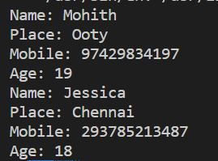

2. Write a class Student2...

public class L2Q2

{

    public static void main(String args[])

    {

        Student2 S1 = new Student2();

        Student2 S2 = new Student2();

        S1.getData("Mohith","Ooty","923329857","Loveboy","25.02.2003");

        S2.getData("Jessica","Chennai","9273523493","Rajsekar","16.06.2003");

        S1.printData();

        S2.printData();

    }

}

class Student2

{

        String name;

        String place;

        String mobnum;

        String Parent;

    String DOB;

        public void printData()

        {

                System.out.println("Name: "+this.name);

                System.out.println("Place: "+this.place);

                System.out.println("Mobile: "+this.mobnum);

                System.out.println("Parent name: "+this.Parent);

        System.out.println("DOB: "+this.DOB);

        }

    public void getData(String name, String place, String mobnum, String Parent, String DOB)

    {

        this.name = name;

        this.place = place;

        this.mobnum = mobnum;

        this.Parent = Parent;

        this.DOB = DOB;

    }

}

Output:

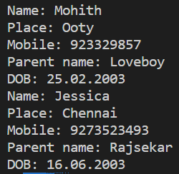

3. Rewrite the class in Q2 to include constructors.

public class L2Q2

{

        public static void main(String args[])

        {

                Student2 S1 = new Student2("Mohith","Ooty","923329857","Loveboy","25.02.2003");

                Student2 S2 = new Student2("Jessica","Chennai","9273523493","Rajsekar","16.06.2003");

                S1.printData();

                S2.printData();

        }

}

class Student2

{

        String name;

        String place;

        String mobnum;

        String Parent;

        String DOB;

        Student2(){}

        public void printData()

        {

                System.out.println("Name: "+this.name);

                System.out.println("Place: "+this.place);

                System.out.println("Mobile: "+this.mobnum);

                System.out.println("Parent name: "+this.Parent);

                System.out.println("DOB: "+this.DOB);

        }

        Student2(String name, String place, String mobnum, String Parent, String DOB)

        {

                this.name = name;

                this.place = place;

                this.mobnum = mobnum;

                this.Parent = Parent;

                this.DOB = DOB;

        }

}

Output:

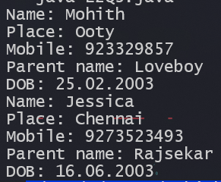

4. Create a class Car...

import java.util.Scanner;

public class L2Q4

{

    public static void main(String args[])

    {

        Car cars[] = new Car[5];

        Scanner sc = new Scanner(System.in);

        System.out.println("Enter the details: ");

        for(int i=0;i<5;i++)

        {

            cars[i] = new Car();

            cars[i].edit_info();

        }

        int choice=0,x;

        while (choice!=3)

        {

            System.out.println("1.Display details\n2.Edit details\n3.Exit");

            choice = sc.nextInt();

            if (choice==1)

            {

                System.out.print("Enter car number: ");

                x = sc.nextInt();

                cars[x-1].display_detail();

            }

            else if (choice==2)

            {

                System.out.print("Enter car number: ");

                x = sc.nextInt();

                cars[x-1].edit_info();

            }

            else

                break;

        }

    }

}

class Car

{

    String model;

    int year;

    String color;

    String fuel_type;

    Car(){}

    Car(String model, int year, String color, String fuel_type)

    {

        this.model = model;

        this.year = year;

        this.color = color;

        this.fuel_type = fuel_type;

    }

    public void display_detail()

    {

        System.out.println("Model: "+model);

        System.out.println("Year: "+year);

        System.out.println("Color: "+color);

        System.out.println("Fuel type: "+fuel_type);

    }

    public void edit_info()

    {

        Scanner sc = new Scanner(System.in);

        System.out.print("Model: ");

        model = sc.nextLine();

        System.out.print("Year: ");

        year = sc.nextInt();

        sc.nextLine();

        System.out.print("Color: ");

        color = sc.nextLine();

        System.out.print("Fuel type: ");

        fuel_type = sc.nextLine();

    }

}

Output:

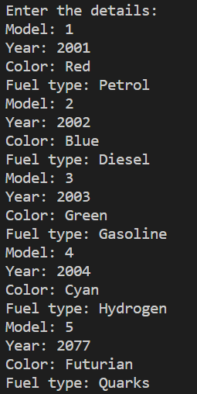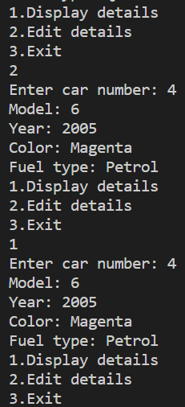

5. Write a java program with class A, which has two public, two private and two protected data members...

import java.util.Scanner;

class A

{

    public int a;

    public int b;

    private int c;

    private int d;

    protected int e;

    protected int f;

    A(){

        Scanner sc = new Scanner(System.in);

        System.out.println("Enter a, b, c, d, e, f");

        a = sc.nextInt();

        b = sc.nextInt();

        c = sc.nextInt();

        d = sc.nextInt();

        e = sc.nextInt();

        f = sc.nextInt();

    }

    void get(int a,int b, int c, int d, int e, int f)

    {

        this.a = a;

        this.b = b;

        this.c = c;

        this.d = d;

        this.e = e;

        this.f = f;

    }

    A(int a,int b, int c, int d, int e, int f)

    {

        this.a = a;

        this.b = b;

        this.c = c;

        this.d = d;

        this.e = e;

        this.f = f;

    }

    public void print()

    {

        System.out.print(a+"\n"+b+"\n"+c+"\n"+d+"\n"+e+"\n"+f+"\n");

    }

}

public class L2Q5

{

    public static void main(String[] args)

    {

        Scanner sc = new Scanner(System.in);

        int a = sc.nextInt();

        int b = sc.nextInt();

        int c = sc.nextInt();

        int d = sc.nextInt();

        int e = sc.nextInt();

        int f = sc.nextInt();

        A obj = new A();

        obj.get(a,b,c,d,e,f);

        obj.print();

        //Trying to access all data members in the main method

        System.out.print(obj.a+"\n"+obj.b+"\n"+obj.c+"\n"+obj.d+"\n"+obj.e+"\n"+obj.f+"\n");

    }

}

Output:

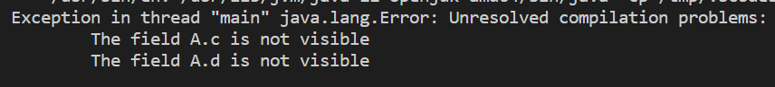

6. Create a class Number with two public integer members. Include three methods...

import java.util.Scanner;

class Number

{

    public int a;

    public int b;

    Number(){

        this.a = 0;

        this.b = 0;

    }

    Number(int a, int b){

        this.a = a;

        this.b = b;

    }

    Number(Number obj){

        this.a = obj.a;

        this.b = obj.b;

    }

    public void sum(){

        System.out.println("Sum = "+(a+b));

    }

    public void diff(){

        System.out.println("Difference = "+(a-b));

    }

    public void product()

    {

        System.out.println("Product = "+(a*b));

    }

}

public class L2Q6 {

    public static void main(String args[])

    {

        Number obj = new Number(5,10);

        obj.sum();

        obj.diff();

        obj.product();

    }

}

Output:

