**Java Lab Sheet - 5**

**-Mohith LS  
AM.SC.U3CSC21036**

1. Create a square matrix initialize it find the sum of lower and upper triangle sum.

import java.util.Scanner;

public class L5Q1

{

    public static void main(String args[])

    {

        Scanner sc = new Scanner(System.in);

        System.out.print("Enter the size of square matrix: ");

        int n = sc.nextInt();

        int a[][] = new int[n][n];

        System.out.println("Enter the elements of the matrix: ");

        for (int i=0;i<n;i++)

            for (int j=0;j<n;j++)

                a[i][j] = sc.nextInt();

        System.out.println("The matrix is: ");

        for (int i=0;i<n;i++)

        {

            for (int j=0;j<n;j++)

                System.out.print(a[i][j] + " ");

            System.out.println();

        }

        //Finding upper triangle sum

        int sum = 0;

        for (int i=0;i<n;i++)

            for (int j=i;j<n;j++)

                sum += a[i][j];

        System.out.println("The sum of upper triangle is: " + sum);

        //Finding lower triangle sum

        sum = 0;

        for (int i=0;i<n;i++)

            for (int j=0;j<=i;j++)

                sum += a[i][j];

        System.out.println("The sum of lower triangle is: " + sum);

    }

}

Output:

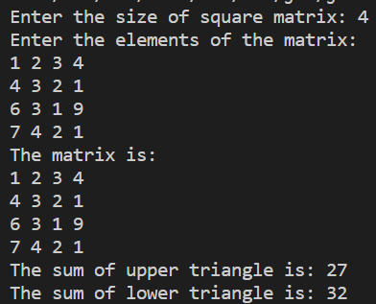

2. Create an interface Shapes with two method void area(double x, double y) and void perimeter(double x, double y). implement the interface to two classes Rectangle, Square and Triangle. And test the classes.

import java.util.Scanner;

public class L5Q2a

{

    public static void main(String args[])

    {

        Scanner sc = new Scanner(System.in);

        System.out.print("1. Rectangle\n2. Triangle\n3. Square\nEnter your choice: ");

        int choice = sc.nextInt();

        System.out.print("Enter the dimensions: ");

        Shapes myshape;

        switch (choice)

        {

            case 1:

                myshape = new Rectangle();

                double l = sc.nextDouble();

                double b = sc.nextDouble();

                myshape.area(l,b);

                myshape.perimeter(l,b);

                break;

            case 2:

                myshape = new Triangle();

                double a = sc.nextDouble();

                double h = sc.nextDouble();

                myshape.area(a,h);

                myshape.perimeter(a,h);

                break;

            case 3:

                myshape = new Square();

                double side = sc.nextDouble();

                myshape.area(side,side);

                myshape.perimeter(side,side);

                break;

            default:

                System.out.println("Invalid choice!");

        }

    }

}

interface Shapes

{

    void area(double x, double y);

    void perimeter(double x, double y);

}

class Rectangle implements Shapes

{

    public void area(double x, double y)

    {

        System.out.println("Area of rectangle is: " + (x*y));

    }

    public void perimeter(double x, double y)

    {

        System.out.println("Perimeter of rectangle is: " + (2*(x+y)));

    }

}

class Square implements Shapes

{

    public void area(double x, double y)

    {

        System.out.println("Area of square is: " + (x*x));

    }

    public void perimeter(double x, double y)

    {

        System.out.println("Perimeter of square is: " + (4*x));

    }

}

class Triangle implements Shapes

{

    public void area(double x, double y)

    {

        System.out.println("Area of triangle is: " + (0.5*x*y));

    }

    public void perimeter(double x, double y)

    {

        System.out.println("Perimeter of triangle is: " + (3*x));

    }

}

Output:

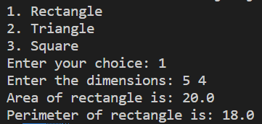

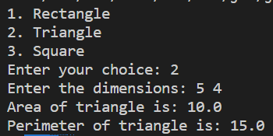

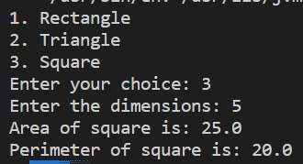

Two classes 'Employee' and 'Manager' inherits the 'Member' class. The 'Employee' and 'Manager' classes have data members 'specialization' and 'department' respectively. Call the parent class constructor in the child class and initialize all members. Include the methods for displaying the data.

import java.util.Scanner;

public class L5Q2b

{

    public static void main(String args[])

    {

        Manager mohith = new Manager();

        mohith.getData();

        mohith.displayData();

    }

}

class Member

{

    String name;

    int age;

    String phone;

    String address;

    int salary;

    public void printSalary()

    {

        System.out.println("Salary is: " + salary);

    }

    Member()

    {

        name = "No name";

        age = 0;

        phone = "No phone";

        address = "No address";

        salary = 0;

    }

}

class Employee extends Member

{

    String specialization;

    String department;

    Employee()

    {

        super();

        specialization = "No specialization";

        department = "No department";

    }

    public void getData()

    {

        Scanner sc = new Scanner(System.in);

        System.out.print("Enter name: ");

        name = sc.nextLine();

        System.out.print("Enter age: ");

        age = sc.nextInt();

        sc.nextLine();

        System.out.print("Enter phone: ");

        phone = sc.nextLine();

        System.out.print("Enter address: ");

        address = sc.nextLine();

        System.out.print("Enter salary: ");

        salary = sc.nextInt();

        sc.nextLine();

        System.out.print("Enter specialization: ");

        specialization = sc.nextLine();

        System.out.print("Enter department: ");

        department = sc.nextLine();

    }

    public void displayData()

    {

        System.out.println("Name: " + name);

        System.out.println("Age: " + age);

        System.out.println("Phone: " + phone);

        System.out.println("Address: " + address);

        System.out.println("Salary: " + salary);

        System.out.println("Specialization: " + specialization);

        System.out.println("Department: " + department);

    }

}

class Manager extends Member

{

    String specialization;

    String department;

    Manager()

    {

        super();

        specialization = "No specialization";

        department = "No department";

    }

    public void getData()

    {

        Scanner sc = new Scanner(System.in);

        System.out.print("Enter name: ");

        name = sc.nextLine();

        System.out.print("Enter age: ");

        age = sc.nextInt();

        sc.nextLine();

        System.out.print("Enter phone: ");

        phone = sc.nextLine();

        System.out.print("Enter address: ");

        address = sc.nextLine();

        System.out.print("Enter salary: ");

        salary = sc.nextInt();

        sc.nextLine();

        System.out.print("Enter specialization: ");

        specialization = sc.nextLine();

        System.out.print("Enter department: ");

        department = sc.nextLine();

    }

    public void displayData()

    {

        System.out.println("Name: " + name);

        System.out.println("Age: " + age);

        System.out.println("Phone: " + phone);

        System.out.println("Address: " + address);

        System.out.println("Salary: " + salary);

        System.out.println("Specialization: " + specialization);

        System.out.println("Department: " + department);

    }

}

Output:

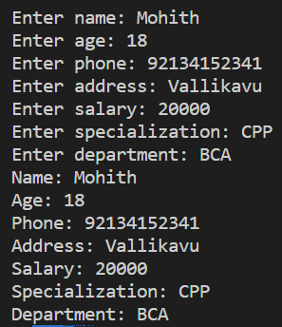

3. Create a class named Shape...

public class L5Q3

{

    public static void main(String[] args)

    {

        square sq = new square();

        sq.ShapeOutput();

        sq.RectangleOutput();

    }

}

class shape

{

    public void ShapeOutput()

    {

        System.out.println("This is This is a shape!");

    }

}

class rectangle extends shape

{

    public void RectangleOutput()

    {

        System.out.println("This is rectangular shape ");

    }

}

class circle extends shape

{

    public void print_circle()

    {

        System.out.println("This is circular shape")

    }

}

class square extends rectangle

{

    public  void squareOutput()

    {

        System.out.println("Square is a rectangle");

    }

}

Output:



4. Write a program to generate an Arithmetic Exception.

public class L5Q4

{

    public static void main(String args[])

    {

        try

        {

            System.out.println(5/0);

        } catch (Exception e) {

            System.out.println(e);

        }

    }

}

Output:  


5. Create a user-defined exception called IncorrectNumberDivision...

import java.util.Scanner;

public class L5Q5

{

    public static void main(String args[])

    {

        Scanner sc = new Scanner(System.in);

        System.out.print("Enter two numbers: ");

        int a = sc.nextInt();

        int b = sc.nextInt();

        try

        {

            int c = a/b;

            if (b%4!=0)

                throw new IncorrectNumberDivision("b is not divisible by 4");

            System.out.println("The quotient is: " + c);

        }

        catch (ArithmeticException e)

        {

            System.out.println("Division by zero is not possible!");

        }

        catch (IncorrectNumberDivision e)

        {

            System.out.println(e);

        }

    }

}

class IncorrectNumberDivision extends Exception

{

    public IncorrectNumberDivision(String s)

    {

        super(s);

    }

}

Output:

