**Java Lab Sheet 6**

**-Mohith LS  
AM.SC.U3CSC21036**

**1. Display the number of words in the sentence**

import java.util.Scanner;

public class L6Q1

{

    public static void main(String args[])

    {

        Scanner sc = new Scanner(System.in);

        System.out.print("Enter a string: ");

        String str = sc.nextLine();

        String words[] = str.split(" ");

        System.out.println("Number of words: " + words.length);

    }

}

**Output:**



**2. Display the number of characters except whitespaces in the sentence**

import java.util.Scanner;

public class L6Q2

{

    public static void main(String args[])

    {

        Scanner sc = new Scanner(System.in);

        System.out.print("Enter a string: ");

        String str = sc.nextLine();

        String words[] = str.split(" ");

        int count = 0;

        for (int i = 0; i < words.length; i++)

            count += words[i].length();

        System.out.println("Count of characters (except whitespace): " + count);

    }

}

**Output:**



**3. Display the shortest word in the sentence**

import java.util.Scanner;

public class L6Q3

{

    public static void main(String args[])

    {

        Scanner sc = new Scanner(System.in);

        System.out.print("Enter a string: ");

        String str = sc.nextLine();

        String words[] = str.split(" ");

        String shortest = words[0];

        for (int i = 1; i < words.length; i++)

            if (words[i].length() < shortest.length())

                shortest = words[i];

        System.out.println("Shortest word is: " + shortest);

    }

}

**Output:**



**4. Display the longest word in the sentence**

import java.util.Scanner;

public class L6Q4

{

    public static void main(String args[])

    {

        Scanner sc = new Scanner(System.in);

        System.out.print("Enter a string: ");

        String str = sc.nextLine();

        String words[] = str.split(" ");

        String longest = words[0];

        for (int i = 1; i < words.length; i++)

            if (words[i].length() > longest.length())

                longest = words[i];

        System.out.println("Longest word is: " + longest);

    }

}

**Output:**



**5. Display the frequency of each character in the sentence. (Frequency means number of occurrences of character)**

import java.util.Scanner;

public class L6Q5

{

    public static void main(String args[])

    {

        Scanner sc = new Scanner(System.in);

        System.out.print("Enter a string: ");

        String str = sc.nextLine();

        char chars[] = str.toCharArray();

        int freq[] = new int[chars.length];

        for (int i = 0; i < chars.length; i++)

        {

            freq[i] = 1;

            for (int j = i + 1; j < chars.length; j++)

                if (chars[i] == chars[j])

                {

                    freq[i]++;

                    chars[j] = '0';

                }

        }

        for (int i = 0; i < freq.length; i++)

        {

            if (chars[i] != '0')

                System.out.println(chars[i] + " - " + freq[i]);

        }

    }

}

**Output:**

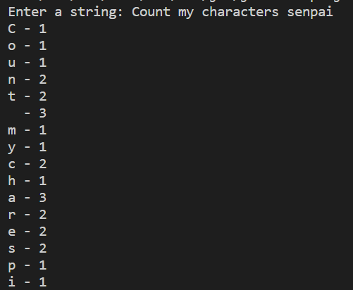

**6. Check whether the sentence have all alphabets or not.**

import java.util.Scanner;

public class L6Q6

{

    public static void main(String args[])

    {

        Scanner sc = new Scanner(System.in);

        System.out.print("Enter a string: ");

        String str = sc.nextLine();

        String alphabets = "abcdefghijklmnopqrstuvwxyz";

        boolean flag = true;

        for (int i = 0; i < alphabets.length(); i++)

        {

            if (str.toLowerCase().indexOf(alphabets.charAt(i)) == -1)

            {

                flag = false;

                break;

            }

        }

        if (flag)

            System.out.println("The string contains all alphabets");

        else

            System.out.println("The string does not contain all alphabets");

    }

}

**Output:**



