UML Design Modeling for Online Course Enrollment

Louis Murphy
The University of Arizona Global Campus
CST499: Capstone for Computer Software Technology
Charmelia Butler
November 5, 2026

UML Design Modeling for Online Course Enrollment
The Week 1 specification defines registration, enrollment, and fair waiting lists. UML connects these requirements to implementable structure and behavior. Consistent, complete models support design review (Mohagheghi et al., 2009). This paper translates the specification into five UML models and defines four testing levels to verify correctness, reliability, and stakeholder acceptance.
Figure 1
Use Case Diagram
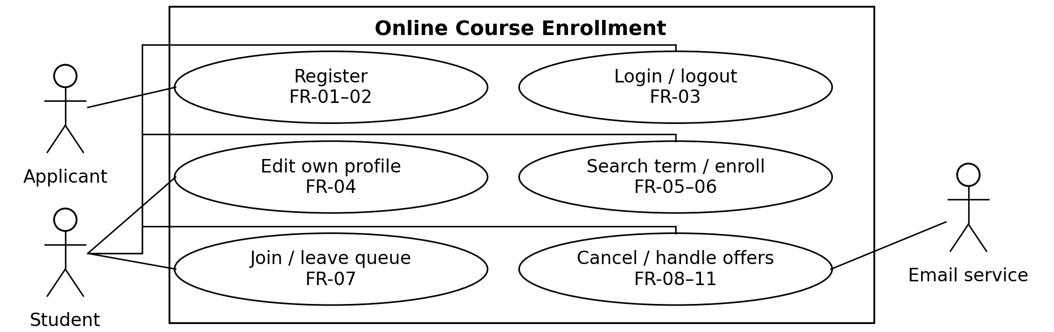
Note. Protected use cases require authentication. Staff seed offerings outside the prototype interface; payment and prerequisites are excluded.
Figure 2
Domain Class Diagram
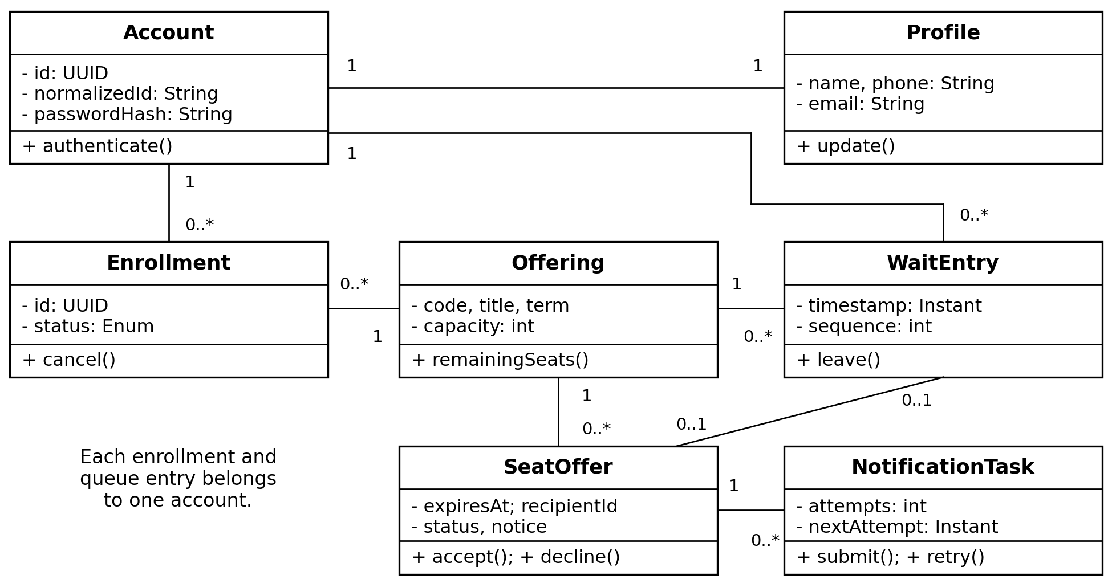
Note. Pending offers require one queue entry; terminal offers retain recipientId. Active enrollments + pending offers ≤ capacity. Normalized IDs and student–offering enrollments are unique.
Figures 3–5 model interactions, decisions, and states. Separating enrollment transactions from email delivery strengthens cohesion and limits coupling (Tsui et al., 2018).
Figure 3
Cancellation and Notification Sequence
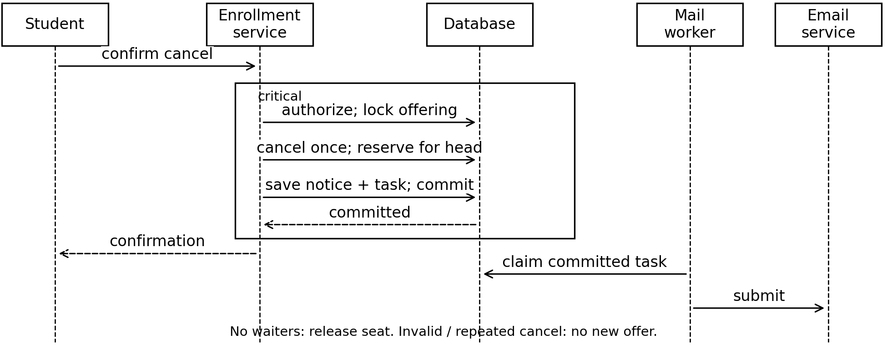
Note. FR-08–11: allocate vacancies by timestamp, then sequence. Submit email within 60 seconds; retry failures every five minutes, up to three attempts, then flag staff review.
Figure 4
Enrollment Activity Diagram
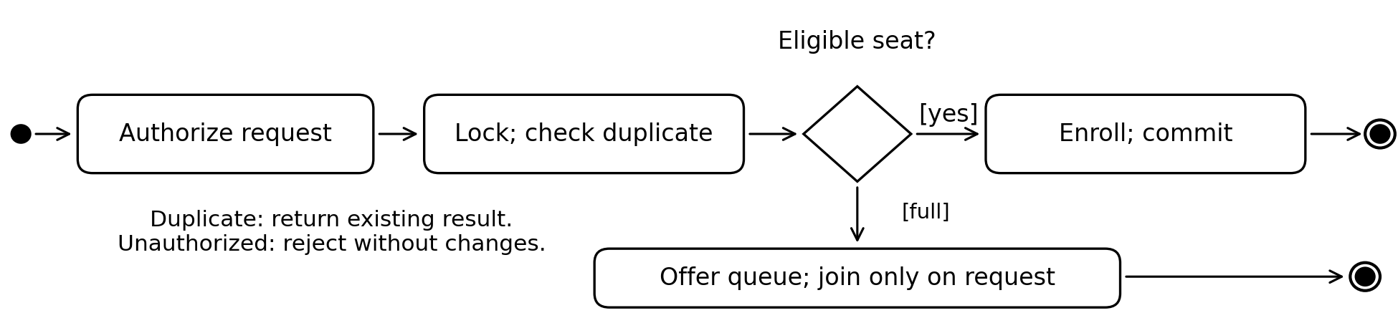
Note. FR-06–07: exclude reserved seats. Joining records server time and sequence and returns queue position.
Figure 5
Seat Offer State Diagram
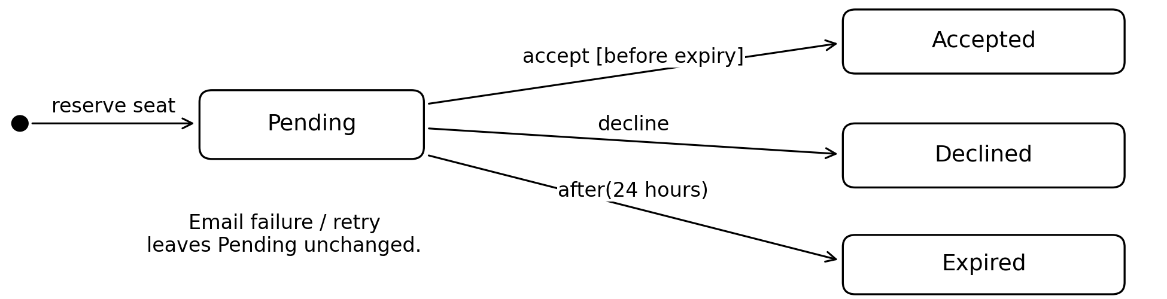
Note. FR-09–10: acceptance atomically enrolls and removes the queue entry. Decline/expiry removes the entry and reallocates or releases the seat. Repeated terminal actions change nothing; 24 hours requires institutional approval.

Testing the Design
Briand and Labiche (2001) derive system test requirements from UML artifacts. Here, use cases supply scenarios, class constraints define invariants, and states expose boundary cases. Planned tests will record requirement IDs, synthetic inputs, expected outcomes, and actual results.

Component Testing
Component testing isolates validators, authentication, seat calculations, queue ordering, and offer transitions. Developers use database and email substitutes to reproduce failures. FR-01–04 cases include missing fields, malformed email, whitespace and case variations in IDs, unchanged IDs during profile edits, and generic login errors. No invalid registration may leave a partial account. FR-06 checks zero remaining seats and capacity boundaries; FR-07 checks identical timestamps resolved by sequence. A controlled clock tests acceptance immediately before and at expiry. Repeated acceptance must not add another enrollment. NFR-02 checks salted adaptive password hashes and session expiry after 30 minutes of inactivity. The completion gate requires correct results for valid inputs, invalid inputs, and modeled branches, not coverage alone.

Integration Testing
Integration testing checks service, database, session, and worker interfaces using a real test database. Two simultaneous requests for one seat must produce exactly one enrollment; two registrations for the same normalized ID must produce one account. Cancellation must commit the released seat, next reservation, notice, and email task together. Injecting failure before commit must leave none of those partial changes. Worker failures exercise the retry schedule without creating another reservation. Tests also reject attempts to modify another student’s records. The gate requires correct persistence, queue order, and capacity after concurrent or repeated requests (FR-02, FR-06–11; DATA-01).

System Testing
System testing evaluates the complete browser, server, database, and email environment. Testers exercise registration, login/logout, profile editing, term filtering, enrollment, cancellation, queue departure, and offers. Empty terms must show “No courses offered.” Multi-student scenarios verify queue positions, multiple vacancies, declines, expirations, and failed email delivery while the in-app offer remains usable. Restart tests confirm durable enrollments and queue order; failed transactions must leave no partial records (NFR-03).
With 50 concurrent users and 1,000 offerings, at least 95% of search and enrollment requests must finish within two seconds, excluding external email delivery (NFR-01). Security checks exercise HTTPS, session invalidation, ownership authorization, and password exclusion from logs. Keyboard navigation, visible focus, labeled fields, textual errors, cancellation confirmation, and layouts at 375 and 1280 pixels verify UI-01. The gate requires passing functional and quality checks with no unresolved critical defects.

Acceptance Testing
Acceptance testing lets representative students and an institutional stakeholder validate business suitability. With synthetic accounts, they fill an offering, join its queue, cancel a seat, and accept an offer. They confirm fair ordering, clear notices, accurate seats, and usable error recovery. Acceptance records link demonstrations to FR-01–11 and relevant quality requirements. Stakeholders must explicitly approve the proposed 24-hour offer duration and performance targets, document exceptions, and sign off before release. Earlier test results support this release decision.

Conclusion
The five UML models connect requirements to structure and behavior. Shared capacity and queue rules guide implementation, while the four testing levels establish whether the system protects student records, allocates seats correctly, and meets stakeholder needs.

References
Briand, L., & Labiche, Y. (2001). A UML-based approach to system testing. In M. Gogolla & C. Kobryn (Eds.), UML 2001: The Unified Modeling Language: Modeling languages, concepts, and tools (pp. 194–208). Springer. https://doi.org/10.1007/3-540-45441-1_15
Mohagheghi, P., Dehlen, V., & Neple, T. (2009). Definitions and approaches to model quality in model-based software development: A review of literature. Information and Software Technology, 51(12), 1646–1669. https://doi.org/10.1016/j.infsof.2009.04.004
Tsui, F., Karam, O., & Bernal, B. (2018). Essentials of software engineering (4th ed.). Jones & Bartlett Learning.

Final Design-to-Code Mapping
Figures 1–5 remain the conceptual requirements model. The final physical implementation maps Account and Profile to accounts and profiles, WaitEntry to waiting_list, SeatOffer to seat_offers, and NotificationTask to notification_tasks. It separates the conceptual Offering attributes into courses, semesters, and offerings.
The conceptual UUID identifiers map to numeric primary keys in MySQL. The Enrollment status in Figure 2 represents the lifecycle conceptually; the implemented enrollments table stores active rows only and deletes a row on cancellation. Seat-offer outcomes remain stored after the waiting-list link is cleared.
The mail worker and external email-service interaction shown in Figure 3 are planned interfaces. The implemented transaction creates an in-app offer and a notification task, but does not send email or run delivery retries. The state model remains applicable to acceptance, decline, and expiration. The proposed 24-hour policy still requires stakeholder approval.

