Landing, Login, and Enrollment Pages Development

Louis Murphy
The University of Arizona Global Campus
CST499: Capstone for Computer Software Technology
Charmelia Butler
November 5, 2026

Landing, Login, and Enrollment Pages Development
The Online Course Enrollment project requires a dependable entry point before students can select courses. Week 3 establishes that foundation through a landing page, authentication, and account registration. The implementation separates presentation, application logic, and database access so that later enrollment features can build on a consistent structure. Quality assurance must accompany development rather than occur only after coding is complete (Tsui et al., 2018). This paper explains how the PHP pages run in XAMPP, how the MySQL-compatible database and custom connection class support registration, and how validation and testing establish reliable storage of user information.

Running PHP in XAMPP
To run the project on Windows, install XAMPP, open its Control Panel, and start Apache and MySQL. Extract the project into C:\xampp\htdocs\online-enrollment. In http://localhost/phpmyadmin/, import database/schema.sql and execute the application-user script after changing its example password. Copy config.example.php to config.local.php and enter the matching database credentials. Confirm that PHP enables pdo_mysql and mbstring, restarting Apache if its configuration changes. Finally, open http://localhost/online-enrollment/public/. Apache processes the PHP file and returns HTML to the browser; opening the file directly does not execute PHP (Apache Friends, n.d.).
XAMPP labels its database service MySQL but distributes MariaDB, which supports the database features used here (Apache Friends, n.d.). Verification for this submission used PHP 8.3.6 and MariaDB 10.11.14 on Linux. The included Windows instructions support local reproduction; they do not imply that XAMPP was installed on the student’s computer.

Page Development and Database Design
The landing page introduces the service and links to registration and login. Shared header, navigation, footer, and stylesheet files maintain a consistent appearance. The registration layout places introductory guidance beside a form on larger screens and uses one column on smaller screens. Explicit labels, input types, autocomplete attributes, and nearby error messages support completion. The form collects full name, user ID, email, phone, password, and password confirmation. Password fields are cleared after a rejected submission. The login page accepts the user ID and password; successful authentication opens a protected account page. Account creation does not yet enroll a student in a course. Figures A1–A4 show these interfaces.
The schema script creates the online_enrollment database with utf8mb4 encoding and two InnoDB tables. The accounts table contains an automatically generated numeric primary key, unique user ID, unique email, password_hash, student role, and creation timestamp. The 255-character hash column accommodates stored password hashes without retaining plaintext passwords. The profiles table stores full name and phone. Its account_id is both its primary key and a foreign key referencing accounts.id, enforcing a one-to-one relationship. Separating credentials from profile fields gives future features a stable account identifier.
Database constraints complement PHP validation: unique indexes reject duplicate identifiers, and the foreign key prevents an unrelated profile. The application database account receives only SELECT and INSERT privileges on these tables. This applies the least-privilege principle described by Saltzer and Schroeder (1975), limiting the operations available if application credentials are exposed. Figures A5, A6, and A11 document the structure, saved demonstration data, and schema source.

Database Connection and Registration Logic
The custom Database class was created by defining a private PDO connection property, accepting a configuration array in its constructor, and building a MySQL data source name with host, port, database, and utf8mb4 settings. The constructor instantiates PDO, enables exception-based error handling, sets associative fetch results, and disables emulated prepares. Its connection() method returns the configured object, while a shared helper reuses it during the request. Credentials remain in a separate local configuration file (Figure A7).
The database API uses prepare() to define parameterized SQL and execute() to bind and submit values. Login uses fetch() to retrieve an account, while lastInsertId() obtains the generated key after registration. beginTransaction(), commit(), and rollBack() coordinate the related inserts. These are PDO methods using the MySQL driver, rather than obsolete mysql_* functions. Parameter binding keeps supplied values separate from SQL structure (PHP Documentation Group, n.d.-b), addressing the injection mechanism examined by Halfond et al. (2006).
Registration was developed by defining the form fields, adding POST processing, and moving validation and persistence into RegistrationService. The controller checks a session-bound cross-site request forgery token, trims contact fields, normalizes the user ID and email, and validates required values, formats, lengths, and matching passwords. Invalid submissions return field feedback before database writes. Valid submissions generate a bcrypt hash, begin a transaction, insert the account, retrieve its key, and insert the linked profile. A successful commit redirects to login; a failure rolls back both changes. Duplicate-key errors produce a useful message without exposing database details (Figures A8–A10).

Password Protection and Verification
The service calls password_hash() with bcrypt and cost 12; PHP generates the salt automatically. Login retrieves the stored hash through a prepared query and calls password_verify(). Bcrypt’s adjustable work factor makes password guessing more computationally expensive (Provos & Mazières, 1999). The application rejects passwords longer than 72 bytes to avoid bcrypt truncation and requires at least 12 characters (PHP Documentation Group, n.d.-a). After successful login, it regenerates the session identifier. Protected pages require a session, displayed profile values are HTML-escaped, and logout requires a valid token.
Following the emphasis on continuous quality checks (Tsui et al., 2018), verification covered successful and unsuccessful requests. All 27 checks passed. The tests confirmed page availability, validation, linked record persistence, password hashing, duplicate rejection, invalid login handling, session rotation, output escaping, and logout protection. An injection-shaped user ID failed authentication, and an intentionally failed profile insert left no orphan account. These checks establish functional behavior, not comprehensive security assurance. Appendix A contains screenshots; the project includes the test script and results. Public deployment would additionally require HTTPS, login throttling, email verification, and password recovery.

Conclusion
The Week 3 implementation provides working landing, login, and registration pages backed by a relational database. A reusable PDO class centralizes connection settings, while validation, parameterized statements, password hashing, and transactional inserts protect the registration process. The recorded tests provide a foundation for connecting course selection and enrollment rules to authenticated accounts.

References
Apache Friends. (n.d.). XAMPP FAQs for Windows. https://www.apachefriends.org/faq_windows.html
Halfond, W. G. J., Viegas, J., & Orso, A. (2006). A classification of SQL-injection attacks and countermeasures. Proceedings of the International Symposium on Secure Software Engineering. https://viterbi-web.usc.edu/~halfond/papers/halfond06issse.pdf
PHP Documentation Group. (n.d.-a). password_hash. PHP Manual. https://www.php.net/manual/en/function.password-hash.php
PHP Documentation Group. (n.d.-b). PDO::prepare. PHP Manual. https://www.php.net/manual/en/pdo.prepare.php
Provos, N., & Mazières, D. (1999). A future-adaptable password scheme. In Proceedings of the 1999 USENIX Annual Technical Conference (pp. 81–92). USENIX Association. https://www.usenix.org/legacy/events/usenix99/provos/provos_html/
Saltzer, J. H., & Schroeder, M. D. (1975). The protection of information in computer systems. Proceedings of the IEEE, 63(9), 1278–1308. https://web.mit.edu/saltzer/www/publications/protection/
Tsui, F., Karam, O., & Bernal, B. (2018). Essentials of software engineering (4th ed.). Jones & Bartlett Learning.

Appendix A
Implementation Screenshots
Figure A1
Landing Page
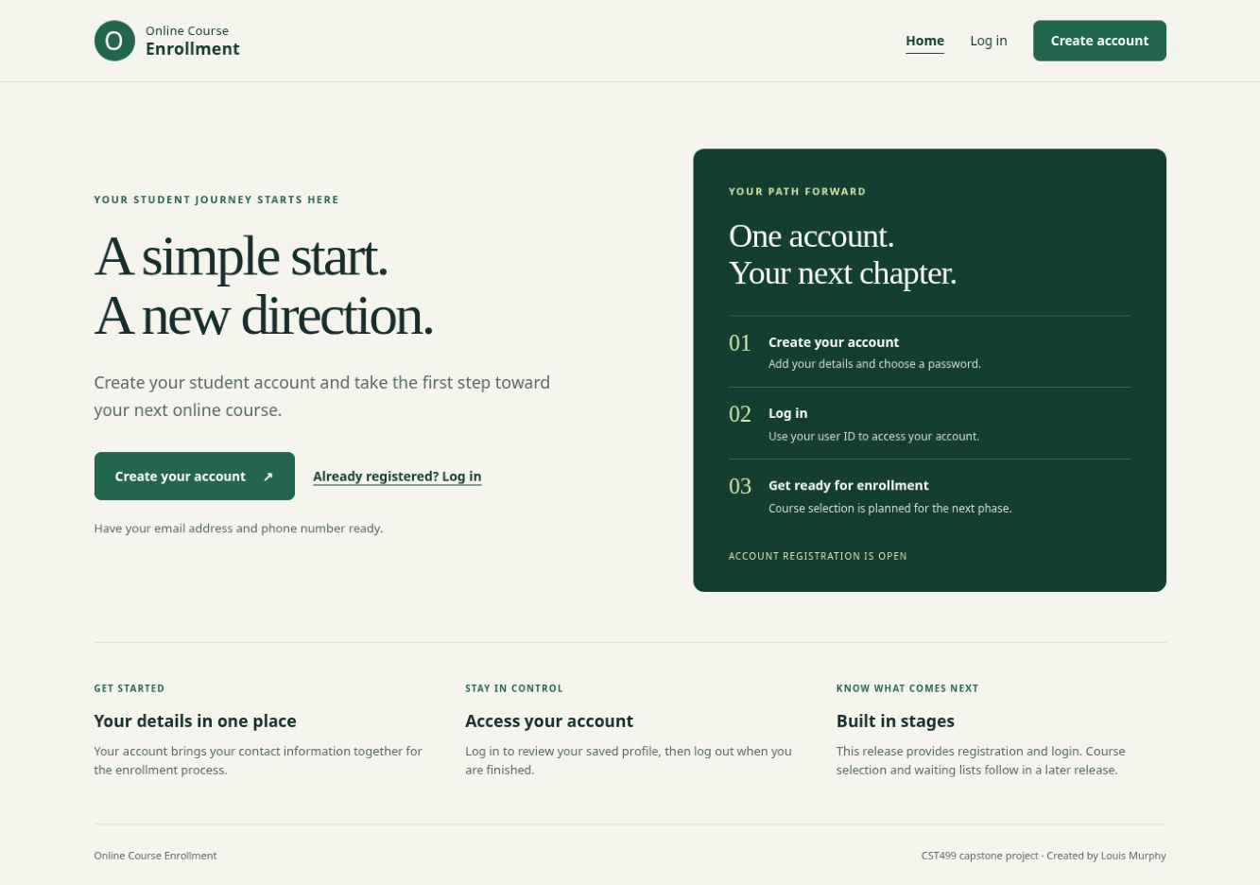
Note. The home page introduces the project and provides working routes to account creation and login.

Figure A2
Login Page
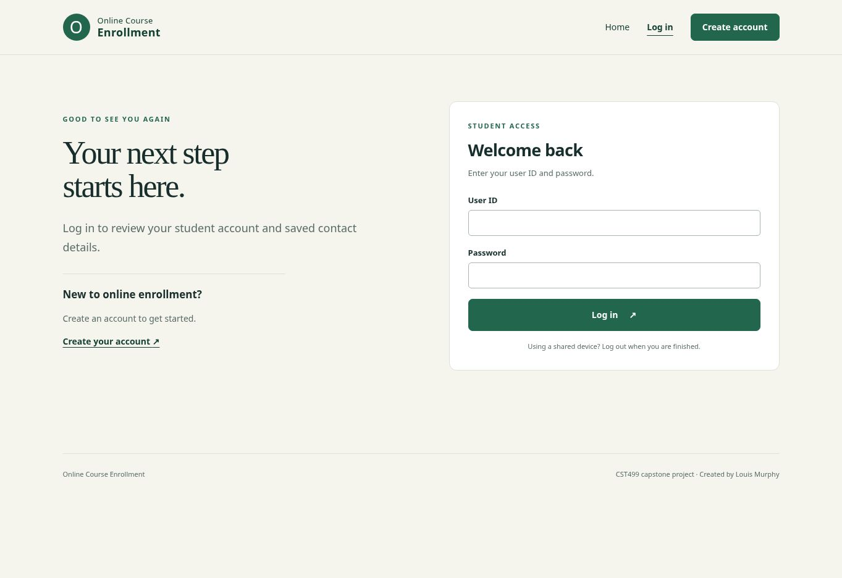
Note. The form authenticates a user ID and password through a prepared query and password_verify().

Figure A3
Registration Page and Layout
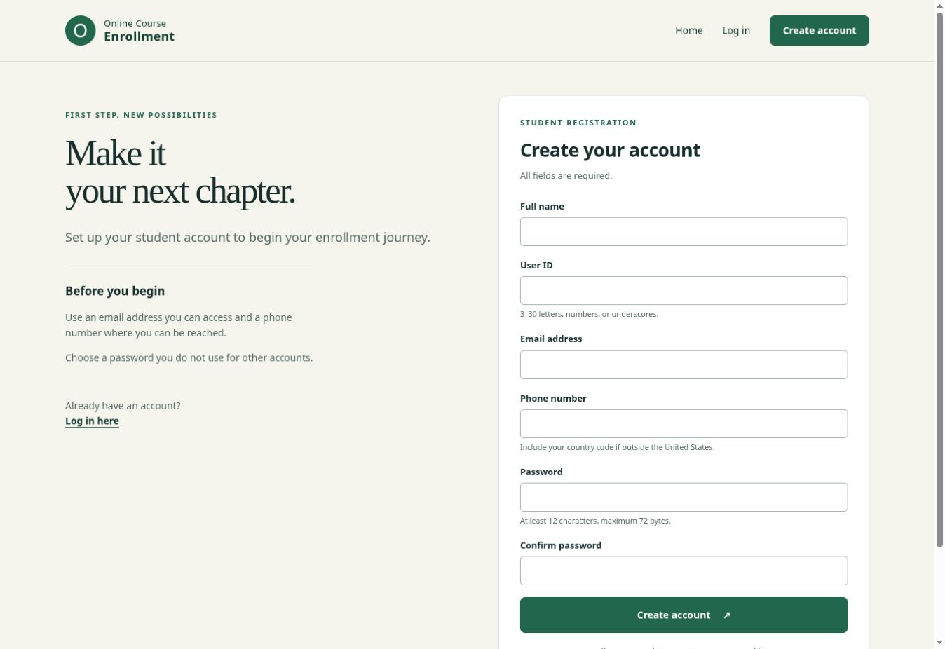
Note. The form collects the required identity, contact, and password fields. The shared stylesheet controls its responsive layout.

Figure A4
Account Page After Successful Authentication
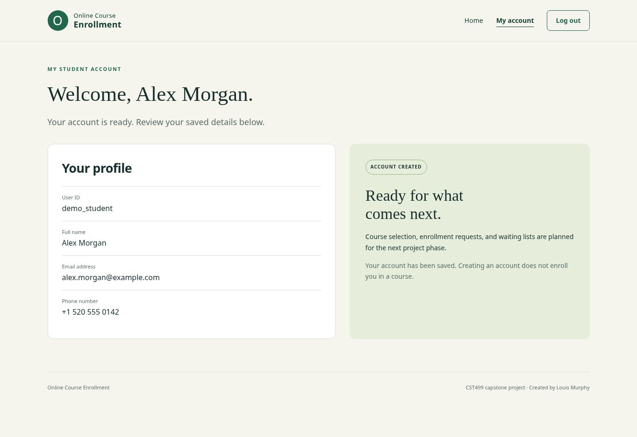
Note. This view renders the HTML response returned by the successful automated login test. The hidden CSRF token was redacted. Alex Morgan is fictional demonstration data.

Figure A5
Database and Table Structure
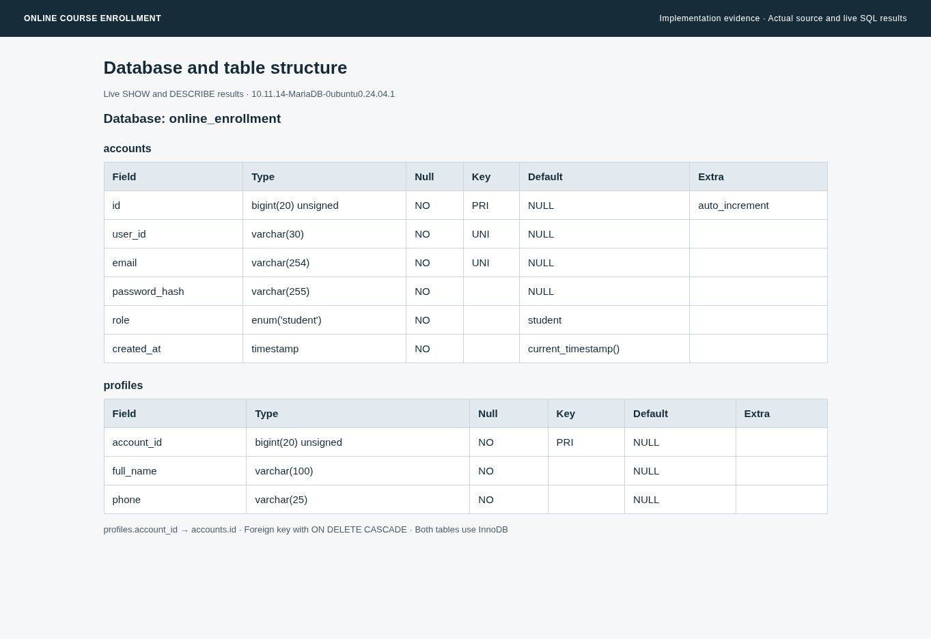
Note. A temporary read-only viewer displays live DESCRIBE results for online_enrollment.accounts and online_enrollment.profiles. This is not a phpMyAdmin screenshot.

Figure A6
Persisted Registration Record
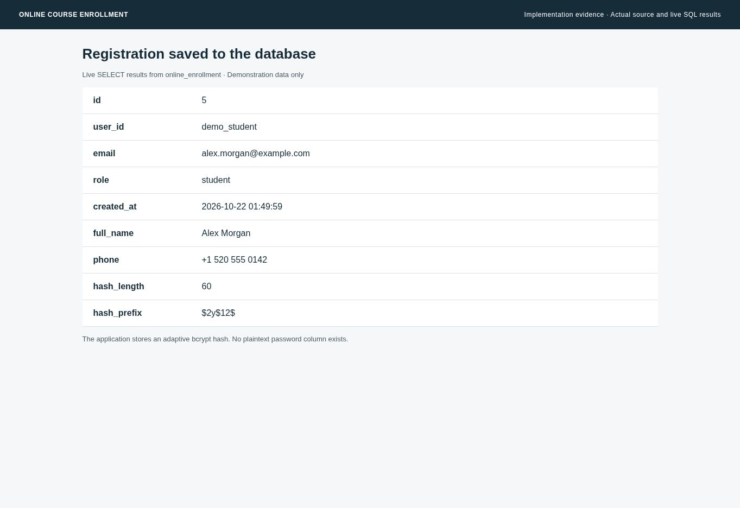
Note. Live joined results confirm that the demonstration account and profile were saved. The hash length and prefix demonstrate the stored bcrypt format; the plaintext password is absent.

Figure A7
Custom Database Connection Class
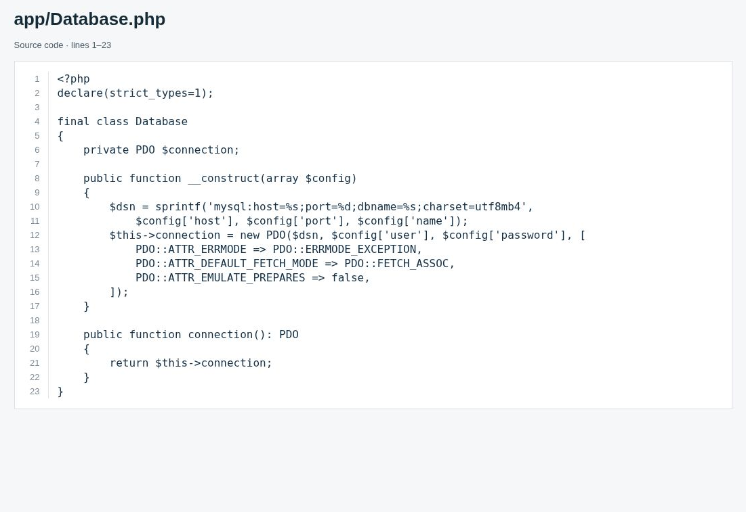
Note. Actual app/Database.php source creates the PDO connection and configures error handling, fetch mode, and native prepared statements.

Figure A8
Registration Validation Source
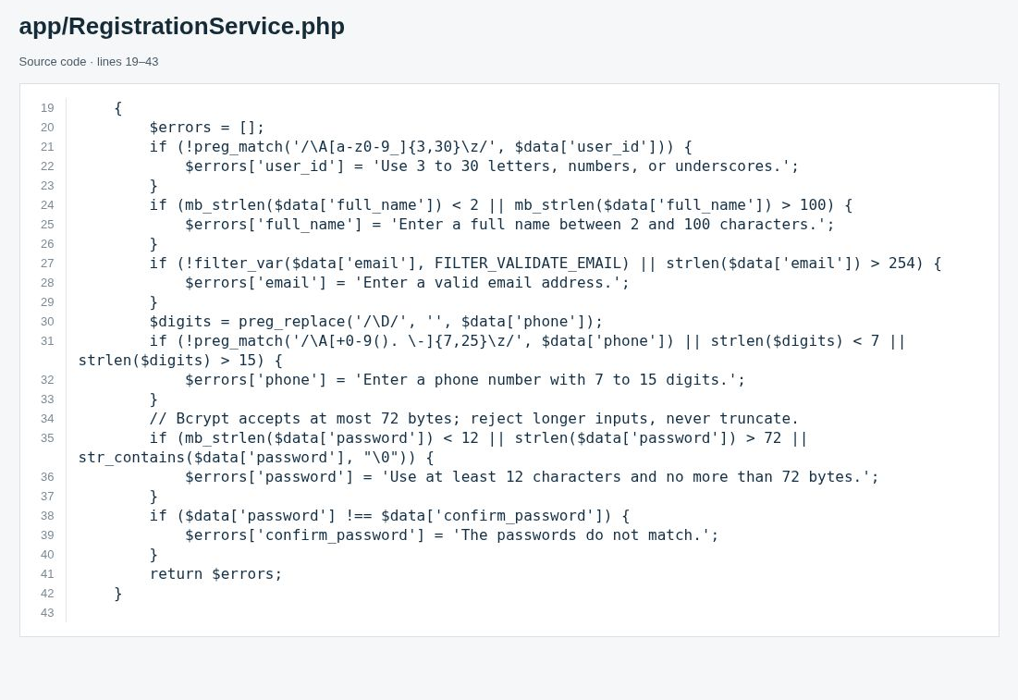
Note. Actual RegistrationService.php code checks the user ID, name, email, phone, password length, and password confirmation.

Figure A9
Registration Persistence Source
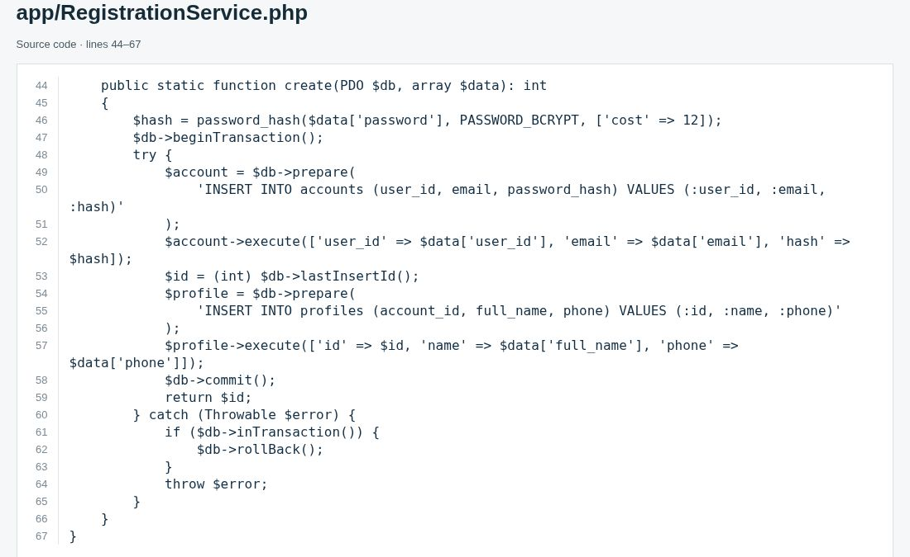
Note. Actual RegistrationService.php code hashes the password, performs both inserts inside a transaction, and rolls back on failure.

Figure A10
Registration Request Handler
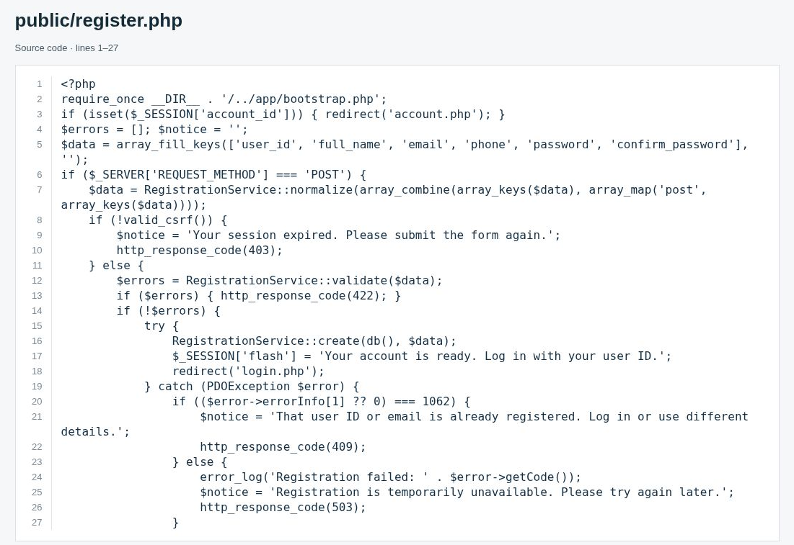
Note. The opening portion of public/register.php checks the token, invokes validation and persistence, redirects on success, and handles duplicate records.

Figure A11
Database Creation Source
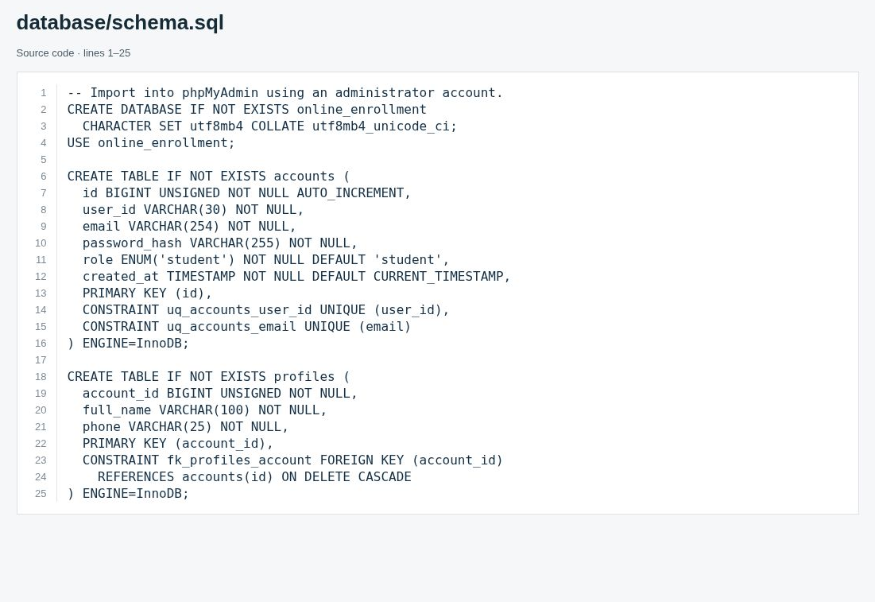
Note. The SQL source creates the database, both tables, unique indexes, and the foreign-key relationship.

Appendix B: Instructor-Requested Database Evidence
The original Week 3 custom database display did not satisfy the request for a MySQL table view. The following actual phpMyAdmin Structure screenshots supply the columns, types, defaults, and keys of accounts and profiles. These figures supersede the custom structure illustration in Appendix A as evidence of the physical database.
The final runnable package uses the Week 4 migration after the base schema. Follow the included source README for the complete import order and current table-specific grants. The earlier Week 3 SELECT/INSERT-only permissions describe the initial account prototype; the final enrollment workflow also requires the update and deletion privileges documented in the supplied application-user script.

Figure B1. Accounts table: actual phpMyAdmin Structure view.
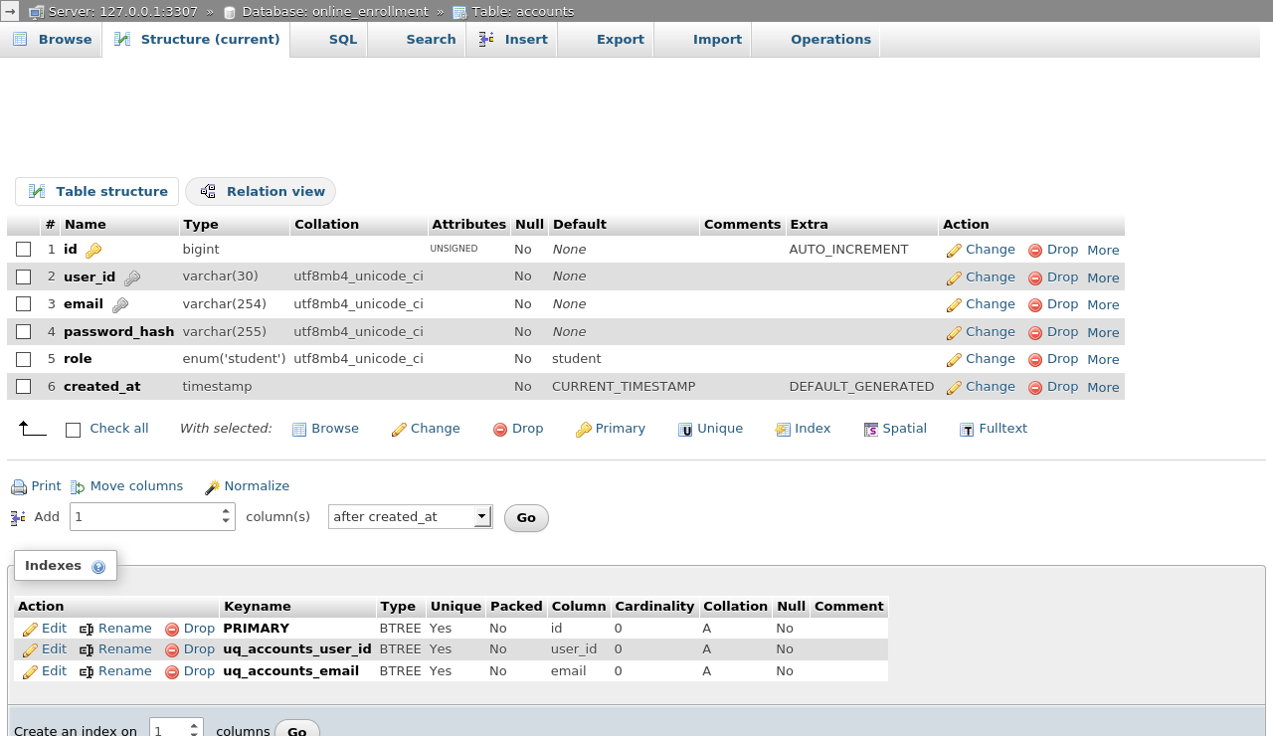

Figure B2. Profiles table: actual phpMyAdmin Structure view.


