ID : 1606038 , 1606059 , 1606062, 1606064

TASK 1:

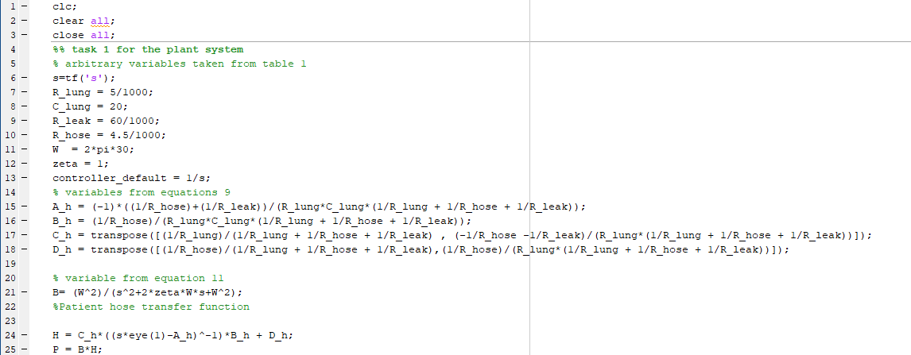

TASK 2:

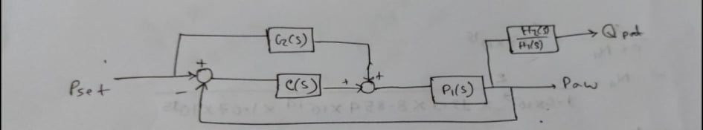

Here,

P1 = B(s)H1(s)

P2 = B(s)H2(s)

P1(s) + P1(s)/s

T1 = ----------------------

1 + P1(s)/s

P2(s) + P2(s)/s

T1 = ----------------------

1 + P1(s)/s

TASK 3:

**Sketch the root locus of the control system shown in Fig. 4 for 0<ki< of the integral controller C(s).**

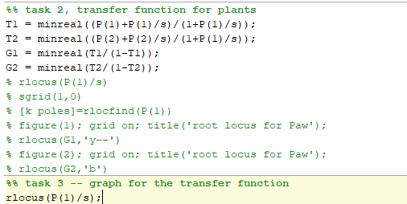

Here, since the denominator for the two transfer functions are the same, the roor locus will be same . The root locus is shown below:

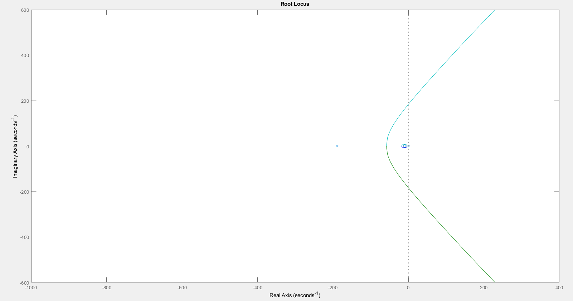

TASK 4:

Output for scope 2

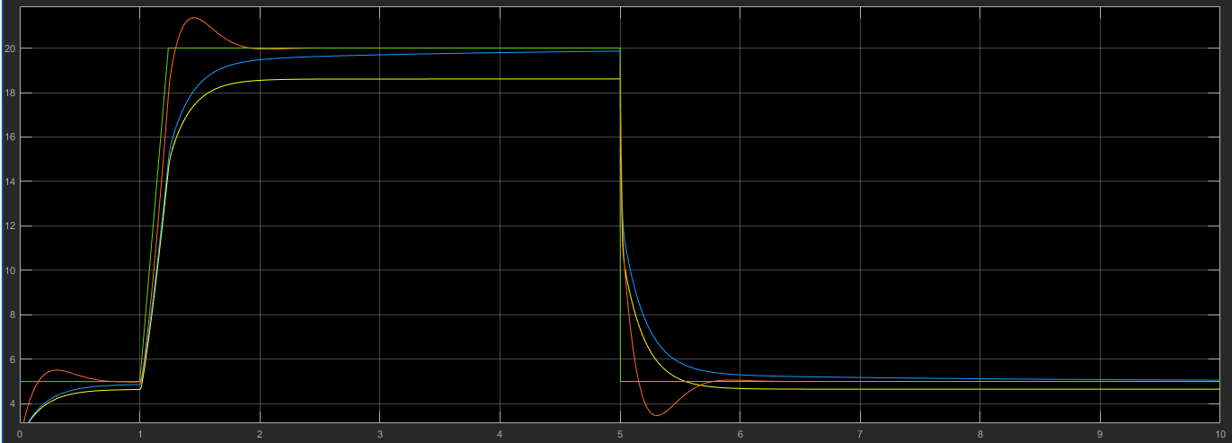

Output for scope 1:

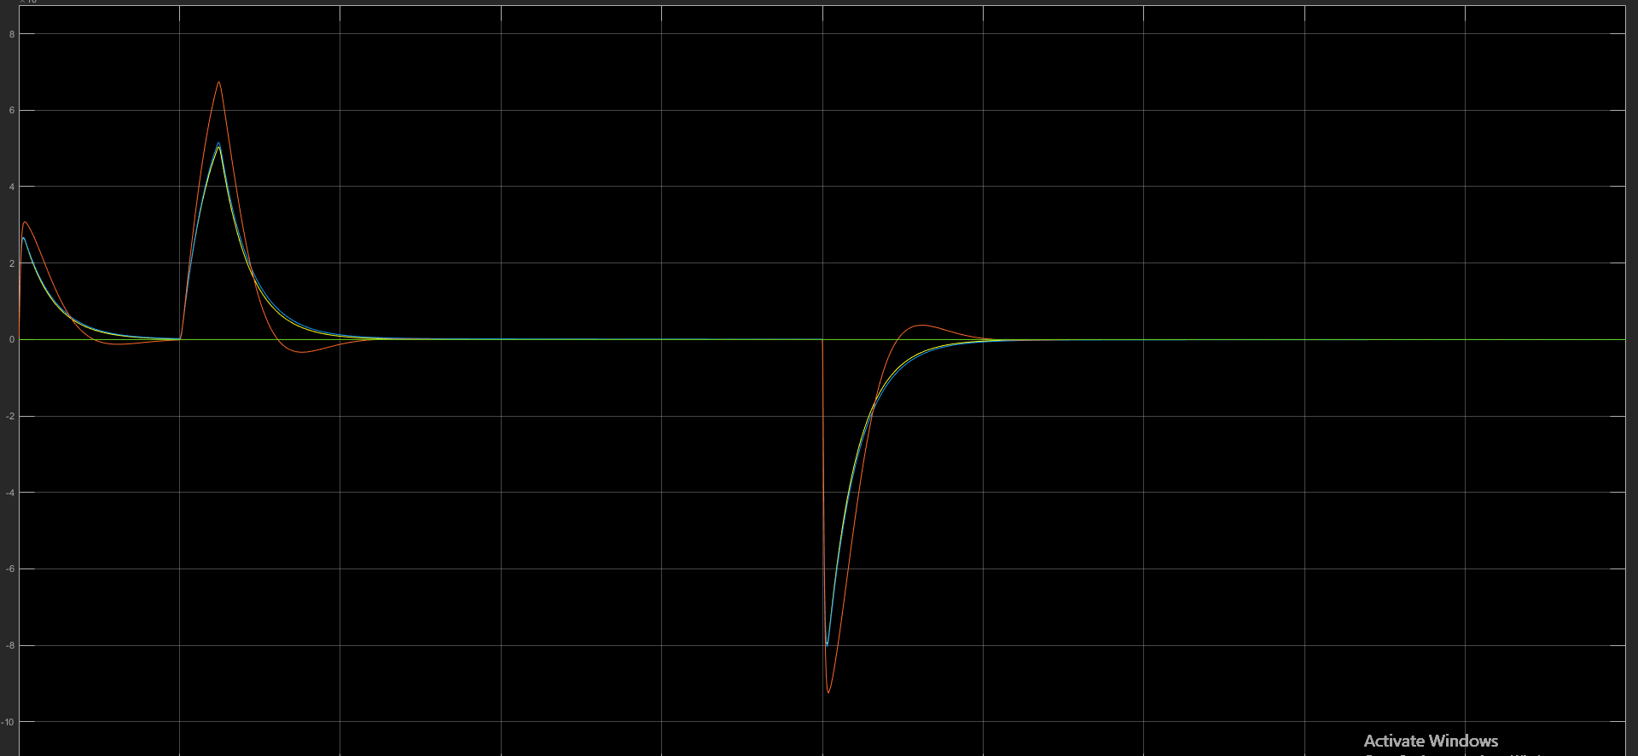

SIMULINK DIAGRAM USED

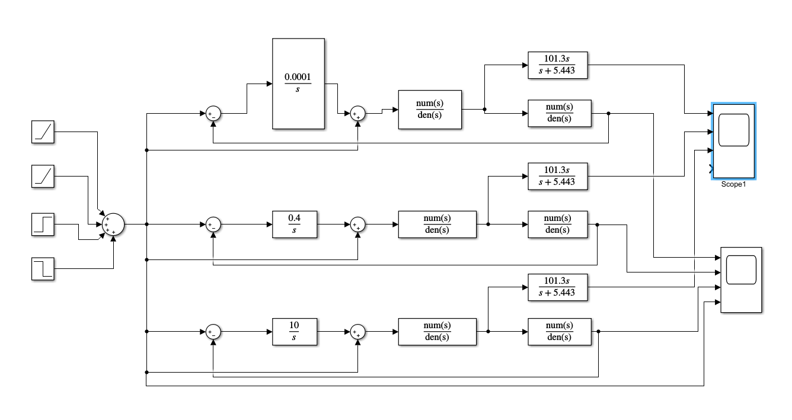

Here, some error was seen at the time range 0 - 1 sec. In order to remove that, the output was shifted to 0 to 15 rather than 5 to 20.

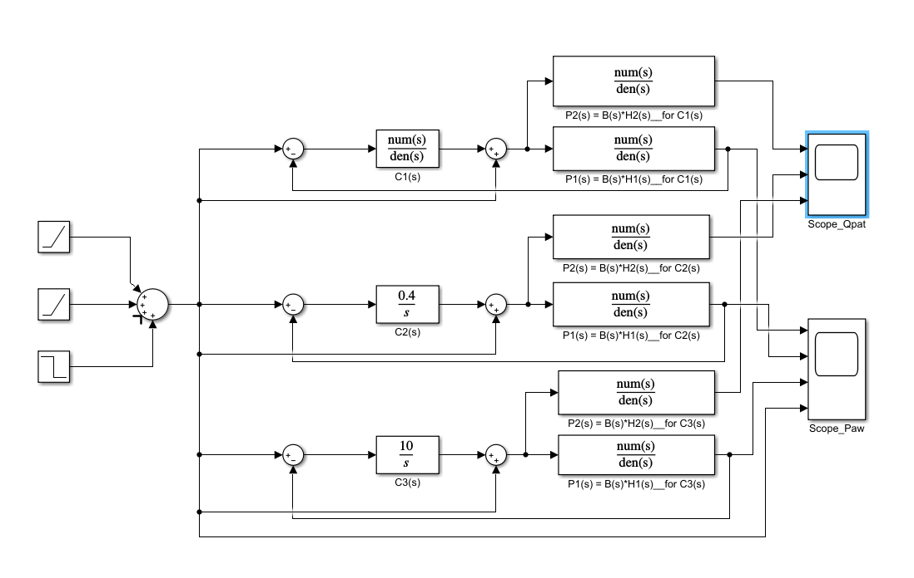

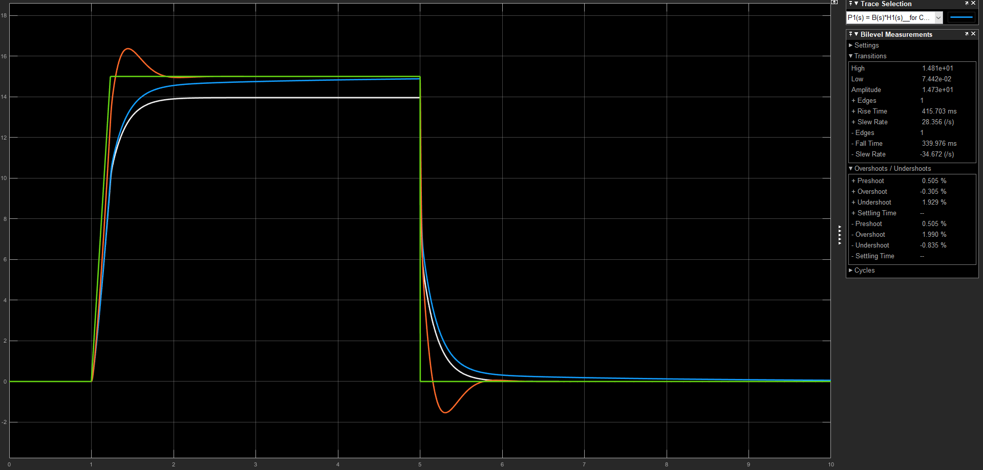

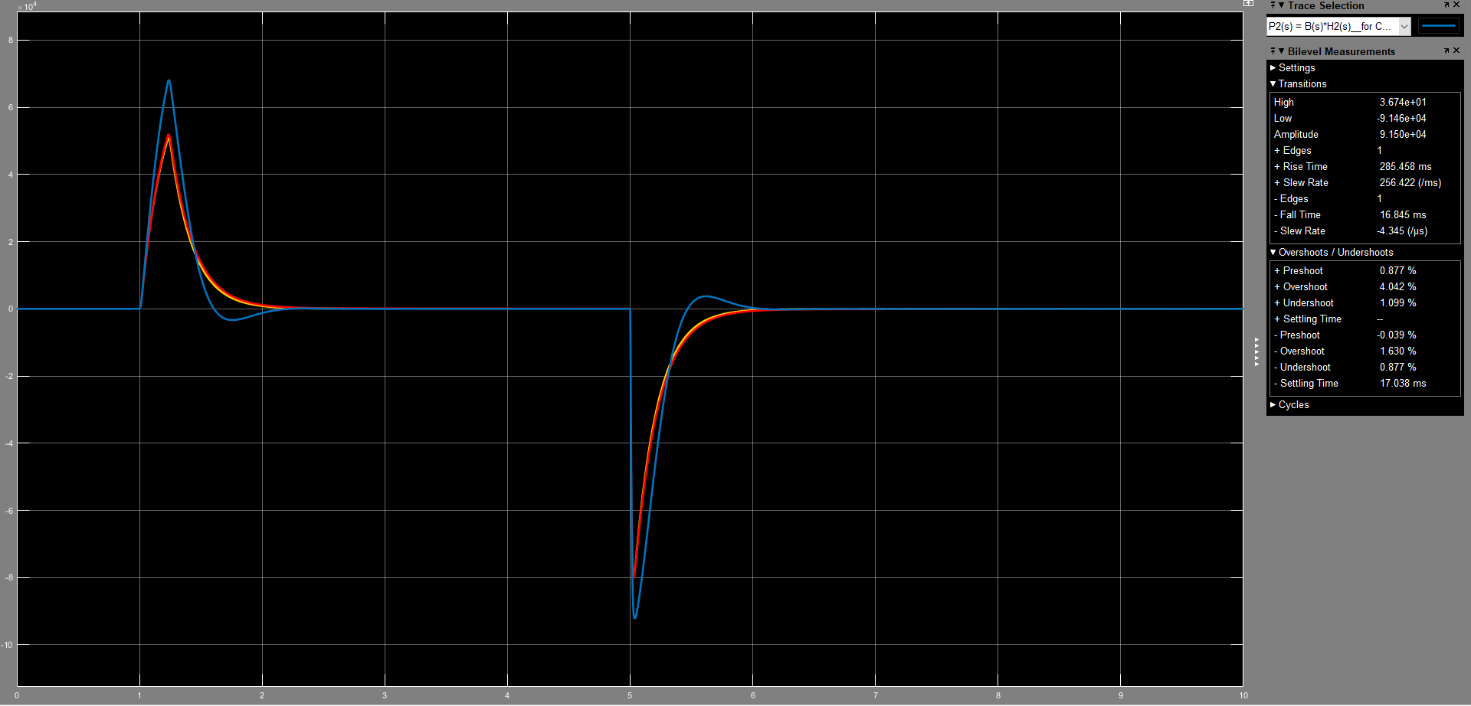

TASK 5:

TASK 6:

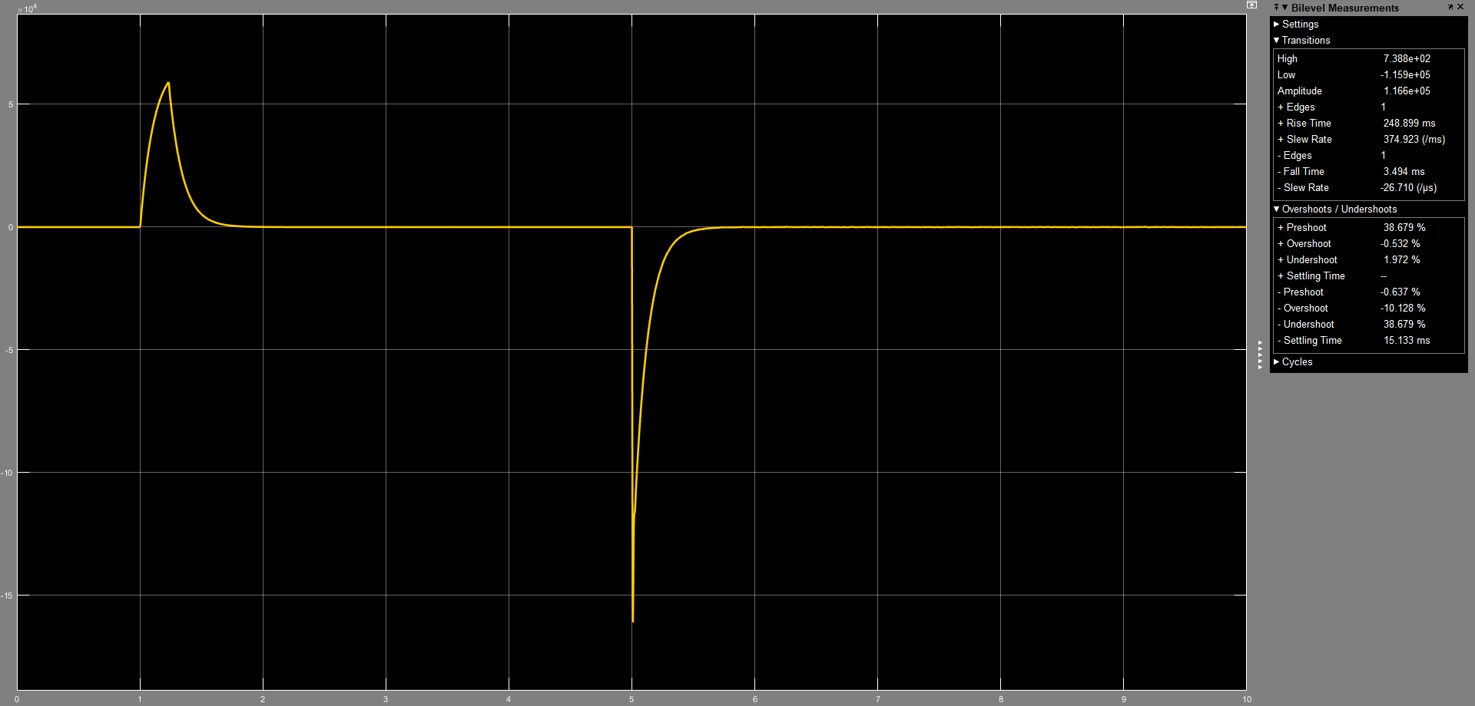

2m/L overshoot

