LAB REPORT FOR EXP 6,7

Course Title : EEE416

Name : Md Maisoon Rahman

ID : 1606038

Section : A2

PROBLEM 1

**Problem Statement:** Write a code snippet in Assembly to add two 16 bit numbers and multiply the result with another 16 bit number. If the 16 bit numbers are denoted by A, B and C, respectively, then you have to calculate (A+B)*C.

CODE

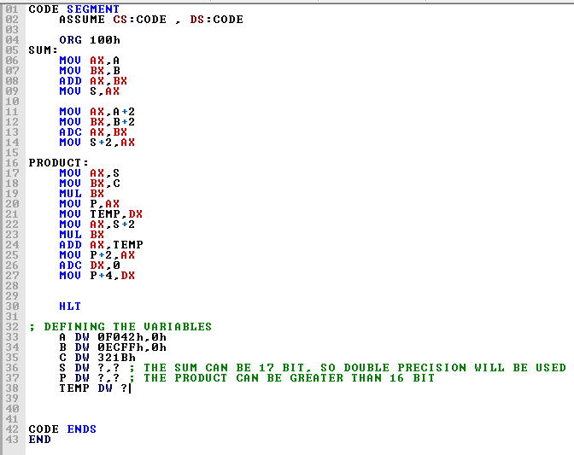

OUTPUT

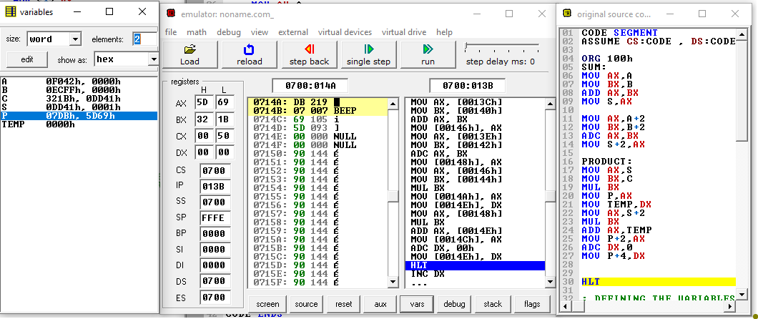

PROBLEM 2

**Problem Statement :** Multiplying two 32 bit numbers

CODE

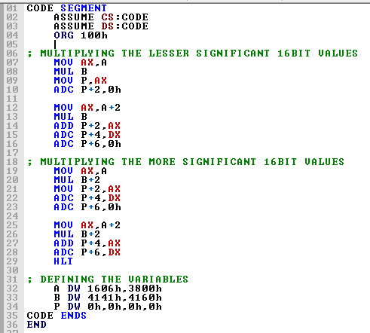

OUTPUT

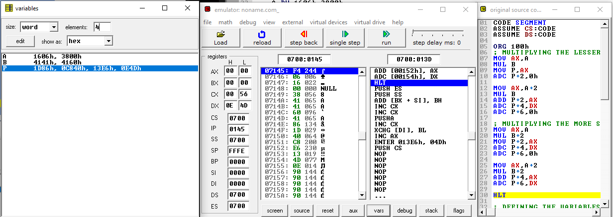

Input values considered

A = 16063800 h B = 41414160 h

Expected Product obtained from online calculators: 1D86000100000000