REPORT ON EXPERIMENT 8

Course No EEE 416

Name : Md Maisoon Rahman

Id : 1606038

Section : A2

Step 1 : Designing the schematic.

In this stage the schematic diagrams were designed based on the lab reference video.

Initially the 8086 part is created while creating the project through project wizard. The following parts were sequentially placed in the schematic capture.

1. 74HC373 2. 8255A 3. 3 seven segment displays

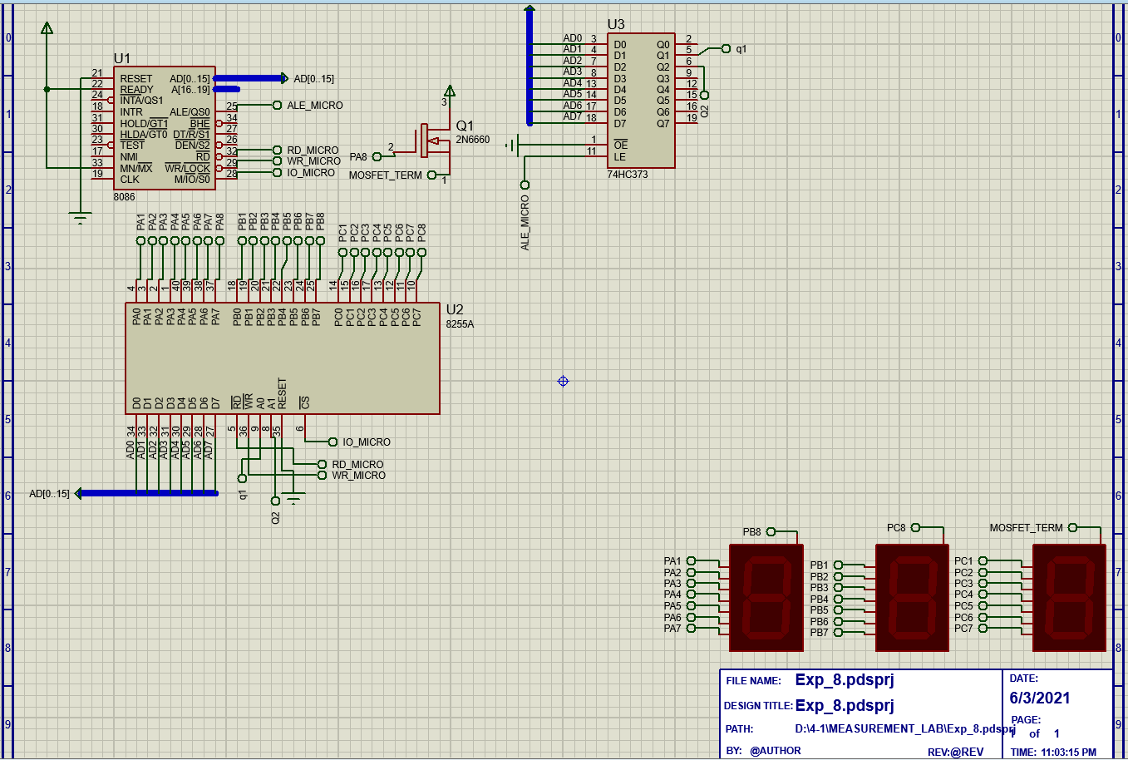

Figure 1 Total schematic layout

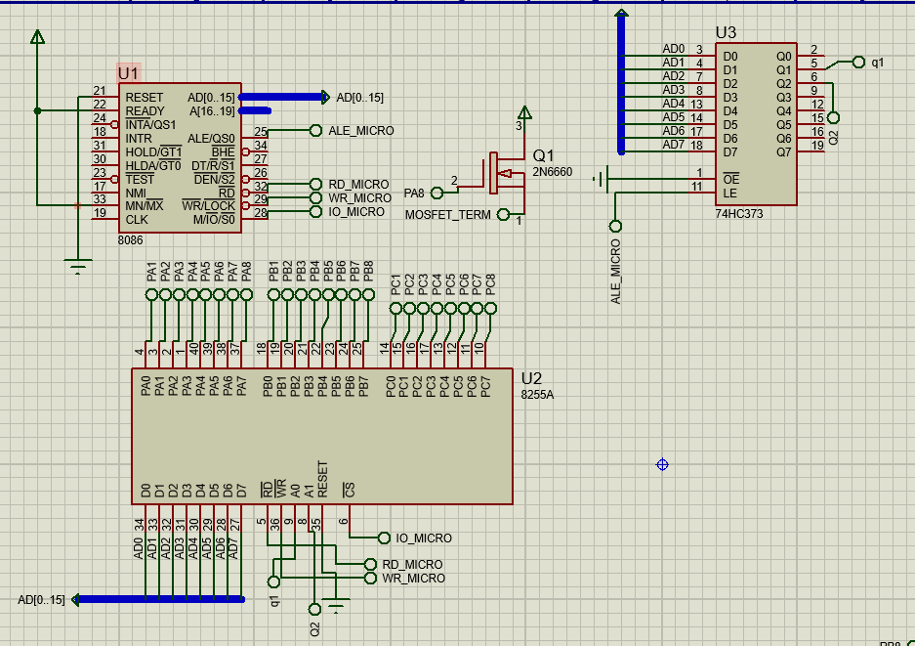

Figure 2 Schematic Capture of the 8225A and 74HC373

Step 2: Creating the source code

Coding for the microprocessor was initially debugged using emu8086.

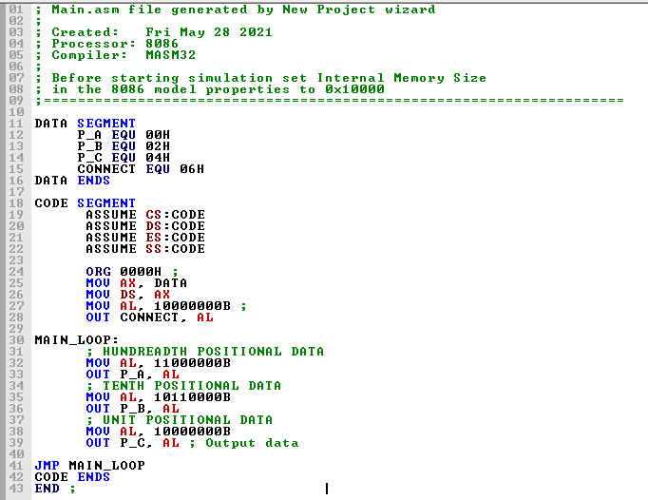

step 3: To display the result, the code was copy pasted to “source code section”. and on running the code, the following out put was opbtained

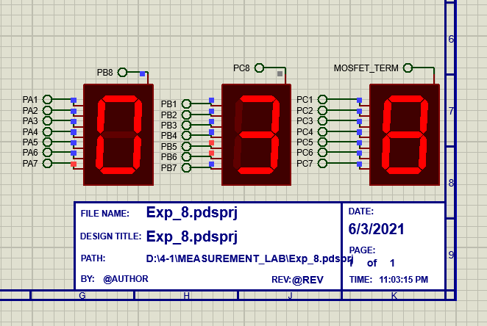

Figure 3 Output