PROBLEM

# CODE

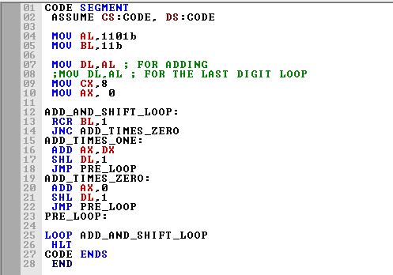

# OUTPUT

Here, The input of 1101 and 11 was considered as the two numbers we must multiply.

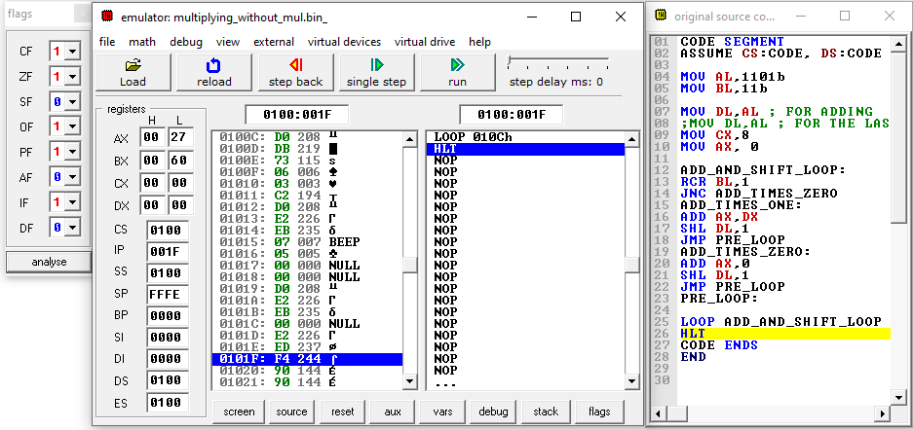

The Following multiplication was carried out

1101

x 11

-----------

1101

110110

------------

100111

In Hexadecimal format, the multiplication output should be 27 h,

As seen in our output, the multiplication out is 27h, leading to the conclusion that the code simulation is valid.

EXPERIMENT 3 LAB TASK 1

# TASKS

Find the LCM of three given numbers (0Fh, 4Bh, 20Dh)

# CODE

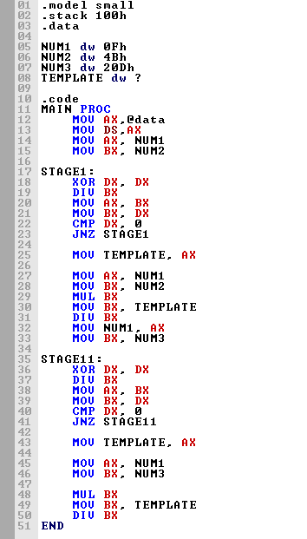

# OUTPUT

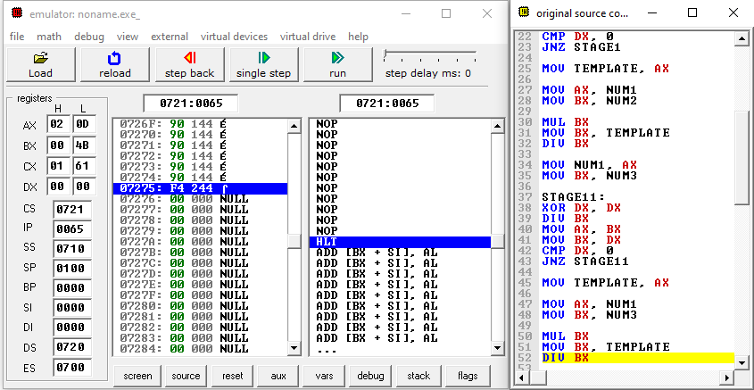

EXPERIMENT 3 LAB TASK 2

# tasks

Consider a number 32h. Reverse its bit pattern and count the number of 1s.

# CODe