**Name: Leo Sharma**

**ID:**

**Title: Hospital Ward**

**Task 1 - Identify the problem**

**Call Discussion with Client: Dilpreet**

I am writing the matter call record with Dilpreet. He is working in Hospital Ward. he needs a software to maintain the records of the all wards and hospital. He wants to maintain all the parts in his business where he is facing so many problems to maintain the record. he always wastes so much time to find the maintain record on manually. so he has to face so many difficulties to maintain the record for future. So he needs an application for the record maintence.

**Task 2 - Define and document requirements**

Requirement of The Software

Scope of Work

*Features: I am going to create software of on Hospital Ward system. Which will be fully automated and daljit can maintain and store the data for future. He can see all the customers and Items through this application online. This application would be fully secure. Data will be saved in the future efficiently. And no unauthorized person can make changes in it. So Application would be very effective and efficiency.*

*Functional Requirements: Demanded requirements by end user:-*

1. *He wants wine doctor save update and delete and list of doctor to view.*
2. *Then he wants nurses module in the software.*
3. *He wants Ward module in the software.*
4. *He wants the record of Patients*
5. *He wants login and logout facility in the software.*

*Non-functional requirements:*

1. System should be secure.
2. System should be portable.
3. Performance of system should be good.
4. System should be flexible.
5. System should be reliable.

Time: It will take minimum 20 days to complete.

The 4 essential steps of the Risk Management Process are:

1. Identify the risk.
2. Assess the risk.
3. Treat the risk.
4. Monitor and Report on the risk.

Cost: $530

Project Management: Project management is the process of leading the work of a team to achieve all project goals within the given constraints. This information is usually described in project documentation, created at the beginning of the development process. The primary constraints are scope, time, and budget. The secondary challenge is to optimize the allocation of necessary inputs and apply them to meet pre-defined objectives.

**Task 3 - Design mockups**

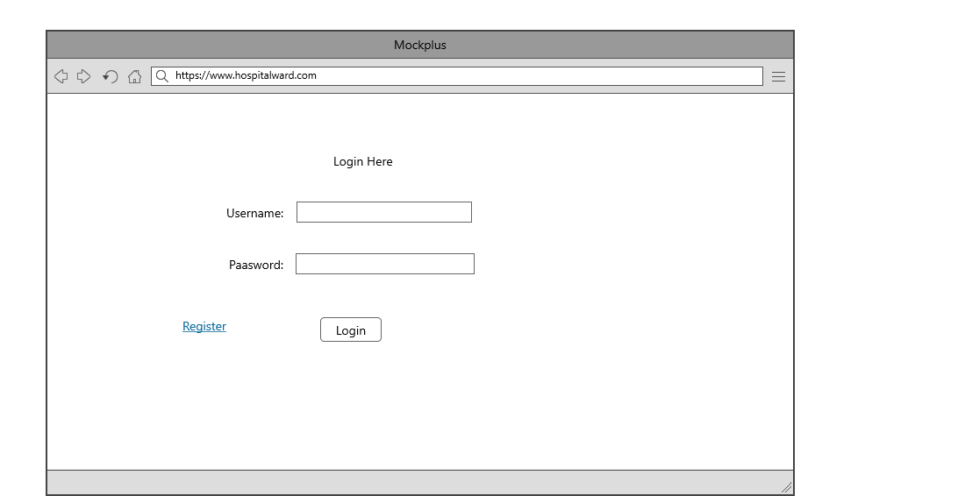

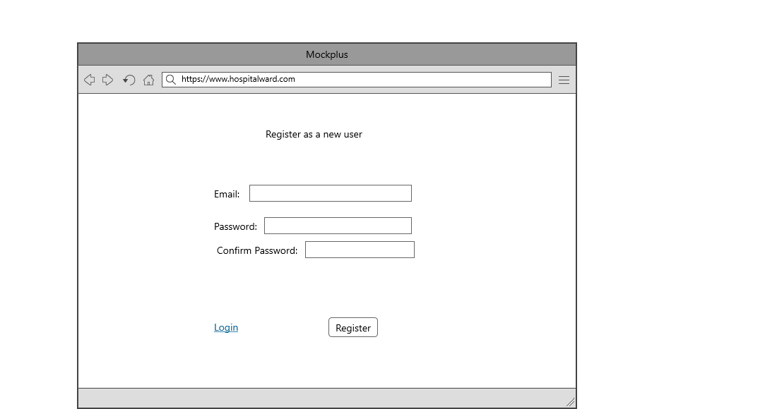

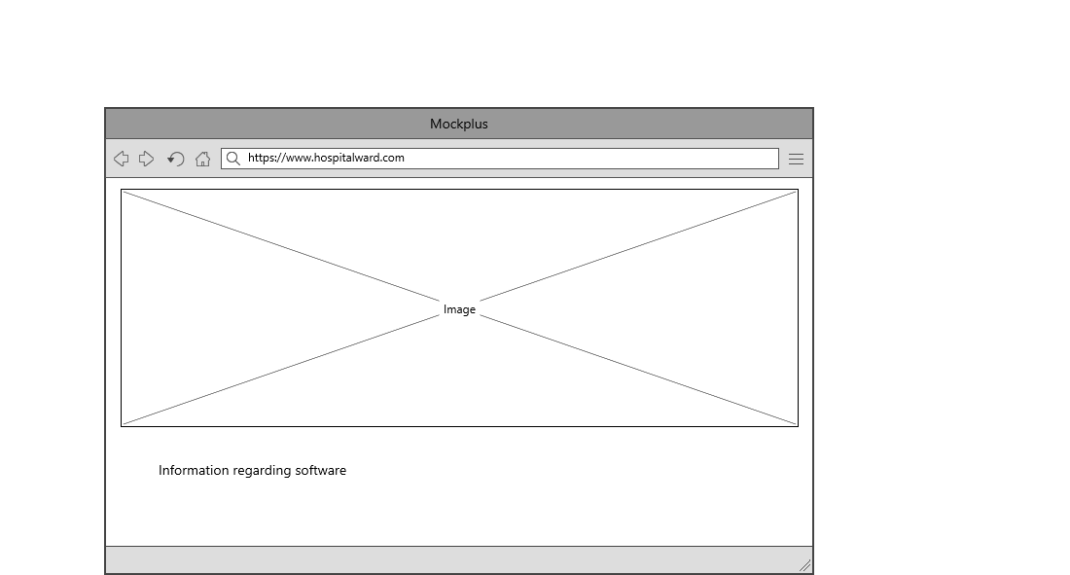

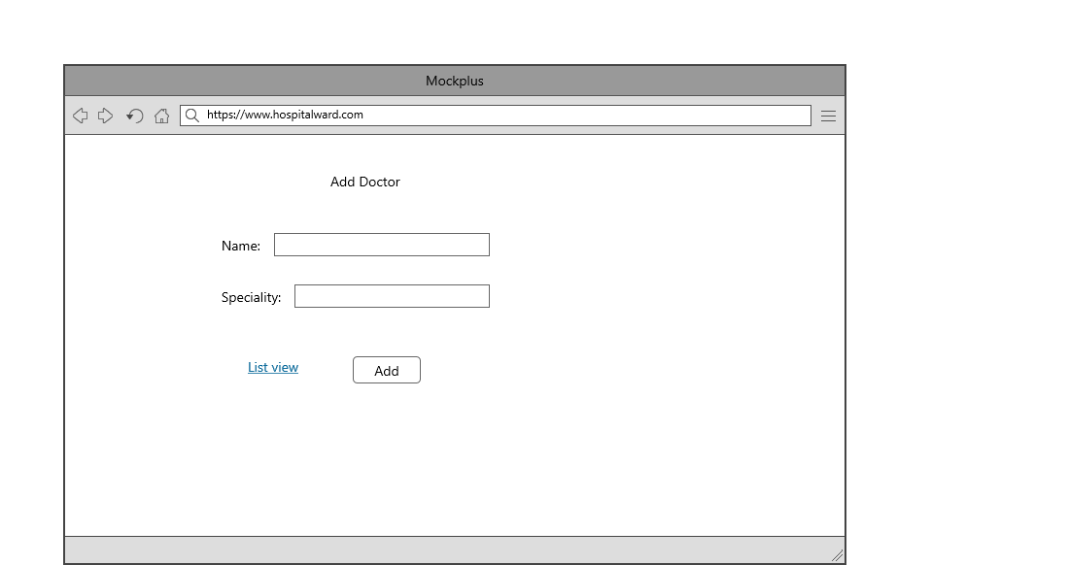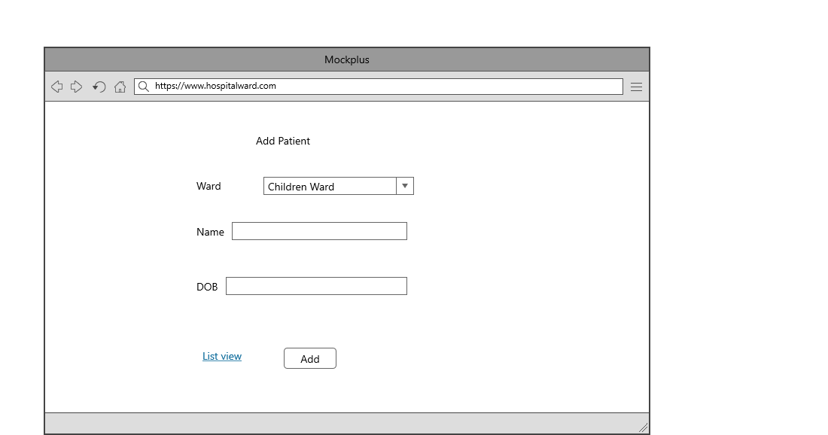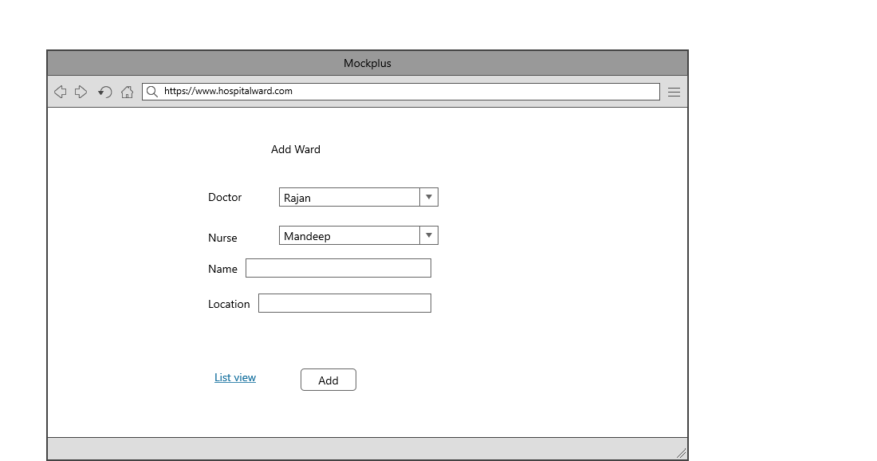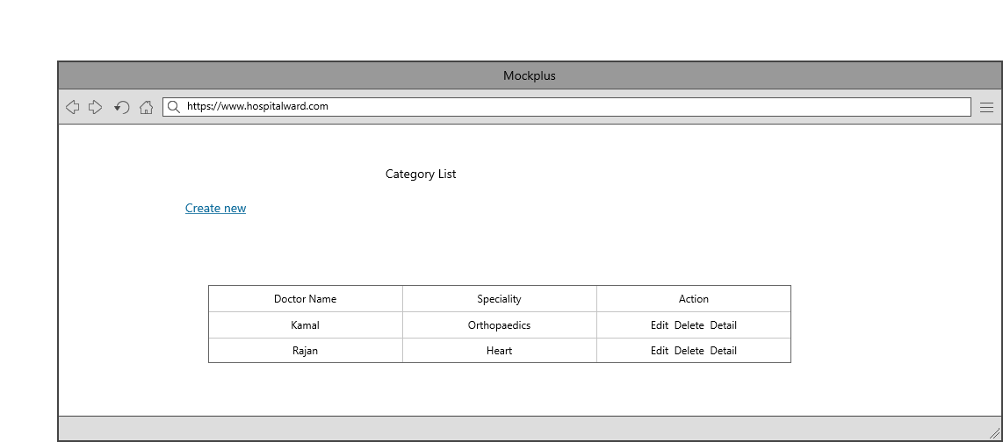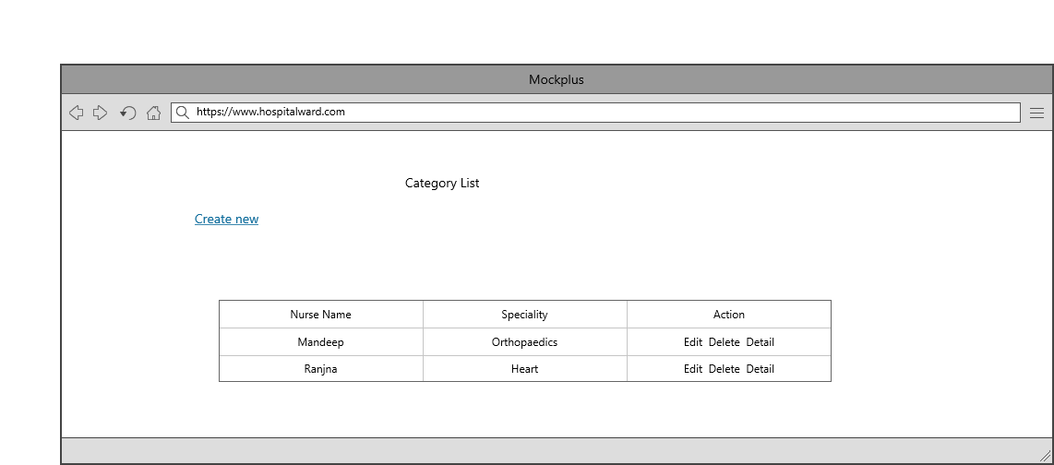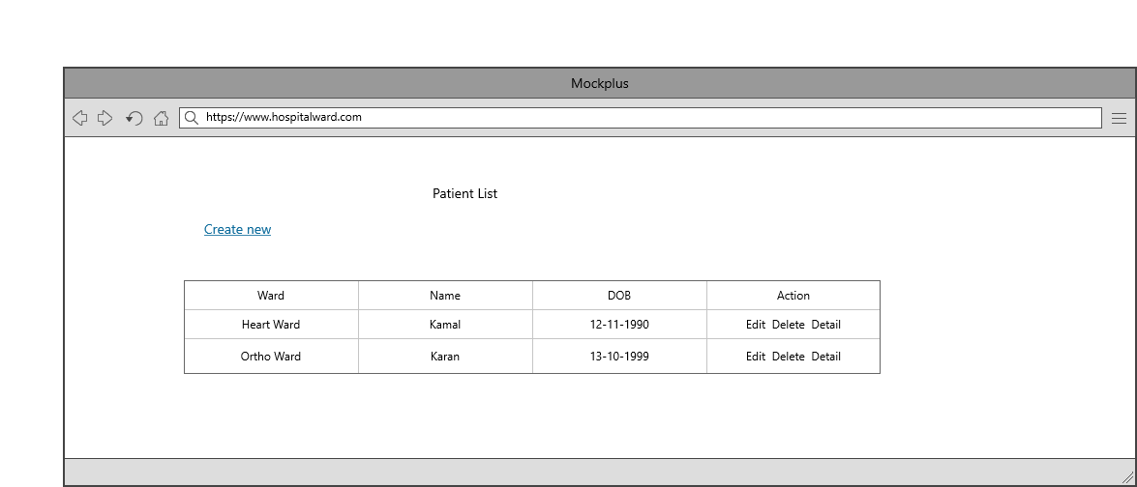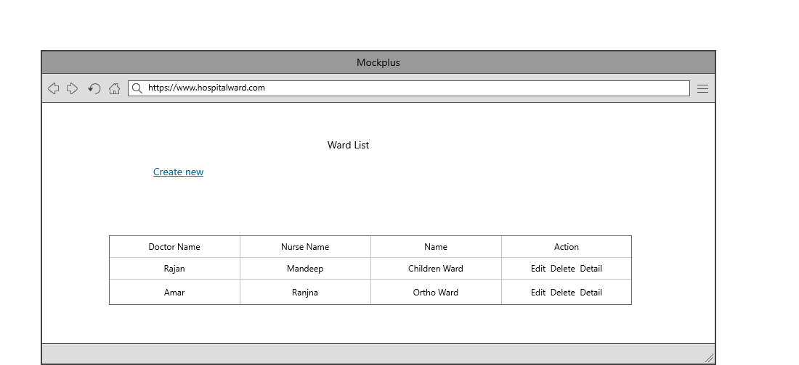

## Task 5- usability testing

|  |  |  |  |  |  |
| --- | --- | --- | --- | --- | --- |
| **User #** | **Login form** | **Patient module** | **Ward Module** | **Pass / Fail / Not executed / Suspended** | **Reviews** |
| Dilpreet | As Expected perfect | Patient | completed as expected | Pass | All modules are fine |
| Daljit | should some changes and expand more | nice | might be more attractive | Pass | Login form should be more attractive |
| Kajal | Ok | good | looking good | Pass | all modules are as expected |
| Rajinder | Perfect | Ok | Nice | Pass | All modules are ok |

**Task 6 - Meet with your client**

Client Meeting:

|  |
| --- |
| Meeting Details |
| * Date and time: 27-Oct-2021 * Location: Newzealand |
| Attendees: Daljit and Leo |
| Agenda: Discussion of Software of Hospital ward system |
| Discussion (Important Points): He wants neat and clean software which will work effectively |
| My To Dos (Actions): Firstly I have to make the mockups of the application. Then Starting the application after the next meeting. |
| Questions requiring Follow- Up: Discussion of the mock ups |
| Comments: Daljit is good person and he described regarding requirements very wisely. |
| Next meeting  Date and Time: 1- Nov-2021 1:00 Pm  Location: Newzealand  Agenda: Showing the mock ups to the client and discussion about further development. |

**Task 7- Presentation**

[**video1995673781.mp4**](video1995673781.mp4)

**Task 8 - Software development life cycle stages**

**Planning :-** Planning for the quality assurance requirements and identification of the risks associated with the project is also done in the planning stage. The outcome of the technical feasibility study is to define the various technical approaches that can be followed to implement the project successfully with minimum risks.

**Requirement :-** Once the requirement analysis is done the next step is to clearly define and document the product requirements and get them approved from the customer or the market analysts. This is done through an SRS (Software Requirement Specification) document which consists of all the product requirements to be designed and developed during the project life cycle.

**Software Design and prototyping :-** SRS is the reference for product architects to come out with the best architecture for the product to be developed. Based on the requirements specified in SRS, usually more than one design approach for the product architecture is proposed and documented in a DDS - Design Document Specification.

Screenshots

Home Page

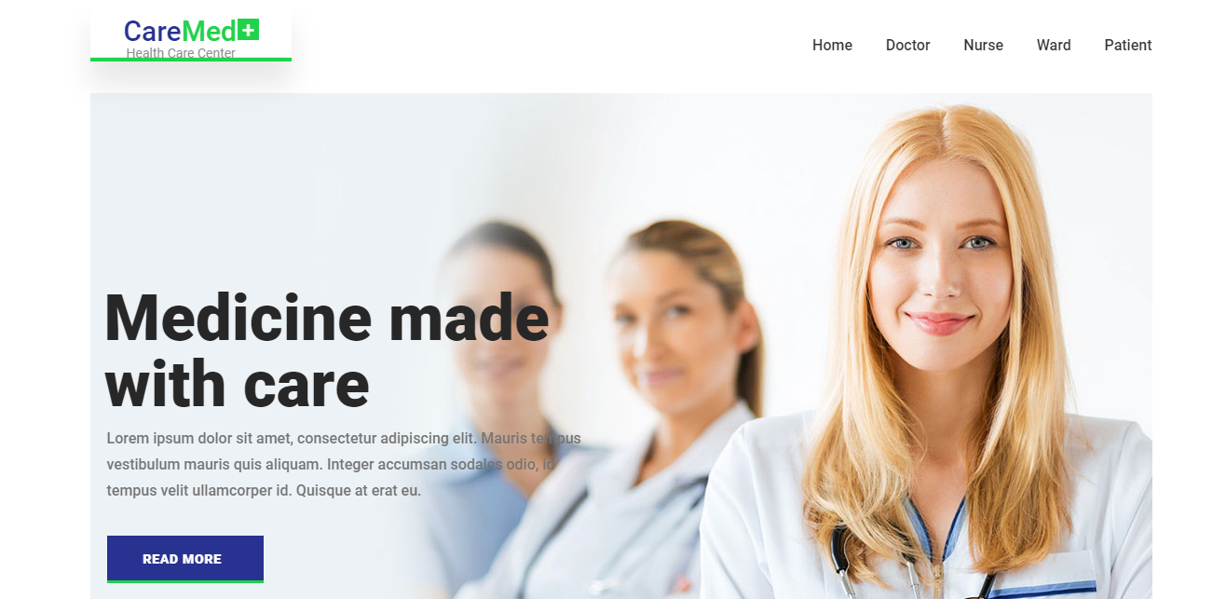

This is the welcome Screen where two option can be seen after login 1. New Project 2. New Story.

Doctor Page: Here you can view the list of doctors in the hospital and also do add, update and delete.

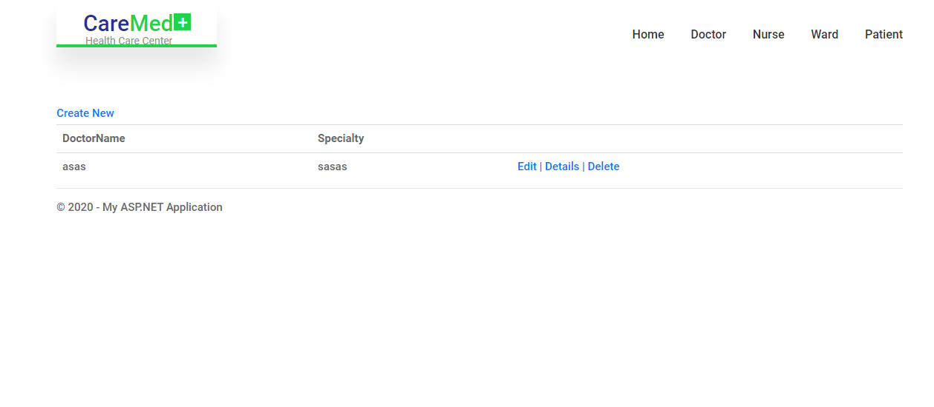

Nurses Page: Here we can save the records of nurses.

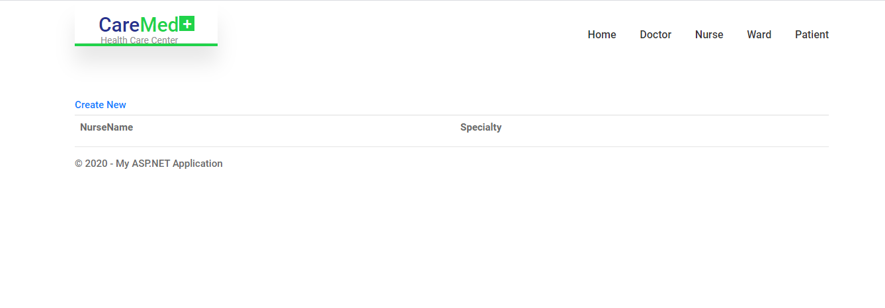

Ward Page: Here we can view the wards available in hospital and also add and update these.

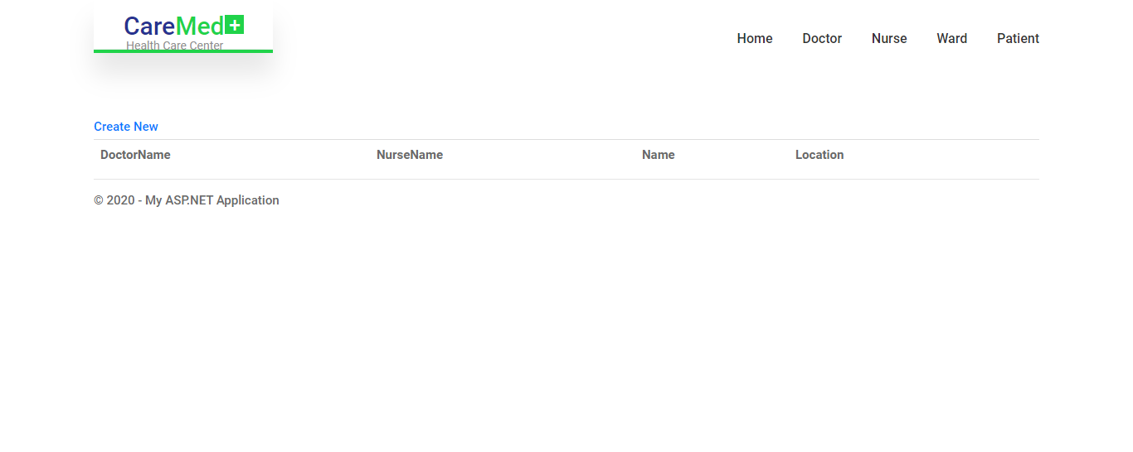

Patient Page: Here we can save the records of patients.

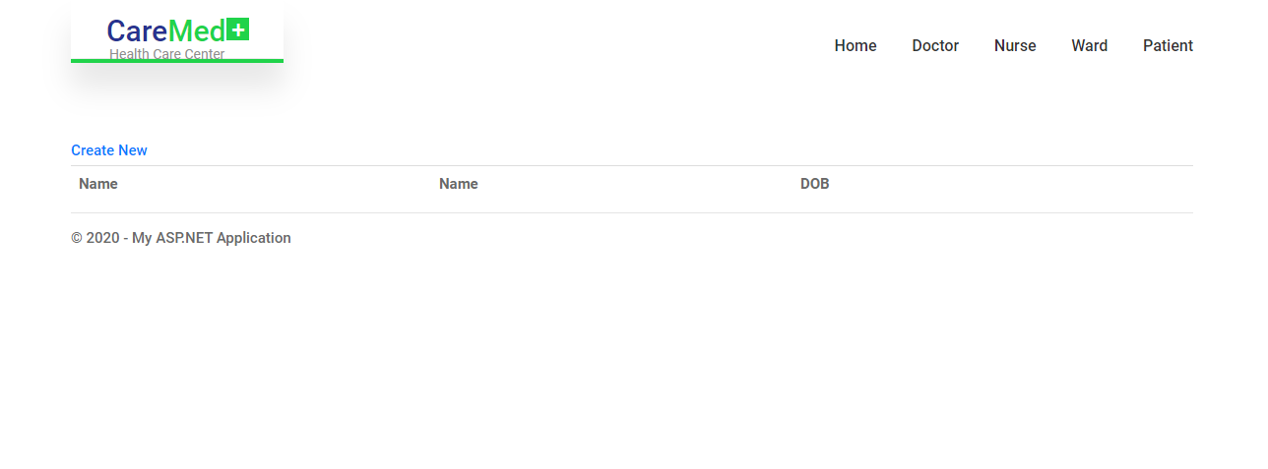

**Software Development:** In this stage of SDLC the actual development starts and the product is built. The programming code is generated as per DDS during this stage. If the design is performed in a detailed and organized manner, code generation can be accomplished without much hassle.

**Testing:-** Testing starts once the coding is complete and the modules are released for testing. In this phase, the developed software is tested thoroughly and any defects found are assigned to developers to get them fixed.

**Task 9- Project management**

All projects are a temporary effort to create value through a unique product, service or result. All projects have a beginning and an end. They have a team, a budget, a schedule and a set of expectations the team needs to meet. Each project is unique and differs from routine operations—the ongoing activities of an organization—because projects reach a conclusion once the goal is achieved.

The changing nature of work due to technological advances, globalization and other factors means that, increasingly, work is organized around projects with teams being brought together based on the skills needed for specific tasks.

Leading these projects are Project Professionals—people who either intentionally or by circumstance are asked to ensure that a project team meets its goals. Project professionals use many different tools, techniques and approaches to meet the needs of a project.

Some projects are needed to quickly resolve problems, with an understanding that improvements will be made over a period of time. Other projects have a longer duration and/or produce a product or other outcome that will not need major improvements outside of projected maintenance, such as a highway.

Still others will be a mix of both of these types of projects. Project professionals use a variety of skills and knowledge to engage and motivate others to reach a project’s goals. Project professionals are critical to the success of projects and are highly sought after to help organizations achieve their goals.