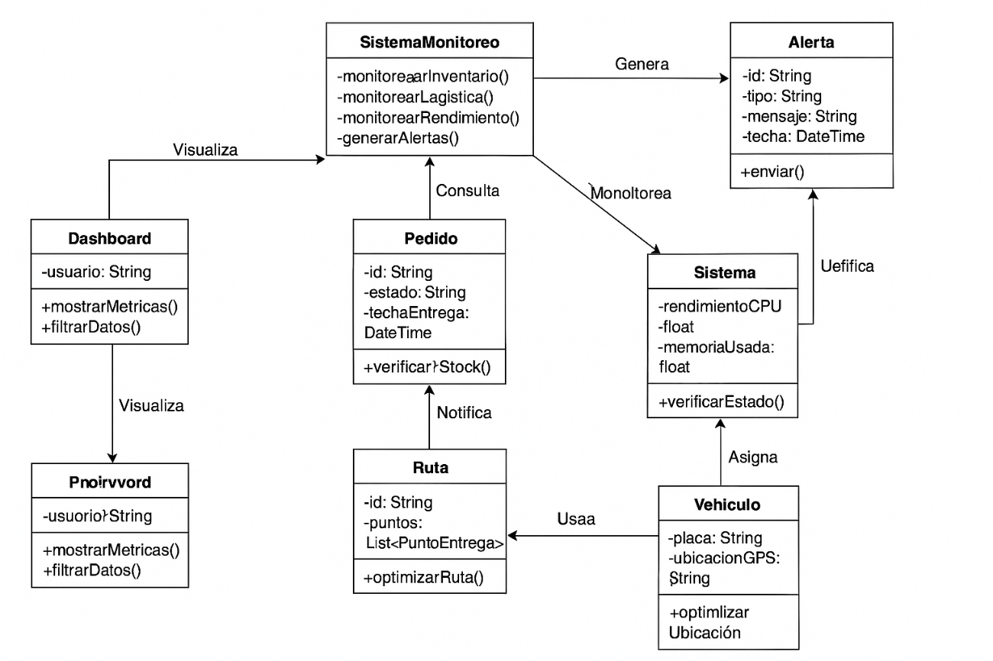

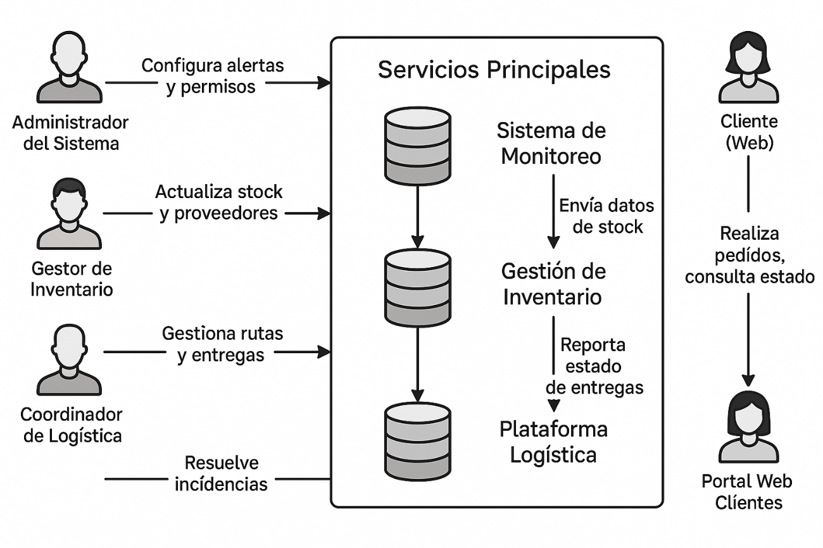

<https://www.planttext.com/>

<https://gemini.google.com/app/37a69e21fa47f935?hl=es>

<https://www.mermaidchart.com/app/projects/87fe8172-16bd-435d-973d-f6fb04732aad/diagrams/05ea37da-af04-4063-822f-0dd65fdbedb1/version/v0.1/edit> <https://chatgpt.com/c/67eaca96-ad38-800f-a4a1-7fdc8a9364da> Herramientas utilizadas

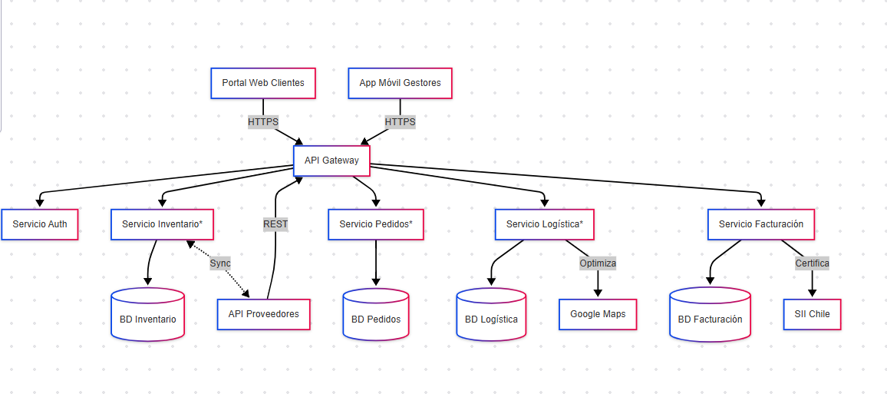v